HOMECOMING 2017 OFFICE DECORATION CONTEST
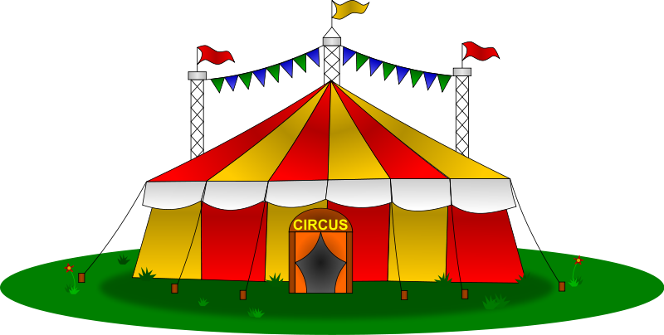

Sammy’s Circus…Bearkats Under the Big Top

October17th – 21st, 2017 is Sam Houston State University Homecoming Week. This is a very special occasion which allows the university to provide an atmosphere of togetherness for students, alumni and the community. The week provides a tremendous vehicle for alumni and retirees to reconnect to the university. Homecoming Week is also a special way to showcase our beautiful campus, offices and Bearkat Spirit.

If you wish for your decorated office to be judged, please enter on the homecoming website at http://www.shsu.edu/homecoming/contest.html by Friday, October 13th. The winner will receive bagels and coffee, compliments of Einstein Bros Bagels.

Please encourage all personnel to show their Bearkat Spirit by wearing orange during Homecoming Week and participating as a team to decorate offices in our Bearkat colors.

There are many significant Bearkat events throughout Homecoming week. Please encourage students, staff and faculty to participate.

Charlie Vienne
Charlie Vienne
Chair, Homecoming Committee

Rules and Regulations:
- Each entry will be judged in 2 categories: Best Decoration Award and Original Decoration Award.
- Each entry must be relative to the Homecoming Theme.
- All entries must be confirmed by Friday, October 13, 2017 to the Homecoming Office Decoration Chair Cutty Gilbert. 294-3755 or to cutty@shsu.edu.
- Entries will be judged on Tuesday October 17, 2017 between 9:00 a.m. and 4:00 p.m.
- You are encouraged to have your display completed by Monday October 10th and leave it displayed through Saturday’s Game.
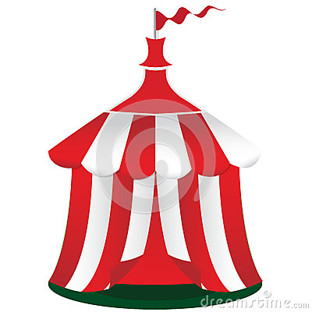
- The winner of the 2 categories will receive a plaque to display in their office/business until next year’s Homecoming, as well as their picture on Today at Sam.
- The winners will be listed on the Sam Houston web site Wednesday, October 18.


