SHSU VIOLIN
EXCERPTS Fall 2015
Solo of your choice & pick 3 of the following excerpts

Respighi Pines of Rome, mvt. 1 (pickup to 8 after Rehearsal 4 – Rehearsal 5)

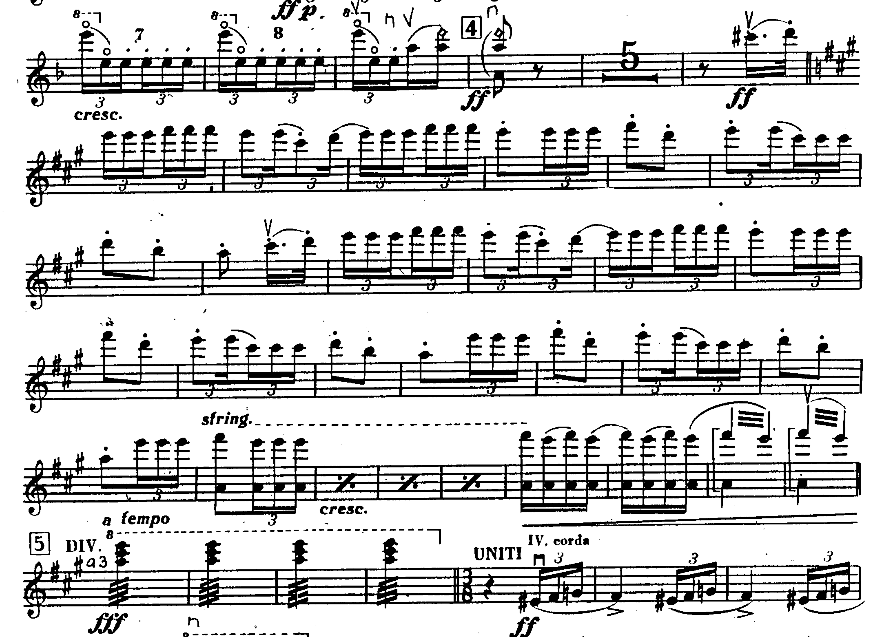

BRAHMS Symphony No. 4, mvt. 4 (mm. 33 – mm. 64)

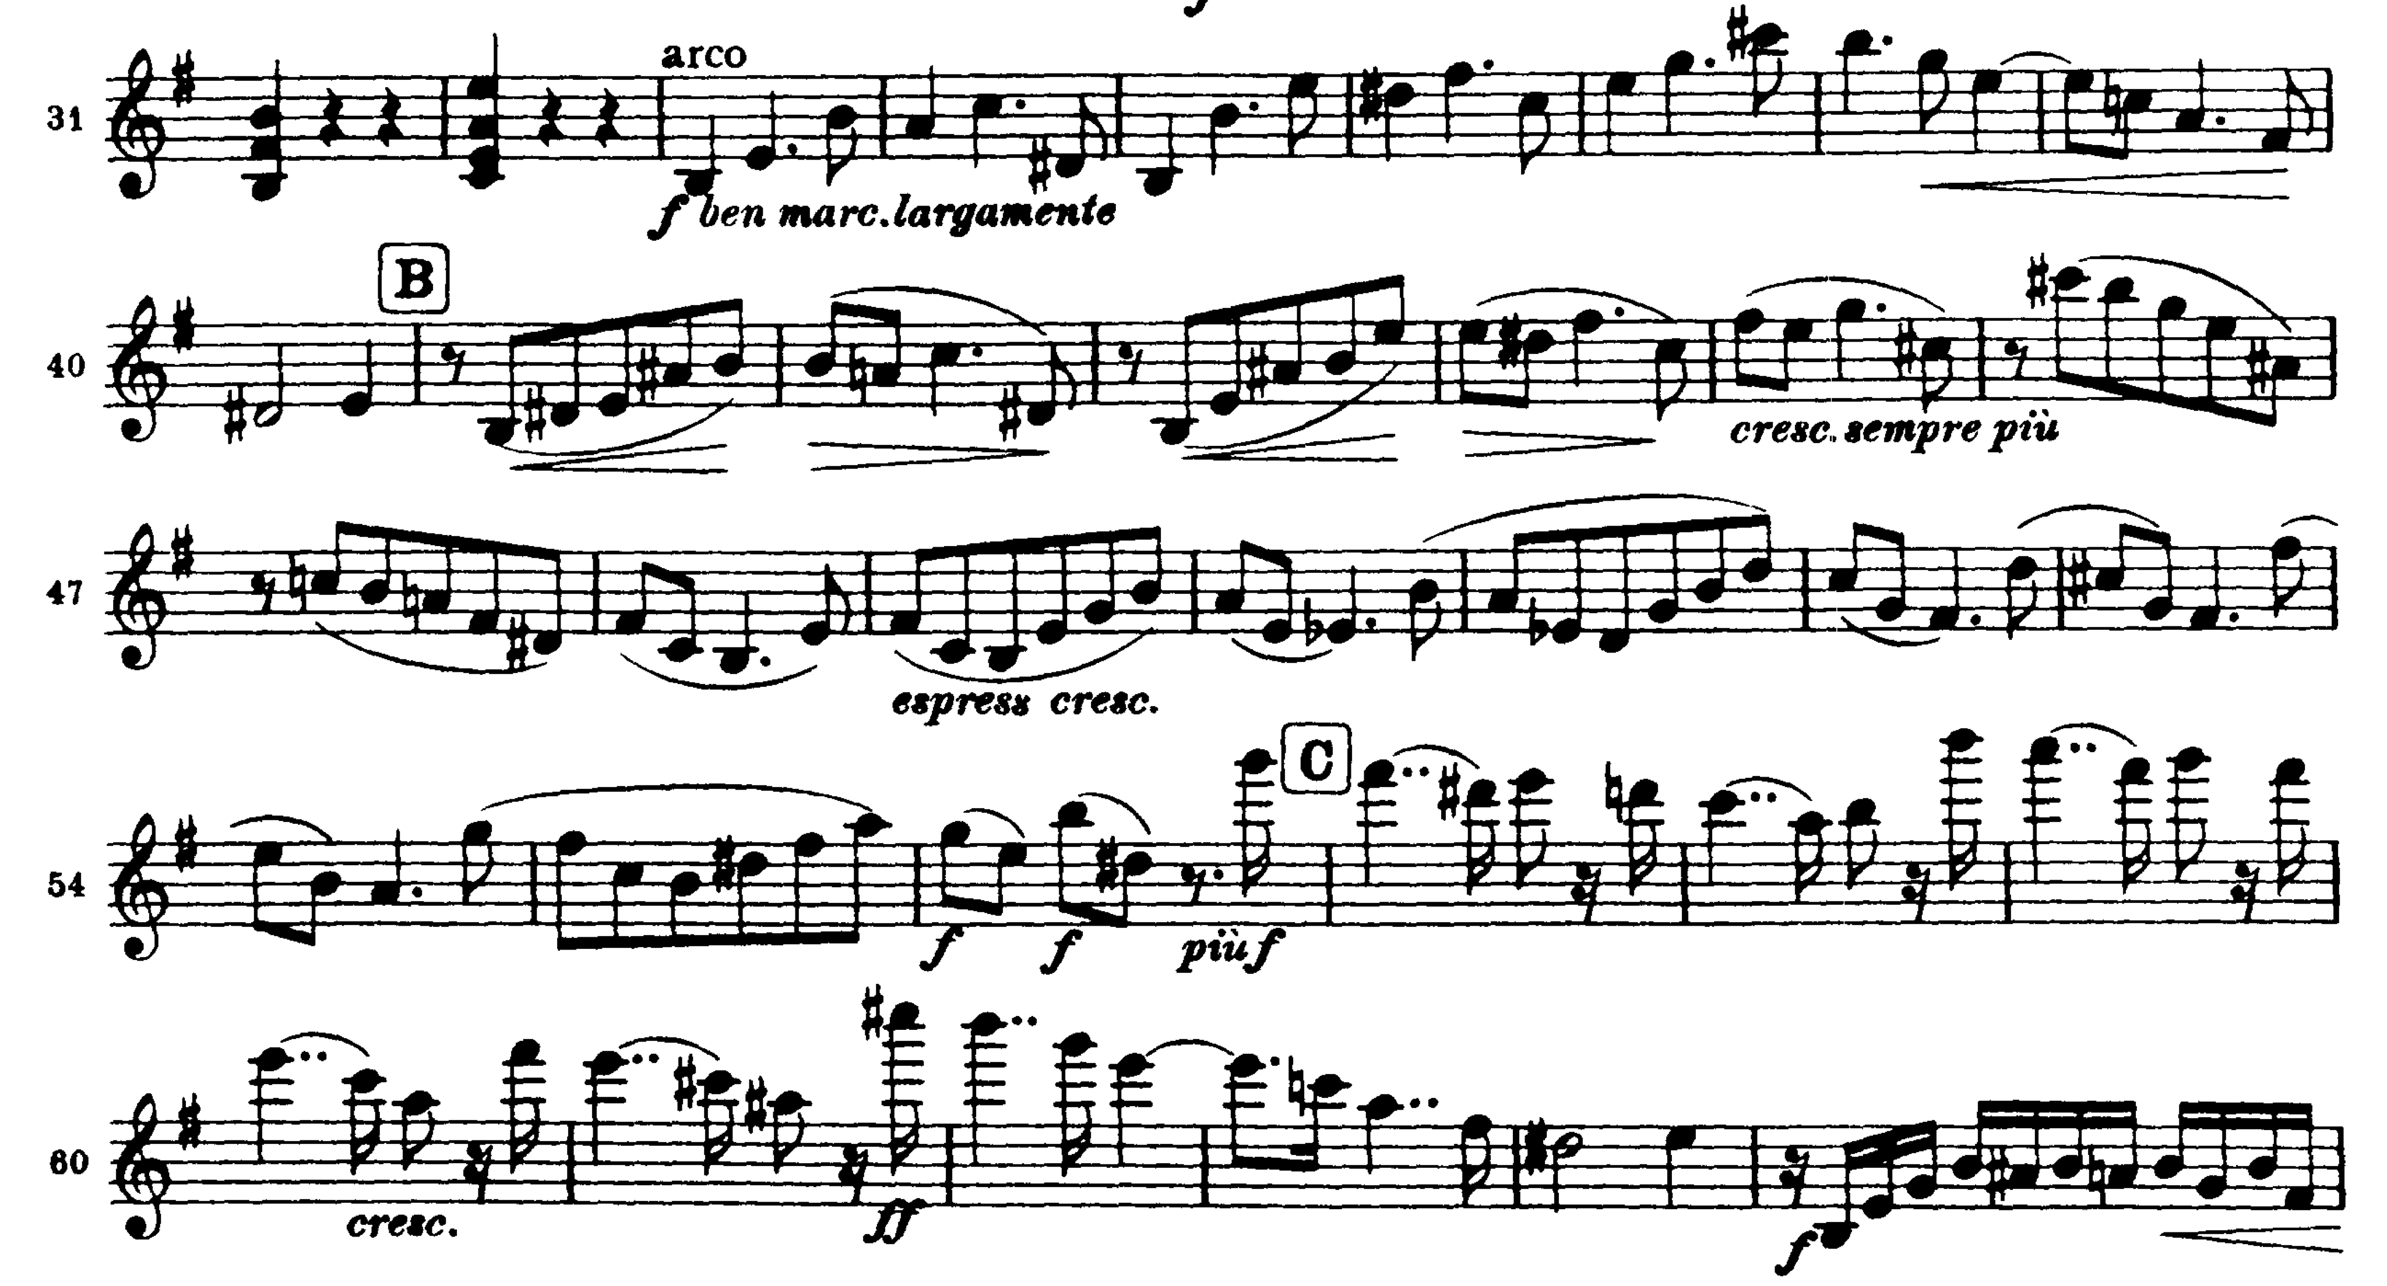

MOZART Symphony No. 39, mvt. 2 (mm. 1 – mm. 27)

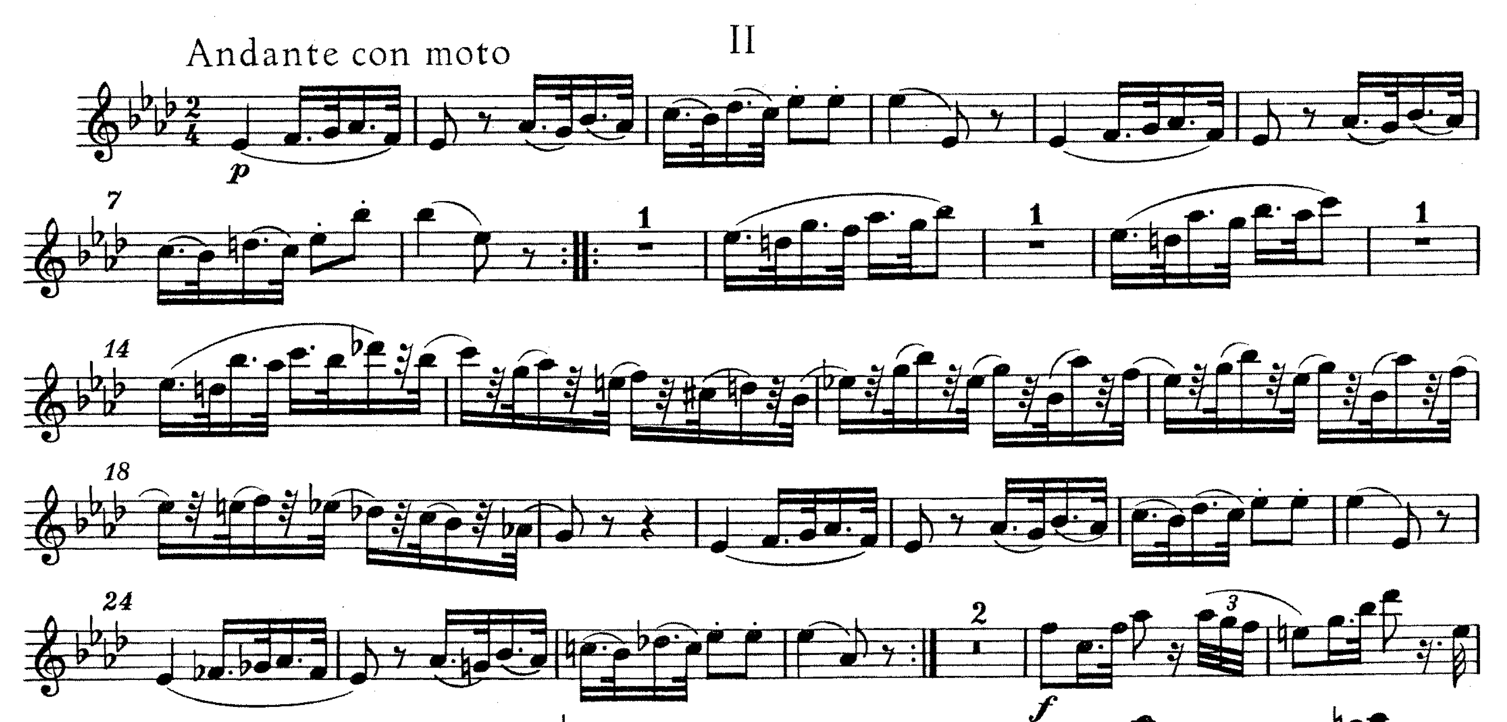

MOZART Symphony No. 39, mvt. 4 (mm. 1 – mm. 41)

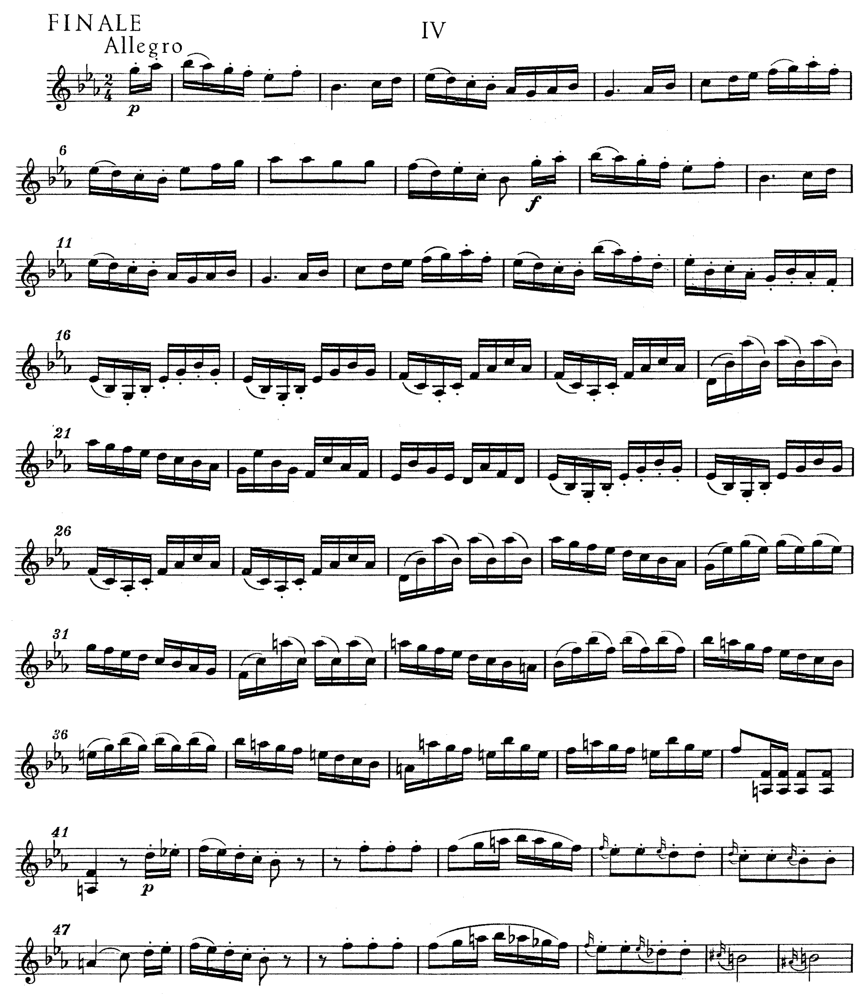
ROSSINI Overture to William Tell (mm. 316 – downbeat of mm. 351)

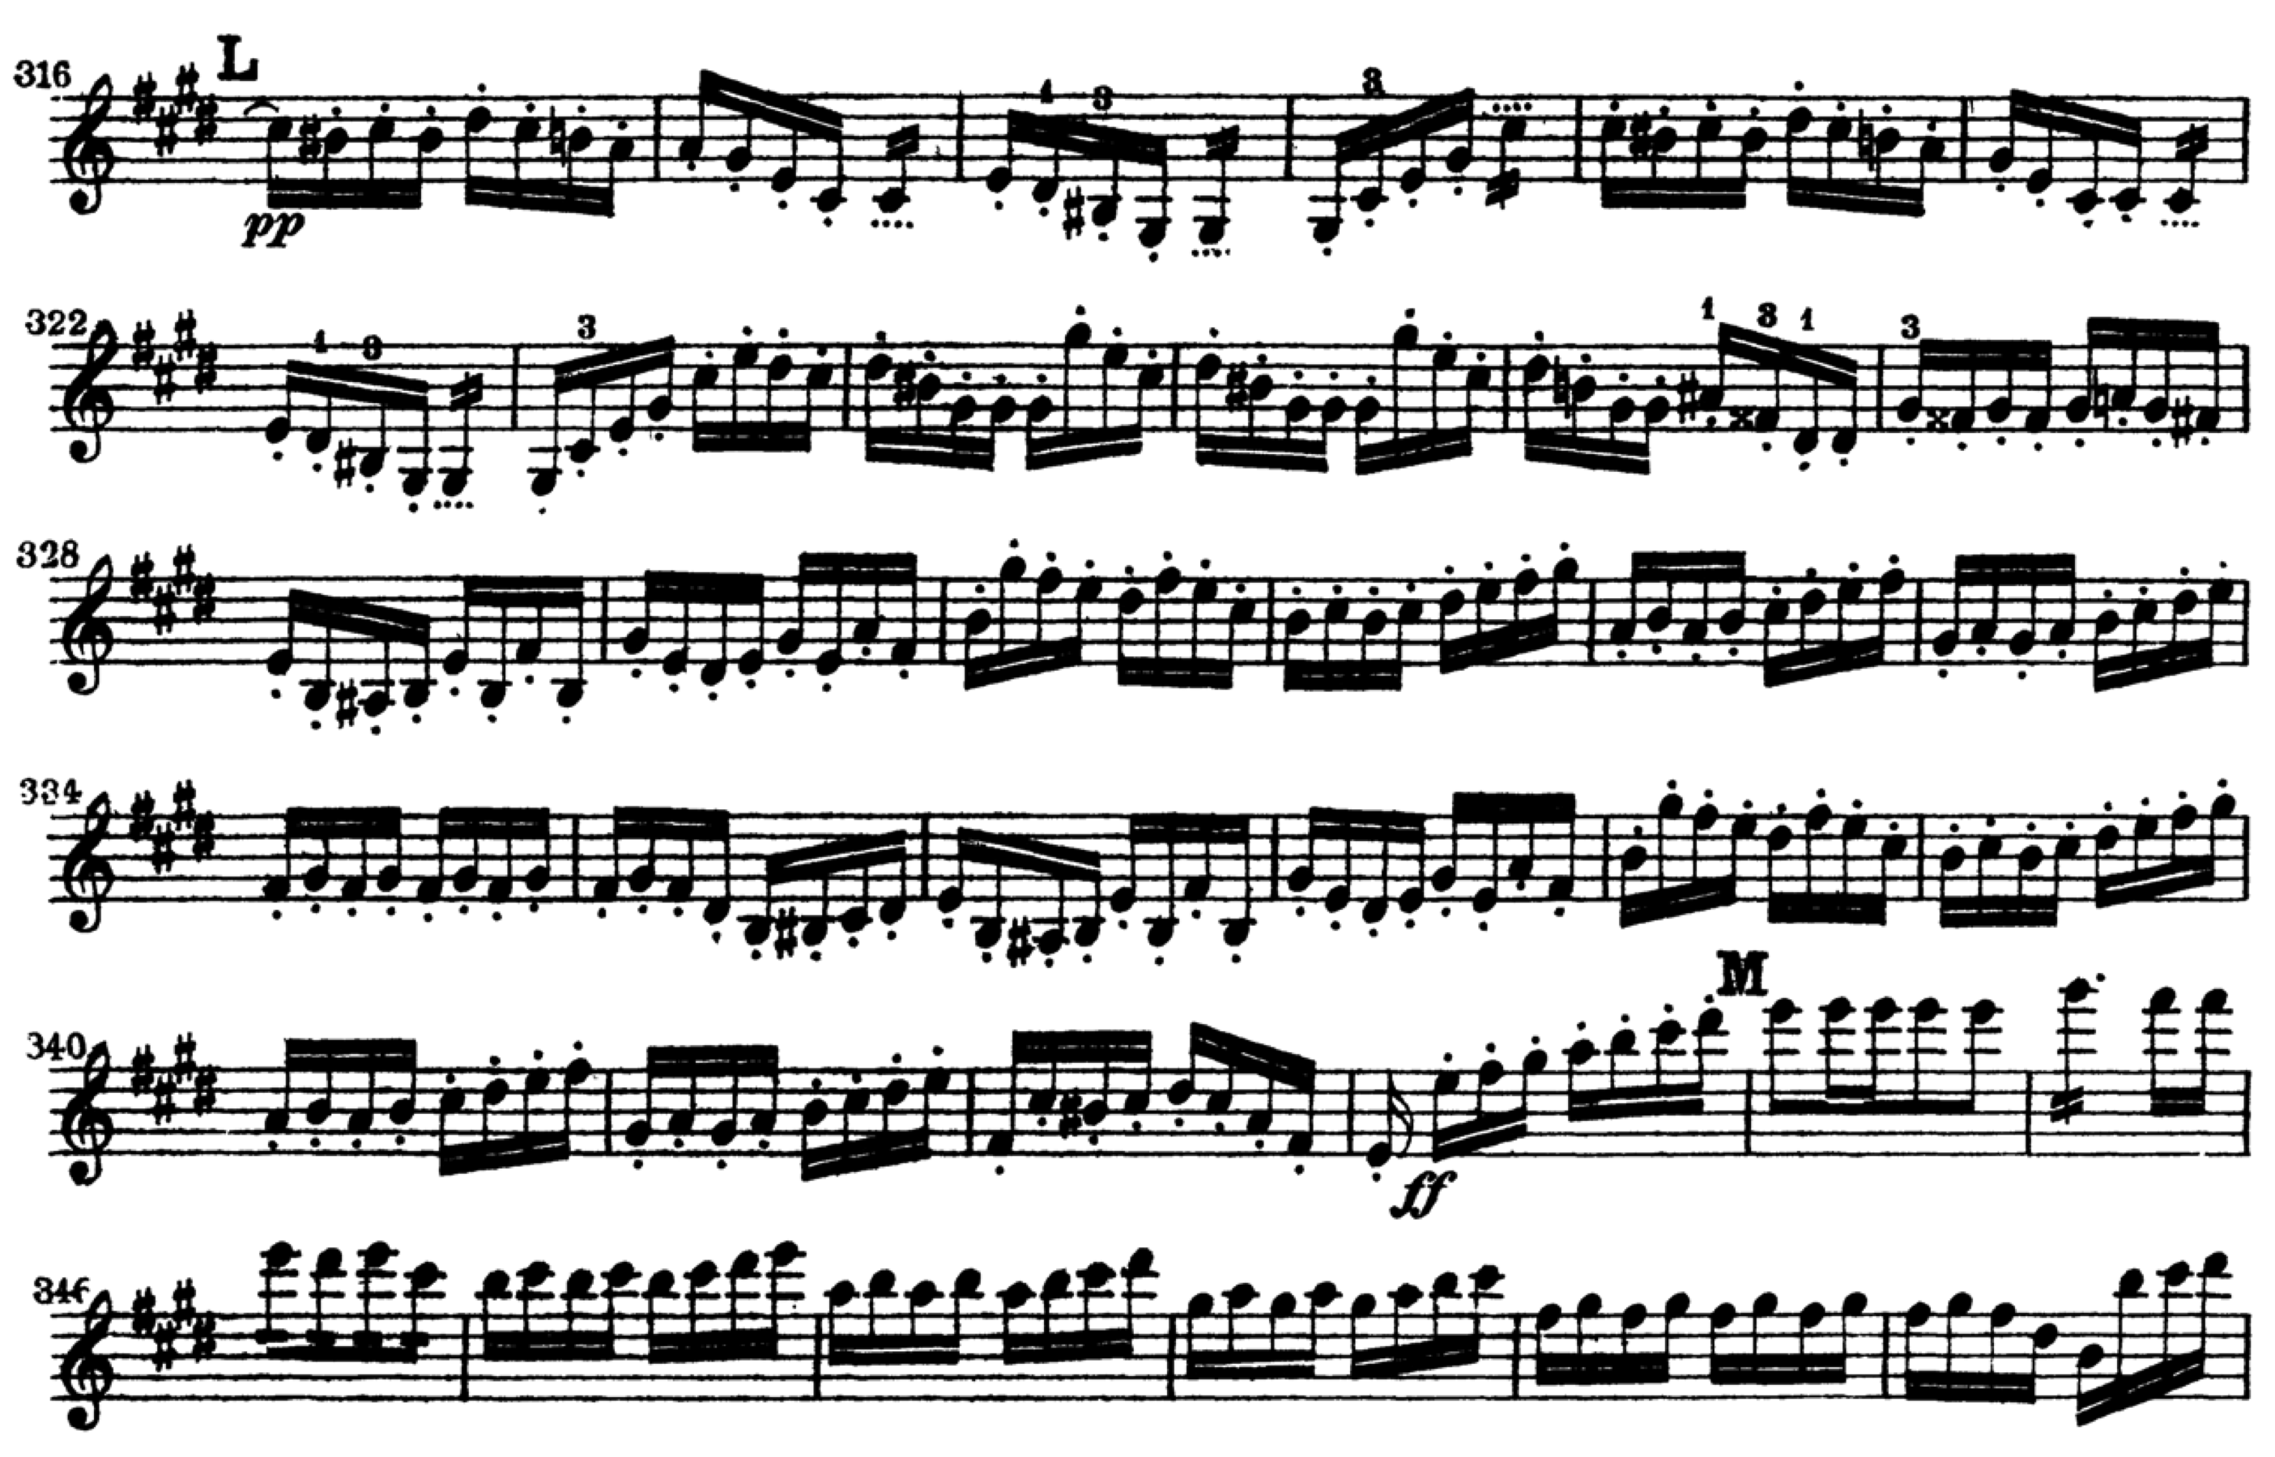

BEETHOVEN Symphony No. 3, mvt. 3 (mm. 1 – mm. 127, no repeat)

