Outdoor Annual → Fishing → Freshwater Fishing → Bass Identification

Bass Identification

Smallmouth Bass
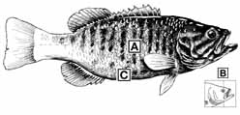
Smallmouth Bass
- A: Vertical barring along the sides.
- B: Jaw does not extend beyond the back margin of the eye when mouth is closed.
- C: Brownish-green color; white belly area does not extend high on the sides.
- Smallmouth Bass Species Details

Guadalupe and Spotted Bass
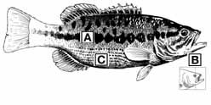
Guadalupe and Spotted Bass
- A: Irregular lateral stripe is similar to, but more broken than in largemouth bass.
- B: Jaw does not extend beyond the back margin of the eye when mouth is closed.
- C: Spots on scales form "rows" of stripes on whitish belly area.
- Guadalupe Bass Species Details
- Spotted Bass Species Details

Largemouth Bass
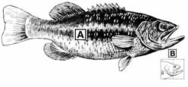
Largemouth Bass
- A: Definite lateral stripe
- B: Jaw extends well behind the back margin of the eye when mouth is closed.
- Largemouth Bass Species Details

Yellow Bass
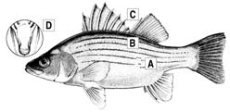
Yellow Bass
- A: Stripes distinct, broken above anal fin
- B: Color - silvery yellow
- C: Dorsal fins joined
- D: Does not have a tooth patch near the midline towards the back of the tongue
- Yellow Bass Species Details

White Bass
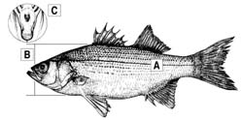
White Bass
- A: Stripes faint, only one extends to tail
- B: Body deep, more than 1/3 length
- C: Has one tooth patch near the midline towards the back of the tongue
- White Bass Species Details

Striped Bass
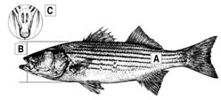
Striped Bass
- A: Stripes distinct, several extend to tail
- B: Body slender, less than 1/3 length
- C: Has two, distinct tooth patches near the midline towards the back of the tongue
- Striped Bass Species Details

Hybrid Striped Bass
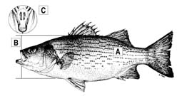
Hybrid Striped Bass
Also known as Palmetto or Sunshine bass
Note: For hybrids, all characteristics should be considered in combination, as characteristics in individual fish may vary.
- A: Stripes distinct, usually broken, several extend to tail
- B: Body deep, more than 1/3 length
- C: Has two tooth patches near the midline towards the back of the tongue. Tooth patches may be distinct or close together.

Back to Top

