31st Annual Newsletter
(Fall 2008)

Department of Biological Sciences
Sam Houston State University

HOMECOMING!
Celebrate Homecoming with us on Saturday, October 18, 2008

Homecoming Activities
(See http://www.shsu.edu/homecoming/calendar.html for details of SHSU Homecoming)

Thursday, October 16
6:30 pm Homecoming Parade- Sam Houston Avenue

Friday, October 17
6:00 pm Distinguished Alumni Gala Reception and Dinner- LSC Ballroom
(Call Alumni Relations at 936-294-1841 to make reservations)

Saturday, October 18
11:00 am Pre-game with the President- Austin Hall
12 noon SHSU Tailgate Party Bearkat Alley- Bowers Stadium parking lot
2:00 pm Football Game SHSU vs McNeese State -Bowers Stadium

5:00 p.m. Department of Biological Sciences Homecoming Barbecue, rain or shine,at the home of Dr. Jimmie Long, 3352 Winter Way, Spring Lake
Subdivision (located one mile west of I-45 on FM 1374). Sponsored by
Department faculty and staff. No charge.

Newsletter Under Construction

To Alumni: Recently you received notice by U. S. Mail of the Department of Biological Sciences Homecoming BBQ and electronic publication of the Annual Newsletter. This issue of the Newsletter is currently under construction.

As we receive information from alumni and faculty over the next two weeks, the Newsletter will be updated and finalized. The Alumni News section of the Newsletter is of great interest to our readers; therefore, we urge former students to send news of their careers, families and reminiscences by email to Newsletter Editor Andrew Dewees at bio_aad@shsu.edu. We look forward to hearing from you and seeing many of you at the Homecoming BBQ.

Posted September 30 and Oct 17, 2008

News of Graduates

Katy Dehm (MA 1993 BIO) reports: “… I will begin my career as a Gene Expression Technologist at the Jackson Laboratory (Bar Harbor, ME) on August 11, 2008. I'll be working with RNA in the lab next door to Todd's (Todd Dehm MA 1993 BIO)”

Amadou Diop (MA 1988 BIO) reports by email: “I am doing quite well my wife and my 7 children. I am now retired from government agricultural Ministry and work as national consultant at FAO representation in Niamey, Niger.” Amadou did his thesis research on grasshoppers with Dr. John Hilliard.

Dr. Rusty Pool (MA 1974 BIO), thesis student of Dr. Terry Hoage, is Scientific Director of Fertility Center of San Antonio. He presented a report of the work taking place at his center on in vitro fertilization at SHSU Biology Seminar last March.

Dr. Neudorf reports on the following Biology students:
Mallory Christian (BS 2007) is working on her MS at SHSU with Dr. Neudorf.
Sheena Humbird (MS 2007) is working as a naturalist at Jesse H. Jones Park and Nature Center in Humble, TX.
Kelly D’Orazio (MS 2003) is working as a veterinarian in Apache Junction, AZ.

Leslie Hughes (BS 1998) reports that she and husband Phillip Hughes (MS 2000) “live in the Florida Keys with their 3 sons, Phillip (9), Avery (7) and Luke (3). Phillip works for the US Fish and Wildlife Service as the Endangered Species Recovery Biologist and is stationed at the National Key Deer Refuge on Big Pine Key. Leslie works part time as the youth ministry coordinator at their church and spends the rest volunteering at the elementary school that her children attend. The Hughes' send their greetings to all friends from the SHSU Biology Department and can be contacted at Leslie@stpeterbpk.com.”

Dr. Wilson reports that Christopher Preskitt (BS 2007 BIO) has recently taken a position as 7th grade science teacher at Sulfur Bluff ISD.

Sean Daly (M.A. 2005) “is currently working for Burns & McDonnell Engineering Company, having transferred to Southern California last year. He serves as one of the lead field biological monitors on a large “Greening the Grid” transmission line project that connects several windfarms to the power grid. Sean also serves on the Board of Directors for the Desert Tortoise Council and as the newsletter editor. The DTC conducts the recommended handling workshop for people requesting handling permits.”

NOTES from the CHAIR
I now have the auspicious task of addressing the faculty, staff, and students of the Department, along with the alumni and retired faculty and staff, in the Notes from the Chair this year. First of all, most of you have noticed, there is a new Interim Chair. I am honored to serve in this role, leading our Department. Many thanks to our previous Chairs, Dr. Matthew Rowe who served almost three years, and Dr. Jerry Cook, who served for one semester. As I now understand, serving as Chair is a challenging and important task. Dr. Cook has now moved on to be Vice President of the Office of Research and Special Programs. With his NSF experience, we are all very confident he will do an excellent job. Dr. Rowe is back to what he loves, teaching and mentoring students as a Professor (and chasing scorpions in the desert).
Ok, who is the new guy? Yes, he’s a bit younger. My name is Todd P. Primm (it’s a German regional name), and I am a recently tenured Associate Professor in the Department. This is a time of historic opportunity for this Department. The University-at-large has experienced very strong growth in student numbers in the past few years, going from 12,355 full-time students in 2000 to 16,445 in 2007 (an astounding 33% increase in 7 years). How have we grown here in Biology lately?
- Biology has four new tenure-track faculty joining us this fall (see new faculty section). This is an excellent group of teachers and researchers, from the University of Oklahoma, Ohio State, University of Texas Health Science Center in Houston, and the Marshfield Clinic Research Foundation in Wisconsin.
- I also very pleased to say that we now have a faculty member, Dr. Jack Turner, as Director of Medical and Allied Health Programs at SHSU. By the way, thanks to Dr. Thies and Wilson for advising pre-medical students for a number of years. I know that Dr. Turner has been working hard recently to expand our services to students planning professional school in the medical field. Its good to have his experience and enthusiasm in a position like that.
- A new building is still in the works. The University just broke ground on the Performing Arts Center, and the word is that we are next in line.
- We have a record 34 active graduate students in our program this fall, performing research with the faculty. Dr. Anne Gaillard is serving very capably as our Graduate Program Coordinator, with assistance from the graduate committee. Note several of these students are supported by the new NSF-funded PEERS program (see section on that later).
- The University clearly recognizes the capability of faculty in this Department, as a number have been appointed to administrative positions. Monte Thies is continuing to serve as Director of the Field Station, Joan Hudson is serving as Departmental Assistant Chair, Tamara Cook is Associate Dean of the College of Arts and Sciences, and Bill Lutterschmidt is Director of TRIES (Texas Research Institute for Environmental Studies). Clearly a lot of our faculty are serving in leadership roles for SHSU.
- For alumni and former faculty, if you have not yet seen, visit the Departmental webpage at www.shsu.edu/~bio_www/ It has recently been revised, with efforts from Dr. Lutterschmidt and Andy Johnson. We hope it now serves to communicate well to everyone. If you have any comments on the page, feel free to contact me. Especially of note, see that the Alumni Survey can now be filled out online. Thanks to Diane Neudorf and the rest of the assessment committee for making that possible. If you are an alumni and have not filled out the survey, please do so. You input will help us to continue to improve.
- Finally, the Department again has a great strength in getting undergraduates involved in research. For more information, see the section on student research written by Dr. Deaton. Also, note that our Distinguished alumnus, Dr. Bill Brinkley, has again been honored (see section on endowed chair at Baylor College of Medicine). I’ve heard him say that his undergraduate research experience with Dr. Long involving mosquitoes was invaluable in launching in his career. It is very interesting how things in life come full circle, as I obtained my PhD from Baylor with Dr. Brinkley as Dean of the Graduate School. When it comes to giving undergraduates a quality research experience, we are among the best in the nation.
- Note in the section on scholarships that we continue to raise funds for student support. This is simply the result of an excellent job by the scholarship committee, other faculty, and especially the donors. With the majority of our students supporting themselves financially, this is such a critical activity.
- Another item you can note on the Departmental webpage is the Seminar Series, directed by Dr. Chad Hargrave. Our faculty and students have enjoyed an excellent array of speakers over the past year, from institutions such as Johns Hopkins, Yale, Rutgers, BYU, Kansas State, Tulane, George Washington, Duke, Cornell, and others. What tremendous exposure this has been for our program to the external scientific community. Many of these visitors have also met with students to discuss career issues. Many of the visitors have remarked to me about how impressed they were with the level of student research involvement here. We now have an endowment for the seminar program to pay expenses and bring in speakers from all over the world. As alumni, feel free to visit any of the seminars you would find interesting.
- Speaking of national recognition, Dr. Rowe’s research on how squirrels use snake skins to give themselves the scent of snakes as a defense mechanism has been covered in the New York Times (see http://www.nytimes.com/2008/02/05/science/05obsqui.html), and discussed on the National Public Radio show “Moment of Science” on March 18, 2008. Research from Dr. Lutterschmidt on snake skin physiology and water retention was featured on the History Channel, in a series called “Evolve.” Check it out on (http://www.youtube.com/watch?v=ImQcIkvpRAM).

I had a special experience during the recent Hurricane Ike I’d like to share. We had a number of evacuees from the University of Houston at Clear Lake on campus. It was wonderful to see a number of students and faculty from our Department, indeed from the College of Arts and Sciences, assisting these evacuees. It made me proud to be a part of this generous group. So, it has been another good year for the Department, and we are expecting even better things to come.

Endowed Chair Established in Honor of Dr. William R. Brinkley

Baylor College of Medicine’s Board of Trustees in Houston, TX announced the establishment of the William R. Brinkley/BRASS Endowed Chair, named in honor of long-time BCM faculty member, Bill Brinkley, Ph.D (BS ‘59, MS ’61, SHSU), senior Vice President Dean of the Graduate School of Biomedical Sciences at Baylor College of Medicine. Dr. Brinkley, the first holder of the Chair, has served as Dean of the Graduate School for the past 17 years and has led the school to its present standing as one of the nation’s leading centers for graduate education. The $1.5 million endowment for the Chair was raised by a special group of friends of the Graduate School known as Baylor Research Advocates for Student Science (BRASS), a committed support-group of prominent Houston citizen established in 1993 to provide scholarships and other benefits to the Graduate School’s top applicants for the PhD and MD/PhD degrees. BRASS President, Diana Brown, said, “as the Dean of the Graduate School of Biomedical Sciences, William R. Brinkley, Ph.D., has championed BRASS and recognized its existence as an important element in the overall success of the graduate school. In gratitude for Dr. Brinkley’s long-standing support of its mission, BRASS recently voted to name its
endowed chair in his honor. The William R. Brinkley BRASS Chair will enable BCM to support the dean and his successors who will steward the goals and activities of BRASS for generations to come. An endowed chair is one of the highest honors that can be bestowed on a faculty member, and BRASS is proud to confer such an honor on one of the College’s most dedicated academic leaders”
Dr. Brinkley received his BA and MS degree in Biology from Sam Houston State University in the early 1960s under the tutelage of Professor. James Long and later received his Ph.D degree in Cell Biology at Iowa State University. His wife Shirley is also an alumnus of SHSU.

Dr. Karölis Richard Bagdonas
(1944 – 2007)

Long-time member of the Biology faculty, Dr. Karolis Bagdonas, suffered a sudden stroke and passed away on October 16, 2007. Dr. Bagdonas joined the faculty in 1990 and taught courses in entomology, human anatomy, and evolution. He taught the Human Anatomy course at SHSU every semester for over 15 years, exposing several thousand students to this subject during his career. Each week, he spent many hours in the anatomy labs assisting his students. After their first lecture exam in this course, the students could look forward to a “fireside chat” with Dr. Bagdonas, during which time they received a review of their progress or lack there of. Dr.
Bagdonas served many years as the pre-nursing advisor and was able to assist students in this career field. He served for many years as faculty advisor for SHAMOS, Sam Houston Association of Medically Oriented Students. Under Dr. Bagdonas’s direction, SHAMOS members conducted yearly blood and food drives on campus, visited area medical institutions, and sponsored on-campus lectures. Trained in entomology, botany and ecology, Dr. Bagdonas particularly enjoyed teaching his entomology courses. His students learned to appreciate the study of insects and would spend many hours preparing their insect collections.

Prior to coming to SHSU, Dr. Bagdonas taught at Casper College (WY) and the University of Wyoming. He did extensive field research in the mountains of north western Wyoming, and in 1994 he established the Northwestern Wyoming Wilderness Research Field Station near Dubois, Wyoming. Dr. Bagdonas and his family spent every summer there, engaged in studies of Lepidoptera of the area. As a lepidopterist he was so highly regarded in the field that from 1980-1985 he served five terms as president of the Xerces Society, an international organization dedicated to the preservation of invertebrates. Over the years several SHSU students spent part of their summers working with Dr. Bagdonas at his field station.

From Dr. Bagdonas’s Obituary in the Hunstville Item: “Karolis was a devoted and loving father, husband, friend, mentor and teacher. His teachings and research in both the natural and medical fields have left an impact on the world, inspiring many to follow their life’s passions, leaving many naturalists and future and present nurses to continue with theirs and his life’s work in the preservation and healing of the earth and all the creatures who inhabit it. He is survived by his wife, Patrice Lussy of Huntsville; son, Davin Bagdonas and daughter, Halena Bagdonas of Laramie, Wyo.; daughter, Lynell Bagdonas and grandson, Zann Bagdonas of St. Petersburg, Fla. and sister Carolyn Stana of Denver, Colo.”

Biology Graduate Program

Over the last three years, the Graduate Program in the Department of Biological Sciences has grown substantially. From 2006-2007 the program nearly doubled in size, and over the last year the program grew another 50% to its current number of 31 graduate students. This growth is due, in large part, to a significant increase in faculty members with active research programs in the department.

The diversity of the graduate program has also increased. The program currently has four international students from the respective countries of Belize, Greece, China, and India. Furthermore, the program has grown to include students who received bachelor’s degrees from far-away locations within the United States, including Rhode Island, Kentucky, Nebraska, Georgia, and Pennsylvania.

As of October, four students have graduated this year with an M.S. degree from the department: Joanna Hays Cielocha, Jessica Belen-Rivera, and Anna Buchman, all full-time graduate students, as well as Laurie Pierrel, who most recently was a part-time graduate student. Joanna Hays Cielocha recently began a Ph.D. program in parasitology at the University of Kansas and Anna Buchman is a new Ph.D. student at the California Institute of Technology. Jessica Belen-Rivera recently accepted a position as a research associate at Lexicon Pharmaceuticals in the Woodlands, TX.

Other SHSU graduate program alumni in the news include Robert Puckett (BS 2001, MS 2003), who will receive his Ph.D. from Texas A&M University this December and Autumn Smith (MS 2004) who will be getting her Ph.D. from Texas A&M University-Kingsville in December.
Dr. Anne Gaillard, Department Graduate Advisor

Departmental Academic Scholarships

It is essential that our alumni be informed of the healthy status of the scholarship endowments currently in the biology department. We are very pleased with our efforts to encourage and attract these donors and, as the old saying goes, more is bound to be better! Current endowments, as of September 1, 2008, are as follows:

SHSU Biology Endowment (from lab manual sales) $100,714
Wilson-Warner Endowment $845,380
James D. Long Biology Endowment $680,574
Patrick Neal O’Bryant Endowment $ 77,092
Emma Normand Biological Endowment $ 34,138
Environmental Science Endowment $ 33,303
Everett D. Wilson Biology Endowment $ 14,893
Harold F. Foerster Biology Endowment $ 8,791
Roy Turner Biology Endowment $ 6,924

With the interest earned from these endowments the scholarship committee selected 27 students to be the recipients of scholarships ranging in amounts from $8,000 for three scholars and varying amounts down to $1,000 for the remaining 24 students for the 2008-09 academic year. A total of a little over $60,000 was available for scholarships 2008-2009.

Dr. Everett D. Wilson,
Scholarship Committee Chairman

New Faculty

Dr. Madhusudan Choudhary joined the biology faculty this fall as Assistant Professor of Biology. From 1993 to 2008 Dr. Choudhary served as Research Assistant Professor at The University of Texas Medical School in Houston, Texas. Prior to this period, Dr. Choudhary held research positions at Rice University and Duke University. Dr. Choudhary obtained the PhD. in genetics and molecular evolution from McMaster University in Ontario, Canada. He received the M. Sc. (with specialization in cytogenetics) and B. Sc. (Hons) from Patna University in India. Dr. Choudhary has broad research experiences in genome structure and organization, bioinformatics, gene expression, phylogenetic analyses, and functional genomics. He has an extensive list of publications, four of which are shown below:

Choudhary, M. and S. Kaplan (2000) DNA sequence analysis of photosynthetic region of Rhodobactersphaeroides 2.4.1T. Nucleic Acid Res., 28:862-867.

Choudhary, M., Fu, Y. X., Mackenzie, C., and Kaplan, S. (2004) DNA Sequence duplication in Rhodobacter sphaeroides genome: Evidence of an ancient partnership between chromosome I and II. J. Bacteriology, 186: 2019-2027.

Morton, R. A., Choudhary, M., Cariou, M., and Singh, R. S. (2004) A reanalysis of protein polymorphism in Drosophila melanogaster, D. simulans, D. sechellia and D. mauritiana: effects of population size and selection. Genetica, 120: 101-114.

Choudhary, M., Zanhua, X., Fu, Y. X., and Kaplan, S. (2007) Genome analysis of three strains of Rhodobacter sphaeroides: Evidence of rapid evolution of CII. J. Bacteriology, 189: 1914-1921.

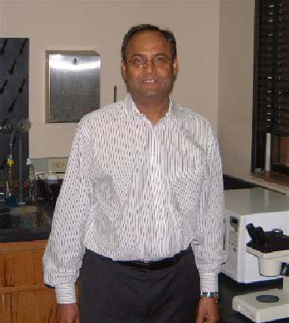 | Dr. Choudhary’s recent research focus is in  the area of the annotation and metabolic  reconstruction of Rhodobacter sphaeroides  based on its genomics, biochemistry,  physiology, and gene regulation. Dr.  Choudhary will teach the Introductory  Genetics course for biology majors and is  developing a course in Human Genetics for  the spring semester. Dr. Choudhary’s wife,  Abba, is a biochemist at Baylor College of  Medicine in Houston. They have three grown  children. We welcome Madhu to the biology  faculty.

Dr. Sibyl Bucheli was appointed to the faculty this fall as Assistant Professor of Biology, after serving as visiting assistant professor at SHSU for the past year and a half. Prior to her arrival in Huntsville, Dr. Bucheli did post-doctoral research at Ohio State University on the evolution of the Lepidopteran superfamily Gelechioidea. She received the M. S. and PhD. Degrees from the Department of Entomology at Ohio State University with research specialization in molecular and morphological evolution of Lepidoptera. Dr. Bucheli
has a B.A. degree in biology from Hiram College in Hiram, Ohio. Her three most recent publications are shown below:

BUCHELI, S.R. AND J.W. WENZEL. 2005. Gelechioidea (Insecta: Lepidoptera) systematics: A reexamination analysis using combined morphology and mitochondrial DNA data, Molecular Phylogenetics and Evolution 35, 380-394.

BUCHELI, S.R., D. HORN, AND J.W. WENZEL. 2006. Biodiversity of Gelechioidea (microlepidoptera): An assessment of a re-established Appalachian forest in southern Ohio, Biodiversity and Conservation 15 (1), 503 – 516. Themed Issue: Looking after the Woof and Weft of Life: Arthropod Diversity and its Conservation.

BUCHELI, S.R., J.A. BYTHEWAY, S.M. PUSTILNIK, AND J. FLORENCE. Insect successional pattern of a corpse in cooler months of subtropical southeastern Texas: A case report. In Press; Journal of Forensic Sciences.

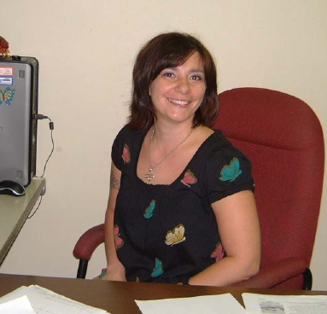 | Dr. Bucheli teaches courses in General  Entomology, Economic Entomology,  Forensic Entomology, Invertebrate  Zoology, and Contemporary Biology.  Currently working with Dr. Bucheli in  the research lab are two undergraduates  and one graduate student. Dr. Bucheli is  married to fellow biology faculty  member, Dr. Chris Randle, and they  have a two year old daughter, Gloria.  We welcome Sibyl to the SHSU biology  faculty.

Dr. Raelynn Deaton joined the biology faculty this fall as Assistant Professor of Biology. For the past two years Dr. Deaton served in the Department as Adjunct and Visiting Assistant Professor. She received a B. A. in biology from Berea College (KY), an M. S. in biology from the University of New Orleans and the PhD. From the University of Oklahoma. Between her undergraduate and graduate education, Dr. Deaton served as a volunteer in the Peace Corps in Papua, New Guinea, and in AmeriCorps in Kentucky. Dr. Deaton conducts research in several areas of biology including animal behavior, evolution, ecology and genetics. She is currently working with students on the following diverse topics: sexual conflict in live-bearing fishes; behavior, genetics, and life history of isolated populations of the Largespring Gambusia; effects of parasites on life history and mating behavior in live-bearing fish; phenotypic plasticity in response to predators in mosquitofish; and population and conservation genetics of box turtles in Texas. Currently, Dr. Deaton is working with three M. S. students and seven undergraduates. Dr. Deaton’s most recent publications include:

Raelynn Deaton. 2008. Effects of parasites on male mate choice in the western mosquitofish, G. affinis (Behavioral Processes; doi:10.1016/jbeproc.2008.07.010).

Edie Marsh-Matthews, Raelynn Deaton, and Melody Brooks. 2008. Survey of matrotrophy in lecithotrophic species. In Viviparous Fishes II, the Proceedings of the III International Symposium on Viviparous Fishes (Ed. Mari Carmen Uribe and Harry Grier).

Raelynn Deaton. 2008. Use of microsatellite markers to determine male reproductive success in western mosquitofish, Gambusia affinis. Behaviour 145:795-814.
Raelynn Deaton. 2008. Factors influencing male mating behavior in a coercive mating system. J Fish Biol 72(7): 1607–1615.

Dr. Deaton is currently teaching courses in Conservation Genetics and Human Anatomy. She also teaches Human  Biology (BIO 341), Introductory Zoology and Contemporary Biology. Dr. Deaton lives with her husband, fellow faculty member Dr. Chad Hargrave, in downtown Huntsville. We welcome Dr. Deaton to the  biology faculty. | 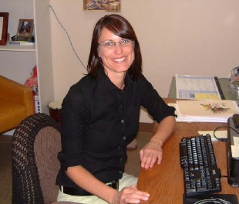

Dr. Aaron Lynne joined the faculty this fall as Assistant Professor of Biology. Dr. Lynnne is a microbiologist, replacing Dr. Harold Foerster. He received the B. S. degree in microbiology and the PhD. In molecular pathogenesis from the North Dakota State University. For the past two years Dr. Lynne was a Post-Doctoral Fellow, National Farm Medicine, Marshfield Clinic Research Foundation in Marshfield, Wisconsin. Prior to that Dr. Lynne served two years as Pre-Doctoral Associate in the Department of Veterinary Microbiology and Preventative Medicine at Iowa State University. This fall he is teaching Introductory Applied Microbiology and Molecular Biology. Dr. Lynne’s research interest is the molecular basis of virulence and antimicrobial resistance of Escherichia coli and Salmonella in humans and animals. He is currently directing two graduate students in their research for the M. S. degree. His latest publications are shown below:

Foley, S.L. and Lynne, A.M. 2008. Food Animal-Associated Salmonella Challenges: Pathogenicity and Antimicrobial Resistance. J Anim Sci. 86(14 Suppl):E173-87.

Foley, S.L, Lynne, A.M, and Nayak, R. 2008. Salmonella Challenges: Prevalence in Swine andPoultry and Potential Pathogenicity of Such Isolates. J Anim Sci. 86(14 Suppl):E149-62.

Lynne, A.M., Rhodes-Clark, B.S., Bliven, K., Zhao, S. and Foley, S.L. 2008. Antimicrobial Resistance Genes Associated with Salmonella enterica serovar Newport Isolates from Veterinary Sources. Antimicrobial Agents and Chemotherapy. 52(1):353-356

Lynne, A.M., Skyberg, J.A., Logue, C.L., Doetkott, C., Foley, S.L., and Nolan, L.K. 2008. Characterization of a Series of Transconjugant Mutants of an Avian Pathogenic Escherichia coli Isolate for Resistance to Serum Complement. Avian Diseases 51:771-776.

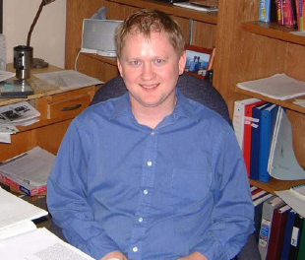 | Dr. Lynne is a native of North Dakota. He and wife Dorie, who is a veterinarian in  Houston, are expecting their first child this  spring. We welcome Dr. Lynne to the biology  faculty.

Dr. Harold Foerster Retires

This fall semester for the first time in 45 years Dr. Harold Foerster will not be in the classroom at Sam Houston State University. Following one year of halftime teaching, Dr. Foerster decided it was time to fully retire and devote more time to farming his recently acquired property near Bryan, Texas. Dr. Foerster once again returns to work familiar to him as a youth on the family farm near Schulenburg, Texas. In recognition of Dr. Foerster’s dedicated service to the Department and to the field of microbiology, the Department of Biological Sciences, represented by Dr. James DeShaw, has established The Dr. Harold F. Foerster Endowment Fund. Funds
from the endowment will support one or more academic scholarships in the amount of $1000, to be awarded each spring to biology majors demonstrating financial need. The following is excerpted from the Endowment Agreement:

Dr. Harold Foerster is being honored for 45 years of service (1963 – 2008) as a teacher, mentor, researcher, and scholar in the Department of Biological Sciences at Sam Houston State University.
During his career as a teacher, Dr. Foerster taught over 3000 students in the subject of microbiology. He expected maximum effort from his students and from himself. Dr. Foerster was a lifelong student, reading current scientific literature in his field and imparting the latest knowledge in the classroom and laboratory.
As mentor, Dr. Foerster directed graduate students and undergraduates in basic research in microbiology. He and his students published numerous reports of their research in national, peer-reviewed scholarly journals. Due to Dr. Foerster’s encouragement, several of his students went on to graduate and professional schools, and to successful careers of their own. Dr. Foerster was active in professional societies in microbiology and was a longtime contributor to the Texas Branch of the American Society for Microbiology which serves as a mentoring organization for young scholars beginning their careers.
Dr. Foerster leaves a legacy as scholar, teacher and mentor that is greatly appreciated and will long be remembered in the Department of Biological Sciences at Sam Houston State University.

Interested donors may make contributions to the Dr. Harold F. Foerster Endowment Fund at Department of Biological Sciences, P.O.Box 2116, Sam Houston State University, Huntsville, TX 77341. Phone (936) 294-1538

Faculty News

Dr. Diane Neudorf

I have been busy over the last year with my research program and directing the Research Experiences for Undergraduate program with Dr. Lutterschmidt. There are currently three graduate students (Mallory Christian, Anne - Marie Prouty, and Guadalupe Quiroz) and one undergraduate (Priscilla Ortiz) working in my lab. This year I was elected to serve a three-year term as a Councilor to the Association of Field Ornithologists. I have continued to stay
active in community service through Huntsville Audubon.

Four publications and five scientific presentations have come out of the Neudorf lab over the last year. Two of the publications are with graduate students*:

*D'Orazio, K.A. and D.L.H. Neudorf. 2008. Nest defense by Carolina Wrens. Wilson Journal of Ornithology 120:467-472.

*Humbird, S.K. and D.L.H. Neudorf. 2008. The effects of food supplementation on extraterritorial behavior in female Northern Cardinals. Condor 110:392-395.

Gill, S.A., Neudorf, D.L.H., and Sealy, S.G. 2008. Do hosts discriminate between sexually dichromatic male and female brown-headed cowbirds? Ethology 114:1-9.

Neudorf, D.L.H., Stutchbury, B.J.M. and Piper, W.H. 2008. The function of breeding season chip calls by female hooded warblers. Behaviour 145:231-250.

Research Experiences for Undergraduates (REU) in Experimental Field Biology at Sam Houston StateUniversity. (Neudorf and Lutterschmidt)

Last summer was the second year of our four-year grant for our National Science Foundation supported REU program. We had eight student participants who lived on campus for ten weeks over the summer. The students worked on independent research projects with biology faculty mentors as well as attending weekly seminars to learn about the research process. Students also received course credit in BIO 495 as part of the program. We took the students on several field trips including the Houston Zoo, the Houston Museum of Natural Science, Moody Gardens, and the University of Texas Marine Science Institute in Port Aransas. The final week of the programs students gave a poster conference in the Lowman Student Center that was well attended by the university community. We had student participants from SHSU, Bethel University, Texas A & M International, the University of California at Berkeley, the University of Kansas, the University of Miami, and Unity College. The program was a great success. The students left
with positive feelings regarding careers in research and our university.

Dr. Diane Neudorf

Dr. William Luterschmidt Report

Dr. William Lutterschmidt and his wife Kathryn celebrated the birth of their new son in March of 2008. Greyson Isaac Lutterschmidt was born on March 27th at approximately 3:15 pm weighing 6 lbs. 5 oz.

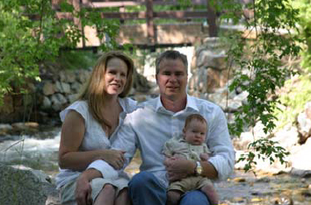

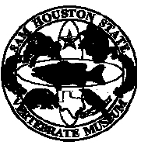 The Sam Houston State Vertebrate Museum (SHSVM), directed by Dr. William I. Lutterschmidt, invited a world renowned ornithologist and conservation biologist to the Univerity last March to give the 4th Biennial Edward O. Wiley Lecture. Dr. Bridget Stutchbury from York University delivered a popular lecture to both the University and Huntsville community about her research findings in bird conservation which prompted Dr. Stutchbury to write a best seller entitled “Silence of the Songbirds”. The E.O. Wiley Lecture was entitled Migratory songbirds: canaries in the coal mine? held on 27 March 2008 at 7:00 pm in the Sam Houston State University’s Olson Auditorium.
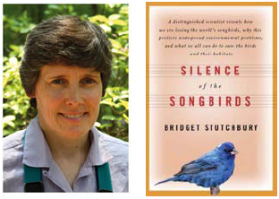 | Migratory songbirds are disappearing at a frightening rate. By some estimates, we may have already lost almost half the songbirds that filled the skies only 40 years ago. Following the birds on their 10,000-kilometre migratory journey, Dr. Bridget  Stutchbury looks at the most threatening factors in their extinction. A powerful warning, very much in the vein of Rachel Carson’s Silent Spring – Kirkus Reviews.

The Sam Houston State Vertebrate Museum offered its Natural History Education Program (NHEP) for Huntsville’s young naturalists. In June of 2008 the SHSVM offered 6 classes where over 50 children participated in the Natural History Education Program (NHEP) for the first time since the summer of 2004. Many parents and residents of Huntsville expressed their excitement for the return of this summer educational program. We are pleased at the overwhelming interest and support by the Huntsville community. The goals and objectives of the NHEP are to introduce young students to local ecosystems and the biotic diversity that these ecosystems support. This early introduction to vertebrate natural history may help youngsters appreciate local ecosystems, promote future conservation efforts, and allow for environmental awareness within our community. Our graduate instructors and helpers this summer were Mona Avalos, Scot Goetz, Melissa Miller, and Angela Hawkins.

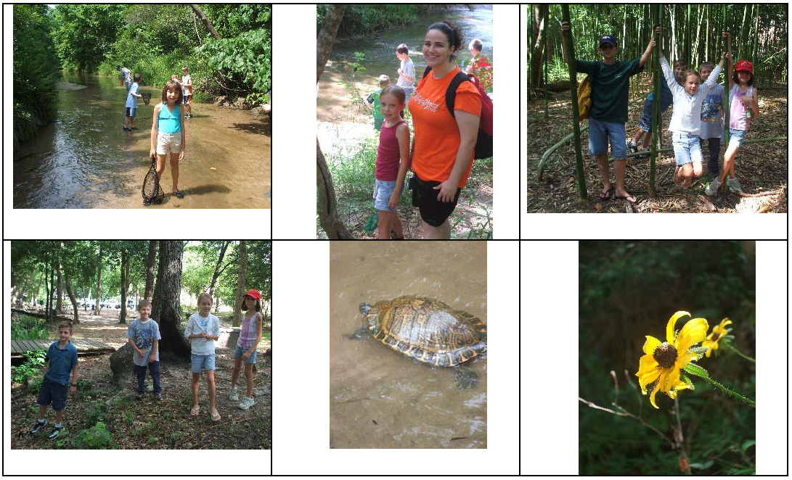
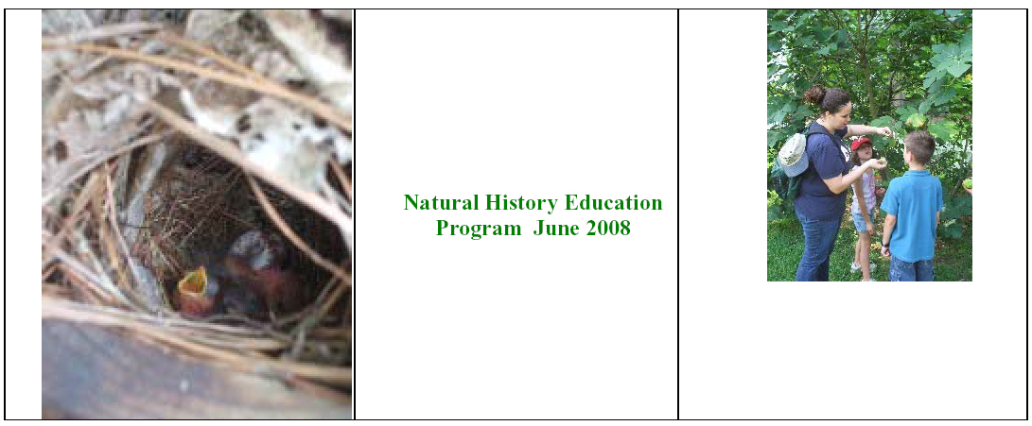
If you would like to make a donation to the Sam Houston State Vertebrate Museum, please contact Dr. Lutterschmidt at Sam Houston State University, Huntsville. Alumni and community support of the museum and its programs will allow us to better develop our commitment to education and service to Huntsville and its surrounding communities. Please visit the SHSVM and learn about its events at www.shsu.edu/~shsvm.

Program for Excellence in Education and Research in the Sciences (PEERS)

SHSU was recently awarded a STEM grant from the NSF to fund the PEERS program. The PI for this grant is Dr. Brian Loft from the Department of Mathematics (co-PI's are Dr. Melinda Holt from the Department of Mathematics and Dr. Anne Gaillard from the Department of Biological Sciences). The PEERS program provides scholarships for undergraduate and graduate students in biology, geology/geography, math, and statistics to encourage participation in student research projects. For the 2008-2009 year, two freshmen, three sophomores, four juniors, four seniors, and four graduate students in the Department of Biological Sciences have been awarded PEERS scholarships of up to $5500.00. For more information about this program, please see the PEERS program website at www.shsu.edu/~peers<http://www.shsu.edu/~peers>.

Undergraduate Research in Biology is Stepping Up
By: Raelynn Deaton and Chad Hargrave

Taking part in “real scientific research” is one of the most valuable experiences an undergraduate
student can gain. Unlike many small colleges or Research-1 institutions (e.g., University of Texas, Texas A & M) where undergraduate research opportunities may be limited, Sam Houston State provides abundant research opportunities for eager undergraduates. Dr. Everett Wilson, former Dean of the College of Science at SHSU, says “Mentoring undergraduate research is one of the most important things we do as academics. It adds an extra dimension to learning that students can not get in the classroom”. He adds “Research is the student’s opportunity to excel above and beyond the classroom”. The Department of Biological Sciences at SHSU has an active research faculty, many of which are supported by excellent undergraduates. Biology professors currently supporting undergraduate research include Drs. Sibyl Bucheli, Madhusudan Choudhary, Jerry Cook, Tami Cook, Raelynn Deaton, Anne Gaillard, Chad Hargrave, Patrick Lewis, Diane Neudorf, Todd Primm, Chris Randle, Matt Rowe and Monte Thies, among others.

(RIGHT) Big Thicket National Preserve, an  important study area for many of our  SHSU students.  (BELOW) Juan Garcia, Natalie Lindgren, and Alan  Archambeault collecting insects with a  Malaise trap. | 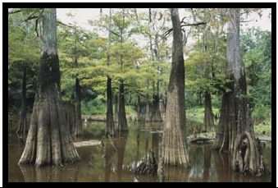

One highly active research lab in the department is that of Dr. Sibyl Bucheli. Dr. Bucheli is an
entomologist who currently has two undergraduates in her lab. Natalie Lindgren and Alan
Archambeault are working in The Big Thicket National Preserve as part of the Thicket of Life ATBI (All Taxa Biotic Inventory). When asked why he chose to do research as an

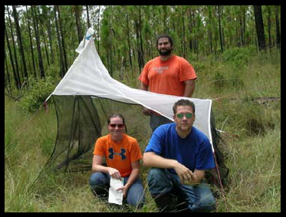 | undergraduate, Alan Archambeault explains that he “wants to be competitive for the best jobs”. Alan and Natalie will be presenting their research this November at The Entomological Society of America Annual Meeting in Reno, NV, an event with over 2,000 entomologists from around the world.  Dr. Anne Gaillard has several undergraduates conducting cell biology research in her lab. Her students include Victoria Alfaro, Crystal Liles, Shakila Evans, Prudence
Ibezim, and Josh Farthing. Their projects focus mainly on motility of Chlamydomonas, a flagellated single-celled alga. Dr. Gaillard believes that “Undergraduate research is very important because it gives students an opportunity to experience science first-hand”. She adds “From my perspective, most students who participate in research become passionate about science, and the experience ends up being very rewarding for them”. This is evident in that many SHSU undergraduates continue with graduate degrees. For example, Terah McClendon currently is a graduate student in Dr. Gaillard’s lab, but she got her start as an undergraduate researcher at SHSU.

Drs. Deaton and Hargrave have a joint lab where they are studying a variety of topics in aquatic ecology. Together they have 12 undergraduates doing research in behavior, evolution, conservation, and ecology of aquatic organisms (primarily fish). Dr. Hargrave believes that “Undergraduate research is key to fully understanding complex biological concepts” and “students who do research, present at meetings, and contribute to the publication process enhance their oral and written communication skills, which will benefit their futures no matter what career path they take”. Current undergraduates in their labs include: Deaton – Stacy Stoops, Janalyn West (graduate), Abby Marcotte, Sarah Sendelbach, Allie Titlow, Rick Lewis. In addition, Dr. Deaton has three new graduate students this semester (James Cureton, Rachel Martin, and Chris Kroll) who she trained as undergraduates; Hargrave – Landis Shoemaker, Samir Rosado, Laura Gaides, Travis Hardcastle, Kaitlen Gary (graduate), Adrian Hensley, Stephanie Lehman, and Jenee Farrar.

During the past year, Dr. Todd Primm (Chair, Biological Sciences) has supported several
undergraduates in his lab. One of his undergraduates, James Spurlin, has demonstrated the
competitive level to which SHSU undergrads belong. James has presented at several meetings and won second place in the poster competition at the Texas Branch of the American Society for
Microbiology. Other undergraduates who have worked with Dr. Primm include Pamela Vazquez, Clay Barton, Anthony Nguyen (graduate), Chase Pedersen (currently in nursing school), Tamala Taylor (graduate), Rick Lewis, and Lori Center (currently with TRIES).

Why do Sam students do undergraduate research? Some students get involved in research to
become more competitive, increasing their chance of acceptance into professional and graduate
schools. For example, Sam senior Stacy Stoops has been conducting research in behavioral ecology and evolutionary biology in Dr. Raelynn Deaton’s lab for the past year. Stacy says that “Research is a lot of hard work but

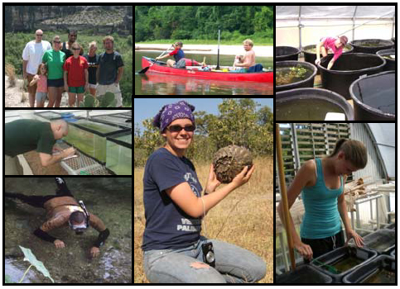 | From top left: Dr. Chad Hargrave and students in the Rio  Grande Valley overlooking Mexico; Landis Shoemaker and  Andrea Heim (REU student) canoeing the Neches River for  their work on the Big Thicket ATBI; Sarah Sendelbach cleaning fish tubs at the Center for Biological Field Studies (CBFS); Jason Randall taking behavioral data at the CBFS; Samir Rosado snorkeling in the San Marcos River; Alicia Kennedy in Botswana holding a pangolin; and Rachel Martin sorting fish for an experiment at the CBFS.

rewarding in the end”. When asked why she chose to do research as an undergraduate, she replied “Because I want to attend graduate school here at Sam and wanted to prove to the professors in the department that I am a hard worker”. In addition, Stacy added “I love learning in this type of setting…where you can apply what you learn to a real life situation, and actually synthesize your knowledge to ask biological questions”. Some students get involved in research purely because they have been ‘bitten by the science bug”. When Juan Garcia was asked why he wanted to do research as an undergraduate, he replied “Because I have always been a curious person. I don’t really believe things until I see them for myself, so I wanted to get out into the field to start answering interesting questions in biology”. Juan further explained that his undergraduate research experience gave him a sound understanding of the scientific method, and was able to hit the ground running in his Master’s program. Some students receive academic credit for their research in the form of a BIO 495 Independent Research Course, which directly and indirectly affects their academic careers. For example, undergraduate Samir Rosado has received classroom credit by doing research with Drs. Deaton and Hargrave. Samir recognized that “research has strengthened his performance in the classroom by enhancing his critical thinking skills.”

A sampling of the undergraduate study organisms shown on the next page, from bacteria and algae to insects up to fish and turtles..

This also has been a big year for undergraduate research in terms of “putting Sam on the research
map”. Our undergraduates have made a strong showing in the scientific community, which has gotten the attention from scientists across academic institutions. Our students have showcased their work with both oral and poster presentations, from small local to large international conferences including Tri-Beta, Texas Branch of the American Society for Microbiology, Texas Academy of Science, Great Plains Limnology Conference, Oklahoma-Texas Aquatics Research Group, Southwestern Association of Naturalists, Society of Vertebrate Paleontology, and the Third European Conference for Poeciliid Biologists, among others. Many of our students have been recognized for stellar research at these meetings. Rick Lewis won second place in the poster competition at the Tri-Beta Regional Meeting. Alicia Kennedy, a student working with Dr. Patrick Lewis and a McNair scholar, has presented her work at several scientific conferences, and her research was funded by Sigma Xi. Chris Kroll won second place for his oral presentation at the Tri-Beta Regional Conference and received three grants for his work with Dr. Deaton on sexual selection in livebearing fishes. Chris explains that undergraduate research for

Undergraduate study organisms from top left: singlecelled  alga Chlamydomonas, moth in the family Gelechioidea, bacterial plate from fish, SEM micrograph of fish embryo, blackstripe topminnow and box turtle. | 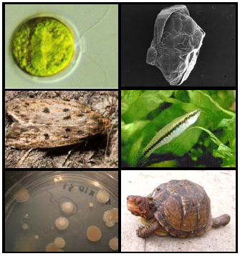

him “is a given”. He adds, “This is what I want to do for the rest of my life, so starting early will only help me in the future”. Associate Dean and Professor of Biology Tami Cook says “Having our students present at conferences is exactly how we are going to get Sam noticed and recognized in terms of research, and let people see that we have excellent undergraduates in our program.” As scientists we know the job isn’t complete until the work is published. Undergraduate researchers are learning the importance of this process, which will put them well ahead of the curve in an academic career. Eddie Realzola, a student of Dr. Jerry Cook, has published one scientific article, has a second in press, and a third in preparation. Dr. Deaton’s students James Cureton, Rachel Martin, and Jason Randall (currently a PhD student at University of Connecticut) each have at least on paper in review from their undergraduate work. Alicia Kennedy has submitted one article on her work in Africa and has a second in preparation for submission. Finally, Kaitlen Gary is preparing a manuscript based on work she did as an undergraduate with Dr. Hargrave. It is evident that Sam undergraduates are excelling with respect to research. These experiences surely will benefit them in academic and other professional fields. The importance of this educational experience has been recognized by our administration. For example, Dean Jaimie Hebert and the biology department Chairs (M. Rowe, J. Cook and T. Primm) have graciously funded undergraduate participation in local, regional, and international conferences. However, there is never enough money to fully fund these invaluable experiences. If you would like to make a donation to the undergraduate research cause, please contact the Department chair, Dr. Todd Primm (tprimm@shsu.edu), Dr. Chad Hargrave (cwhargrave@shsu.edu) or Dr. Raelynn Deaton (rdeaton@shsu.edu) for information on
contributing to an undergraduate research endowment.

2007-08 Undergraduate Highlights – Department of Biological Sciences, SHSH
*Not an exhaustive list*

CONFERENCE PRESENTATIONS
Southwestern Association of Naturalists

Clay Barton, Pamela Vazquez, Richard Lewis, Chad W. Hargrave, and Todd P. Primm. “Microbial communities involved in leaf degradation” (poster)
Kaitlen Gary and Chad Hargrave. “Effects of elevated CO2 on stream ecosystem properties” (oral presentation)

Chris Kroll and Raelynn Deaton. “Does female resistance interact with male size to affect male
mating success in the Western Mosquitofish?” (oral presentation)

Richard Lewis Clay Barton, Sybil Bucheli, and Todd P. Primm. “A novel compound family with
pesticide activity against Solenopsis invicta, the red fire ant” (poster)

Anthony Nguyen, Clay  Barton, Pamela Vazquez,  Chad W. Hargrave, and  Todd P. Primm.  “Identification of bacterial  roles in leaf degradation”  (poster)  Chase Pedersen, Todd P.  Primm, and Raelynn Deaton. “Does coercive mating by male Western Mosquitofish increase female susceptibility to microbial pathogens?” (poster) | 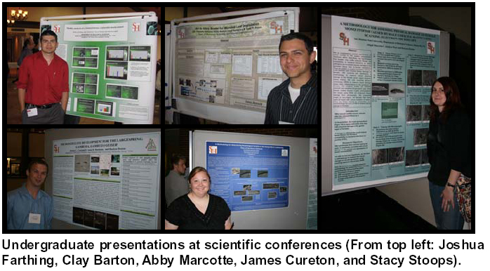

Jason Randall and Raeynn Deaton. “Effects of temperature and body size on male mating in the Western Mosquitofish” (oral presentation)

Landis Shoemaker and Chad Hargrave. “Direct and indirect effects of fishes on leaf litter
decomposition” (oral presentation)

Stacy Stoops and Raelynn Deaton. “Effects of sex ratio  and density on female foraging in the Western  Mosquitofish” (oral presentation)  Janalyn West, Abby Marcotte, and Raelynn Deaton.  “Direct effects of male harassment on female physical  condition in the Western Mosquitofish” (oral presentation)  Pamela Vazquez, Clay Barton, Anthony Nguyen, Richard  Lewis, Chad W. Hargrave, and Todd P. Primm. “Taxonspecific effects of microbial-mediated leaf litter  decomposition in aquatic ecosystems” (oral presentation) | 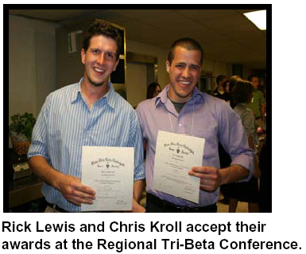

Texas Academy of Science

Alicia M Kennedy and Bhart-Anjan S. Bhullar. “An Apomorphy Based Identification of the
Herpetofauna from the Koanaka Hills” (poster)
Abby Marcotte, Janalyn West and Raelynn Deaton. “A methodology for assessing tissue damage to female Mosquitofish caused by coercive mating by males” (poster)

Samir Rosado, Andres Palencia, Chad Hargrave and Raelynn Deaton. Predator-induced phenotypic plasticity in the Western Mosquitofish (oral presentation)

52nd Annual Wind River Conference on Prokaryotic Biology

James Spurlin. “LPS-Induced Autophagy in Murine Macrophage Cells via TLR-4 Signaling Cascade and its Effect on BCG Viability After an In Vitro Infection”(P26) (poster)

Texas Branch of the American Society for  Microbiology  Clay Barton, Anthony Nguyen, Pamela Vazquez,  Richard Lewis, Chad Hargrave, and Todd P.  Primm. “Microbial Ecology of leaf Degradation”  (poster)  Josh Farthing. “Motility analysis of a  Chlamydomonas reinhartdtii double mutant” (poster)  James Spurlin III, Yi Xu, Tony N Eissa. “LPS  Induced Autophagy in murine macrophage cells via TLR-4 Signaling Cascade and its Effect on BCG Viability after an In Vitro infection” (poster)  Pamela Vazquez, Clay Barton, Chad Hardgrave, &  Todd P. Primm. “An In Vitro Model for Microbial Leaf Degradation” (poster) | 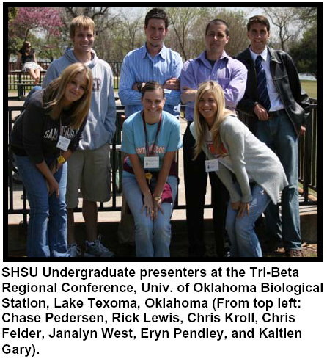
Oklahoma Texas Aquatics Research  Group  Laura Gaides and Chad Hargrave. “Indirect  food web interactions affect secondary production in stream fishes” (oral presentation)  Landis Shoemaker and Chad Hargrave. “Context dependent trophic cascades in stream ecosystems” (oral presentation)  The Lepidopterists' Society Annual  Meeting | 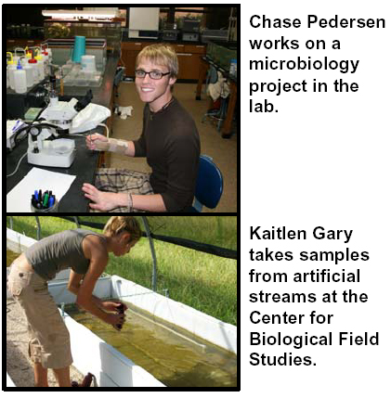
Juan Garcia, Sibyl Bucheli and John W. Wenzel. “Addition of the ND1 gene to an existing molecular data set to help determine higher level relationships within Gelechioidea (Lepidoptera)” (poster presentation)
HONORS AND AWARDS

Kelly Forson – Sigma Xi Undergraduate Research Grant

Alicia Kennedy – Sigma Xi Undergraduate Research Grant

Chris Kroll – Tri-Beta National Research Grant, Texas Academy of Science Research Grant,
Southwestern Association of Naturalists Research Grant, Second Place for Best Oral Presentation, Tri-Beta Regional Conference

Rick Lewis – Second Place, poster competition, Tri-Beta Regional Conference

James Spurlin – Second Place, poster competition, Texas Branch of the American Society of
Microbiology, Wind River Conference on Prokaryote Biology NSF Travel Grant

Janalyn West – Joey Harrison Undergraduate Research Grant, SHSU Department of Biological
Sciences

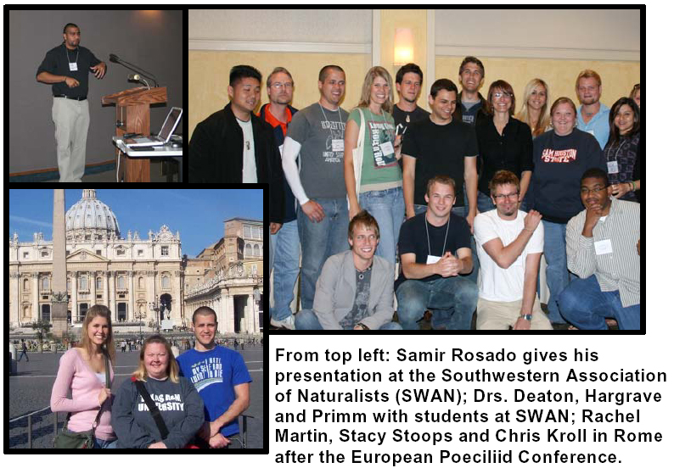

Retired Faculty from Department of Biological Sciences and Years Served (Current Location)

Dr. Ruth Thomas1964-91 (Huntsville) Dr. Robert Stewart 1959-60, 1967-92 (Nacogdoches)
Dr. Terrell Hoage 1968-97 (Huntsville) Dr. Ralph Moldenhauer 1968-98 (Dubois, WY)
Dr. Darrell Hall 1965-98 (Huntsville) Dr. Thomas Meade 1965-99 (Tucson, AZ)
Dr. Jimmie Long 1959-99 (Huntsville) Dr. John Hilliard 1968-95 (San Antonio)
Dr. Maynard Yoes 1961-1985 (Mimbres, NM) Dr. Andrew Dewees 1967-2004 (Huntsville)
Dr. Harold Foerster 1963-2008 (Huntsville)

Current Faculty in Department of Biological Sciences

Sibyl Bucheli, PhD. (Ohio State University), Assistant Professor. Entomology. srb009@shsu.edu

Madhusudan Choudhary, PhD. (McMaster University), Assistant Professor. Genetics and Molecular Biology. mchoudhary@susu.edu

Jerry L. Cook, PhD. (Texas A&M University), Associate Professor. Entomology, Anatomy and Physiology. bio_jlc@shsu.edu

Tamara J. Cook, PhD. (Texas A&M University), Associate Professor. Entomology, Invertebrate Zoology, Parasitology and Ecology. bio_tjc@shsu.edu

P. Raelynn Deaton, PhD, (University of Oklahoma), Assistant Professor. Prd002@shsu. Ecology

James R. DeShaw, Ph.D. (Texas A&M University), Professor. Environmental Science. bio_jrd@shsu.edu

Anne Roush Gaillard, Ph.D. (Emory University), Assistant Professor. Cell Biology and Genetics. bio_arg@shsu.edu

Chad Hargrave, Ph.D. (University of Oklahoma), Assistant Professor. Aquatic Community Ecology and Ichthyology

Joan E. Hudson, Ph.D. (Iowa State University), Associate Professor. Plant Morphology and Plant Physiology. bio_jxn@shsu.edu

Patrick Lewis, Ph.D. (Duke University), Assistant Professor. Paleobiology. pjlewis@shsu.edu

James D. Long, Ph.D. (University of Texas), Professor Emeritus. Medical Entomology. bio_jdl@shsu.edu

Aaron Lynne, PhD. (North Dakota State University), Assistant Professor. Microbiology and Molecular Biology. aml027@shsu.edu

William Lutterschimdt, Ph.D. (University of Oklahoma), Associate Professor. Comparative physiology, Physiological ecology, Herpetology. bio_wil@shsu.edu

Diane Neudorf, Ph.D. (York University), Associate Professor. Avian Biology and Animal Behavior. bio_dln@shsu.edu

Todd Primm, Ph. D. (Baylor College of Medicine). Associate Professor. Bacterial Physiology. tprimm@shsu.edu
Christopher Randle, Ph.D. (Ohio State University). Assistant Professor. Plant Molecular Systematics and Evolution. randle@shsu.edu

Monte L. Thies, Ph.D. (Oklahoma State University), Professor. Ecological and Systematic Studies of Mammals. bio_mlt@shsu.edu

Matthew Rowe, Ph. D. (University of California, Davis). Professor. Behavioral Ecology
mpr002@shsu.edu

Jack C. Turner, Ph.D. (University of California-Riverside), Professor. Physiological Animal Ecology. bio_jct@shsu.edu

Justin K. Williams, Ph.D. (University of Texas at Austin), Associate Professor. Plant Taxonomy and Systematics. bio_jkw@shsu.edu

*Everett D. Wilson, Ph.D. (Purdue University), Professor. Mammalian Reproduction and Endocrinology. bio_edw@shsu.edu

* Retired, but teaching half time

