Register | Login

Wild Turkey Subspecies  Eastern Wild Turkey  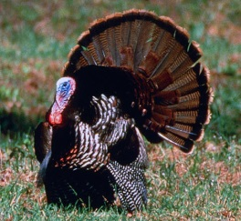  (Meleagris gallopavo silvestris)This subspecies of wild turkey is the most numerous and hunted species and is also the most widely distributed of all the subspecies in North America. It nearly inhabits the entire eastern half of the country.  The Eastern turkey is best found in hardwood and thick forests. More specifically, it ranges from New England and southern Canada and northern Florida in the east, to Texas, Missouri, Iowa and Minnesota in the West. Along with its’ origin states, it has been successfully transplanted to California, Oregon and Washington.  Read more about the Eastern Wild Turkey  Osceola Wild Turkey or the Florida Wild Turkey  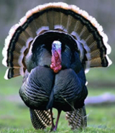  (Meleagris gallopavo osceola) One the most hunted and sought-after game species in Florida. This unique turkey is known for its location, strictly in the Florida region of the United States.  It lives only on the Florida peninsula and has never lived anywhere else in the entire world. This fact makes it extremely desired by out-of-state-hunters. It is similar to the eastern wild turkey but typically runs a bit smaller and with a darker shade and not as much barring on the flight feathers.  Read more about the Osceola Wild Turkey  Merriam’s Wild Turkey  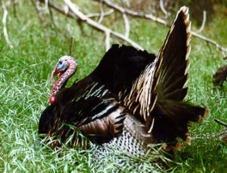  (Meleagris gallopavo merriami) This subspecies of turkey is primarily located in the pines of the western mountain regions of the U.S. It was named by Dr. E.W. Nelson in 1900 in honor of C. Hart Merriam, the first chief of the U.S. Biological Survey.  Its historic range, Arizona, New Mexico and Colorado, made it a relatively isolated from other species of wild turkey. Current evidence supports the idea that it was a relative newcomer to western American wildlife when the Europeans discovered it.  Read more about the Merriam's Wild Turkey  Rio Grande Wild Turkey  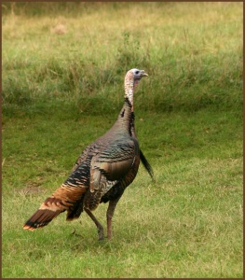  (Meleagris gallopavo intermedia) The Rio Grande wild turkey or Rio, Meleagris gallopavo intermedia, is one of two subspecies of Utah's largest game bird. The Rio is similar in size and appearance to the other subspecies of wild turkey. Adult males (gobblers or toms) weigh from 17 to 21 pounds. Adult females (hens) average 8 to 11 pounds. Rios can be distinguished from the other subspecies by the coloration of the tips of the tail feathers in the upper tail coverts (feathers of the lower back, covering the base of the tail feathers). In the Rio Grande bird, these feather tips are buff or tan, contrasting with the white tips of the Merriam's subspecies.  Read more about the Rio Grande turkey  Gould’s Wild Turkey  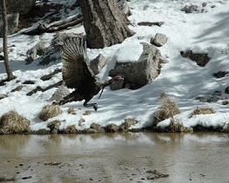  (Meleagris gallopavo mexicana) The fifth recognized, but least known, wild turkey subspecies is the Gould's found in portions of Arizona and New Mexico, as well as northern Mexico. It was first described by J. Gould in 1856 during his travels in Mexico.  Like the Merriam's, the Gould's is a bird of the mountains. It exists in very small numbers along the U.S./Mexico borders in Arizona and New Mexico, but is abundant in the northwestern portions of Mexico.  Read more about the Gould's wild turkey  **All this information is courtesy of the National Wild Turkey Federation (NWTA).  For more information on anything having to do with wild turkeys, visit http://www.nwtf.org/. |  | More Turkey Links:  TURKEY HUNTING LINKS:  - Wild Turkey Subspecies- Turkey Identification for Hunters  - How To Age A Turkey  - Three Ways To Mess Up A Turkey Hunt  - Taking Better Turkey Hunting Photos  - Why Do Turkeys Fight?  - 2011 Show Us Your Gobbler Contest  - Wild Turkeys and Predators  - Is Hen Culling Good Turkey Management?  - How To Score A Wild Turkey  - How To Age A Wild Turkey  - Turkey Hunting Myths Debunked  - Turkey Food Plots - Planting Food Plots For Wild Turkeys  - Featured Turkey Hunting Articles  - Glossary of Turkey Hunting Terms  - Wild Turkey Myths & Facts  - Of Turkey Hunts Loved And Lost  - Winter Food Sources for Wild Turkeys  - Browse our complete Library of Turkey Resources

