**SHSU Catalog: *Review Guide and Process***

Office of Academic Planning and Program Development

Sam Houston State University

**Initial Review: to be used in conjunction with the SHSU Catalog: Degree Program Audit Checklist**

* Carefully review and edit all necessary catalog content for the 2024-2025 Undergraduate and Graduate & Professional Catalogs.
* Ensure the lists of academic programs within each department are complete and accurate.
* Ensure all specified Core Curriculum Courses in the Degree Specific Requirements are marked with a footnote to denote “double-dipping.”
* Ensure all approved curriculum changes are reflected in the degree plan. Ensure all curriculum is under the appropriate header.

**Common Errors:**

* For each undergraduate degree program, ensure changes/updates are completed to both the Course List and the Plan of Study.
* Ensure the Course List and Plan of Study sum to the correct total SCH.
* A Core Curriculum course identified in the Degree Specific Requirements not properly “double dipped” and/or missing coordinating footnote.
* Footnote sequencing errors (numerical) in the Course List and/or Plan of Study as well as in the Footnote Listing.
* Inconsistencies between the Course List and the Plan of Study.
* Ensure the Grade Point Average (GPA) restriction statements are correct.
* Ensure all dates, names, and contact information are up to date.
* Ensure all narrative text is accurate, clear, and grammatically correct.

**NOTE:** Double Dipping – To prevent double counting of SCHs that are associated with major-specific courses that are also part of the Core, enter the hours in the “what you see: what you add” format (3:0), and add a footnote denoting Core Component Area requirement satisfied.

**Catalog Review CANs and CANNOTS:**

* Add: Bulleted Content
* Add: Content Block Page Headers
* Add: Course Bubbles to Inline Course References
* Add/Delete: Courses to Degree Plans
* Reorganize: Courses in a Degree Plan
* Update: Content Block Information



* **Change**: Title of Courses / Degree Programs / Minors / Certifications / Departments / Schools / Colleges (Requires Curriculum Approval)
* **Change:** Total SCHs of a Degree Program / Certificate / Minor / Certification (Requires Curriculum Approval)
* **Change:** Core Curriculum courses (Component Area) in Degree Program (Course List) (Academic Planning Only)
* **Enter:** Courses using the Comment Field (Will not pull from Banner)
* **Add:** Tabs (Academic Planning Only: Upon Request)
* **Add:** New Program and/or Concentrations / Tracks / Minors / Certificates / Certifications (Academic Planning Only: Upon Request)
* **Change:** Faculty Listing (pulled from Banner)
* **Change:** Course Descriptions (Requires completion of Registrar’s Office Course Description Change Request Form)

**CANs**

**CANNOTs**

**Headers: Defined**

1. **Core Curriculum:** Definition: Includes the specified courses and semester credit hours (SCHs) in each Component Area required to meet the Core Curriculum requirement of 42 semester credit hours.
2. **Degree Specific Requirements:** Definition: Includes coursework specific to the degree (e.g., BA, BS, BBA, etc.) but not part of the major.
3. **Major:** Definition: Includes coursework specific to the major, including major electives and major prescribed electives.

**Major / Major: Foundation / Major: Electives / Major: Prescribed Electives / Major: Prescribed Advance Electives / Major: Concentration / Major: Concentration Prescribed Electives**

1. **Minor:** Definition: Includes a minimum of 18 semester credit hours of coursework specific to the student’s secondary area of study.

**Minor: Required** = Listing of restricted minors, requirements, or SCHs needed.  
**Minor: Not Required** = Footnote: A minor is **not required** for this degree program; however, a student has the option to add a minor, but to do so additional semester credits hours will be needed above the degree program’s stated total semester credit hours.

1. **Electives:** Definition: (Undergraduate) Includes coursework, if required, outside of the Core Curriculum, Degree Specific Requirements, Major, and the Minor needed to reach the specified total semester credit hours as well as the minimum 42 advanced hours. (Graduate) Includes coursework outside of the Major needed to reach the specified total semester credit hours.

**Electives: General  
Electives: Advanced General**

**Grade Point Average (GPA) Restrictive Statements: Calculations** [Red font]: Denotes variable, degree plan-specific values.

Students must earn a [2.0] minimum overall GPA in all coursework.

* Overall GPA = All courses under all headers (Core Curriculum/Degree Specific Requirements/Major/Minor/Major: Concentration/Electives), both SHSU + Transfer.

Students must earn a [3.0] minimum overall major GPA in all major coursework.

* Overall major GPA = All courses under the Major headers (Major: Foundation, Major, Major: Concentration; Major: Prescribed Electives), both SHSU + Transfer.

Students must earn a [2.0] minimum SHSU GPA in all coursework.

* Overall SHSU GPA = All courses under all headers (Core Curriculum/Degree Specific Requirements/Major/Minor/Major: Concentration/Electives), only SHSU.

Students must earn a [2.5] minimum SHSU major GPA in all major coursework (SHSU Only).

* Overall SHSU major GPA = All courses under the Major headers (Major: Foundation, Major, Major: Concentration, Major: Prescribed Electives), only SHSU.

**Questions?**

Amy Gándara, (936) 294-4189; [arg019@shsu.edu](mailto:arg019@shsu.edu) or [catalogs@shsu.edu](mailto:catalogs@shsu.edu)

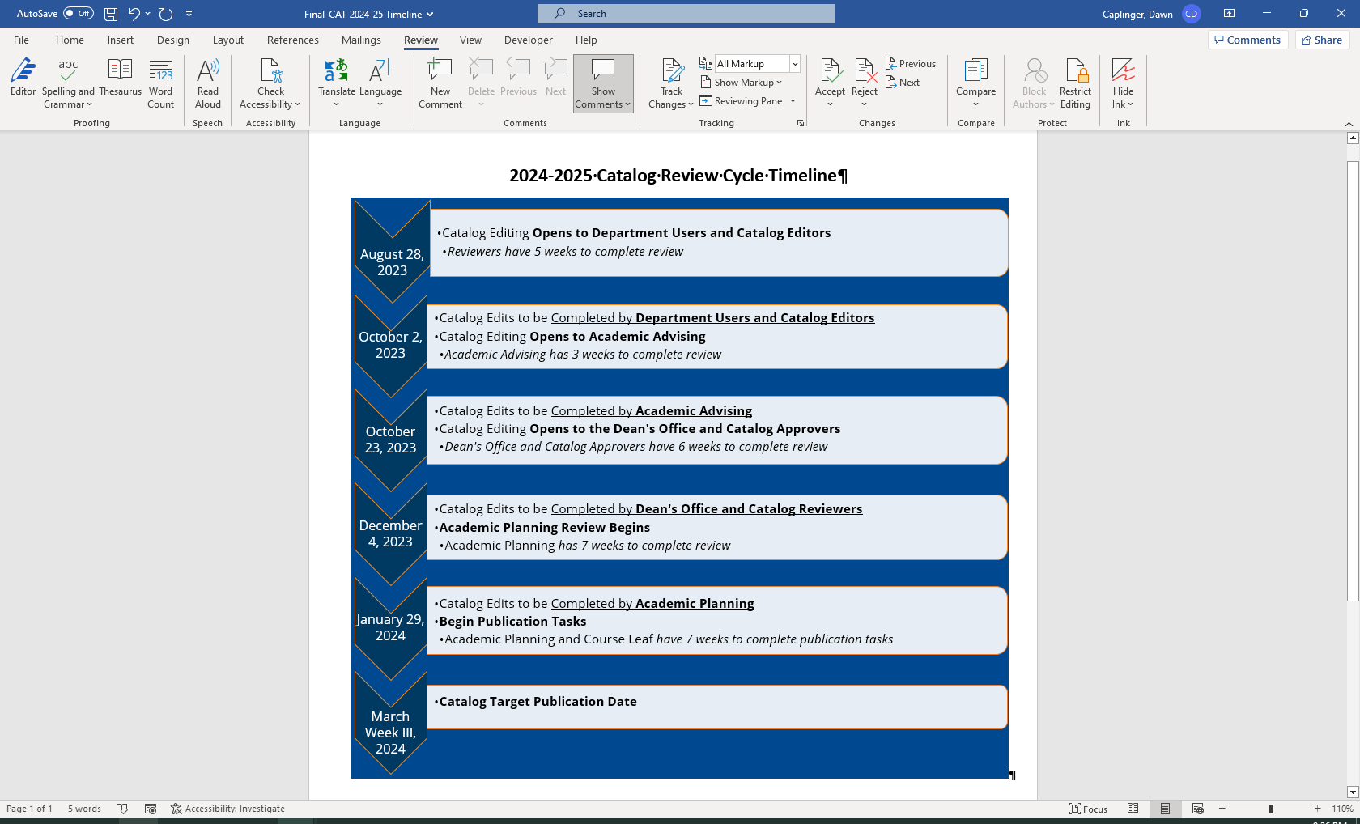

**REMINDERS:**

* **Changes to Course Descriptions:** Edits to course descriptions cannot be made using the CourseLeaf Academic Catalog Management Software. To request a change to a course description, the [Course Prerequisite and Course Description Change Request](https://www.shsu.edu/contentAsset/raw-data/976ebb05-8e44-4057-a4e8-99c4bbd02e97/fileAsset?language_id=1) form needs to be completed, signed, and submitted to the Office of Academic Planning and Program Development during the catalog review cycle.
* **Changes to Faculty Listing:**Edits to the faculty listing cannot be made using the CourseLeaf Academic Catalog Management Software, but instead upon the catalog is published (Mid-March), a request will be sent from the Office of Academic Planning and Program Development to the departments, prompting a review of the faculty listing, with any needed changes, additions, and/or deletions to be reported to the Office of Academic Planning and Program Development.

**Helpful Hints:**

* Preferred Browser: Google Chrome
* Open email from CourseLeaf and click on the link provided to begin editing OR Log onto https://nextcatalog.shsu.edu
* Make sure the Your Role window box displays your “Role” in the workflow, not your name. Example: OAPA Chair



**First Time User or Role Changed (Editor/Approver):**

To gain access to the Course Leaf system after access has been granted, a first-time user or user whose catalog role has changed will need to turn-off (shut down) his/her computer **(DO NOT** merely hit restart), turn the computer back on, and log in using his/her official SHSU username (no aliases). Please, verify that when viewing your Course Leaf Console that the appropriate “Role” is displayed on the “Your Role” dropdown and not the user’s name.

**CourseLeaf Help:** <https://help.courseleaf.com/>

