Section Animal Science

Unit Unit 7—Anatomy and Physiology

Lesson Title Lesson 7: The Circulatory System

Student Learning Objectives
As a result of this lesson, the student will:
- Understand the purpose of the circulatory system.
- Understand and label the circulatory system components.
- Create a brochure including all components of the circulatory system.

Time Instruction time for this lesson: 150 minutes *NOTE THREE DAY LESSON*

Resources/References
- http://school.discovery.com/lessonplans/programs/ultimate_humanbody/
- http://www.accessexcellence.org/AE/ATG/data/released/0285-FayeCascio/
- http://www.aged.tamu.edu/agsc/stb/lessonplan/SearchField2.asp
- http://encarta.msn.com/encyclopedia_761566878/Circulatory_System.html
- Agriscience Fundamentals and Applications, Fourth Edition, Cooper and Burton
- Biology: The Dynamics of Life, Glencoe

Tools, Equipment, and Supplies
- Copy of rubric (on page 11 of this document); project on board or one per student
- Printed copy of sample brochure, included in lesson 7 (on pages 12-13 of this document), one per class to be passed around
- Digital or overhead projector
- Copies of Notes over the Circulatory System, one per student
- Order of blood passage with brochure guidelines on bottom 1/2, one copy per student

Key Terms

Heart
Lungs
Kidneys
Arteries
Veins
Liver
Lymph glands
Heart rate
Upper right chamber
Lower right chamber
Upper left chamber
Lower left chamber

Interest Approach
You are going to have the students take their own pulse for one minute to discover their resting heart rate. You may have to help them find their pulse.

Welcome to Physical Education class today! I want to start by getting you warmed up and stretched out! Everybody up! Let’s take our resting pulse rate. When I say go, count the number of times you feel your heart beat. I would suggest finding your pulse on your wrist or on the side of you neck. Has everyone found his or her pulse? Ready, set, go!

Let students count their pulse rate for one minute. Select a student to be the leader for the jumping jacks.

Okay, now you have to remember this number! Next, let’s do 40 jumping jacks. You can spread out if you need to! When I say “go,” we’ll do 40 of them together. __________, would you come up and be our PE leader?

Allow students to do 40 jumping jacks. At the end they will count their heart beats again!

Great job athletes!
Raise you hand if your working heart rate was between 120 and 170 beats per minute (bpm). Were the rest of you more or less that those numbers? Actually, the 120 to 170 bpm is a target for working out. I wouldn’t say that we had a very extensive workout doing the jumping jacks, but at least we got our heart rates up! With an increased heart rate comes an increased demand by the body to handle the stress. Specifically, our respiratory and circulatory systems must “step it up” to keep up with our demands for oxygen. So, it’s evident that we all need to maintain healthy hearts! The same is true for livestock. As producers, we need to provide them with available nutrients and a healthy living environment so that, if pressed, they can handle stressful situations!

Summary of Content and Teaching Strategies
Objective 1 Understand the purpose of the circulatory system.

Hand out accompanying worksheet titled, “Notes over the Circulatory System,” to each student. Use slide #2 to teach this portion of the lesson.

Purpose of the circulatory system:
Provides food and oxygen to the cells of the body and filters waste materials from the body.

Objective 2 Understand and label the circulatory system components.

Teach from slides #3-5. Students should take notes on their worksheet as you teach definitions.

There are so many components of the healthy circulatory system. To fully understand what makes our heart beat and our body tick, we need to understand the individual components. Please write the definitions of the important key terms on your notes worksheet.

Slides #3-5

a. Heart—hollow, muscular organ that pumps blood through the body.
b. Lungs—elastic, spongy organs used in breathing, must be supplied with adequate blood.
c. Kidneys—paired organ that removes waste from the blood.
d. Arteries—Tubular vesicles that carry oxygenated blood from the heart to the rest of the body.
- Aorta—principal artery that carries oxygenated blood to other smaller arteries in the body.
- Capillary—tiny blood vessels that connect veins to arteries.
- Valve—Closure on arteries and veins
- Red blood cells—oxygen-carrying components of the blood, most numerous blood cells
- White blood cells—make up 1% of the blood, attack foreign bodies in the blood.
- Platelets—sticky surfaces allow them to form structures to stop blood flow; a portion of the blood
- Plasma—clear, yellowish liquid that forms the fluid portion of blood and lymph. Plasma transports red and white blood cells and platelets
- Ventricle—either of the two lower chambers of the heart that receives blood from the upper chambers (atria) and pumps it into the arteries by contraction of its thick muscular walls
- Veins—in anatomy, blood vessels that conduct the deoxygenated blood from the capillaries back to the heart.

Use an eye-witness e-moment to have students verbally review with a partner the terms and corresponding definitions.

So that we can remember the definitions, we are going to take five minutes to conduct an e-moment. Select a partner near you and for one minute, use the Eyewitness E-Moment to interview your partner about what they have learned. Remember, you are a newscaster trying to get the latest information! After one minute, we will switch roles. Go!

Great job newscasters! We are going to take one more step to help us understand how the components work together to make an entire circulatory system.

Project slide #8 for students to label their heart diagram.

As we look at an up-close view of the heart, we can see some of the components we have already talked about. The heart is the center of the circulatory system, so it’s important that we understand its function and parts. Go ahead and label the diagram in your notes.

Give students time to label their diagrams as you go over the projected heart picture label by label. Be ready with slide #9 next.

Now, we need to see how the heart fits in with the entire body. As we look at the horse, we can see the heart highlighted in the chest cavity as well as the major arteries and veins.

Objective 3 Create a brochure including all components of the circulatory system.

Be sure you have enough computers for each student in class. Ideally, students are going to create their own six-page brochure (tri-fold) in MS Publisher. If this is not an option because you don’t have that program included in MS Office, have students create it in MS Word using three columns on two sides of the paper. There is a sample of the brochure included on pages 12-13 of this document. It was created in Publisher. There is also a guideline page for the student at the end of this lesson as well as a rubric (page 11 of this document).

You are all introductory experts on the subject of the circulatory system! At this time, you are going to have the rest of today and the next two class periods to create a brochure. The good news is that this will count as a grade instead of having you take a quiz over the material! I have handed out the guidelines for the project as well as the rubric I will be using to grade this project. If you are unfamiliar with MS Publisher (or MS Word), please ask me for help.

Review/Summary

Application
Extended classroom activity:
Compile the brochures created to make a class portfolio. You can also use the same idea for the nervous, digestive and respiratory system to encourage the class to get the large picture of bodily systems.

FFA activity:
As part of an agriscience project, encourage students to further research issues associated with the circulatory system and create an agriscience project to compete in the agriscience fair at the FFA State Convention.

SAE activity:
For those students with an SAE related to veterinary medicine, have them bring in the main components of the circulatory system for the class. Encourage them to talk to their supervisors about potential problems that could develop within the circulatory system.

Evaluation

Grade the brochure the students have created in MS Publisher or MS Word using the rubric provided. The rubric can be changed to meet your needs.

Answers to Assessment:

See rubric on page 11.

Notes over the Circulatory System
Name:
Date:

- What is the purpose of the circulatory system?

- Define the components of the circulatory system?
a. heart

b. lungs

c. kidneys

d. arteries

e. aorta

f. capillary

g. valve

h. red blood cell

i. white blood cell

j. platelets

k. plasma

l. ventricle

m. veins

- What happens in each of the heart chambers?
Upper right chamber
Lower right chamber
Upper left chamber
Lower right chamber

- Correctly identify the heart diagram

- Label the horse circulatory system
Answers to Notes Page
- Functions of the circulatory system
Provides food and oxygen to the cells of the body and filters waste materials from the body.

II. a. Heart—hollow, muscular organ that pumps blood through the body.
b. Lungs—elastic, spongy organs used in breathings, must be supplied with adequate
blood.
c. Kidneys—paired organ that removes waste from the blood.
d. Arteries—Tubular vesicles that carry oxygenated blood from the heart to the rest of
the body.
- Aorta—principal artery that carries oxygenated blood to other smaller arteries in the body.
- Capillary—tiny blood vessels that connect veins to arteries.
- Valve—Closure on arteries and veins
- Red blood cells—oxygen-carrying components of the blood, most numerous blood cells.
- White blood cells—make up 1% of the blood, attack foreign bodies in the blood.
- Platelets—sticky surfaces allow them to form structures to stop blood flow; a portion of the blood.
- Plasma—clear, yellowish liquid that forms the fluid portion of blood and lymph. Plasma transports red and white blood cells and platelets.
- Ventricle—either of the two lower chambers of the heart that receive blood from the upper chambers (atria) and pump it into the arteries by contraction of its thick muscular walls
- Veins—in anatomy, blood vessel that conducts the deoxygenated blood from the capillaries back to the heart.

III. Heart Chambers
Upper right chamber - collects blood from the body.
Lower right chamber - pumps blood to the lungs.
Upper left chamber - receives blood form the lungs.
Lower right chamber - pushes blood to the rest of the body.

IV.

V. 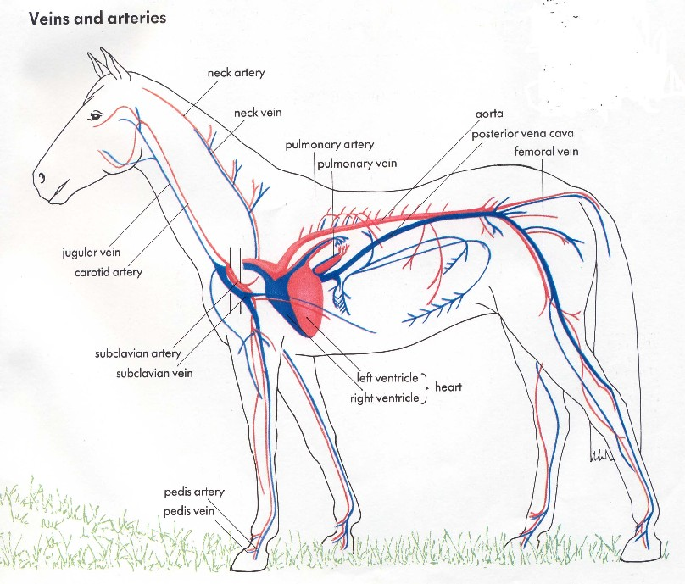

TRAVELING THROUGH THE CIRCULATORY SYSTEM

Order of Blood Passage in the Body
The heart ejects oxygen-rich blood under high pressure out of the heart’s main pumping chamber, the left ventricle, through the largest artery, the aorta. Smaller arteries branch off from the aorta, leading to various parts of the body. These smaller arteries in turn branch out into even smaller arteries, called arterioles. Branches of arterioles become progressively smaller in diameter, eventually forming the capillaries. Once blood reaches the capillary level, blood pressure is greatly reduced.
Capillaries have extremely thin walls that permit dissolved oxygen and nutrients from the blood to diffuse across to a fluid, known as interstitial fluid, that fills the gaps between the cells of tissues or organs. The dissolved oxygen and nutrients then enter the cells from the interstitial fluid by diffusion across the cell membranes. Meanwhile, carbon dioxide and other wastes leave the cell, diffuse through the interstitial fluid, cross the capillary walls, and enter the blood. In this way, the blood delivers nutrients and removes wastes without leaving the capillary tube.
After delivering oxygen to tissues and absorbing wastes, the deoxygenated blood in the capillaries then starts the return trip to the heart. The capillaries merge to form tiny veins, called venules. These veins in turn join together to form progressively larger veins. Ultimately, the veins converge into two large veins: the inferior vena cava, bringing blood from the lower half of the body; and the superior vena cava, bringing blood from the upper half. Both of these two large veins join at the right atrium of the heart.
Because the pressure is dissipated in the arterioles and capillaries, blood in veins flows back to the heart at very low pressure, often running uphill when a person is standing. Flow against gravity is made possible by the one-way valves, located several centimeters apart, in the veins. When surrounding muscles contract, for example in the calf or arm, the muscles squeeze blood back toward the heart. If the one-way valves work properly, blood travels only toward the heart and cannot lapse backward. Veins with defective valves, which allow the blood to flow backward, become enlarged or dilated to form varicose veins.

Taken from: http://encarta.msn.com/encyclopedia_761566878/Circulatory_System.html

Guidelines for Brochure
Must include five graphics
Must be tri-fold printed on both sides, for a total of six pages
Back center page must be references, including all sites where graphics were taken
Topic of brochure must be “traveling through the circulatory system”
Must include at least five components or structures in the circulatory system
Include the species you have designed this for
You will be graded using the provided rubric
Use 12-point font for a majority of the writing

Making A Brochure : Travel Brochure of the Circulatory System
 | Scoring Rubric
Teacher Name:
Student Name: ________________________________________
CATEGORY | 4 | 3 | 2 | 1
Content - Accuracy | All facts in the brochure are accurate. | 99-90% of the facts in the brochure are accurate. | 89-80% of the facts in the brochure are accurate. | Fewer than 80% of the facts in the brochure are accurate.
Graphics/Pictures | Graphics go well with the text and there is a good mix of text and graphics. | Graphics go well with the text, but there are so many that they distract from the text. | Graphics go well with the text, but there are too few and the brochure seems "text-heavy". | Graphics do not go with the accompanying text or appear to be randomly chosen.
Spelling & Proofreading | No spelling errors remain after one person other than the typist reads and corrects the brochure. | No more than 1 spelling error remains after one person other than the typist reads and corrects the brochure. | No more than 3 spelling errors remain after one person other than the typist reads and corrects the brochure. | Several spelling errors in the brochure.
Attractiveness & Organization | The brochure has exceptionally attractive formatting and well-organized information. | The brochure has attractive formatting and well-organized information. | The brochure has well-organized information. | The brochure's formatting and organization of material are confusing to the reader.
Writing - Organization | Each section in the brochure has a clear beginning, middle, and end. | Almost all sections of the brochure have a clear beginning, middle and end. | Most sections of the brochure have a clear beginning, middle and end. | Less than half of the sections of the brochure have a clear beginning, middle and end.
Sample Brochure