Section: Animal Science

Unit: Unit 7: Anatomy and Physiology

Lesson Title: Lesson 5: The Digestive System

Student Learning Objectives (Enablers)
As a result of this lesson, the student will …
- Become familiar with the digestive system and the 3 different types of digestive systems.
- The student will be able to visualize the processes the ingested food as it passes through the digestive system.

Time: Instruction time for this lesson: 50 minutes.

Resources:
- Agriscience Fundamentals and Applications Edition 4, Elmer Cooper & DeVere Burton , Thomson, Delmar Learning, Publisher 2005.

Tools, Equipment, and Supplies
- Computer equipped with Power Point and Projector or copies with overhead projector
- Copies of student note outline Slides 11-20 of Powerpoint, one per student
- pieces of apple
- rubber tubing
- Funnel
- beaker
- paper towels
- mallet
- hydrochloric acid
- sponge
- diagram of the digestive system
- Lab Instruction Sheet, one per group or student, page 6

Key Terms.
Ruminant Mouth Esophagus
Peristalsis Enzymes Monogastric
Modified Monogastric Small Intestine Large Intestine
Pancreas Liver

Interest Approach

Display the following items for the class to see (not touch) and have them record what they believe each item has to do with the digestive system. Inform them that each item may play a role or just represent something in the digestive system. Allow them 1-2 minutes to think about this and record their response. Have the students share their responses for the items with you. Then explain that today we are going to explore the digestive system and learn how each of these items represents some part of our own digestive system.
Items to be displayed: Apple, rubber tubing, funnel, beaker, hydrochloric acid, sponge, mallet, paper towels.

I have a challenge for you today! I have displayed a number of items on the table and it’s your job to tell me what each of them has to do with animal digestion. Remember that each item may play a role or just represent something in the digestive system. I need to write your answers on a scratch piece of paper and we will come back to it later to determine if you were correct! Go!

Summary of Content and Teaching Strategies

Objective 1. The student will become familiar with the digestive system and the three different types of digestive systems.
-Use the Powerpoint to present the lesson
-Hand each student the Powerpoint Note Outline, whereby they have to fill in the blanks
-All information needed for the presentation is available for the instructor on the power point presentation. As you go over the presentation have the students complete the note outline that corresponds with the power point.

Let’s get started by diving into the digestion process. As I am teaching digestion, you are going to watch for the missing words in your handout.

Present Slides 1-3
Digestive System
- Large complex molecules broken down into simpler molecules
- Long tube beginning with mouth and ending with the anus
- Man & Pig have a simple stomach with an extensive intestinal system
- Ruminants have a complex stomach with a simpler intestinal system
- Horses & Rabbits have a simple stomach with an extensive intestinal system and an enlarged cecum

Present slides 4-11
- Mouth: “Prehension” tool (grasps food)
- Salivary Glands secrete juices containing enzymes (digest food)
Chewing food breaks down
- Esophagus: muscular tube that connects mouth to stomach
Peristaltic Movement: sequential contraction of ringlike muscles
Reverse Peristalsis = vomiting
- Simple Stomach
Muscular contractions break down food
Enzymes break down food:
Gastric: proteins
Liver & Pancreatic: fats
- 3 Major Digestive Systems
All 3 systems will be addressed in detail in the lesson to follow:
Ruminant—have four stomachs
Monogastric—have one stomach
Modified Monogastric—have one stomach but the ability to digest roughages
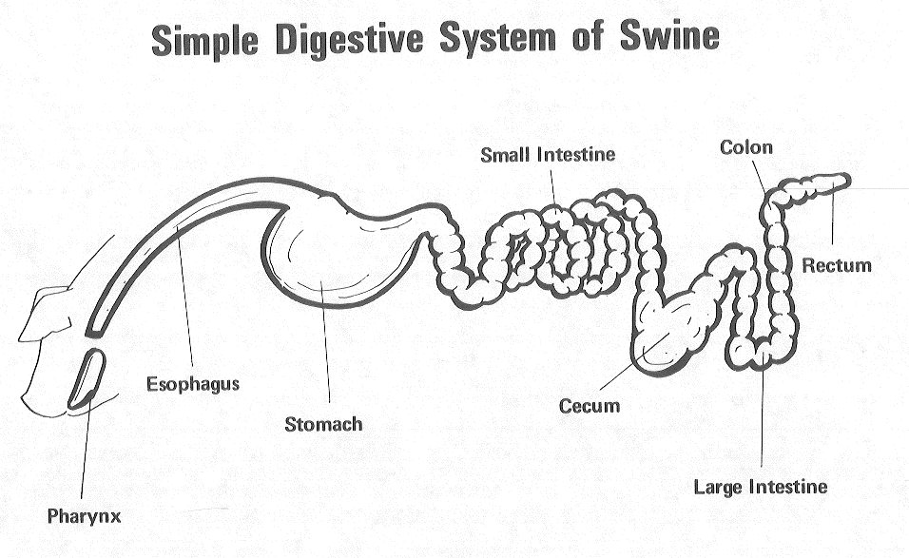

- 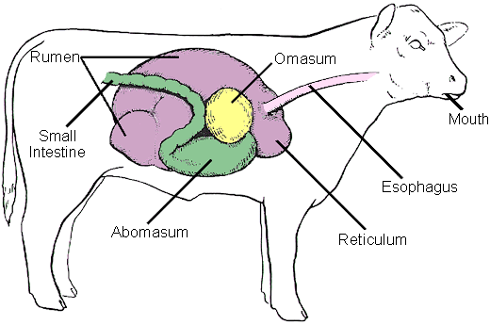

- Small Intestine: long coiled tube connecting stomach to large intestine
rest of the digestion and absorbtion takes place here
surface covered with villi (surface area)
- Large Intestine: Cecum, colon, rectum
absorbs water (makes feces more solid)
some vitamins & minerals absorbed here
Cecal Fermenters (Horse): similar to rumen
- Accessory organs:
  - Pancreas secretes enzymes to break down fat
  - Liver (largest internal organ) secretes bile, which digests fats
also stores iron

Objective #2: The Student will be able to visualize and identify the organs of the digestive system and their functions.

Introduction to Digestion Laboratory:

Materials Needed:
-pieces of apple -rubber tubing -Funnel -beaker
-hydrochloric acid -sponge -mallet -paper towels
-diagram of the digestive system -Student Instruction Sheet (page 6)

Procedure for laboratory:
After you have given the students the basics about the digestive system through the slideshow presentation, their notes and discussion then present the class the original items you used in you interest approach and have them match each component up with a function/organ in the digestive system. Excellent opportunity to review the organs and their function.

OK guys…we have the basics out of the way! Now it’s time to come back to our materials and figure out how they play into the digestion process. Remember, these items aren’t actually in the cow of a stomach, but they do represent something that is. Check your list on your scratch paper and decide if you want to stick with the answers you wrote earlier. Feel free to change any answers if you have learned anything which would cause you to change you mind after the last lesson.

- Students, now I need you to break into groups of _________. (Vary the group size according to the supplies and space you have available.) Refer to the student laboratory procedure and follow each step exactly. Remember that some of these steps could be dangerous and to use extreme caution. If you do not understand some portion of the exercise then please ask for assistance. Also don’t forget to record you observations.

Student Laboratory Procedures: Instructor Key
- Crush the pieces of the apple with the mallet and add a little water to the mixture.
-Teeth and Saliva

- Using the funnel, pour the mixture into the rubber tubing and using your hands, squeeze it into the beaker. (esophagus and peristalsis)

3. Put the mixture into a beaker containing a small amount of hydrochloric acid(remember
safety precautions). (stomach)

4.. Pour the mixture onto the sponge and allow the liquid portion to be absorbed. (small intestine)

5.. Collect the solid pieces and place them on the paper towel to absorb water. (Large Intestine)

- Then dispose of all wastes into the trashcan. (rectum)

Group Members:_______________________________________________________
_______________________________________________________
______________________________________________________

Date_____________________
Student Laboratory Procedures:
After each procedure record what you observed and how this step is directly related to the digestive process and what organs are involved.

- Crush the pieces of the apple with the mallet and add a little water to the mixture.

- Using the funnel, pour the mixture into the rubber tubing and using your hands, squeeze it into the beaker.

3. Put the mixture into a beaker containing a small amount of hydrochloric acid(remember
safety precautions).

4.. Pour the mixture onto the sponge and allow the liquid portion to be absorbed. The nutrients are enclosed in the liquid, while the waste is the solid material.

5.. Collect the solid pieces and place them on the paper towel to absorb the water

- Then dispose of all wastes into the trashcan.

Review/Summary
Summarize the laboratory and how it relates to digestion. This is an excellent time to allow the students to review what they have learned and tie it to a visual experience during the laboratory that they can remember in the future.

Application
Extended classroom activity:
Obtain a digestive tract from a local butcher to label and dissect. Compare and contrast the different types of digestive tracts, and how they vary from species to species.

FFA activity:
Through the PALS program, have FFA members teach elementary students about the basics of digestion and how our digestion may differ from that of their cattle or horses at home. People remember more when they teach others the same information.

SAE activity:
Relate this concept to the importance of understanding how their animals digest their food to help them better gain and obtain optimal health.

Evaluation
Grade the lab looking for the following answers

Answers to Assessment:
- Teeth and Saliva, teeth use mechanical breakdown (mallet) and saliva uses chemical breakdown (water).
- esophagus and peristalsis, tube is esophagus, the squeezing of the tube is peristalsis forcing the food to the stomach.
- stomach, hydrochloride breaks down feed with enzymes
- small intestine, absorbs water with the nutrients contained within
- large intestine, further absorbs remaining water from feedstuff
- rectum, assists in the disposal of waste

