Section: Animal Science

Unit: Unit 7—Anatomy and Physiology

Lesson Title: Lesson 4, The Muscular System

Student Learning Objectives
As a result of this lesson, the student will:
- List the functions and classifications of the muscular system.
- Explain the function of front and rear limb muscles, as well as trunk, neck and head muscles.
- Identify important muscle groups in livestock, specifically cattle.

Time Instruction time for this lesson: 50 minutes.

Resources
- Biology: The Dynamics of Life Textbook
- Muscular System Lesson, Written by: Karen Kier

Tools, Equipment, and Supplies
- Cloth, flexible tape measure
- Copies of “Muscle Groups of Cattle,” one per student
- Copies of slide #8, one per student
- Copies of entire PowerPoint presentation printed three slides to a page for each student. Do not print teacher notes at the bottom of each slide (this is an option on the print screen).
- One copy of the PowerPoint presentation, printed with notes, for your use

Key Terms

Voluntary
Involuntary
Smooth Muscles
Striped muscles
Serratus Ventralis

Interest Approach
Have students stand in a line around the perimeter of the classroom, shoulder to shoulder. You are going to ask them to flex, and most are going to assume that they are to use their arms. However, if they were really thinking, their biggest muscle would be around their upper leg, with a combination of the thigh and quad muscles. Use the student that gets measured first to record the other sizes on the board.

Who thinks they are the strongest person in this classroom? Who has the biggest muscles? Prove it! I want everyone to stand in a line along the wall in the classroom, shoulder to shoulder. I am going to measure your flexed muscle and record it on the board. _________, after I measure your muscle, would you be the recorder on the board?
Upon completion of the measurements, explain that they should have flexed their upper thigh muscles instead of their biceps to get a bigger measurement.

Bigger is better right? So, if that’s the case, aren’t your leg muscle combinations larger than your upper arm? Most guys think that the more muscle they have, the better off they are…and in fact they are right! As producers, heavier muscled cattle, sheep and hogs make more of a profit than do those that are heavily finished and lighter muscled!

Summary of Content and Teaching Strategies
Objective 1 List the functions and classifications of the muscular system.
Be prepared with copies of the PowerPoint presentation for each student printed three to a page. They will use these as notes for the entire lesson instead of taking their own notes. There are notes included for you as an instructor to add to the presentation, which are included on the slide show presentation under each slide.

Today is your lucky day! The reason I say this is because most of the work for today has already been done for you! I am handing you a copy of a majority of the notes you would need to take for this lesson. However, occasionally throughout the lesson, I may add notes for you to add to the lines on the right side of the slides, so keep your ears open and catch any extra notes I throw your way!

Project slides #1-3. Add the notes that are underlined to the lesson and ask students to write them on the lines opposite the slide.

Slide #2 Function of the muscular system
- Provides movement in conjunction with the skeletal system
- Important in life support
- Used by humans for food
Ask students why we need the muscular system before going over this slide

Slide #3 Classifications of Muscles
- Voluntary: Movement of the muscle is under the control of the animal
- Involuntary: Movement of the muscle is not controlled by the animal
Ask students if the following are voluntary or involuntary: Heart (involuntary), lungs (involuntary), bicep (voluntary), big toe muscles (voluntary)

Slide #4 Types of Muscles
- Cardiac Muscles: Muscles that form a network to make up the heart.
- Smooth Muscles: Involuntary muscles, found in the walls of internal organs and blood vessels.
- Skeletal Muscles: Have a striped appearance, include voluntary and involuntary, attached to and moves your bones. This is a majority of the muscle tissue in your body.
Additional definitions to be added to the notes:
Flexor: decreases the angle between two bones when it contracts (biceps)
Extensors: Increases the angle between two bones when it contracts (triceps)

Objective 2 Explain the function of front and rear limb muscles, as well as trunk, neck and head muscles.
We are now going to work our way into the purpose of some specific muscle groups. Choose a student for this exercise.

Great job so far! Now that we understand the different types of muscles, we can begin to put together an entire skeletal system. ___________, could you tell me the names of one of the muscles in your right arm?

Allow student to answer. Answers may include biceps, triceps, etc.

You are right! Each muscle in our body, as well as in the bodies of the livestock we raise, has a purpose. They are responsible for movement, attachment and the continuation of life. We are going to take some time to make some generalizations about the muscles found in bodies.

Slide #5 Muscles of the Front Limb
- The largest and most important muscle attaching the front legs to the body is the serratus ventralis. It is fan shaped and supports the trunk of the body between the legs.

Slide #6 Muscles of the Back Limb
- The primary movements are extension and flexion.
- The main extensor muscle of the hip is the hamstring.
- Movement of the hock is primarily accomplished by flexors and extensors.

Slide #7 Muscles of the Trunk, Head and Neck
- The loin muscle is responsible for extension of the spinal column
- Many of the muscles originate from the vertebrae
- There is greater flexibility in the neck than in the spinal column because of the muscles within.

Objective 3 Identify important muscle groups in livestock, specifically cattle.
Hand out a copy of the “Muscle Groups of Cattle” worksheet (slide #8) to each student. Project slide #9 with the answers so the students can write them down.

Now that we have an idea of the function, classification and type of muscles, we need to look at the specific muscle groups. As I show the names of the muscles, write them on your worksheet.

Review/Summary.
Be prepared for some entertainment if you have a class that likes to have fun and step outside the box. Put students into groups of three or four.

How in the world are we going to remember all this information? Let’s try something different today! As a review, use the karaoke e-moment
- List facts. With the group brainstorm key words, phrases, concepts or steps from the lesson.
- Check the lists. Everyone checks their list against the notes.
- Rewrite a song. Rewrite the lyrics of a familiar song using items you learned today.
- Sing it!

Example: Content: Paragraphs Tune “Wild Thing”
Paragraphs….you make my words sing…you make everything…clearer…
Paragraphs…you make one idea sing…you make everything…clearer…

Application
Extended Classroom Application
Have interested students correspond the names of the muscle groups to the names of retail meat cuts as well as the muscle groups contained within a wholesale cut.

FFA activity:
Have students compete on the meat judging team after studying the meats unit and the anatomy and physiology unit.

SAE activity
For those students with SAEs involving production agriculture, have them compare similar aged animals in terms of frame size and muscle definition. This may lead into interest in livestock judging.

Evaluation.
Review worksheet, complete individually.

Answers to Assessment:
1. Provides movement in conjunction with the skeletal system
-Important in life support
-Used by humans for food
- Between the front legs to support the trunk of the body
- hamstring
- smooth muscles: Involuntary muscles, found in the walls of internal organs and the blood vessels.
- cardiac muscles: Muscles that form a network to make up the heart.
- skeletal muscles: Have a striped appearance, include voluntary and involuntary, attached to and moves your bones. This is a majority of the muscle tissue in your body.
- flexors decrease the angle between two bones
- extensors increase the angle between two bones
- Trapezius cervicalis
- voluntary muscles: under conscious control by the body
involuntary muscles: not under conscious control by the body

Answers to “Muscle Groups of Cattle”
- Trapezius cervicalis
- Trapezius troacalis
- Latissimus dorsi
- External intercostals
- Serratus dorsalis
- Obiquus abdominis externus
- Tensor fasciae latae
- gluteus superficialis
- Biceps femoris
- Semitendinosis
- Aponeurrosis
- Serratus thoracis
- Posterior deep pectoral
- Anterior superficial pectoral
- Long head of triceps
- Deltoid
- Brachiocephalicus
- Sterno-cephalicus
Muscle Groups of Cattle
Name:
Date:

Label the following diagram with the correct muscle group names

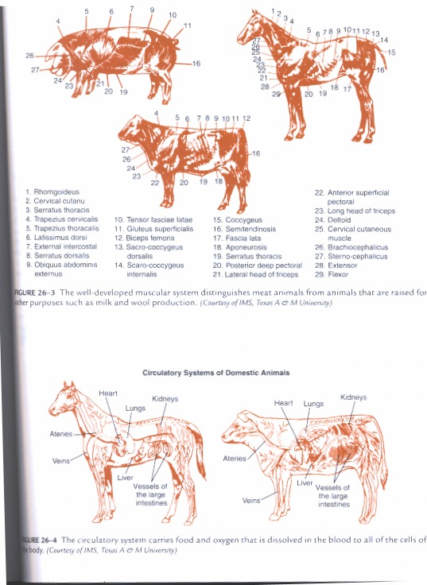

4.
5.
6.
7.
8.
16.
18.
19.
20.
22.

9.
10.
11.
12.
23.
24.
26.
27.

Review Worksheet Over the Muscular System
Name:
Date:

- What are the reasons we need muscles?

- Where is the serratus ventralis located?

- What is the main extensor muscle of the hip?

- Define smooth muscles.

- Define cardiac muscles.

- Define skeletal muscles.

- What do flexors accomplish?

- What do extensors accomplish?

- Using the cattle muscle diagram with labels, what is the name of the muscle over the top of the neck?

- What is the difference between voluntary and involuntary muscles?

