Section Animal Science

Unit Unit 7: Anatomy and Physiology

Lesson Title Lesson 10: The Reproductive System

Student Learning Objectives
As a result of this lesson, the student will:
- Describe the importance and process of animal reproduction.
- List the sexual classification of animals for major species.
- Explain the reproductive development of animals.

Time Instruction time for this lesson: 50 minutes.

Resources
- CAERT Agriscience CD, 2004

Tools, Equipment and Supplies
- Blank paper
- Colorful markers
- Writing utensil and surface
- PowerPoint Presentation or overhead transparencies of slides
- Digital or Overhead Projector
- 5 copies of the P.I.G. Reality Show Development Phases Competition
- 5 Envelopes

Key Terms
Reproduction Sexual Reproduction Sperm Egg
Fertilization Insemination Heat Castration
Artificial Insemination Natural Insemination Neutering Gestation
Sexual Classification Prepuberty Puberty Parturition
Lactation

Interest Approach

Class, pretend with me for a moment that you are on the P.I.G. Reality Show. I am giving you each two sows, along with a full swine production facility. They are yours to keep with the stipulation that you have to increase your herd as quickly as possible, without purchasing any new females. The best part is that there is a $100,000 cash prize for the individual who has the highest herd increase in three years. Sounds like a great reality show, huh? Well, the lucky thing is that you have a couple of weeks to gather the agriscience knowledge you’ll need to win. Class, what types of things will you need to know and understand to win this reality show?

Brainstorm a list with the class on the board that should include things like: knowledge of reproductive systems, animal health, artificial insemination knowledge, gestation length, how to farrow out pigs, etc.

Today, we’re going to begin focusing on the reproductive systems knowledge you will need. We’ll discover why reproduction is important, what the basic process is, and talk about the terms we use to describe different sexual classifications of animals. To begin, we’re going to think about a definition of the word “reproduction.”

Summary of Content and Teaching Strategies

Objective 1. Describe the importance and process of animal reproduction.

Today, we’re going to capture our new knowledge in a “knowbook.” So, when I say go, please come to the front and pick up three pieces of blank paper, several markers and get out your own pencil or pen. Go!

These materials should be stacked at the front of the room. After students are in seats, continue.

First, let’s create our books by folding the three pieces of paper together. Take three minutes to make a cover page for your book that contains the information on the board (Title: The Reproductive System, Author:, Copyright Date: ) Now, let’s record some important information. We’re going to title page 1, “General Reproduction.”

Show slides #2-3 and discuss them while students record this information in their knowbooks.

- Reproduction is the process by which animals produce offspring.
  - Parents are selected and mated to achieve certain goals with offspring
    - Example: Produce offspring with high milk productivity.
  - The end result of reproduction is new animals that are raised for the products they produce
    - Example: Milk, eggs, meat, wool.
- Sexual reproduction is the union of sperm and an egg. Two parents are required. Most animals are produced with sexual reproduction.
  - Sperm is the sex cell of male animals, produced in the testes.
  - Egg or ovum is the sex cell of female animals, produced in the ovaries.

After recording this information, I’d like for you to get one of the colored markers out and underline all the important key words, such as reproduction, sperm and egg. This will make it easy for you to reference these definitions. Next you can title page 2 of your knowbook, “Fertilization.”

Show slides #4-5 and discuss them while students record this information in their knowbooks.

- Fertilization is the process by which the union of sperm and an egg occurs. It is also known as conception.
  - Insemination is the union of sperm and egg; occurs in the female reproductive tract.
  - Natural Insemination: When male and female mate, sperm placed in female’s tract by copulation, or the mating process. Females are only receptive to males during the time in the estrous cycle known as heat.
  - Artificial Insemination: Placing semen collected from a male in the female reproductive tract with special equipment. Must be done when the female is in heat.
  - After fertilization, the embryo attaches to the uterus for nourishment, develops as a fetus until it can live outside uterus, then it’s born.

Again, get out the colored markers out and underline all the important key words, such as fertilization, natural and artificial insemination. Next, you can title page 2 of your knowbook, “Sexual Classification.”

Objective 2. List the sexual classification of animals for major species.

Before we go on with the content, we’re going to take a break and go back to the P.I.G. Reality Show. I need five volunteers to participate in our trivia contest. To motivate you, I’m offering a prize of one additional bred sow for the winners. Bring five students to the front. See PowerPoint slide #6. One click will bring up a question, another the answer.

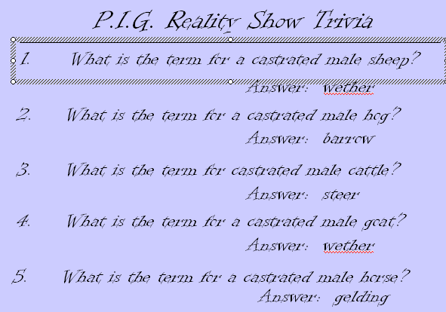

Participant 1, remember that you can win an additional bred sow if you are correct. If you are wrong, however, you have to go for a “swim” in the swine waste lagoon. No pressure. Student should answer question 1., etc. Don’t forget to have fun presenting the students with the “prize.”

Now, let’s go record more information in our knowbooks. Show slides #7 and #8.

- Sexual Classification: condition of an animal based on its age and sexual condition. Includes animals that are both capable and incapable of reproduction.
  - Animals can be made incapable of reproduction by removing the ovaries or testes or altering the condition of the reproductive organs so they are not fertile and the animals isn’t capable of conception.
  - Castration: removal of testes from the male. Management process used on young male animals, promotes growth and development in more desirable ways.
    - Also known as emasculation and gelding.
  - Neutering: process of making female incapable of reproduction. Ovaries of the female removed to render female incapable of reproduction.
    - Also known as spaying
    - Neutering also refers to male castration sometimes.
  - Terms for sexual classification
    - Vary by species, age and gender
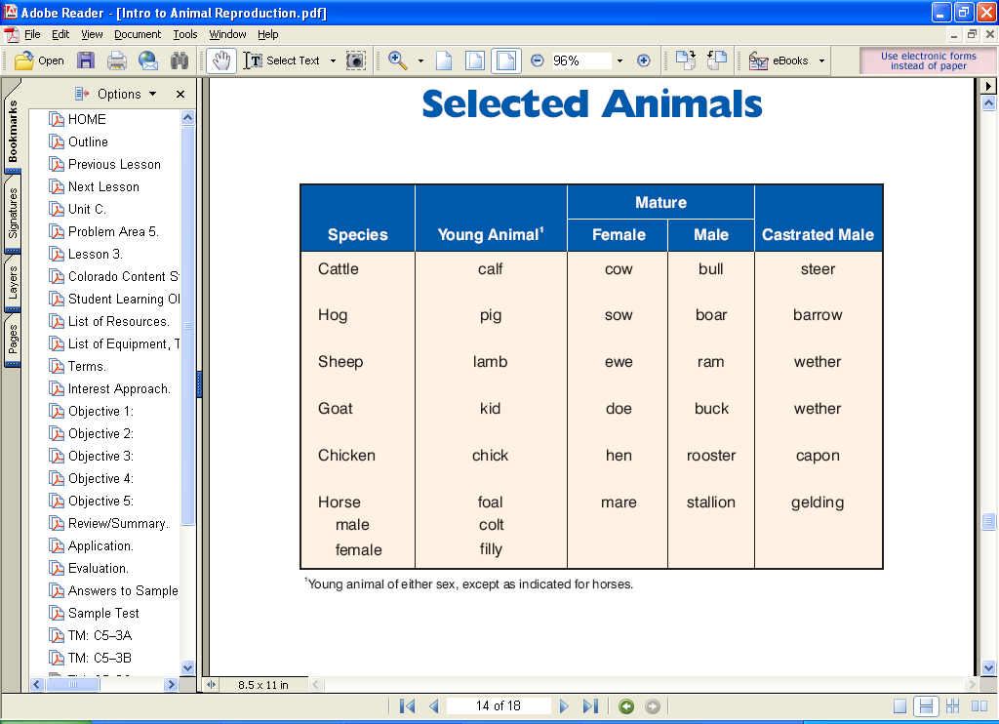
    - See table

Remind students to underline major terms in their knowbooks and create this table on pages 3 and 4.

Objective 3. Explain the reproductive development of animals.

Okay class, it’s time to go back to the P.I.G. Reality show. I need fove new volunteers to participate in the Development Phases competition. Bring five students to the front. The winners of this contest will receive two female piglets; but the losers will be responsible for cleaning the farrowing pens of the rest of the class’s swine operations. I’m going to give each of you five slips of paper that represent the reproductive development stages of a typical female animal. You are to put them in the correct order as quickly as possible. You should have made five envelopes of the P.I.G. Reality Show Development Phases competition handout earlier. Ready, set, go! They should put them in this order: prepuberty, puberty, gestation, parturition, lactation. It is shown on slide #9. Award prizes, and then ask students to record this information in their knowbooks on pages 5-6. Go through slides #10-12. Remind students to underline key words using a colored marker.

- Reproductive development of males and females follows fairly definite stages.
  - Prepuberty: The stage of a young animal before it is capable of reproduction. Sufficient development has not been reached for animal to reproduce.
  - Puberty: The stage when animal reaches a level of sexual development where it is capable of reproduction.
    - Females: Estrous cycle results in release of mature eggs that can support mating, conception and gestation.
    - Males: Can produce viable sperm.
    - Age of puberty varies with species and nutrition and health condition.
      - Cattle (8-12 months)
      - Sheep (5-7 months)
      - Swine (4-7 months)
      - Horses (12-15 months)
    - Mating behavior
      - Males develop libido (desire to mate) and social status
      - Females are receptive to mating during heat
  - Gestation: Period when female is pregnant. Length varies by species
  - Parturition: Process of giving birth. Hormones are produced to support process and prepare for lactation.
  - Lactation: The secretion of milk by the mammary glands of female, initiated by hormone activity. Lasts for several months following parturition.

Review/Summary.
Pretend you are a reporter from the local paper who is interviewing contestants in the P.I.G. Reality Show. Bring several random students to the front and ask them review questions like the ones listed below to review main concepts. Allow students to use their knowbooks as references for the interview.

Possible interview questions: Why is it important to understand reproduction for this contest? How does fertilization work? What’s the difference between natural and artificial insemination? What is castration? What is neutering? What are the five stages of reproductive development in animals?

Application
Extended classroom activity:
Have students investigate careers that require detailed knowledge of the reproductive system and bring in one as a guest speaker or have students conduct a phone interview to discover the importance of the knowledge.
FFA activity:
Students in this class could use their knowledge by creating quiz bowl questions about animal reproduction for the FFA team to practice with.
SAE activity:
Showcase the SAEP of one student who uses reproductive knowledge to increase profitability and scope. Perhaps a pictorial story of the SAE could be presented via PowerPoint.

Evaluation.
Students should complete Reproductive System Quiz

Answers to Assessment:
Part One: Matching
- i
- f
- a
- b
- d
- c
- e
- j
- h
- g
Part Two: Completion
- Steer
- Barrow
- Ewe
- Gelding
- Buck

Reproductive System Quiz

Part One: Matching
Match the term with the correct response. Write the letter of the term by the definition.

a. sexual reproduction f. gestation
b. fertilization g. lactation
c. sperm h. testicle
d. egg i. puberty
e. castrate j. parturition

_______ 1. The stage at which an animal becomes capable of reproduction.

_______ 2. The period of time when a female is pregnant.

_______ 3. Reproduction that involves the union of an egg and sperm.

_______ 4. The process by which union of an egg and sperm occurs.

_______ 5. The female sex cell.

_______ 6. The male sex cell.

_______ 7. To remove the testicles from a male.

_______ 8. The process of giving birth.

_______ 9. The male organ that produces sperm.

_______ 10. The secretion of milk.

Part Two: Completion
Provide the word or words to complete the following statements.

1. _____________________ is a castrated male bovine.

2. _____________________ is a castrated male pig.

3. _____________________ is a mature female sheep.

4. _____________________ is a castrated male horse.

5. _____________________ is a mature male goat.

