Section Animal Science

Unit Unit 6 - Reproduction and Genetics

Lesson Title Lesson 8 - Fertilization Laboratory Part 2

Student Learning Objectives
As a result of this lesson, the student will. . .
- Be able to identify concentration, motility and sperm abnormalities.
- Be able to explain the use of technology in semen evaluation.
- Be able to identify sperm.

Time Instruction Time for this lesson: 50 minutes

Resources:
- Scientific Farm Animal Production, Robert E. Taylor.
- Biology The Dynamics of Life, Biggs, Kapicka, and Lundgren

Tools, Equipment, and Supplies
- Overhead Projector and transparencies of all diagrams or
- Projector and PowerPoint slide show
- One copy per student of Lesson 8, slide 2
- One copy per student of Lesson 8 Worksheet
- Semen/Liquid Nitrogen Freezer
- 1 or 2 straws of semen
- compound microscope
- glass slide
- cover slip
- paper clip
- water bottle
- cito cutter
- cito thaw or water in a glass that is between 95-98 degrees F
- safety glasses

Key Terms
Semen Sperm Concentration Motility Sperm Abnormalities Spectrophotometer Compound Microscope

Interest Approach
How many of you liked the egg lab that we did previously?

Good, now, when I say go, I want you to get in pairs and draw an example of what you saw in the egg lab. Once everyone has a piece of paper you will have 3 minutes. Go.

Benchmark time at 1.5 minutes and again at 30 seconds to keep the students on track. Move through the room guiding student memory.

Stop, your three minutes is up. Now we are going to go around the room pair by pair so you can share your drawings with each other.

Wonderful, now that you have seen the egg, how many of you are interested in seeing a sperm?

Good, first let’s form a visual reference by studying a few photos.

Show slide 2 either on overhead projector on as transparency. Have handouts ready for each student of this slide so they can capture notes on it.

This first picture is a drawing of a sperm without all of the parts labeled. I am going to hand out a copy of this picture so you can have this in your notes. You need to fill in the blanks, using the next slide, so you will be able to identify all of the parts. You’ll have 1 minute, 30 seconds to capture this information.

(Show slide 3.) While you are recording names, make some notes about the purposes of some of these parts off to the side. It will help you remember the information.

I. Labeled Sperm Diagram
- Sperm are highly adapted for reaching and entering the female egg.
- Head portion contains nucleus and is covered by a cap containing enzymes that help penetrate the egg.
- Mitochondria are found in the midpiece of the sperm; provide energy for locomotion.
- Tail is a typical flagellum that propels the sperm along its way

Alright, it looks like everyone is close to finishing. Now I want you to study the next slide/transparency. (Slide 4) Using your wonderful deductive reproductive reasoning consider quietly in your own brain, why you think these three pictures are different.

After 30 seconds, ask for responses from the class. Lead them to the correct answer that the sperm are from different species of animals. By clicking forward, the PowerPoint presentation will reveal the species names.

That’s correct; they are from different species
Before we go to the laboratory today we need to make some discoveries in the classroom.

Summary of Content and Teaching Strategies

Objective 1. Be able to identify concentration, motility and sperm abnormalities.

In a semen sample there are several things to look for to make sure the quality of the sperm is good. Show slide 5 and ask students to build this info into their notes.

- Evaluation of Semen
  - Concentration – “The number of sperm in an ejaculate is measured by using a spectrophotometer. By measuring optical density, the number of sperm per milliliter can be calculated” (ABS A.I Manual). This is important because if there are few sperm the chances of pregnancy in a female greatly decrease.
  - Motility – Is how well sperm swim. If a sperm has two tails, they will work against themselves and not be able to swim well. Some sperm that don’t have any tails can’t move at all. Some may even swim in circles. These are all bad characteristics of sperm, if the goal is to get a female pregnant.
  - Sperm Abnormalities – Sperm must be normal. Sperm with two heads, two tails, no tails, short tails, and many other problems can not be used effectively to get a female pregnant.

Now that we have discussed this slide I want you to get into groups of three and fold a blank piece of paper into sections of three. I want each person in the group to take one of the sections and draw a picture of one of the above terms we discussed in order to explain to the class what concentration, motility, and sperm abnormalities. You have five minutes, go. This is a Picasso Moment.

Your five minutes is up! Now I want each group to share what your drawings mean. Let’s start with this group . . . (teacher guides group sharing.)

Thank you, those were all wonderful drawings. Now that we have the basics of sperm evaluation, we need to discover the technology that helps us make those decisions.

Objective 2. Be able to explain the use of technology in semen evaluation

Our next goal is to learn more about the technology used in semen evaluation. These are some of the technologies you would use if you worked at a semen collection facility. Show Slide number 6.

- Technologies used in semen evaluation
  - Spectrophotometer – Machine that measures optical density, the number of sperm per milliliter can be calculated.
  - Compound Microscope – Used to observe sperm motility and abnormalities.

Objective 3. Be able to identify sperm

Now you all are going to actually identify real sperm.

You will need to obtain a semen freezer with a straw of semen. You will need a compound microscope, glass slide, cover slip, a paper clip, and water bottle, a cito cutter or scissors, and cito thaw (or water in a glass that is between 95 and 98 degrees F) (Caution: If you use the glass method, make sure not to look directly over the top of the glass or wear safety glasses for this part. If you use this method, there is a good chance the straw could explode and pieces of the straw could get in your eye.) First you need to get all equipment and supplies ready before you get the straw of semen out of the tank. Divide the class into groups of 3 and have enough microscopes for each group. Have each group obtain a slide and a paper clip. Have them unfold their paper clip so it is straight. Also have them get a cover slip and a water bottle. Next, the teacher should get the straw out of the semen tank. Make sure if there are other straws, in the canister or goblet you are using, that you don’t keep it in the neck of the freezer for longer than 10 seconds. If you do, you run the risk of ruining the other straws of semen. If you need a reference on how to get a straw out of the tank properly, ABS has an excellent manual for these procedures. Once you have the straw out immediately put it in a cito thaw or glass of water that is between 95 and 98 degrees. Keep it in the water for at least 30 seconds or up to 15 minutes max. The less it is in the thaw unit the better the sample should be. But keep it in the thaw unit before you use it. If sperm get too cold they will die. Pass the straw around to each group, once you have cut the crimped end off with a cito cutter or pair of scissors, and have the students put a small drop on their slide using the modified paper clip to push the cotton plug. Make sure to remind them to be careful not to slip and push the plug too far. Once they have a drop on their slide have them put the cover slip over the sample. Have them adjust their microscopes in order to see the sample. Sperm are much smaller than eggs – so the adjustment will have to be much more magnified. They should be able to see the sperm swimming very fast. Have them examine motility and abnormalities. If anyone thinks they see either, look and have the entire class examine.
For this lab, we will be dividing into groups of three. Once I have divided you into your groups and say “Go Find It”, one person from each group will go and get a compound microscope and plug it in to use. The second person in the group needs to go and get a slide and cover slip. The last person needs to get a water bottle, a paper clip, and the picture we used at the beginning of class that labeled the parts of the sperm from your notebook. Once you have gathered these things you need to come over here to observe what I am going to do for the next steps. “Go Find It.” (You may need to list these responsibilities on the board to prevent needless questioning about them.)

Get the straw out of the tank and put it in the cito thaw. Pull the straw out after about 30 seconds. Make sure it is unthawed. Cut the crimped end with a cito cutter or scissors. Pass it around to each group and have them get a small drop on their slide by pushing the cotton plug with their paper clip. Remind them they don’t need a lot of force – if they use too much force they are going to end up with a big mess.

Now I am going to get a straw of semen out of the semen tank. Once out of the tank I am going to put it in a water bath that is 95-98 degrees F. for 30 seconds. Once I have put it in the water bath, I want you all to go to your stations and get your paper clips ready. You are going to push the cotton plug very slowly to get a very small drop of semen on your slide. Once this step is done cover the sample with a cover slip and try to find the semen in your microscope. If you find any motility or abnormalities call me over.

They should be able to see the sperm swimming very fast. Have them examine motility and abnormalities. If anyone thinks they see either, look and have the entire class examine.

Now, take a look again and tell me if you think this sample is of good quality. Why or why not? Is it likely to get a female pregnant? Discuss these issues with students, while recognizing that this is just to prompt thinking for a more detailed exploration of sperm motility.

Once everyone in you group has seen the moving sperm you need to make another sample, but with this sample I need you to put a very small droplet of water on top of the semen drop. Look at this sample and tell me what you see.

Once they have seen the slide with the live sperm, have them prepare another slide and put a very small drop of water on the sample. Explain that water is deadly to sperm and we want to kill the sperm to get a better look at abnormalities. Have everyone at this point draw a detailed picture of a sperm and label it using the picture they were given at the beginning of class.

Review/Summary
Now that you have dead sperm, I need each one of you to draw and label one of the sperm you see on your worksheet. You can use the chart we did at the beginning of class. There are also several other questions for you to answer. You have 5 minutes to do this. Once you are done, clean your slides and put away all of your materials.
Application
Extended Classroom Activity:
Schedule a tour at a semen collection facility to show students how semen collection is actually done. This will also provide an opportunity to explore different career options that many students had probably not thought about.
SAE Activity:
Have students write a paragraph explaining how this could help their SAE if they were using artificial insemination on their project.
FFA Activity:
Develop a variety of ideas that a student could use to complete an Agriscience project for competition at state FFA convention.

Evaluation
Students should complete worksheet for a grade and be graded on participation in lab.

Answers to Assessment:
- Sperm drawing
- Concentration – “The number of sperm in an ejaculate is measured by using a spectrophotometer. By measuring optical density, the number of sperm per milliliter can be calculated” (ABS A.I Manual). This is important because if there are few sperm the chances of pregnancy in a female greatly decrease.
- Motility – Is how well sperm swim. If a sperm has two tails, they will work against themselves and not be able to swim well. Some sperm that don’t have any tails can’t move at all. Some may even swim in circles. These are all bad characteristics of sperm, if the goal is to get a female pregnant.
- Sperm Abnormalities – Sperm must be normal. Sperm with two heads, two tails, no tails, short tails, and many other problems can not be used effectively to get a female pregnant.
- Spectrophotometer – Machine that measures optical density, the number of sperm per milliliter can be calculated.
Compound Microscope – Used to observe sperm motility and abnormalities.

Lesson 8 Worksheet

Fertilization Laboratory Part II

- Draw the sperm you saw today and label the parts with the help of your notes.

- Define sperm concentration.

- Define motility.

- What are two sperm abnormalities that reduce sperm motility?

- What are two instruments that are used to evaluate sperm?

Lesson 8, Slide 2

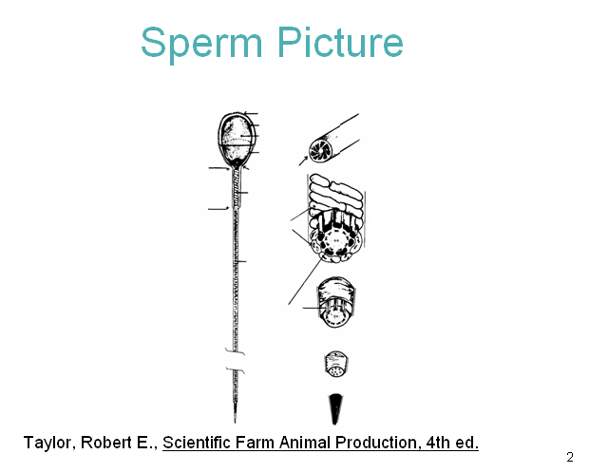

Lesson 8, Slide 3
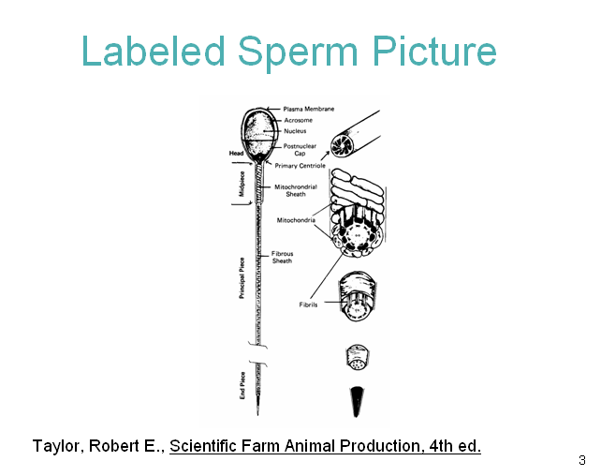

Lesson 8, slide 4

