Section: Animal Science

Unit: Unit 6 - Reproduction and Genetics

Lesson Title: Lesson 4 - Female Hormones of Reproduction and Estrous

Student Learning Objectives
As a result of this lesson, the student will. . .
- Be able to define the hormones of female reproduction and explain how they work through the system as a whole.
- Explain body functions in terms of interacting organ systems and identify mechanisms involved in homeostasis, such as negative feedback in the endocrine system.

Time Instruction time for this lesson: 50 minutes

Resources
- Scientific Farm Animal Production, Robert E. Taylor.
- Biology, The Dynamics of Life, Biggs, Kapicka, and Lundgren.
- American Breeders Service A.I. Management Manual

Tools, Equipment, and Supplies
- Overhead Projector / Computer with projector
- Blank Paper
- Transparencies / PowerPoint slideshow
- 1 Copy per student (Quiz)
- Student Notebook
- Writing Surface and Tools

Key Terms
follicle stimulating hormone leutinizing hormone
gonadatropin releasing hormone hypothalamus
pituitary gland hypothalamus
estrogen progesterone
estrous estrus

Interest Approach

Yesterday students learned about Follicle Stimulating Hormone (FSH), Leutinizing Hormone (LH), and Gonadatropin Releasing Hormone (GnRH), the hypothalamus, and pituitary gland. In order to review this process and set up for a comparison of males and females, tape brightly colored pieces of paper to your white board or chalk board. Use a different color for each hormone. Divide the class into 5 groups and have each group write under the piece of paper what they know about the hormone or gland they have been given.

I am going to count you off in 5’s. I want the ones to go to the colored piece of paper on the board labeled FSH, the twos to go LH, the threes to go to GnRH, the fours to go to hypothalamus, and the fives to go to pituitary. Once you get there, quietly wait for your next instruction.

When I say “go,” your group needs to list as many things as you can think of about your part of the reproduction process. You have two minutes.

(Warn them after one minute.) Once they are done discuss the lists and make sure they correspond with the following from the previous lesson:

Hormones in Male Reproduction
- Gonadotropic Releasing Hormone (GnRH) – Hormone that stimulates the gonads. Works like a light switch turning LH and FSH on and off.
- Follicle Stimulating Hormone (FSH) – Causes production of sperm cells.
- Luteinizing Hormone (LH) – Causes endocrine cells in the testes to produce the male hormone – testosterone.

Hormones are secreted from glands.
  - Hypothalamus – Area of the brain directly above the pituitary that produces one of the hormones which control reproduction. Gonadotropic Releasing Hormone (GnRH).
  - Pituitary – Gland situated beneath and stimulated by the hypothalamus, releases follicle stimulating hormone (FSH) and Leutinizing hormone (LH), which serve such functions as stimulating production of sperm and testosterone in males.

Great job, everyone. As you return to your seats, think about how the female reproductive hormones might differ from the male hormones we covered yesterday. What do you think will be similar? Take responses. What do you think will be different? Take responses.
These are some great thoughts! Let’s take a closer look at the hormones that effect females and learn about the estrus cycle in cattle. Keep an eye out for connections in the hormones we learned about in the males.

Summary of Content and Teaching Strategies

Objective 1. Student will be able to define the hormones of female reproduction and explain how they work through the system as a whole.

In the last lesson you learned about the hormones of male reproduction. Can anyone refresh my memory as to what a hormone is exactly?

Wait for an answer similar to “A chemical secreted by an animal that affects another part of the organism.”

Super, a hormone is a chemical secreted by an animal that affects another part of the organism. Does anyone have a guess as to what hormones are utilized in female reproduction?

You may get an answer stating that they are the same, but probably not. Prod them along by giving obvious clues that they are similar.

Come on, can anyone guess? They are very similar to the male hormones.

Yes, they are the same hormones but they do affect the female in different ways. Let’s take a look at those differences and capture them in our notes.

Show Slide 2 and 3. Read or have students alternately read each hormone aloud while they write.

I. Hormones in Female Reproduction
- Gonadatropic Releasing Hormone (GNRH) – Hormone that stimulates the gonads. It also acts as a light switch turning FSH and LH on and off through the negative feedback system. (Released by the Hypothalamus)
- Follicle Stimulating Hormone (FSH) – Signals the follicle on the ovary to begin production of an egg. (Released by the Anterior Pituitary).
- Leutinizing Hormone (LH) – Causes the follicle to undergo changes which lead to egg release. (Released by the Anterior Pituitary).
- Estrogen – As the follicle grows larger, it begins to secrete more and more estrogen. This hormone affects the nervous system causing restlessness, the desire to mount other animals. It is the hormone that causes the signs of heat and it causes the female to accept service from the male. (Released by the Follicle)
- Progesterone – The yellow body, which is the new gland formed by the collapsed cells of the follicle, secretes this hormone. It is the hormone that maintains pregnancy. It prepares the uterus for pregnancy and prevents the heat cycle.

Does everyone understand the hormones and what they do? Are there any questions?

Now write each hormone we have discussed today and yesterday on a piece of paper without the definition. You may use the notes on the board to copy the hormones of today. You will need to think about the hormones we talked about in the last lesson on male hormone. After you have the names of the hormones written, I want you to think back to yesterday’s lesson and compare it with today’s lesson.

Give students time to catch up at this point. Once students are caught up, have them contrast and compare what the hormones do for the female and what they do for the male.

Now you will have 2 minutes to contrast and compare what each hormone does in the female body vs. what it does in the male body. If it is a hormone mainly found in the male or female note that. Remember, you only have 2 minutes. Go.

Time, now I want you to turn to a neighbor and share your thoughts and findings. I am going to give you 60 seconds. Go.

Time, now I want you to share your findings with the class. I need one volunteer to come up to the board and write all of the hormones of male and female reproduction on the board without your notes. The class may help you out – but they may not look at their notes. Make sure you spread the terms out across the board.

Once the hormones are on the board - have each group write their findings on the board under the hormone. If they had the same thing as the previous group they don’t have to write it again. Have all groups that can fit go up to the board at the same time under different hormones. Once they are done have them switch and add any missing information. As a group, go over the discoveries.

Thank you, now I need each group to go up the board pick a hormone and write your discoveries on the board.

Now have a class discussion on the discoveries and comparisons that were made. Make sure they are in line with the information on slides 2-3 and outlined above and then review material presented on male hormones at the very beginning of the lesson.

Wonderful job everyone. Are there any questions?

Objective 2. Explain body functions in terms of interacting organ systems and identify mechanisms involved in homeostasis, such as negative feedback in the endocrine system.

Now that we understand the hormones of female reproduction let’s consider negative feedback in females. In females this process is more commonly known as the estrous cycle. The heart of understanding the estrus cycle begins with knowing the difference between estrous and estrus. Review Slide Number 4.

- The Difference Between Estrous and Estrus
  - Estrous – In cattle the series of events occurring in the ovaries and other female reproductive organs between two successive ovulations. In cows the average heat estrous cycle is 21 days, although 18 to 24 days is a normal range.
  - Estrus – Portion of the female reproductive cycle when cows and heifer are sexually active, receptive and fertile. Estrus usually lasts about 18 hours, although it can range from 8 – 30 hours.

Now we are going to go into the estrous cycle and estrus a little more in depth so you understand the negative feedback system. Show slide number 5 and 6. Also show the 21 day chart (slides 7-8) after you explain each part of the cycle.

- The Estrous Cycle
  - Day 1 – Estrus. The day the heifer is sexually receptive to the male and fertilization of the egg may occur. Estrogen production is high at this point.
  - Days 2-6 – Developing Corpus Luteum (Yellow Body) – Replaces the follicle, secretes progesterone and some estrogen, and prepares the uterus for pregnancy and prevents heat. (Luteal phase)
  - Days 7-16 – Developed Corpus Luteum. Will stay in this stage if pregnant, secreting progesterone and some estrogen to prevent heat and maintain pregnancy. If no pregnancy is detected the CL will begin to regress, the follicle will begin to develop and mature, and estrogen production will begin to increase from the follicle site.
  - Day 17-21 – Regressing CL stage. The corpus luteum regresses in size and produces less progesterone. The follicle begins to grow and mature releasing more estrogen. The growth of the follicle happens due to the anterior pituitary producing more Follicle Stimulating Hormone and Leutinizing Hormone. (Follicular Phase)
  - Day 1 again – Estrus. Period of time the cow will accept service. Ovulation actually occurs after this period of time. Ovulation is the actual release of the mature egg from the follicle. It occurs about 10 to 14 hours after the end of heat. A sharp increase in Leutinizing Hormone causes the follicle to rupture and the egg to release. It also stimulates the corpus luteum to develop from the ruptured follicle so progesterone can be produced to help maintain pregnancy if it occurs. This means actual fertilization does not occur until after heat; however the male was accepted during heat.

Now I am going to project the pictorial of the Estrous Cycle on the board. I want each of you to copy it in your notes. Show slide 7.
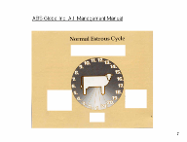

Wait for the students to copy the chart.

Now that you have the chart copied, I want to go through this as a class and write what happens in every stage.

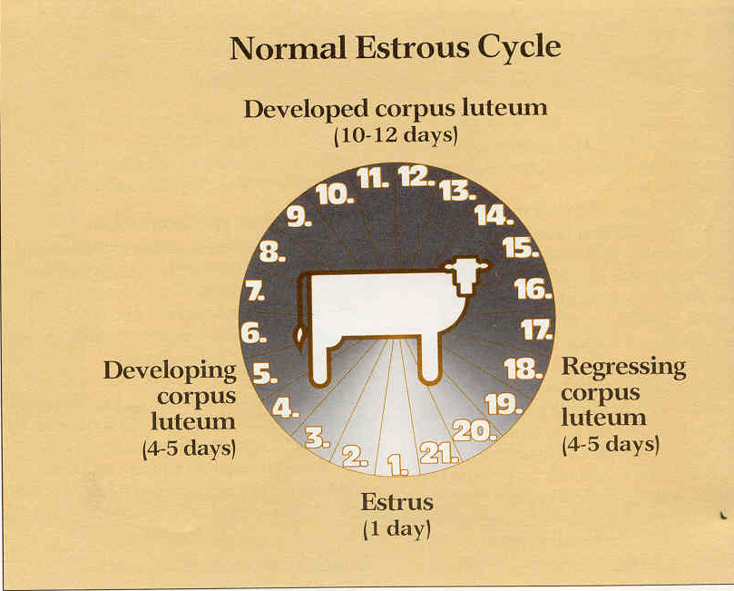
As a class, go through this together putting what you said in words on the chart. You may do this on an overhead projection, tape words up on the screen, or draw the diagram on the board. It is slide 8; you can project it on the board when you have finished brainstorming. Once done check your work with the diagram below.

Super, now that everyone understands the estrous cycle, I want to go over the negative feed back system in females.

Show slide 9.
Negative Feedback In the endocrine system is the means of self-regulation by which the body maintains correct hormone levels. If fertilization occurs, this cycle is broken and the levels of hormones change.

Review/Summary
Have a “Show what you know moment”. Have all students put away their notes, pick a partner, and draw the estrous diagram with as much information as they can remember on the diagram. When done show slide 8. Have them make corrections and turn in the chart.

Application
Extended Classroom Activity
Have students go home and draw the estrous cycle on their own one more time. Utilizing color, pictures or whatever they need to remember the cycle. It is critical that they know the cycle in order to synchronize and manipulate it for later sections. Have them turn it in for a homework grade.
FFA Activity
Have students join a livestock judging team to extend their knowledge of the animal science industry.
SAE Activity
Have students observe their female animals, if they have them, to observe heat. Whenever they do observe heat, in the right time of year, have them come back to class to report their findings.

Evaluation
Students should complete Female Hormones of Reproduction and Estrous Quiz. This can be recorded as a grade or used as a study tool in class.

Answers to Assessment:

- D
- B
- B
- B
- A
Labeling
- Developed corpus luteum
- Regressing corpus luteum
- Estrus
- Developing corpus luteum
Lesson 4 Quiz
Female Hormones of Reproduction and Estrous Quiz

Multiple Choice: Pick the answer that best fits.

- This hormone is secreted by the yellow body

  - GNRH
  - FSH
  - LH
  - Progesterone

- This hormone causes the follicle to undergo changes that leads to egg release.
  - FSH
  - LH
  - GNRH
  - Progesterone

- The series of events occurring in the ovaries and other female reproductive organs between two successive ovulations.
  - Estrus
  - Estrous

- Regressing CL Stage
  - Day 1
  - Day 17-21
  - Day 2-6

- Portion of reproductive cycle when the animal will accept a male
  - Estrus
  - Estrous

Labeling: Label the Stages of the Reproductive Cycle
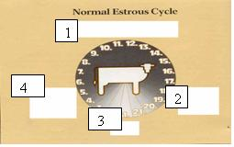
1.

2.

3.

4.

