Section Animal Science

Unit Unit 6: Reproduction and Genetics

Lesson Title Lesson 13: Genetic Variation and Gamete Formation

Student Learning Objectives (Enablers)
As a result of this lesson, the student will …
- Understand the principles of spermatogenesis
- Understand the principles of oogenesis
- Explain what occurs during fertilization on the cellular level

Time: Instruction time for this lesson: 50 minutes.

Resources/References
- Scientific Farm Animal Production
- Biology: “Principles and Exploration”

Tools, Equipment, and Supplies
- Overheads or PowerPoint’s (Unit 4, Lesson 13 – Gamete Production PowerPoint)
- Crayons or colored pencils
- Blank unlined paper (3 per student)

Key Terms. The following terms are presented in this lesson and appear in bold italics:
Gametogenesis Spermatogenesis Oogenesis
Primary Spermatocyte Primary Oocyte Secondary Oocyte
Secondary Spermatocyte Spermatids Polar Bodies
Fertilization Haploid Diploid

Interest Approach
In our last lesson we explored the process of meiosis. Today we are going to use what we know about meiosis and see how it is applied to form gametes or sperm and ovum cells. We will also begin looking into how we can use this biological process to improve our herds. Meiosis and the joining of gametes are essential to evolution or improvement. No genetic process generates variation more quickly. In many cases, the pace of evolution, or improvement, appears to increase as the level of genetic variation increases. For example, when genetic variation is used in agricultural breeding programs to increase the size of livestock, many large animals are produced at first. But as the existing genetic combinations become used up, the ability to obtain larger and larger animals slows down. Further progress must then wait for the formation of new gene combinations.

Racehorse breeding provides another example. Thoroughbred racehorses are all descendants of a small number of individuals, and selection for speed has accomplished all it can with this limited amount of genetic variation. The winning times in major races stopped improving decades ago.

Genetic variation is accomplished by crossing over and random assortment from individuals as discussed in the last unit. Let’s now look at how this variation is put into practice in the production of gametes.

Summary of Content and Teaching Strategies
Objective 1. Understand the principles of spermatogenesis
(Unit 4, Lesson 13 – Gamete Production PP)
Use overhead numbers one through six for this objective. You will also need one blank, unlined, piece of paper for each student and enough crayons or colored pencils for each student.

Show overhead number two and explain that this is an overview of what will be covered today. Both forms of gametogenesis are displayed, spermatogenesis and oogenesis.

Show overheads number three and four and allow students to put the information into their notebooks. Reiterate the information with the following.

The testicles of the male and the ovaries of the female produce sex cells by a process called gametogenesis. The gametes produced by the testicles are called sperm; the gametes produced by the ovaries are called eggs or ova. Specifically, the production of sex cells that become sperm is called spermatogenesis; the production of ova is known as oogenesis. The unique type of cell division in which gametes are formed is meiosis. Each newly formed gamete contains only one member of each of the chromosome pairs present in the body of the cells.

Let us examine gametogenesis in a theoretical species in which there are only two pairs of chromosomes in each body cell. Meiosis occurs in the primordial germ cells located near the outer wall of the somniferous tubules of each testicle and near the surface of each ovary. Primordial germ cells are cells capable of undergoing meiosis. The initial steps in meiosis are similar for the male and female. The chromosomes replicate themselves so that each chromosome is doubled. Then each pair of chromosomes comes together in extremely accurate pairing call synapsis. After chromosome replication and synapsis, the cell is called a primary spermatocyte in males and a primary oocyte in the female. From this point on there are large differences between spermatogenesis and oogenesis.

(Unit 4, Lesson 13 – Gamete Production PP)
Display overhead number five and allow students time to take notes. Once they are caught up read the following;

Remember this is a theoretical species with only two pairs of chromosomes. The primary spermatocyte contains two pairs of chromosomes in synapsis. Each chromosome is doubled following replication. Thus, the primary spermatocyte contains two bodies or structures formed by four parts. (Remind students of chromatids here – each chromosomes has 2 chromatids thus making the four parts) By two rapid cell divisions, in which no further replication of the chromosomes occurs, four cells, each of which contains two chromosomes, are produced. The spermatid cells, each of which contains two chromosomes are produced. The spermatid cell each loses much of their cytoplasm and develops a tail. This process of spermatogenesis results in formation of sperm. Four sperm are produced from each primary spermatocyte. Four chromosomes in two pairs are present in the primordial germ cell. Only two chromosomes, on half of each chromosome pair, are present in each sperm. The number of chromosomes in the sperm has been reduced to half the number as compared to the primordial germ cell.
Pass out one of the blank, unlined, pages of paper to each student. Also distribute the colored pencils or crayons throughout the class. Display overhead number six and allow them to replicate it on their blank piece of paper. Explain that this organism has a total of four chromosomes or two pair. If this was a human cell it would have twenty-three chromosomes in the sperm cell since humans have twenty-three pairs of chromosomes.

Objective 2. Understand the principles of oogenesis

You will need overhead seven and eight as well as a second piece of paper and the crayons again. Display slide seven, allow student time to get the information into their notebooks and then read the following;

Remember this species has only two pair of chromosomes. Like the primary spermatocyte of the male, the primary oocyte of the female contains a tetrad. The first maturation division produces one relatively large nutrient containing cell known as the secondary oocyte and a smaller cell called the first polar body. At this point each of these two cells are diploid, or contains a pair of chromosomes. The unequal distribution of nutrients that results from the first maturation division in the female serves to maximize the quantity of nutrients in one of the cells, the secondary oocyte, at the expense of the others, the first polar bodies.

The second maturation division produces the ovum and the second polar bodies, each of which are now haploid or containing half of the original chromosomes. The vast majority of nutrients are diverted to the secondary oocyte to ensure its survival and all of the polar bodies are reabsorbed by the female’s body. The egg, like the sperm, contains only one chromosome of each pair that was present in the primordial germ cell. The gametes each contain one member of each pair of chromosomes that existed in each primordial germ cell.

(Unit 4, Lesson 13 – Gamete Production PP)
Pass out the second blank paper and redistribute the colored pencils or crayons. Display overhead number eight and have students recreate the drawing like they did for spermatogenesis.

Objective 3. Explain what occurs during fertilization on the cellular level

For objective three you will need overheads nine through eleven, the last blank page, and colored pencils or crayons. Display slides nine and ten and allow students to copy the notes into their notebooks and then discuss the following.

When a sperm and an egg of our theoretical species unite to start a new life, each contributes one chromosome to each pair of chromosomes in the fertilized egg, now called a zygote. Fertilization is the union of the sperm and the egg along with the establishment of the paired condition of the chromosomes. The zygote is termed diploid because it has chromosomes in pairs; one member of each pair comes from the sire and one member comes from the dam. Gametes have only one member of each pair of chromosomes; therefore, gametes are termed haploid. Gametogenesis thus reduces the number of chromosomes in a cell to half the diploid number. Fertilization reestablishes the normal diploid number. It is important to remember that gametogenesis produces gametes that carry a random sample half of each parent’s genetic code. Which sperm fertilizes the egg is also a random event. As such, genetic diversity in the population is assured.

(Unit 4, Lesson 13 – Gamete Production PP)
Pass out the remaining blank page and display slide eleven. Have students recreate the drawing as they did with the previous two. Collect to grade or have the students put the finished diagrams into their notebooks for future reference.

Review/Summary.

The process by which sperm are produced in male animals is called spermatogenesis. Spermatogenesis occurs in the testes. A diploid cell first increases in size and becomes a large immature cell or germ cell. The germ cell then undergoes meiosis I. Two cells are produced; each of which undergoes meiosis II to form a total of four haploid cells. The four cells change in form and develop a tail to become male gametes called sperm.

The process by which gametes are produced in female animals is called oogenesis. Oogenesis occurs in the ovaries. Notice that during cytokinesis (division of cytoplasm during cell division) following meiosis I, the cytoplasm divides unequally. One of the resulting cells gets nearly all of the cytoplasm and nutrients. It is this cell that will ultimately give rise to an ovum cell. The other cell is very small and is called a polar body. The polar body may divide again, but its cells will not survive and will be reabsorbed by the body.

The larger cell undergoes meiosis II, and the division of the egg cell during cytokinesis is again unequal. The larger cell develops into a gamete called an ovum. The smaller cell, the second polar body, is reabsorbed. Because of its larger share of cytoplasm, the mature ovum has a rich storehouse of nutrients. These nutrients nourish the young animal that develops if the ovum is fertilized.

The gametes, or sperm and egg cells, join in a process called fertilization, which results in a diploid zygote. After fertilization, the resulting zygote begins to divide by mitosis. This single diploid cell eventually gives rise to all of the cells of the adult. The cells of the adult are also diploid since they are produced by mitosis.

Application
Extended classroom activity:
Use a “Show What You Know” E-moment.

Evaluation
Fill in the blanks of the sperm and egg formation flow chart.
Answer Key

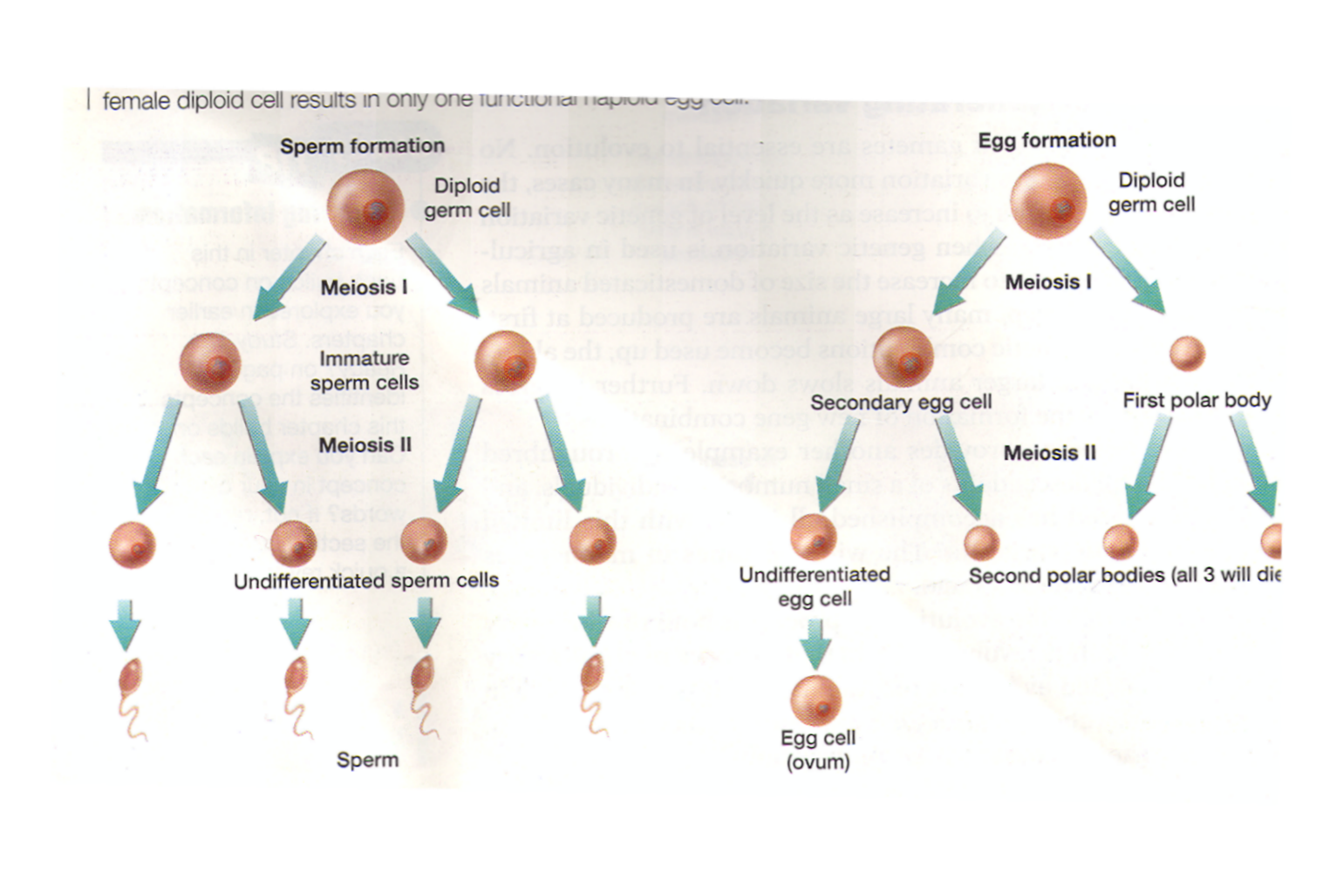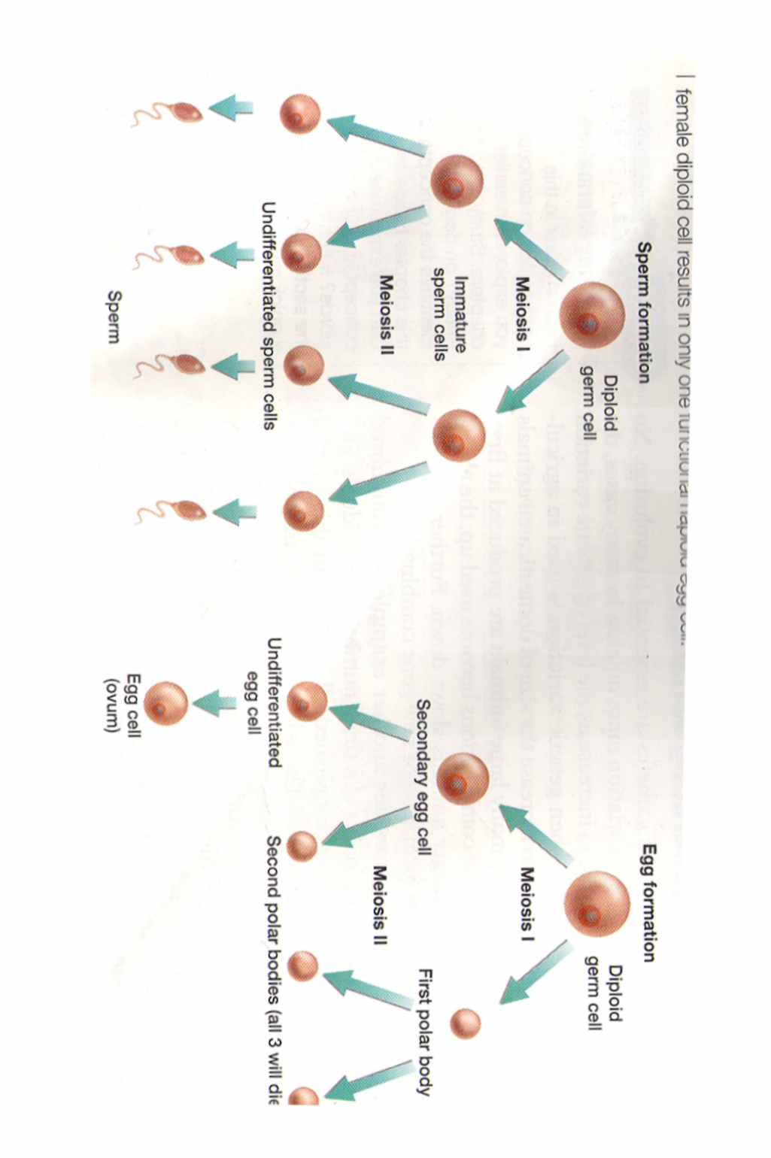
Fill in the blanks.

