Section: Animal Science

Unit: Unit 5: Cell Structure and Function

Lesson Title: Lesson 2: Biology of the Animal Cell 1
“Setting Our Cytes Ahead”
levels of organization and their roles within the whole organism.

Student Learning Objectives
As a result of this lesson, the student will:
- Describe cellular organelles and their functions.
- Select and use appropriate technologies to gather, process, and analyze data and to report information related to an investigation.

Time Instruction time for this lesson 50 minutes.

Resources/References
- “Cells Alive” CD ROM (available online at www.cellsalive.com)
- An Illustrated Guide to Veterinary Medical Terminology, Janet Amundson.
- The Biology Coloring Book, Robert Griffen
- Clinical Anatomy and Physiology for Veterinary Technicians, Thomas Colville.
- Biology, 4th edition, Cambell, 2000
- http://www.ibiblio.org/virtualcell/index.htm
- Agripicture.com by Peter Dean

Tools, Equipment, and Supplies
- Handouts (Lecture Worksheet, one per student)
- Colored Pencils
- Calculators
- Prepared slides of animal and plant cells

Key Terms
Plasma membrane Chloroplast Cell wall
Chlorophyll Chromatin Plastid
Nucleus Cytoskeleton Ribosome
Microtubule Cytoplasm Microfilament
Endoplasmic reticulum Cilia Golgi Apparatus
Flagella Vacuole Unicellular
Lysosome Multicellular Mitochondria
Tissue Organ Organ system

Interest Approach
Prompt the PowerPoint introduction to “Setting Our Cytes Ahead.” Have the first slide up on the screen before students enter the classroom.

We know now how important cells are to living organisms. Now we will look at the cell itself to see exactly how the cell functions. Remember your favorite steak restaurant? Let’s use that example to model the form and function of a living cell.

When you go into the restaurant, each room has a specific function. For instance, the kitchen is the location of food preparation, the freezer in the kitchen is designed for food storage and the dining room is made for guests to eat. Likewise, cells are designed with specific purposes in mind, functions such as building and storage. As you enter a restaurant through a door in the wall, you have entered through the boundary of the business. Cells also have boundaries with passage ways for materials to enter and exit. Just as there is a mastermind in the kitchen, the restaurant manager, we will learn that there is also a mastermind to the cell!

Summary of Content and Teaching Strategies
Objective 1. Describe cellular organelles and their functions.

This is a two-part lesson. Only a portion of the content on the cell will be presented here, to be followed by Cell Biology, Part II. If time permits, you may want to continue on to the next lesson. Go through the PowerPoint presentation slide by slide. Make sure you give enough time for each student to fill in the lecture outline (found in the back of this document) and color each organelle when it is reviewed. Get familiar with the material before you begin so you might field questions or give added examples as you go.

Show Slide #1 - Setting our Cytes Ahead!!
Make sure that each student has the following items:
Cell color sheet Student lecture outline
Colored Pencils Calculator

Show Slide #2 - The Guts of an “Animal Cell.” Highlight the complexity of cellular structure. Each tissue of an animal is made up of millions of cells that perform certain functions in the body! Yet each cell is highly complex! Imagine that each cell has all of these organelles functioning inside of it. AMAZING!

Show Slide #3 – Animal Cell Membrane
Let’s begin by reviewing the different parts of the cell. Remember, we are comparing the cell to a restaurant. Just as each part of a restaurant serves a specific function, so do the parts of a cell. We first must understand the boundaries of the cell, the cell membrane. Unlike the wall of the restaurant business, the plasma membrane is quite flexible and allows the cell to vary its shape.

Show Slide #4 - Cells must have boundaries!!
What are walls of a restaurant made of? (Allow time for answers).Cell membranes or plasma membranes, the boundaries of the cell, are made of fats, proteins and cholesterol.

Show Slide #5 - Functions of the Cell Membrane
As I review the functions of the cell membrane, please fill out the lecture worksheet. There are three primary functions of the cell membrane, they are to:
1. Provide a boundary between the inside and outside of the cell.
2. Control movement of materials going in and out of the cell. Items like waste, water, organic compounds and protein
3. Help maintain a chemical balance within the cell.

Show Slide #6 - Color your Cell Membrane Now!! Allow the students 30-45 seconds to color the membrane of their cell.

Show Slide # 7 - Our manager, “Mr. Nucleus”
Imagine what a restaurant manager looks like. Focused, directed, a multi-tasker! Just like the restaurant business, the cell needs a manager within its boundaries. The manager directs the business affairs of the cell.

Show Slide #8
In real life, the nucleus looks a little different than it does in your graphic. Review these nuclear photos to see what the nucleus and its surface looks like.

Show Slide #9 - The nucleus is the organelle that manages cell functions.

Show Slide #10 – DNA and the Nucleus

Show Slide #11 - The nucleus contains DNA (Deoxyribose Nucleic Acid), the master instructions for building proteins. DNA forms long strands called chromatin which can form chromosomes when cells reproduce. Remember to fill in the lecture worksheet!

Show Slide #12 - Nuclear Envelope
The nucleus is surrounded by a nuclear envelope, which is a double membrane. Each membrane has two layers.

Show Slide #13 - Ribosomes
Inside the nucleus is the nucleolus, a region that produces tiny cell particles called ribosomes that are involved in building proteins. Ribosomes are organelles but do not have a membrane.

Show Slide #14 – Where do we find ribosomes?
Let’s review where we would find ribosomes in the cells! Who can tell me?

Show Slide #15 - Functions of the Nucleus
The nucleus of the cell performs three important functions. The nucleus contains and processes genetic information (located in the DNA), controls cell metabolism and protein synthesis (through the ribosomes located in the nucleolus). It truly acts as a restaurant manager, controlling the efficiency and organization of all of the employees of the restaurant.

Show Slide #16 - Functions of the Nuclear Envelope/Membrane
The nuclear envelope, also known as the nuclear membrane, separates the nucleus from the surrounding cytoplasm. This is like the swinging doors of the restaurant kitchen!

Show Slide #17 - Functions of Chromatin
Chromatin regulates protein building and other molecular interactions. Remember, in the nucleus DNA forms long strands called chromatin which can form chromosomes when cells reproduce.

Show Slide #18 - Functions of the Nucleolus
The nucleolus is the location where ribosomes are made.

Show Slide #19 – Using different colors, color the nucleus, nuclear envelope, chromatin and nucleolus now!! Allow1 to 2 minutes for students to color.

Show Slide #20 – Cytoplasmic, Baby!!!
Just like the restaurant with hallways and rooms, the cytoplasm is used for assembly, ransport and storage of materials.

Slide #21 - Cytoplasm
Cytoplasm is a media for transporting of intracellular substances, contains storage vacuoles, and vesicles to store nutrients and waste. Contains enzymes needed for metabolic reactions.

Slide #22 - Color the cytoplasm now! Allow1 minute for students to color.

Objective 2. Select and use appropriate technologies to gather, process and analyze data and to report information related to an investigation.

Now that we have begun to understand cell organs and how they function, let’s see if we can identify some of these structures!

Give each student or group of students a copy of the Animal Cell Structure Lab Handout and Worksheet and two prepared slides - one with an animal cell labeled “A” and one with a plant cell labeled “B.”

Allow 20 minutes for the lab.

Review/Summary
Ask the students to refer to their lecture worksheet and coloring handout to review for a game coming up next. Divide the class in half and go back to the slide presentation to give a quiz to both teams.

Ask each team to have a representative from their group answer each question. Tell them they will have 15 seconds to give the correct answer. Keep track of the points and give out a small prize (candy, points) to the winning team. Start by presenting slide#23with directions to the class. Then show the first slide to the first team. There are 6 questions total. If at the end, there is a tie, have each team try and answer the bonus question for an extra 5 points. Choose the best answer given. Award the praise and say

It’s Cell Quiz Time!!
Get ready to play.
Have one member represent your team in answering the question.
You will have 15 seconds to answer.
Only one answer is to be given.
Each answer is worth 3 points.
Bonus question is used for a tie breaker.

Show Slide #24 – It’s Cell LET’S PLAY!!

Question #1 - What organelle is responsible for holding all the genetic information or blueprints of the organism?
Answer: Nucleus!!

Question # 2 - Which organelle is responsible for what material (protein, organic compounds, water) goes in and out of the cell?
Answer: Cell membrane or Plasma membrane

Question # 3 - What organelle does not have a membrane surrounding it?
Answer: Ribosomes

Question # 4 - What is the organelle that has two membranes?
Answer: Nuclear Envelope

Question # 5 - This is the site where ribosomes are made.
Answer: Nucleolus

Question # 6 - Where organelles and the cytoskeleton are found and intracellular materials are transported.
Anwser: Cytoplasm

Excellent job!! I am impressed with your answers. Have the students hand in their work for grading purposes.

Application
Extended classroom activity:
Have the students look at other types of white blood cells in charts to determine if they are normal. Have students draw and label the parts of white and red blood cells. Under each label have them describe the function of each part. Visit a veterinarian’s office and have them do a blood work up on one of the student’s animal.

FFA activity:
Ask a local veterinarian to come to speak at the FFA meeting on diagnosis and treatment of sick animals. Ask several of the students who had this lesson to assist. Develop a brochure rack in the agriculture classroom for local veterinarians to distribute health brochures and information on disease prevention.

SAE activity
Ask the students if they would like to observe a veterinarian for the day to see first hand how the diagnostic lab works.

Evaluation
Evaluate student learning through oral quizzes on the cell organelles, through their understanding of specialized cells (blood cells) and through their work in class. Collect their lab assignments and lecture notes for evaluation.

Cell Biology, Part I
Lecture Worksheet

Name:

- What are the functions of the cell membrane?
a.

b.

c.

- The nucleus contains _______the master instructions for building ___________.
DNA forms long strands called ________________ which can form ___________________ when the cell reproduces.

- Inside the nucleus is the ______________ a region that produces tiny particles called _____________that are involved in building _____________. These ________________ do not have a ________________.

- The functions of the nucleus are:
a.

b.

c.

- The functions of the nuclear membrane are:
a.

- The function of the chromatin is to:
a.

- The function of the nucleolus is to:

a.

8. Color and label the parts of the cell below:

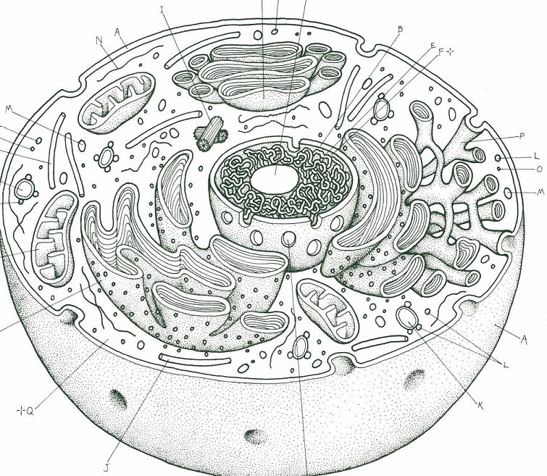
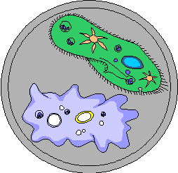
Animal Cell Structure Lab

OBJECTIVES:
- Identifying animal cell parts.
- Ability to distinguish between animal and plant cells.
MATERIALS:
- Worksheets
- Microscope
- Prepared slide of animal cell and plant cell for each student/group

BACKGROUND:
Cells are the fundamental units of living material. The bodies of all living things are formed from cells, and without cells there would be no life. Every large living thing is made of billions of cells.
A cell contains special structures called organelles which have specific functions for maintaining the health of the cell. These functions include taking in food and breaking it apart into simple molecules, releasing energy from food, building and repairing cell parts, getting rid of harmful wastes, and making more cells.
In most plants and animals, the cells are organized to do different types of jobs. In plants, for instance, there are specialized root cells whose function is to take in minerals and water. These specialized cells are arranged into tissues that do the same job. Muscle tissue, for example, is made up of many individual muscle cells. Different tissues that work together form organs. Examples of organs include the stomach, kidneys and lungs. Organs are groups of tissues that work together to perform a specific function. Organs do not operate in isolation and together they form systems, like the respiratory, circulatory and digestive systems.
PROCEDURE:
- Review from your notes the main organelles of an animal cell.
- Set up your microscope and study the two cell slide provided.
- Determine which slide is an animal cell and which is a plant cell. Note this on your worksheet.
- Draw an example of the animal cell from what you see under the microscope on your worksheet labeling any distinguishable parts (ie. Cell Wall, Nucleous)
Animal Cell Structure Lab Worksheet
Name: Date:

1. Which slide contained the animal cell? A B

- How were you able to distinguish the difference?

3. Draw an example of the animal cell you see under the microscope, and label as many parts as you can distinguish.

