Ruminant Digestive Systems Notes
Functions of the digestive system of animals include:
- ___________________ (eating)
- chewing (mastication)
- swallowing (deglutition)
- ____________________________
- elimination of solid wastes (_________________)
Ruminant Digestive Systems
- The digestive system changes food ________________ into compounds that are easily absorbed into the ____________________.
- Ruminants are those animals that contain a multi-chambered digestive system (polygastric) that allows the animal to gain the majority of their nutritional needs from forages and other _______________________.
  - cattle, sheep/goats, ____________ and elk
  - _____________ refers to grasses, roughages refers to other high-fiber food sources.
Ruminant Digestive Systems:
- The digestive tract extends from the __________ to the anus. It includes the mouth, pharynx, esophagus, stomach, and the small and large intestines.
- _________________________ include the salivary glands, the liver, and the pancreas.
- The digestive system of ruminant animals includes the :
  - ____________ - grasps the food
  - Teeth - grind the food
    - Ruminants have _____________ set of teeth in the front of the mouth (incisors), and two sets in the back (molars).
  - ________________ - covered with finger-like projections (_______________) that contain taste buds.
  - _______________________ - secrete saliva, that moistens food and is mixed with the food material to aid in swallowing.
- Ruminant Digestive Systems
  - Pharynx - funnels food into the esophagus, preventing food material from entering the lungs.
  - _____________________ - food tube that leads from the mouth to the stomach.
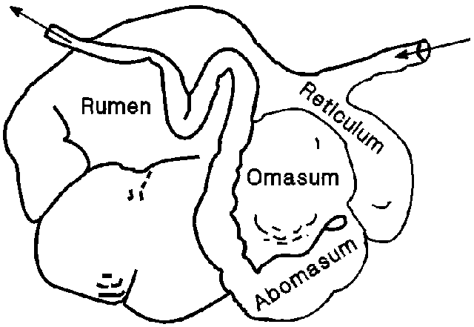

Compartment Capacity
- Reticulum _______ of capacity
- ________________ 80% of capacity
- Omasum 7% of capacity
- _________________ 8% of capacity

Ruminant Digestive Systems
- At this point, ruminant animals have a ______________________ “stomach”
  - ______________________ - honeycomb-like interior surface, this part helps to remove foreign matter from the food material.
  - _________________ empties here
- Prone to _____________________________:
  - Cattle swallow small pieces of metal
  - Can irritate or pierce the lining
  - Helped by putting a small magnet into the reticulum
- Holding area for food; also site of _______________________
  - Ruminant Digestive Systems
- Ruminant animals grasp mouthfuls of food and swallow it before it is chewed.
  - They wrap their tongue around a mouthful of grass, clamp down their teeth, and pull to break the grass at its weakest point, and swallow.
  - Ruminants will “____________________” (regurgitate) their food material and then grind it with their molars at a time when the animal is resting.
  - This is done until the food particles are small enough to pass through the _________________ into the rumen.
Components of Ruminant Digestive System
- ______________ - the organ that allows for bacterial and _______________ breakdown of fiber.
  - The rumen has a very thick, _____________________ wall
  - It fills most of the left-side of the abdomen
- Looks like _____________ due to papillae lining it
- _______________________________
  - Primary digestion site for ruminants
  - Microbial digestion takes place here
  - Breakdown ________________, simple sugars, and __________________ containing compounds like protein
- Physical ______________ and breakdown
- Not active in the _______________ of life
    - Ruminant Digestive Systems
- _________________ - section that is round and muscular.
    - “_____________” the food material and prepares the food material for chemical breakdown.
- Has many folds in its lining, often said to look like the pages of a book
- ________________ particle size of digesta even further
- Some ___________________ starts to take place here
Ruminant Digestive Systems
- __________________ - very similar to the stomach of non-ruminants.
    - this is where the majority of chemical breakdown of food material occurs.
- The “_____________________” of the ruminant animal
- Enzyme secretion takes place here
- Acts like a ________________stomach
- Produces _________, Pepsinogen/pepsin for digestion
  - Also produces ____________ in early stages of life
- Also produces mucus for protection
  - ____________________ - where most of the food material is absorbed into the bloodstream
    - Contains three sections:
      - duodenum
      - _________________
      - ileum
- Ruminant Digestive Systems
    - The food material is continually squeezed as it is moved through the small intestine, becoming more solid.
    - The majority of the food material absorption occurs in the duodenum and the jejunum.
- Ruminant Digestive Systems
  - _______________________ - begins to prepare unused food material for removal from the body
    - a portion of the large intestine in some animals contain pouches that may contain enzymes for further species-specific digestion (horses and rabbits (_____________ )).
- Ruminant Digestive Systems
  - Colon - collects the unused food material that is to be removed from the body
  - _____________ - “poop chute”
  - _____________ - opening through which the waste is removed.
    - Controlled by _______________ muscles, that also help protect the opening.

