Quiz over Ruminants and Non Ruminants
- What is a ruminant?
Ruminants are those animals that contain a multi-chambered digestive system (polygastric) that allows the animals to gain the majority of their nutritional needs from forages and other roughages.

- What is a monogastric (non-ruminant)?
Monogastric system have a simple stomach structure and only one compartment such as carnivores and omnivores
- Label the four parts of a ruminant stomach.
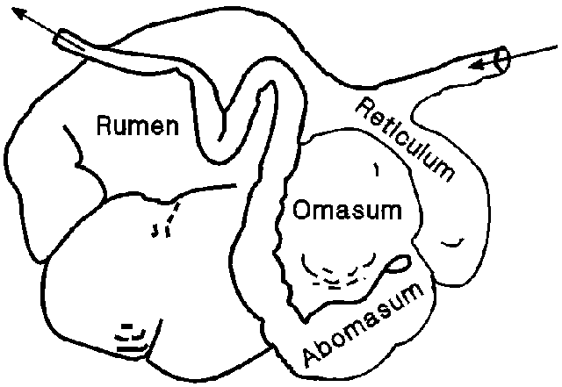

4. Functions of the digestive system of animals include?
1. Ingestion (eating)
2. Chewing (mastication)
3. Swallowing (deglutition)
4. Absorption of nutrients
5. Elimination of solid wastes (defecation)
5. What are the four parts of a monogastric stomach?
1. Esophageal
2. Cardiac
3. Fundic
4. Pyloric
6. Monogastric systems have a simple stomach structure and only one compartment.

7. Some animals with monogastric digestive systems are pigs and rabbits. Humans also have monogastric digestive systems.

