Quiz over Ruminants and Non Ruminants
- What is a ruminant?

- What is a monogastric (non-ruminant)?

- Label the four parts of a ruminant stomach.
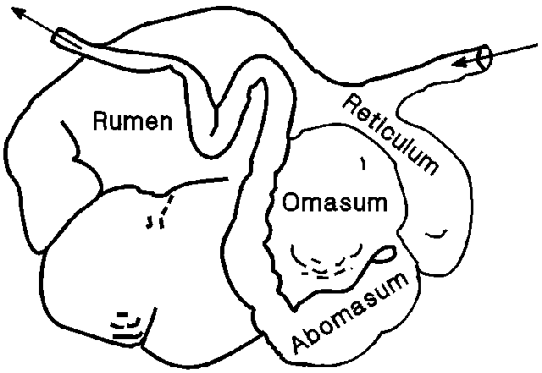

4. Functions of the digestive system of animals include?
1.
2.
3.
4.
5.

5. What are the four parts of a monogastric stomach?
1.
2.
3.
4.
6. Monogastric systems have a ____________ stomach structure and only one compartment.

7. Some animals with monogastric digestive systems are __________ and rabbits. ___________ also have monogastric digestive systems.

