Lesson # 13

Poultry Biosecurity

Core Area: Animal Science

Unit: Poultry Industry

Lesson # 13: Poultry Biosecurity

National Agriculture, Food and Natural Resources (AFNR) Career Cluster Content Standards:
AS.03.01 Prescribe and implement a prevention and treatment program for animal diseases, parasites and other disorders.
AS.07.01 Design animal housing, equipment and handling facilities for the major systems of animal production.
AS.07.02 Comply with government regulations and safety standards for facilities used in animal production.
FPP.01.02 Work effectively with industry organizations, groups and regulatory agencies affecting the food products and processing industry.

Student Learning Objectives. Instruction in this lesson should result in students achieving the following objectives:

- To understand the meaning of biosecurity.
- To understand why biosecurity is used in commercial poultry operation.
- To understand the components of a biosecurity program.

List of Resources. The following resources may be useful in teaching this lesson:

Recommended Resources.

- Barnes, H. J., J-P. Vaillancourt and W. B. Gross. 2003. Colibacillosis. In: Diseases of Poultry, 11th ed., Iowa State University Press, Ames, IA, USA.
- Animal and Plant Health Inspection Service – http://www.aphis.usda.gov/animal_health/birdbiosecurity/
- California Department of Food and Agriculture Avian Health program –http://www.cdfa.ca.gov/AHFSS/Animal_Health/Avian_Health_Program.html

List of Equipment, Tools, Supplies, and Facilities.

- Copies of Student Handouts
- Copies of Student Worksheets
- Power Point Presentation

Terms. The following terms are presented in this lesson (shown in bold italics):

- Biosecurity
- Diseases
- Prevention
- Pathogen
- Zoonotic Diseases
- Euthanasia

Interest Approach. Use an interest approach that will prepare the students for the lesson.

With the guidance of the instructor, have students discuss the importance of disease prevention among livestock production and how it can be applied to the poultry industry. Have the students talk among themselves about how easy it is for a whole class to catch a cold if one person is infected. Discuss how humans prevent infection of a cold. After discussing preventative measures, introduce this lesson and explain the importance of biosecurity as it relates to the industry.

SUMMARY OF CONTENT AND
TEACHING STRATEGIES

Objective 1: Identify and understand what biosecurity is and how it is used to prevent the development of pathogens.

Anticipated Problem: What is biosecurity and how is disease surveillance monitored?

- Biosecurity consists of all the measures that can be taken to keep disease from a farm and to prevent the transmission of disease (by humans, insects, rodents, equipment, trucks, and wild birds/animals) within an infected farm to neighboring farms. Pathogens, a bacterium, virus, or other microorganism that can cause disease, are the biggest threat to the performance of a flock. Biosecurity is used to maximize the health of a flock, minimize the risk of diseases spread, and to ensure the production of a clean product. Biosecurity programs need to be continually monitored and updated based on the risk to the flock of new and emerging threats in the area where they are being raised.

- Three Basic Tenants of Biosecurity
  - Isolation
    - Keeping the birds isolated from common sources of pathogens.
  - Traffic Control
    - Limiting who and what comes on to the farm or has contact with the birds.
  - Sanitation
i. Ensuring that anything that comes into contact with the birds or their environment is clean (people, vehicles, equipment, etc.).

- Disease surveillance is monitored by the United States Department of Agriculture (USDA) Animal Health and Inspection Service.
  - The USDA Veterinary Services works with individual states on disease surveillance and education on biosecurity.
  - State Departments of Agriculture and Cooperative Extension Services may also provide information and educational materials on biosecurity.

Objective 2: To have an understanding why biosecurity is used and which pathogens could arise if not in place.

Anticipated Problem: Why does the industry use biosecurity and which pathogens could arise if not in place?

I. Health
A. Biosecurity promotes animal health by preventing the exposure of birds to disease causing organisms, such as viruses, bacteria, fungi, protozoa, and parasites.
B. Biosecurity also promotes health by preventing the spread of viruses, bacteria, fungi, protozoa, and parasites from one farm to another.
C. Biosecurity also helps to prevent the transmission of zoonotic diseases, which are infectious diseases that can be transmitted from animals to humans.

II. Identification of sick animals
  - Biosecurity programs also require a good understanding of “normal” or “healthy” bird behavior.
  - Detection of abnormal or unhealthy bird behavior may be early warning signs of disease.
  - A trained owner or veterinarian can recognize symptoms of disease.
  - Symptoms of disease may include the following:
    - Respiratory
      - Coughing, sneezing, swollen sinuses, abnormal tearing, labored breathing, nasal discharge.
    - Gastrointestinal
      - Persistent watery diarrhea, bloody or mucoid diarrhea.
    - Reproductive
      - Decreased hatchability, infertility, reduction in rate of lay, soft or misshaped eggs, early chick mortality.
    - Neurological
      - Twisting of the head and neck, circling, falling to one side, unable to stand, complete or partial paralysis.
    - Skin
      - Sloughing, pale comb and wattles.
    - General
      - Decrease in food and water consumption, listlessness, reluctance to move, increase in mortality, ruffled feathers.

III. Economic Benefits
- By preventing diseases from infecting a flock, the producer saves money by not having to euthanize, or humanly eliminate, all of the birds due to lack of biosecurity.
I. Depending on the size of the flock, the economic loss due improper biosecurity could be worth millions of dollars.

Objective 3: Describe how to achieve biosecurity.

Anticipated Problem: How can biosecurity be achieved? Using the three basic tenets listed above each farm can develop a specific biosecurity program that is tailored to the specific farm and geographic inputs.

I. With the following steps and proper actions, biosecurity can be achieved by:
A. Tire wash station(s)
I. Tire wash stations are located at the entry of a poultry farm and are used to disinfect vehicle tires.
2. The purpose is to prevent incoming traffic, such as feed and delivery trucks, from bringing in other pathogens from outside the perimeter of the farm.
- Fencing
I. Perimeter fences help to limit visitors onto the facility and also direct the flow of people in and out of the farm.
2. By restricting access to the farm with perimeter fencing, disease exposure by visitors becomes limited.
- Footbaths
I. Footbaths are located at all farm entrances, as well as entrances to facilities within a farm.
2. Footbaths are small pans or absorbent pads that contain a disinfectant diluted in water. Entrance into a farm or facility containing a footbath requires one to step into the disinfectant solution. This helps to prevent the transfer of material into a farm or other farm facility.
- Sanitation and hygiene
I. All equipment and facilities on a farm must be properly cleaned and disinfected in order to prevent the establishment or harboring of disease causing agents.
2. Prior to entering the facility, employees, as well as visitors, should demonstrate good hygiene by showering and wearing clean designated clothing such as booties, hairnets, and cover-alls.
- Order of entry
- The order of facility entry depends on the age of the birds. Order of entry should always proceed from youngest animals (which have the least resistance to disease) to the oldest animals.
- Hostile environment
I. Creating an environment that is non-desirable, by eliminating trees, grass, ponds, etc, will reduce the risk of transferring pathogens from infected wild life.
- Rodent control
I. Reduces the risk of rodents, which are small enough to easily get into facilities, and are vectors to disease.
- No contact with outside birds
I. Since most avian diseases are transmitted through the air, it is highly important to have no contact with outside birds within 72 hours of entering a facility (this would include pets as well as birds from other flocks).

Review/Summary. Focus the review of the lesson around the student learning objectives. Ask students to explain the content associated with each objective. Use their responses as the basis for determining any areas that need to be covered again.

Application. Application can involve student activity with the provided activity handout.

Evaluation. Evaluation should focus on student achievement of the objectives for the lesson. Various techniques can be used, such as a written test. A sample test is attached.

Answers to Sample Test:

Part One: Matching

B | 1. Biosecurity
E | 2. Diseases
A | 3. Prevention
F | 4. Pathogen
C | 5. Zoonotic Diseases
D | 6. Euthanasia

Part Two: T / F

1. T 6. T

2. F 7. F

3. T 8. T

4. F 9. T

5. T 10. F

Part Three: Biosecurity Steps

Tire wash station(s) Fencing Sanitation/Hygiene

Order of entry Hostile environment Footbaths

Rodent control No outside birds
Under each picture, write “yes”, if it is a potential carrier of a disease or write “no”, if it is not a threat.

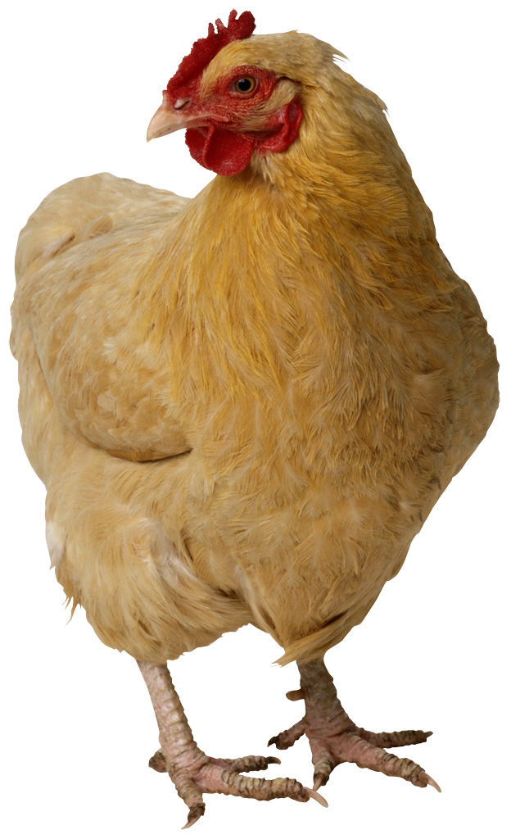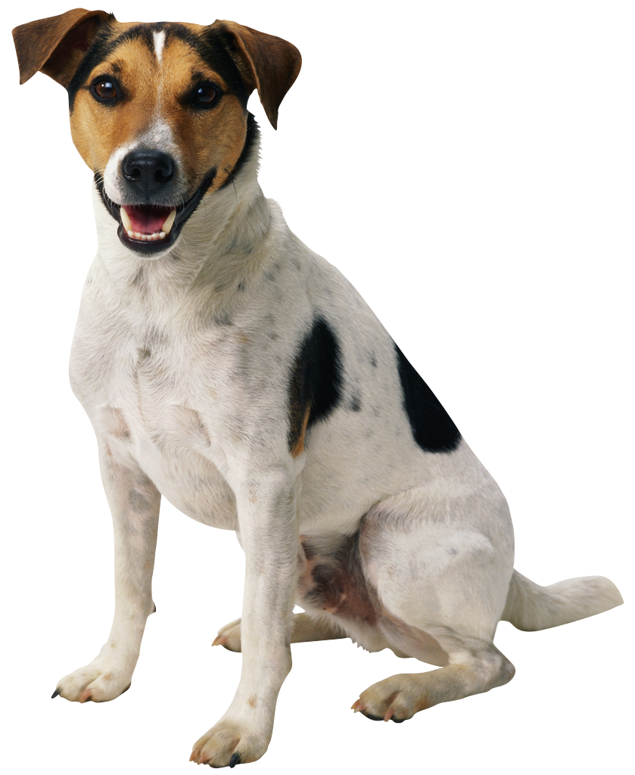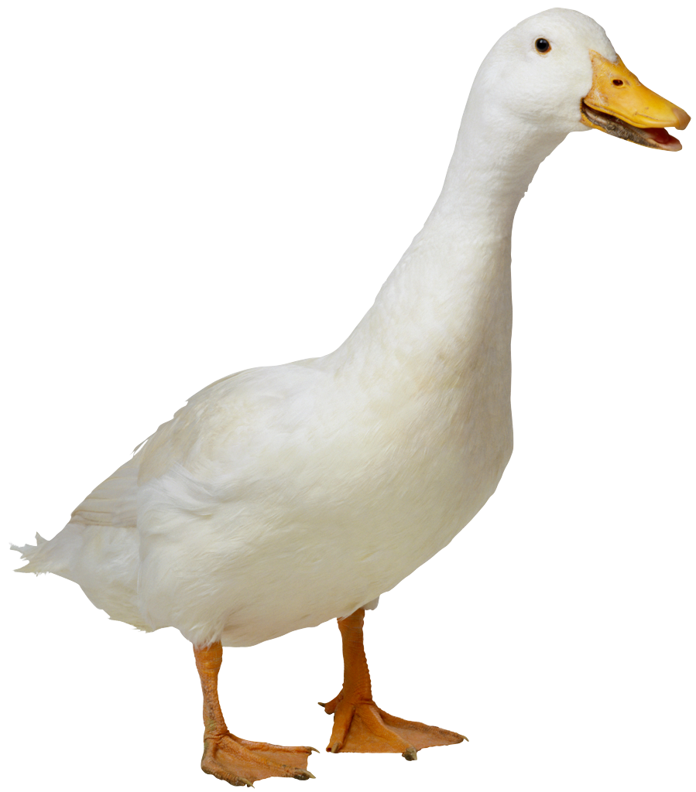

_____________________ _________________________ ______________________



_____________________ __________________________ _______________________

Suppose you are a manager on a farm, and everybody went home for the day. Before you get to clock-out, you must walk through all of the facilities to make sure all is well. Label the diagram below, numbers 1-5 on the order of entrance in which you will enter the buildings.

Hatchery
Grower (2-4 weeks)

Grower (5-6 weeks)

Grower (4-5 weeks) Grower (1-2 weeks)

