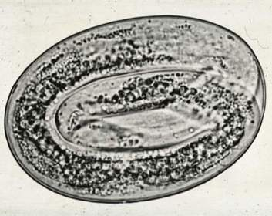
Lung Worm Egg
INCLUDEPICTURE "http://www.phs.d211.org/sped/gavindt/biology/cow digestive system picture.jpg" \* MERGEFORMATINET 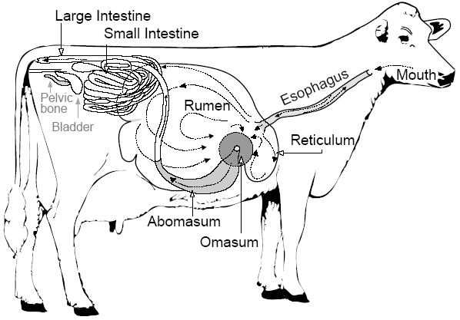
Cow Gastrointestinal Tract
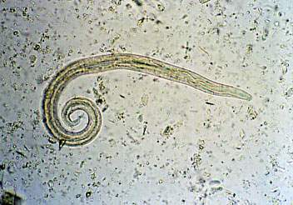
Lung Worm Larvae
INCLUDEPICTURE "http://cdn.wn.com/pd/07/2f/2bf5724e6a195cc0b9c0359649c6_grande.jpg" \* MERGEFORMATINET 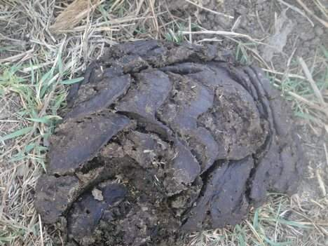
Cattle Feces
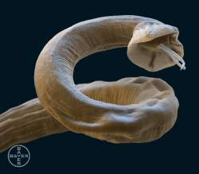
Adult Lung Worm
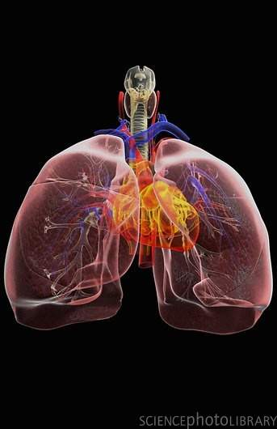
Respiratory System - Lungs
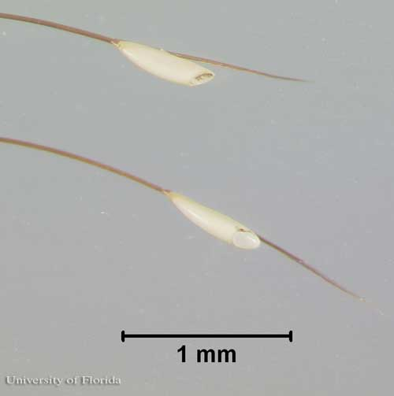
Bot Fly Egg
INCLUDEPICTURE "http://farm4.static.flickr.com/3210/2922354178_8d1c50289d.jpg" \* MERGEFORMATINET 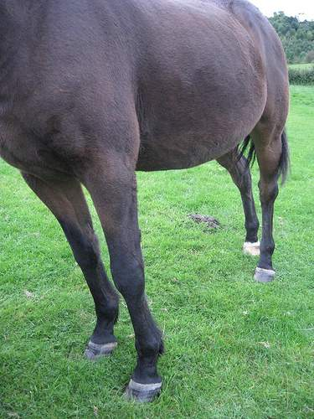
Horse Hair

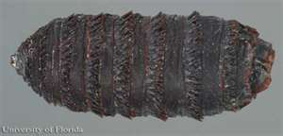
Bot Fly Pupae
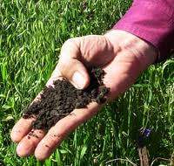
Pasture Soil
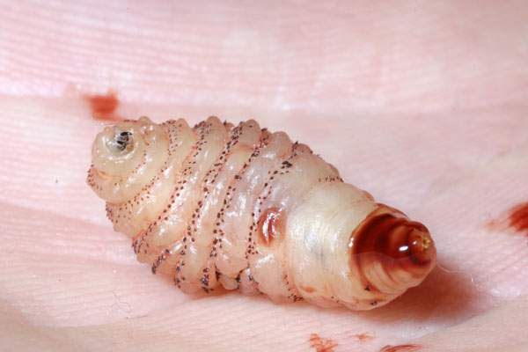

Bot Fly Larvae
INCLUDEPICTURE "http://www.photographyblogger.net/wp-content/uploads/2009/09/Horses15.jpg" \* MERGEFORMATINET 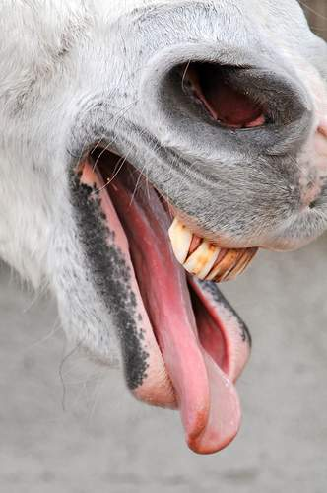
Horse Tongue
INCLUDEPICTURE "http://entnemdept.ufl.edu/creatures/livestock/horse_bot_fly05.jpg" \* MERGEFORMATINET 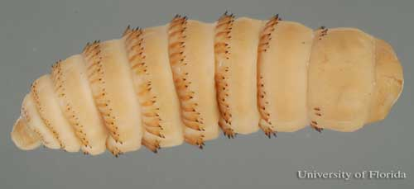
Instar Larva
INCLUDEPICTURE "http://4.bp.blogspot.com/_JJDtYy4Sm1s/S8chkmG0AYI/AAAAAAAAAHM/mk6C4aIEL-4/s1600/IMAGE+-+Equine+anatomy+(2).jpg" \* MERGEFORMATINET 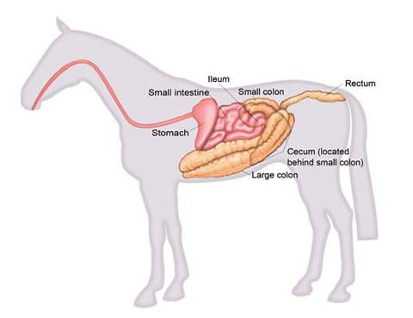
Horse Gastrointestinal Tract
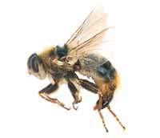
Bot Fly Adult
INCLUDEPICTURE "http://www.localriding.com/image-files/horse-face-flies.jpg" \* MERGEFORMATINET 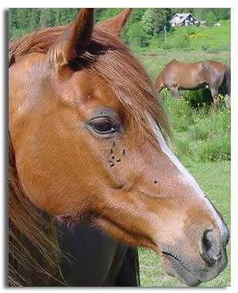
Horse
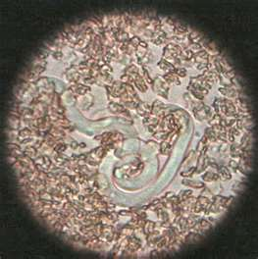
Heartworm Microfilariae
INCLUDEPICTURE "http://www.fi.edu/learn/heart/blood/images/red-blood-cells.jpg" \* MERGEFORMATINET 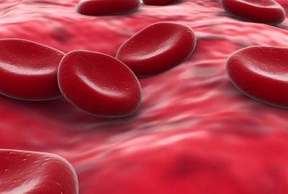
Blood

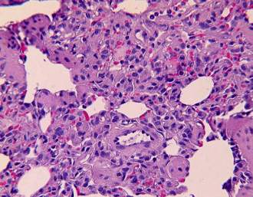
Heartworm Larvae
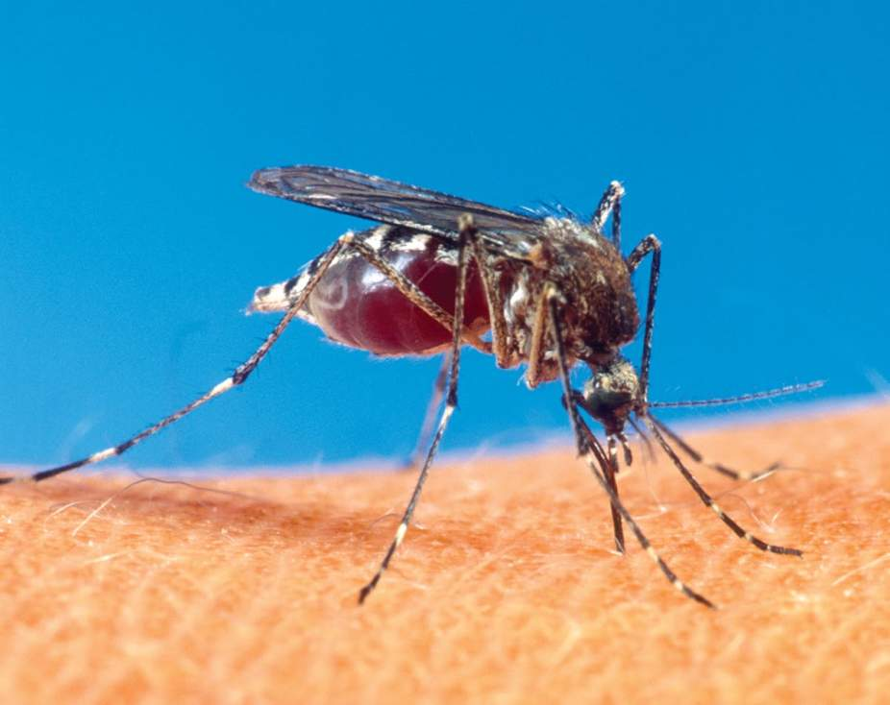
Mosquito
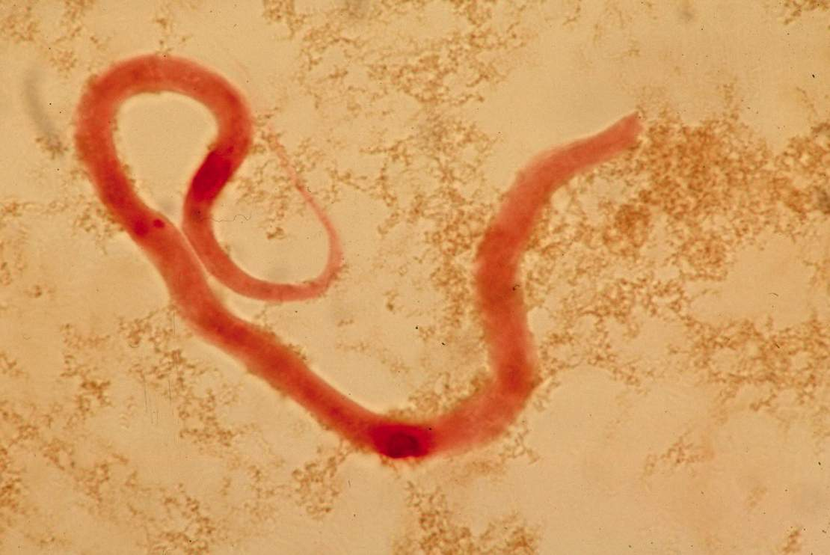
Heartworm Adult
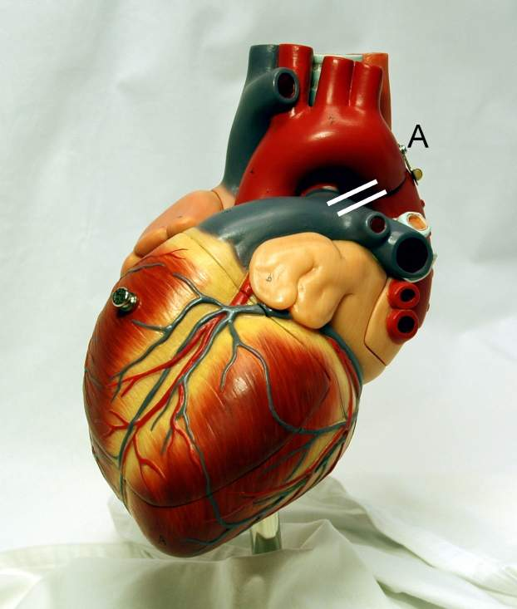
Heart
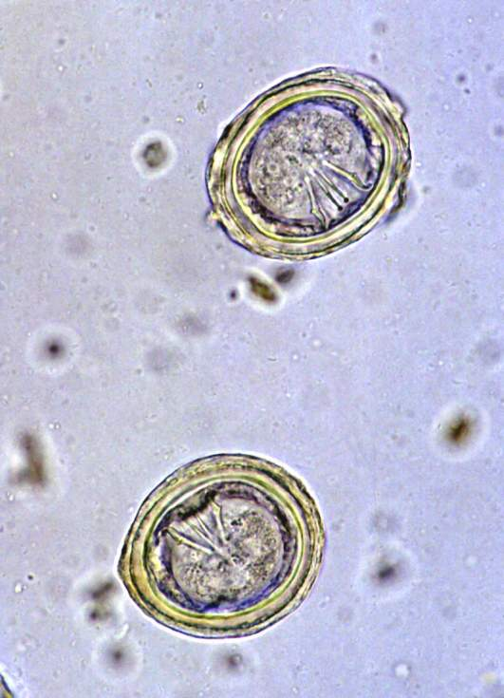
Tapeworm Egg
INCLUDEPICTURE "http://upload.wikimedia.org/wikipedia/commons/0/0a/Feces_de_can_(dog).jpg" \* MERGEFORMATINET 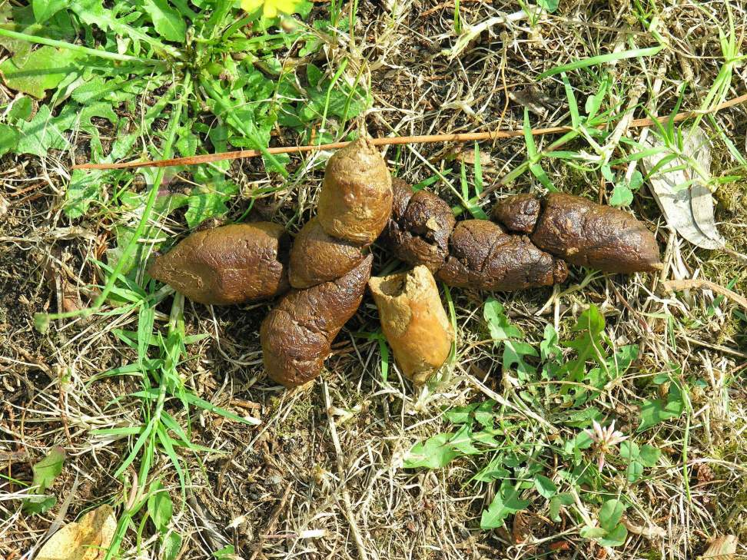
Dog Feces
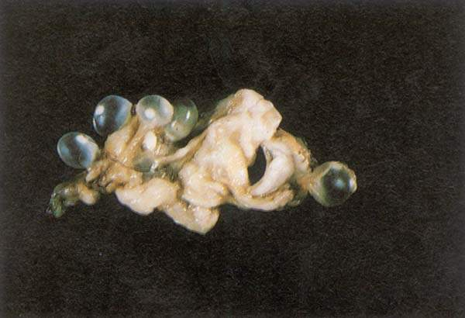
Tapeworm Larvae
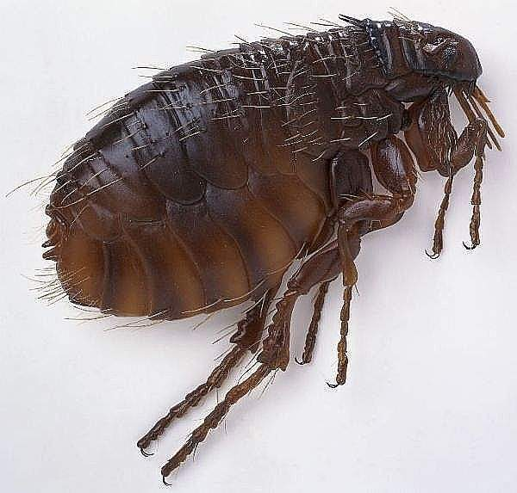
Flea
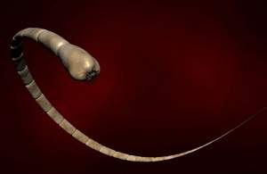
Tapeworm Adult
INCLUDEPICTURE "http://www.healinglightseries.com/IMAGES/Images-Digestion/SmallIntestine.jpg" \* MERGEFORMATINET 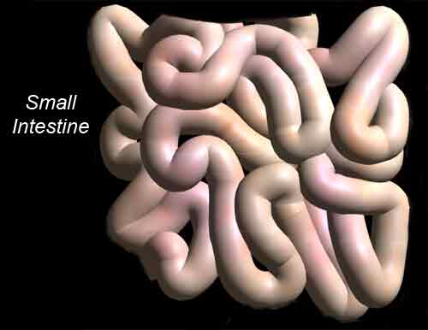
Dog Small Intestine
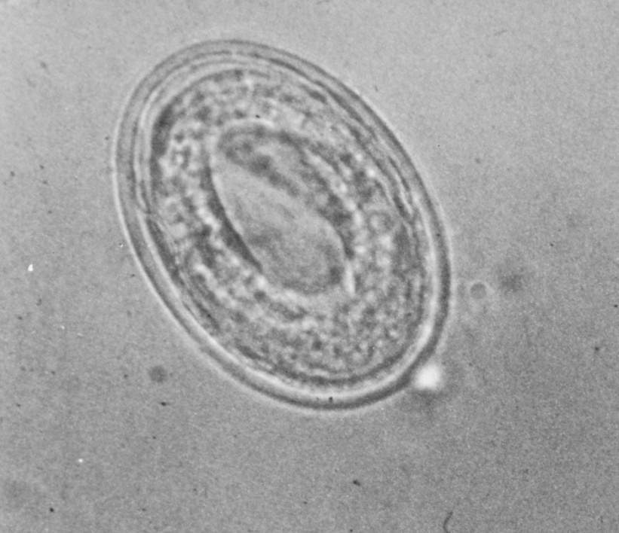
Ascarid Egg
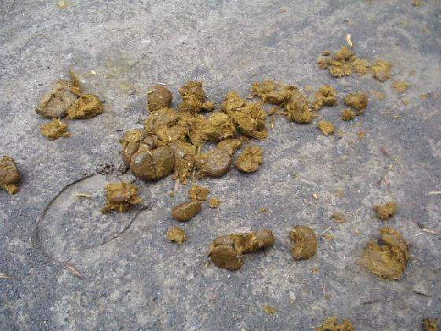
Horse Feces
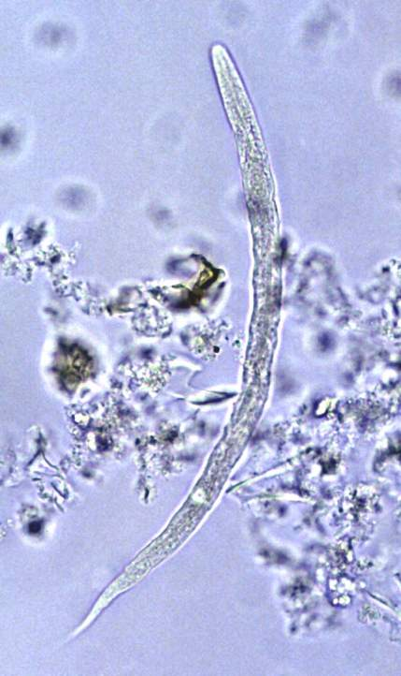
Ascarid Larvae
Lungs
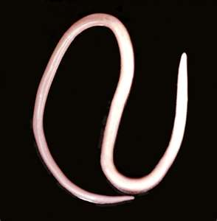
Ascarid Adult
INCLUDEPICTURE "http://www.thehorse.com/images/content/glasshorse/lipoma.jpg" \* MERGEFORMATINET 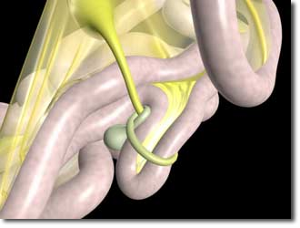
Horse Small Intestine
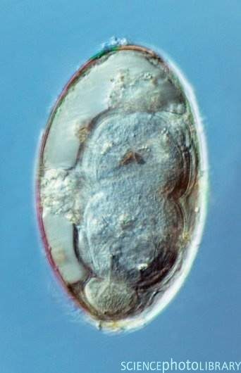
Liver Fluke Egg
INCLUDEPICTURE "http://cdn.wn.com/pd/07/2f/2bf5724e6a195cc0b9c0359649c6_grande.jpg" \* MERGEFORMATINET
Cattle Feces

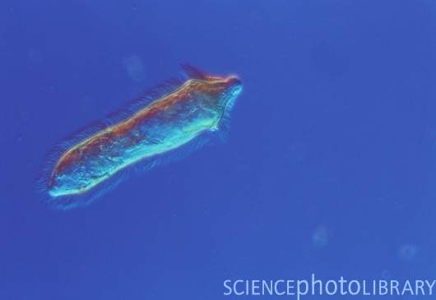
Liver Fluke Metacercariae
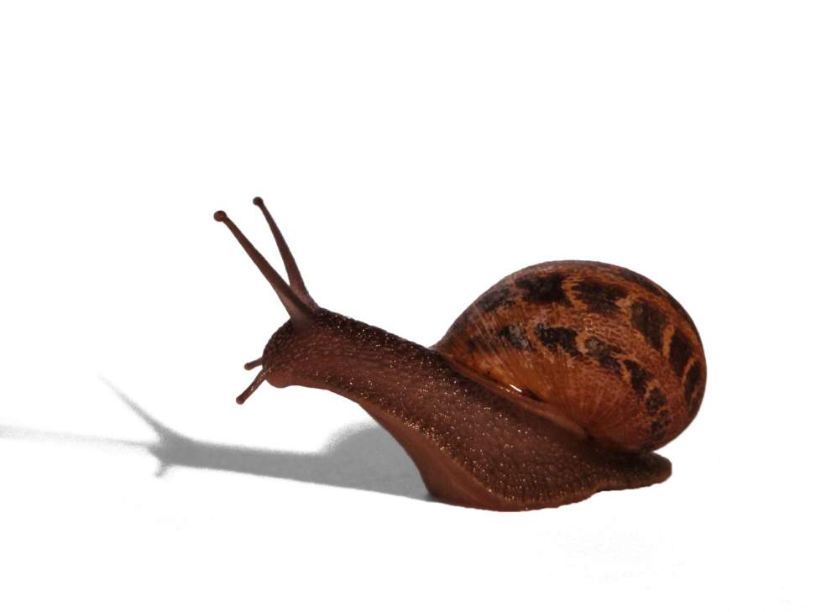
Snail
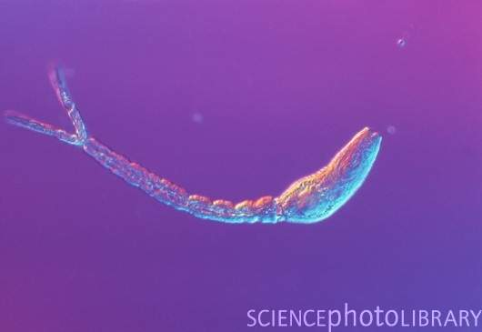
Liver Fluke Cercaria
INCLUDEPICTURE "http://www.retiredaussies.com/WEB Green/Brumbies/Images/g Cowombat Flat 080205 sht/Channel Create Comw 080205 4.jpg" \* MERGEFORMATINET 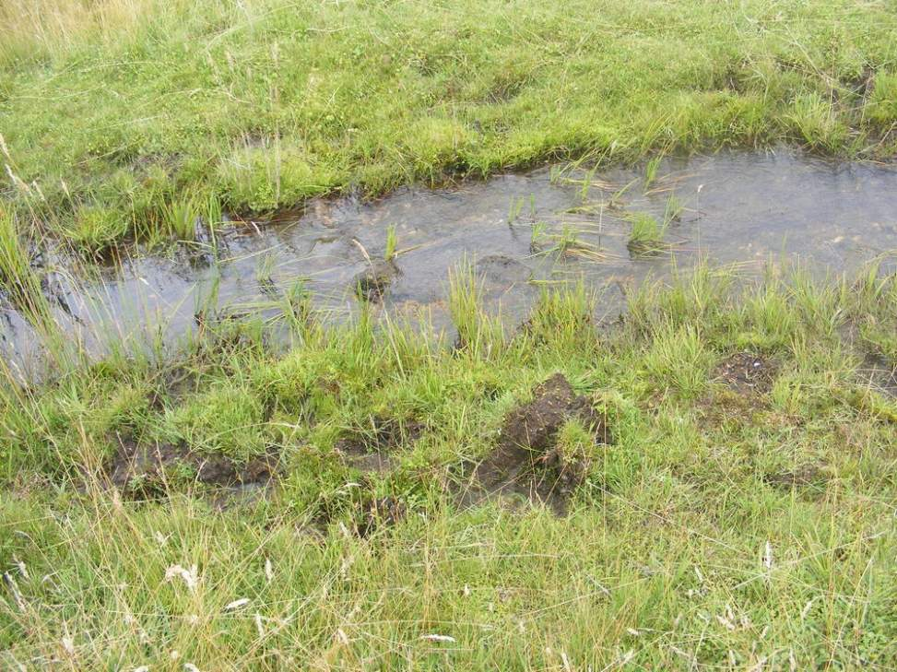
Vegetation
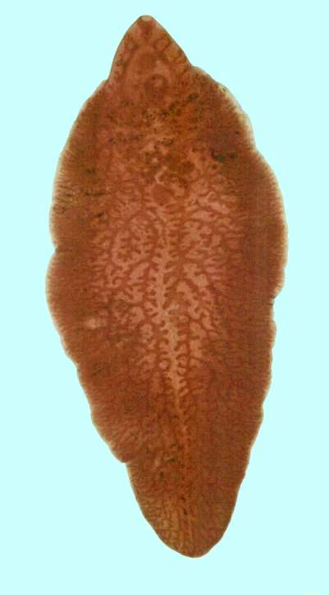
Adult Liver Fluke
INCLUDEPICTURE "http://www.nlm.nih.gov/medlineplus/ency/images/ency/fullsize/8848.jpg" \* MERGEFORMATINET 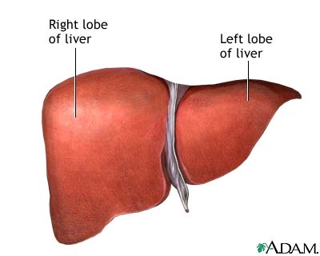
Liver

