Name: Grade:
Date:

AGR 161 Unit-C
Exam

Multiple Choice

- What is the technical term for the leaf stalk?
  - Stick
  - Stem
  - Petiole
  - Branch

- What is the larger center vein on the leaf blade?
  - Margin
  - Midrib
  - Vein
  - Lateral line

- Which of the following is not a leaf arrangement?
  - Whorled
  - Alternating
  - Side by side
  - Rosetted

- What is the purpose of the cuticle?
  - Keeps water in the plant
  - Keeps bugs off the leaves
  - Keeps sunlight reflected
  - Keeps the leaf green

- What is the job of the guard cells?
  - Keep water out
  - Let water in
  - Allow gas exchange
  - Keep gas in

- Which of the following is not a leaf shape?
  - Palmate
  - Pinately
  - Trifoliate
  - Inflorescences

- Pollen sticks to what part of the flower?
  - Stigma
  - Style
  - Anther
  - Filament

- Where does the seed grow on the flower?
  - Ovary
  - Ovule
  - Stigma
  - Style

- Where is the pollen made in the flower?
  - Ovary
  - Anther
  - Filament
  - Style

- These protect the flower before it opens?
  - Petals
  - Sepals
  - Ovary
  - Stigma

- What becomes a seed after fertilization?
  - Ovary
  - Ovule
  - Pollen
  - Anther

- What part of the pistil contains the ovules?
  - Ovary
  - Stigma
  - Anther
  - Stamen

- What is the female part of the flower?
  - Filament
  - Style
  - Anther
  - Pistil

- What is the male part of the flower?
  - Pistil
  - Stamen
  - Stigma
  - Anther

- What does the pistil contain?
  - Stigma
  - Style
  - Ovaries
  - All the above

Essay Question
- List and briefly describe the 4 major types of stems. List 4 of the modified stems and give examples of each.

- What arrangement is this? 18. What arrangement is this?

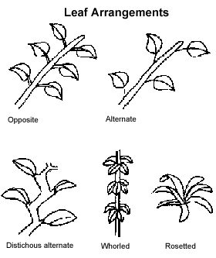
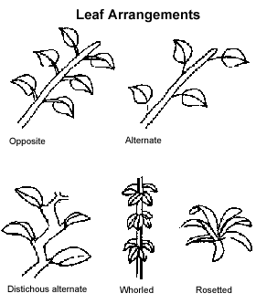

19. What inflorescences is this? 20. What inflorescences is this?

21. What margin is this? 22. What margin is this?

