Nucleic Acid Parts List
The best way to understand the structures of DNA and RNA is to identify and examine individual parts of the structures first. The complete hydrolysis of nucleic acids yields three major classes of compounds: pentose sugars, phosphates, and heterocyclic amines (or bases).

Phosphate
A major requirement of all living things is a suitable source of phosphorus. One of the major uses for phosphorus is as the phosphate ion which is incorporated into DNA and RNA.

Pentose Sugars
There are two types of pentose sugars found in nucleic acids. This difference is reflected in their names--deoxyribonucleic acid indicates the presence of deoxyribose; while ribonucleic acid indicates the presence of ribose. In the graphic below, the structures of both ribose and deoxyribose are shown. Note the red -OH on one and the red -H on the other are the only differences. The alpha and beta designations are interchangeable and are not a significant difference between the two.
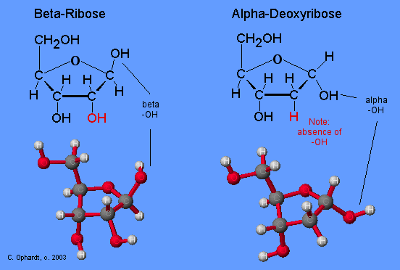
Deoxyribose - Chime in new window
Ribose - Chime in new window

Heterocyclic Amines
Heterocyclic amines are sometimes called nitrogen bases or simply bases. The heterocyclic amines are derived from two root structures: purines or pyrimidines. The purine root has both a six and a five member ring; the pyrimidine has a single six member ring. There are two major purines, adenine (A) and guanine (G), and three major pyrimidines, cytosine (C), uracil (U), and thymine (T). The structures are shown in the graphic on the left. As you can see, these structures are called "bases" because the amine groups as part of the ring or as a side chain have a basic property in water
.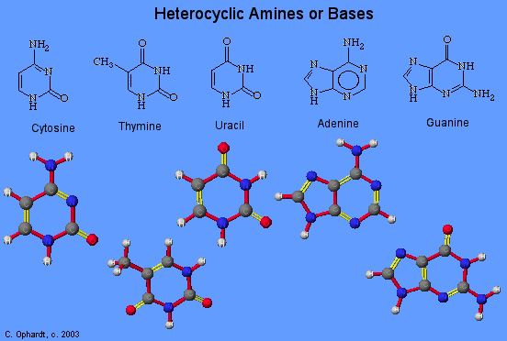
A major difference between DNA and RNA is that DNA contains thymine, but not uracil, while RNA contains uracil but not thymine. The other three heterocyclic amines, adenine, guanine, and cytosine are found in both DNA and RNA. For convenience, you may remember, the list of heterocyclic amines in DNA by the words: The Amazing Gene Code (TAGC).
Heterocylic Amines - Chime in new window

