Name: _________________________
Animal Digestive Systems
Diagram Handout
Date: __________________________
Period: _______

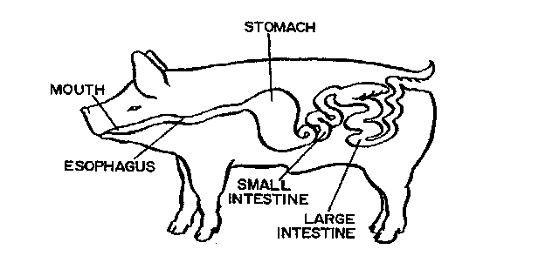
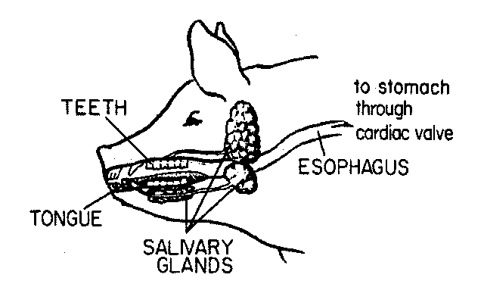
“From Food to Feces” Digestive System Notes: To be used with the Powerpoint Presentation

