Swine
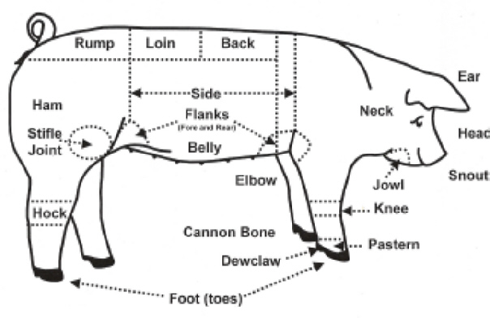
Ideal Market Hog
Ideal Breeding Gilt

Sheep
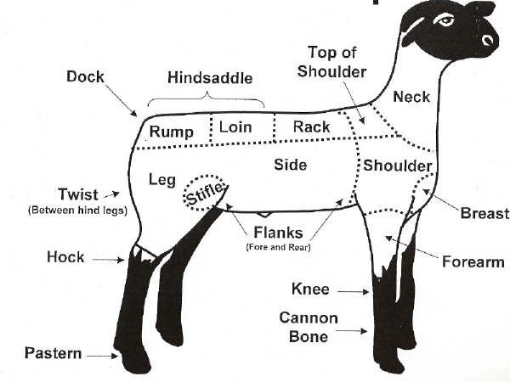

Ideal Breeding Ewe
Ideal Market Lamb

Beef
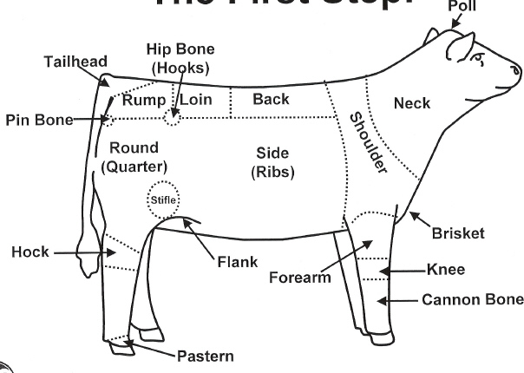

Ideal Breeding Heifer
Ideal Market Beef

Structure

