Lesson: Intro Soils Course:
Prepared BY: J. Ince, B. Boteler, J. Meadows Estimated Time Required:4 days
Date:
Performance Objective: Given worksheets and materials listed below, SWBAT create a model drawing and plan for taking a uniform soil sample that will score 75% on the enclosed checklist.
Enabling Objectives:
- Determine if a given soil sample is one of the three major soil types (on the Warning page) based on a ribbon test.
- Identify soil texture given a description.
- Identify soil based on appearance and what ribbon test should be expected.
- Compare and contrast what effects pH has on Macro and Micronutrients.
- Describe why soil samples are important.
- Relate why nutrients are important to plants.
- Describe some of the most common signs of nutrient deficiencies.
- Recognize the parts of a fertilizer label and use one to determine the important characteristics of the fertilizer
References:
- Basic Soils Study Guide. Daniels, W. Lee. Fall 1999. University Printing Services, Virginia Tech. Blacksburg, VA.
- Basic Soils Lab Manual. Eick, Matt. Fall 1999. University Printing Services, Virginia Tech. Blacksburg, VA
- The Nature and Properties of Soils. Brady, Nyle, and Weil, Ray. 1999. Prentice Hall, Inc. Upper Saddle River, New Jersey. ISBN# 0-13-852444-0
- Virginia Cooperative Extension Soil Sample Information Sheet for Home Lawns, Gardens, Fruits, and Ornamentals. 2001. Publication # 452-125
- Photo Set 1 taken from sited web addresses. (see PhotoSet 1)
- Fertilizer Section: Information from http://www.fertilizer.com/fertilizer/all_about_fert/bag/index.html
- Deficiency section: Information from http://www.ag.uiuc.edu/~vista/html_pubs/hydro/symptoms.html
- Soil Texture Section Information from: http://edis.ifas.ufl.edu/SS169
Equipment, Supplies, Materials:
- Overhead projector and pens
- Water, 1 gallon
- 4- one gallon bags of soil: clay, silt, sand, altered (topsoil and humus)
- Copies of OH1, WS2, WS3, WS4, and WS5 for students (see attached), as well as above VCE publication on Soil Samples.
- Copy of Photo Set 1 for students to see examples of deficiencies.
Administrative Announcements (if appropriate):

Interest Approach: Walk around and have students get a small amount of soil. Have them do a ribbon test. Ask why we do it and who knows what it is used for.
Evaluation: Assignment – Students prepare a map of their backyards, or a neighbor's yard using WS3. Indicate where they would probe for soil samples. Grades based on CS1.
AG ED Task &/OR SOL(s) Addressed by This Lesson:

Tasks: ANR 8051.005 – Identify the role played by soil on turf growth.

ANR 8034.019 – Take Soil Samples
ANR 8034.020 – Analyze samples to determine pH levels.
ANR 8038 - Examine Aspects of Horticulture Industry – Environmental Issues.
SOLs: ES. 9 – The student will investigate and understand how freshwater resources are influenced by geologic processes and the activities of humans. – Processes of soil development.
Potential Integration Activities: This lesson could be integrated with an Ag Production class studying soils in a crop production unit, or possibly as either a Earth Science, Biology, or Chemistry class, studying the different aspects of soil science and chemistry and fertilizer analysis and its effect on plant growth.

INSTRUCTION
PROCEDURES | CONTENT
Use Interest approach | See Cover
Background information | Introduce topic
Post/Write objectives on the board | See Cover
Lecture | What is soil? What does it do for us?  - Soil is a growing media that occurs naturally.  - Composed of Minerals, which make up rocks.  - Also contains organic matter.  - Weathered from Parent rock forations.
Texture | Twelve major textural classes. Their compositions are defined by the USDA textural triangle  Sands  - Loose and single-grained (that is, not aggregated together).  - Feel gritty to the touch and are not sticky.  - Each individual sand grain is of sufficient size that it can easily be seen and felt.  - Cannot be formed into a cast by squeezing when dry. When moist, sands will form a very weak cast, as if molded by the hand, that crumbles when touched.  - Soil materials classified as sands must contain: 85-100% sand-sized particles, 0-15% silt-sized particles, and 0-10% clay-sized particles.
Texture | Coarse Sand:  - Looks and feels most coarse and gritty.  - Must contain 25% or more very coarse sand and coarse sand, and less than 50% any other single grade of sand.
Texture | Sand :  - Normal sort of sand that contains a more or less even distribution of the different sizes of sand grain.  - Not dominated by a particular size.  - Contains 25% or more very coarse, coarse, and medium sand (but less than 25% very coarse plus coarse sand), and less than 50% either fine sand or very fine sand.
Fine Sand :
- Dominated by the finer sizes of sand particle, and feels rather uniform in texture and somewhat less coarse than either sand or coarse sand.
- Contains 50% or more fine sand; or less than 25% very coarse, coarse, and medium sand, and less than 50% very fine sand.
Very Fine Sand :
- Dominated by the very finest of sand grains. Grittiness seems almost to grade into the smoothness that one would expect in a silty soil.
- 50% or more very fine sand.

Loamy Sands
- Consist of soil materials containing 70-90% sand, 0-30% silt, and 0-15% clay.
- Resemble sands in that they are loose and single-grained, and most individual grains can be seen and felt.
- Slightly cohesive when moist, and fragile casts can more readily be formed with them than with sands because of higher percentages of silt and clay.
Loamy Coarse Sand :
- Coarsest and grittiest sort of loamy sand.
- Contains 25% or more very coarse and coarse sand, and less than 50% any other single grade of sand.
Texture | Silt  - Similar to silt loam but contains even less sand and clay.  Silt Loam  Rather small amounts of sand and clay and is composed mostly of silt-sized particles.  When dry, it is often rather cloddy in the field; but lumps are easily broken between the fingers, and the soil then feels soft and floury.  When moistened and squeezed between the fingers it feels soft and smooth. It will not “ribbon out”; it will break into small bits.  Silty Clay Loam  - Resembles clay loam in cohesive properties, but possesses more silt and less sand and thus has a rather smooth feel.  - Small amounts of sand particles which are present are generally quite fine and are very difficult to detect.  Silty Clay  - Quite smooth, nongritty, very sticky and very plastic when wet, and forms very hard aggregates when dry.  Sandy Clay  - Sandy clay is somewhat similar to silty clay, but it contains much more sand and less silt.  Clay  - Finest textured of all soil classes.  - Usually forms extremely hard clods or lumps when dry and is extremely sticky and plastic when wet

Organic Soils

Made up of plant and animal remains that have accumulated, in varying stages of decomposition, in an environment that does not allow decay of the materials to take place rapidly. Such an environment may be found in some swamps, marshes, and lakes, and rarely in drier, more upland environments where the ecosystem is so productive that plant remains accumulate at extremely high rates.

Muck, peaty muck, mucky peat, and peat

Terms used in place of textural class names for organic soils.

Muck consists of highly decomposed remains of plants and other organisms.

Peat consists of relatively raw, less well-decomposed organic materials.

Peaty muck and mucky peat are intermediate in decomposition.

Mineral soils

Not dominated by organic materials, but consist primarily of sand-, silt-, and/or clay-sized particles of minerals or rock fragments.

If you encounter a soil material that has been designated mucky sand or other such mixed name, it indicates that the soil is a mineral soil having a higher than ordinary content of organic matter (say, 10% or so by weight), but not high
Particle size – | Sand – greater than 2mm  - Silt - .5 to 2 mm  - Clay – less than .5 mm  Visual Aid  - Get 4 student volunteers.  - Have 3 of them stand arms width apart. They represent sand particles  - Have 4th student, representing water run through pore space between particles.  - Now have sand particles stand elbow to elbow. They now represent silt particles.  - Send water through pores again. Mention difference and difficulty of water passing through pores.  - Soil particles should now stand shoulder to shoulder. They now represent clay particles. Again mention drainage difficulty, but also relate this to water retention capacity.  - This demonstration shows Porosity and drainage ability of soil particles.
Activity | Complete ribbon test activity described in worksheet.  Handout worksheet .  - Have students complete the activity
Demonstration/ Discussion | - Demonstrate ribbon test from Worksheet 3  - Have students complete 3 ribbon tests each.
Review | Review lecture material
pH of soil | ? - Which of you has had chemistry?  - Everyone recognizes importance of pH.  Optimal pH – 6 to 7 for plants.  What does pH affect?  - Nutrient Availability  - Macronutrients (Ca, Mg, K, P, N, S) less available in low pH  - Micronutrients (Fe, Mn, Zn, Cu, Co) more available.  - Microorganism growth  - Bacteria in intermediate to high pH  - Fungi in low pH  OH2
Taking soil samples | Why take soil samples?  - pH tests  - Nutrient analysis  - Organic matter composition  - Soluble salts  Where do you sample from?  - Various parts of sample area to give even example of what type of soil is there.  - Demonstrate on Blank overhead.  Filling out Sample Box and taking sample.  - Use VCE sheet and sample boxes to explain. (backside of sheet)

Activity | - Have students pair up in groups of 2-3.  - Give each a sample box, and assign groups different trouble areas around schoolyard.  - The following areas will be addressed:  - Hill along track  - Softball Field  - Any other areas that are bare and could use attention.
Review | What relationship does pH have to:  - Macronutrients?  - Micronutrients?  - Microorganism growth?  What is one thing that soil sample analysis provides? What is another? etc.  Continue to ask until all four topics have been answered.
Fertilizers | Nutrients – necessary for healthy plant growth.  Main Nutrients:  Nitrogen  - For new, green growth.  - Grasses need plenty – Mostly green growth occurs.  Phosphorus  - Promotes root development which helps strengthen plants  - Increases blooms on flowers  - Lots of phosphorous - bulbs, perennials, and newly planted trees and shrubs  Potassium  - Improves the overall health of plants  - Helps withstand temperature extremes  - Most soils already have some potassium – Low numbers in fertilizers  Other Nutrients:  Calcium  - Improves general plant vigor  - Promotes growth of young roots and shoots  Magnesium  - Helps regulate uptake of other plant foods  - Aids in seed formation  - Also assists in ability to manufacture food from sunlight  Sulfur  - Helps maintain a dark green color while encouraging more vigorous plant growth  Trace Elements – small amounts  - Iron – promotes dark green color
Activity | WS4 – Pass out and have students complete in groups of 2-3. Discuss answers after 10 minutes.
Nutrient Deficiencies – Pass out WS5 | - Go through and discuss deficiencies – examples students may have seen in greenhouse  - Pass around PhotoSet 1

Types of Fertilizers | Granular Fertilizers  - Applied with a spreader  - Last longer than solubles  Water Soluble  - Dissolve in water  - More expensive  - Last 1-2 weeks  - Serve as a good supplement to granular  Natural Organic  - Manure, dried blood, or bone meal  - Relatively expensive to apply and obtain
Review/ Wrap-up | Review  - Types of fertilizer  - Identify nutrient deficiencies  - Importance of Macro and Micronutrients  Review Texture  Review Soil Samples and pH Importance  Address EOs  Questions:
Assignment | WS6 – Students follow instructions on worksheet. Graded based on CS1.

Worksheet 2

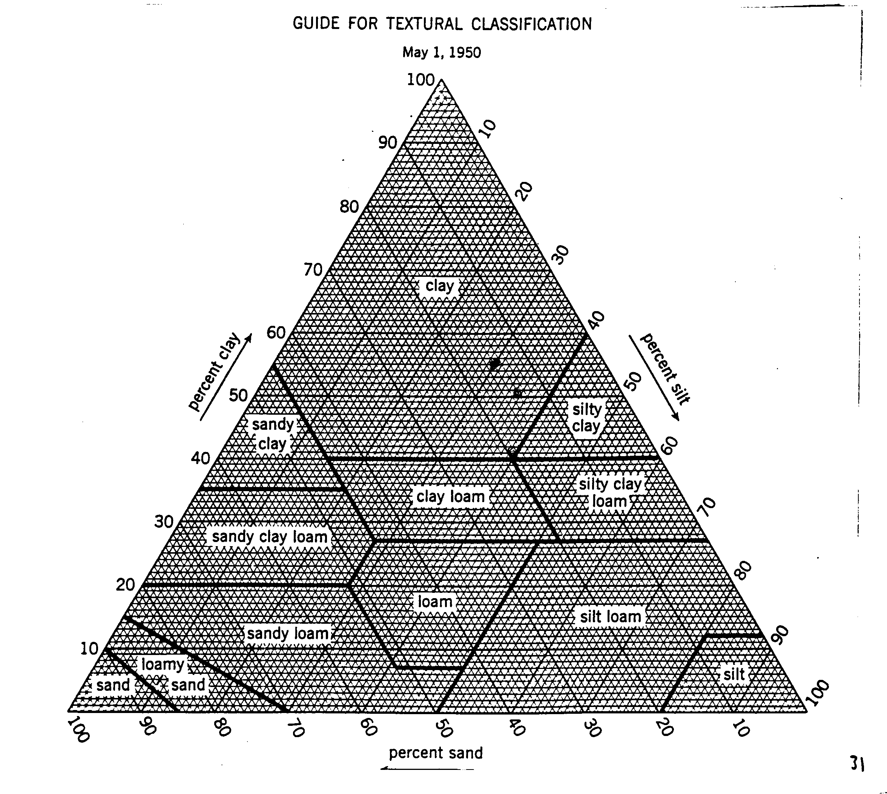
- If your soil sample contains 10 % sand, 30 % silt and 60% clay what it is considered?

- If your soil sample contains 10% clay and 90 % sand what is it considered?

- If your soil sample contains 30 % silt, 35 % sand and 35 % clay what is it considered?

Worksheet 3
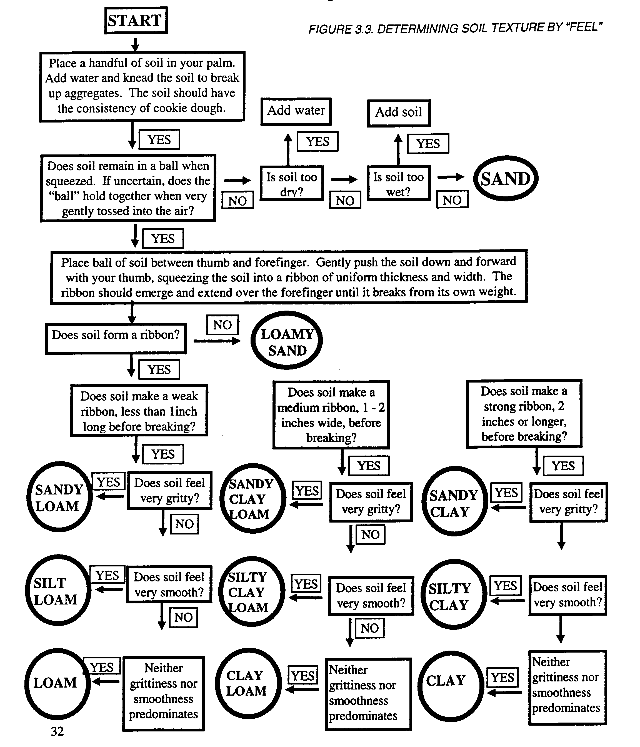
Worksheet 4
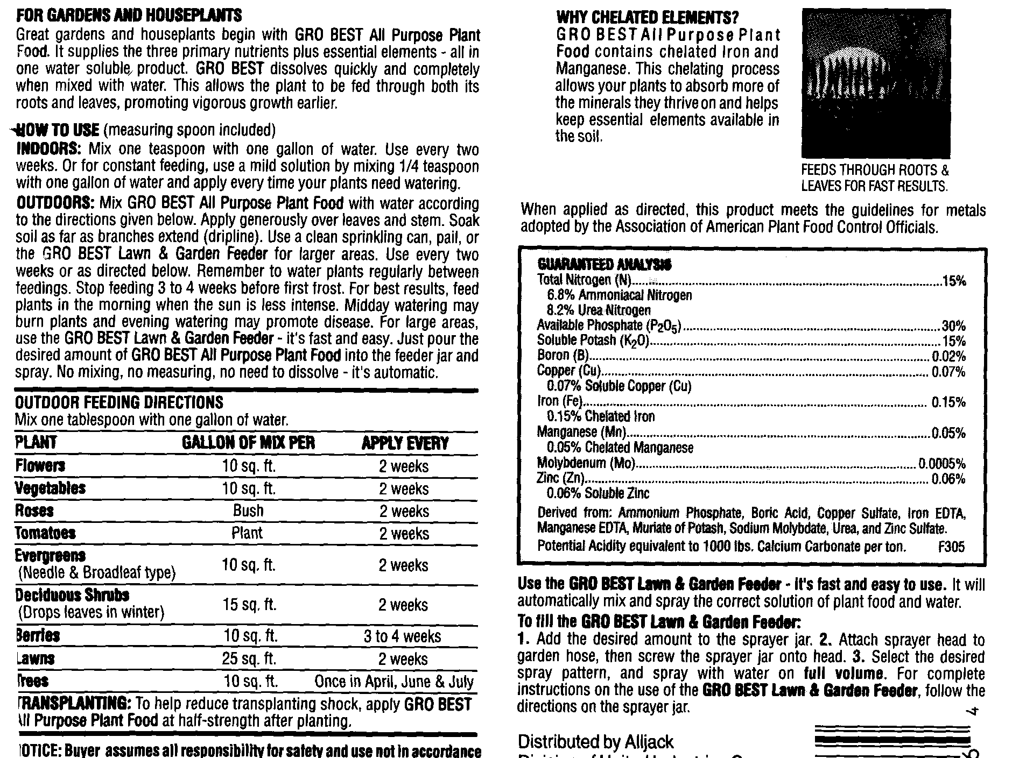

What is the name of this fertilizer?
What form is this fertilizer? Dry Granules Liquid Other ____________
What type of plants is this fertilizer recommended for?

What type of plants should this fertilizer not be used on (if any)?

What is the recommended rate of application for this product?

How often should it be applied?
List the percentages of the following macro nutrients:
Nitrogen (N) _______ Phosphorus (P)________ Potassium (K) _______
Magnesium (Mg) ______ Sulfur (S) _________ Calcium (Ca) _______

List the percentages of the following micronutrients:
Copper (Cu) _______ Iron (Fe) _______ Manganese (Mn)______ Molybdenum (Mo) _______ Zinc (Zn) _______ Boron (B)_______
Chlorine (Cl) ________

Are there hazards or warnings associated with this product? If so, what are they?

Worksheet 5

Deficient nutrient | Symptoms
Nitrogen | Leaves are small and light green; lower leaves lighter than upper ones; not much leaf drop; weak stalks.
Phosphorus | Dark-green foliage; lower leaves sometimes yellow between veins; purplish color on leaves or petioles.
Potassium | Lower leaves may be mottled; dead areas near tips and margins of leaves; yellowing at leaf margins continuing toward center.
Calcium | Tip of the shoot dies; tips of young leaves die; tips of leaves are hooked-shaped.
Magnesium | Lower leaves are yellow between veins (veins remain green); leaf margins may curl up or down or leaves may pucker; leaves die in later stages.
Sulfur | Tip of the shoot stays alive; light green upper leaves; leaf veins lighter than surrounding areas.
Iron | Tip of the shoot stays alive; new upper leaves turn yellow between veins (large veins remain green); edges and tips of leaves may die.
Manganese | Tip of the shoot stays alive; new upper leaves have dead spots over surface; leaf may appear netted because of small veins remaining green.
Boron | Tip of the shoot dies; stems and petioles are brittle.

http://www.ag.uiuc.edu/~vista/html_pubs/hydro/symptoms.html

Worksheet 6


Imagine you are planning replanting your yard at home. There's only one problem…you need to know what to do to the soil to make your garden grow the best it can. You remember from Turfgrass class that you know how to take soil samples, and remember that you still have the box to send in a sample to Virginia Tech to be analyzed.
- Using the above box, draw in where your garden will be placed in relation to your house, as well as where you might take your sample from. Indicate samples to be taken with an "X". Don't forget to include and label any landmarks (trees, hills, ponds, buildings, decks, patios, etc) that might influence the location and content of your sample, as well as which direction North is.
- In the space below, list the components of a complete analysis and describe the advantages that a uniform sample will provide (i.e. if you were to obtain total test results from the Virginia Tech Lab, what information would be contained in it and why is that information important and what can you do with it?).
Checksheet 1
- Students indicate where garden will be placed. 5 pts ____
- Students indicate which way is North. 5 pts ____
- Students include any landmarks as well as label them. 5 pts ____
- Students indicate sample to be taken from various parts of
landscape, allowing uniform example of type of soil in area. 5 pts ____
- Students list components of complete analysis. 5 pts ____
- Students describe what the information can be used for and 10 pts ____
- Students describe why it is important for them to know this information 10 pts ____
OH1

OH2
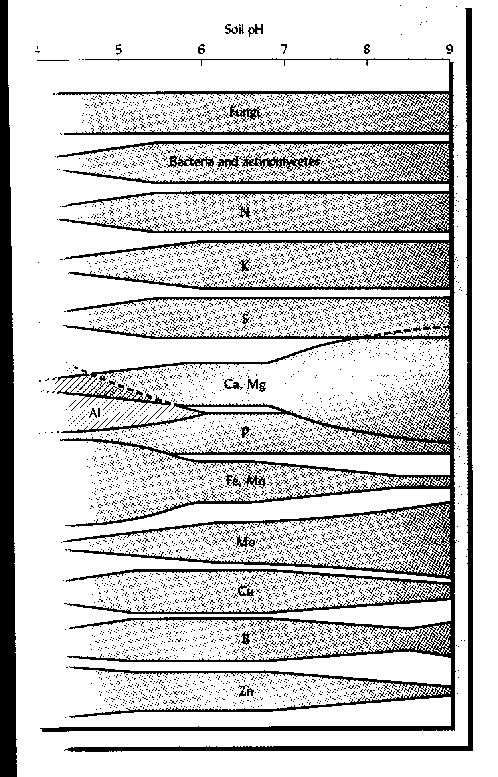
PhotoSet 1
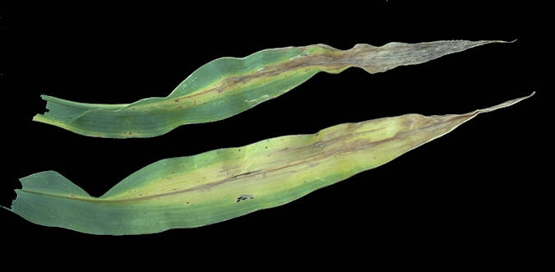 Nitrogen Deficiency http://www.soils.wisc.edu/~barak/soilscience326/nitrogen.htm

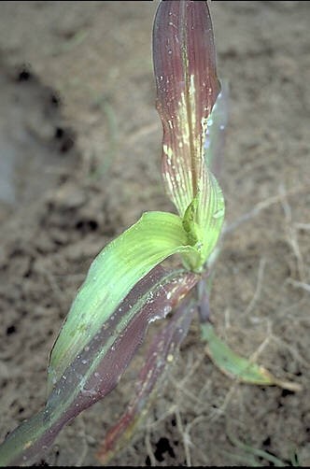
Phosphorus Deficiency http://www.soils.wisc.edu/~barak/soilscience326/phosphorus.htm

Potassium Deficiency
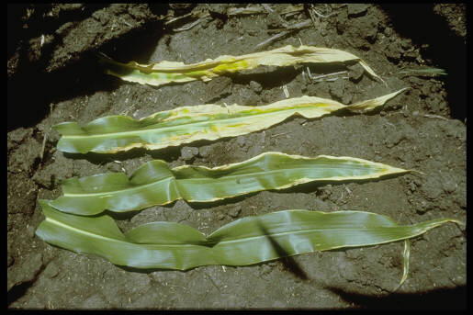
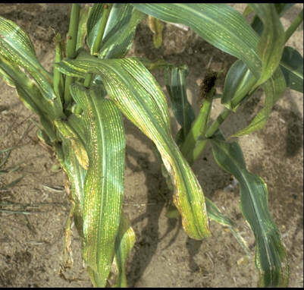

Magnesium Deficiency http://www.soils.wisc.edu/~barak/soilscience326/magnesium.htm

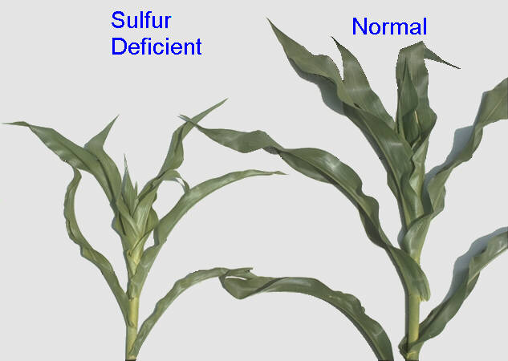
Sulfur Deficiency
http://www.soils.wisc.edu/~barak/soilscience326/sulfur.htm

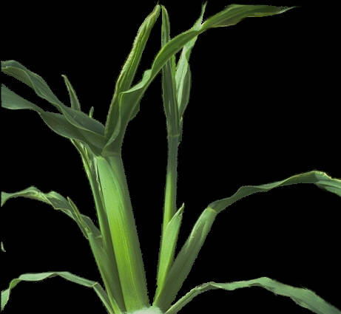Boron Deficiency http://www.soils.wisc.edu/~barak/soilscience326/boron.htm

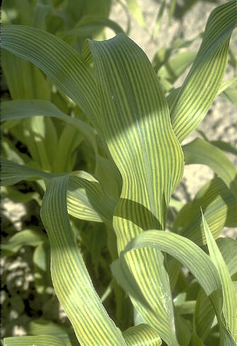Iron Deficiency http://www.soils.wisc.edu/~barak/soilscience326/iron.htm

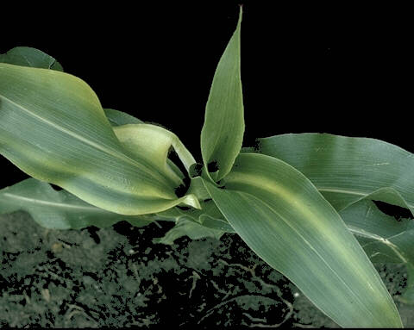 Zinc Deficiency http://www.soils.wisc.edu/~barak/soilscience326/zinc.htm

