Guide to Common Parasite Lifecycles
Parasite Name | Lifecycle Diagram | Lifecycle Description
Liver Fluke | 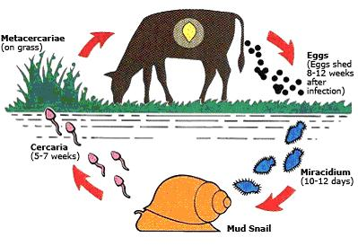 | The adult liver fluke in the liver of its host produces eggs which pass onto the pasture  These eggs hatch in warm damp conditions to produce mobile larvae (miracidia) which then infect a particular species of snail. The larvae multiply within in the snail and develop into another swimming stage (cercaria), which emerge from the snail and settle on the pasture. These then develop into a highly tolerant non-mobile stage (metacercaria) that can survive for at least a year. Once eaten by the cow these hatch and migrate to the liver.
Lungworm | 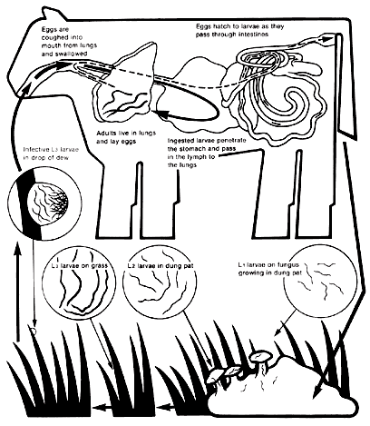 | The general life cycle of a lungworm begins with an ingestion of infected larvae. The infected larvae then penetrate the intestinal wall where larvae migrate into the lungs through the bloodstream. The infected larvae reside in the lungs until the development into adult larvae. The eggs of the adult larvae hatch thus producing lungworm. These eggs that reside in the lungs are coughed up and then ingested back into the stomach and then into feces.
Ascarid | 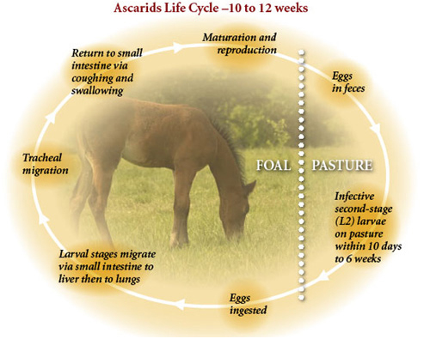 | The life cycle of the roundworm starts when the susceptible horse consumes grass, feed, or water contaminated with the infective eggs. The eggs hatch larvae that burrow into the small intestines, migrating through veins to the liver, heart, and eventually the lungs. After migrating in the air spaces of the lungs, the parasite larvae are coughed up and swallowed. The roundworm larvae are returned to the small intestine, where they mature to egg-producing adults, completing the life cycle.
Heartworm | 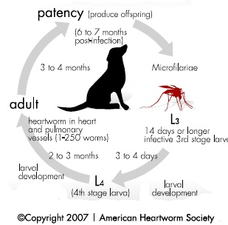 | Heartworm life cycle begins with the adult female heartworm reproducing young heartworms called microfilariae into the animal's bloodstream. When mosquitoes bite the infected animal, they carry these microfilariae, which stay within the mosquitoes for next 10 - 14 days and mature to the larval stage. When these mosquitoes bite another animal, the larvae enter in to that animal's body, and take nearly six months to develop into mature adult heartworms.
Bot | 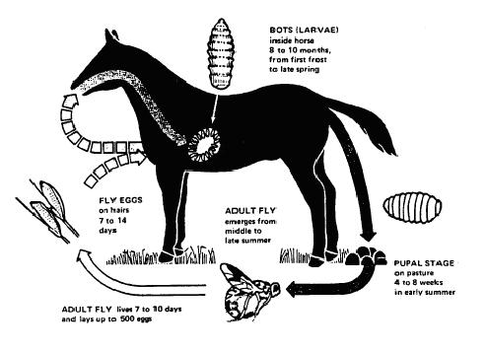 | Larvae develop in the digestive tracts of host animals during the winter. In the late winter and early spring months, full grown larvae are found in host’s feces. From there, they burrow into the soil and form a puparium from their last stage (instar) larval skin. They transform into adult flies inside the puparium and emerge in 3 to 10 weeks. Adult females glue eggs on the hairs of horses, particularly to hair on the front legs but also on the belly, shoulders and hind legs. Eggs hatch with the proper stimulus (moisture, heat and friction) caused by the horse licking or biting egg-infested hair. Tiny first stage (instar) larvae enter the mouth and burrow into the tongue before they molt and travel to the stomach developing into the third stage.
Tapeworm | 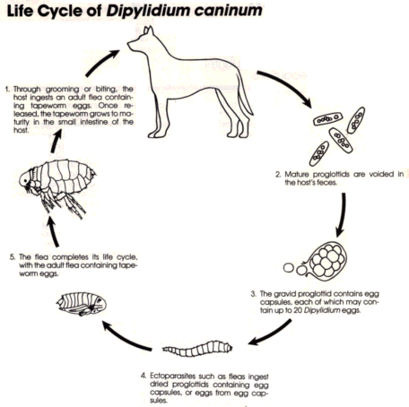 | The adult worm, which can be up to 20 inches long, lives in the small intestine. The segments, full of eggs, are passed in the feces. While warm, the segments are active, but as they dry, they break open and liberate the eggs inside. Either an adult louse or a flea larva ingests the eggs. The egg develops into an immature form in the insect. When a dog or cat eats the insect, the immature form develops into an adult worm and the life cycle is completed.

