Genetics Terms
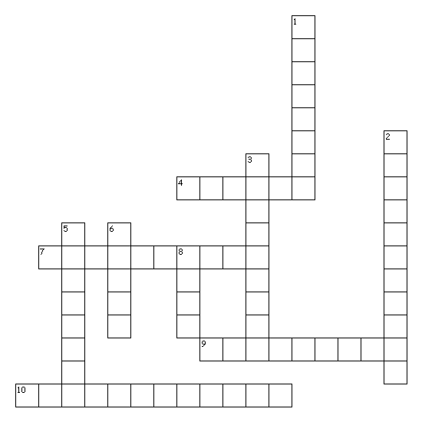
Across
4. Any of the possible forms in which a gene for a specific trait can occur.
7. A one-locus genotype containing functionally identical genes
9. Physical characteristics of an animal.
10. A one-locus genotype containing functionally different genes
Down
1. The genetic constitution of an organism.
2. Long strands of DNA and associated proteins present in the nucleus of every cell
3. The “weaker” gene
5. A gene that is expressed phenotypically.
6. The specific location of a gene on a chromosome.
8. The basic physical unit of heredity

