Supplies:
- Microscope
- Microscope slide
- Cover slip
- Test tube or small prescription pill bottle
- Floatation Solution (http://www.goatbiology.com/fecalsolution.html)
- Fresh Goat feces (goat feces work the best but if you can’t get goat feces try getting a fecal sample from the shelter or as a last resort use fecal samples from students pets)
- Cheese cloth
- Popsicle Stick
- Pipette
- Small disposable cups (2)
- Paper towel

Procedure:
Best if done in small groups but it may be done as a class project if there are not enough microscopes
- In one of the disposable cups place approximately 3-4 goat pellets or a teaspoon of dog feces.
- Add just enough flotation solution to cover the feces and mix well. Discuss with the students how the flotation solution was made and that it is a supersaturated salt solution with a density of approximately 1.2
- Place the cheese cloth over the second cup and poor the fecal/flotation solution through the cheese cloth into the second cup. Have the students note the amount of plant material in the feces. If you are using dog feces it is not necessary to filter the solution.
- Carefully pour the liquid into the pill bottle (be careful not to overflow) until a meniscus forms. The liquid should be forming a slight bubble on the top of the pill bottle
- If the test tube is not completely full slowly add flotation solution until a meniscus forms at the top of the pill bottle.
- Carefully place a cover slip on top of the meniscus (there should be no air between the top of the pill bottle and the cover slip) and let sit for 10 minutes. Need to allow enough time for the eggs to float to the surface of the cover slip
- Gently lift the cover slip off of the pill bottle and place on a slide.
- Examine the slide under magnification; first with the 10x objective to locate the eggs and then use higher magnification to examine the individual eggs.(Microscope Techniques)
- Help the students identify eggs in the sample (bubbles have a thick smooth black ring while eggs tend to have a more irregular surface and something in the middle)
- Have the students draw and write a description of what they see and how many eggs they count on their slide.
- Below is a drawing of common parasites found in goat feces to help you identify what the eggs look like.
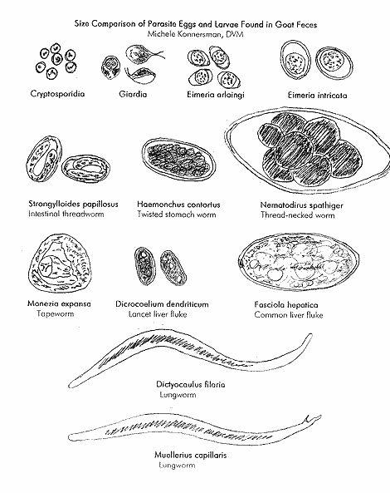

Be sure to emphasize that not all parasites that animals have are transmissible to humans but it is always a good idea to be careful when handling feces. Avoid touching your mouth or face and either wear gloves or wash your hands after handling fecal material.

Questions: (separate handout for the students)
- Why is a salt solution used for the fecal flotation? The different salts and sugars can be used to make a flotation solution but the main goal to increase the specific gravity of the solution. By increasing the specific gravity of the solution to around 1.2 most parasite eggs will float. This allows the eggs to concentrate on the surface of the cover slip and increase the chances of finding eggs if they are actually there
- Why doesn’t the supersaturated solution cause dehydration of the eggs and make then shrivel from osmosis? This might happen if enough time elapsed. But also, the egg is surrounded by a very touch and relatively impermeable shell that under natural conditions protects the egg from hyperosmotic environments. See the PEER Web lesson on osmosis and membranes.
- Why do we filter the solution through cheese cloth? Goats are ruminants and therefore eat a diet of mostly plant material, a lot of plant material is passed undigested and the cheese cloth filters out the undigested plant material while leaving the parasite eggs. This is a method to reduce the “garbage” on the slide and make it easier to locate the eggs.
- What are some methods you can use to identify the different eggs? Have the kids brainstorm but they may not be able to see all the differences depending on the fecal sample. Some ways to help identify the kind of eggs include size, shape, color, and contents inside the egg. Some eggs have larvae inside and some eggs are actually groups of eggs bundled together.
- Why would it be important to count the eggs found on a slide? While a simple fecal flotation is not a precise measure and there are techniques available to do an egg per gram count, the number of eggs seen is a good indicator of the parasite load of the animal.
- Why do you want to use fresh goat feces? If the feces is not fresh enough two things can happen; 1) the eggs may hatch so you will either see larvae or nothing in the sample or 2) if it is hot and dry the sample may dry out and the eggs will shrivel making them hard to see

Resources:

http://www.dairygoatjournal.com/issues/83/83-5/Michele_Konnersman.html
http://www.microscope-microscope.org/basic/how-to-use-a-microscope.htm

