EXAM: LIVESTOCK NUTRITION

- What is a ruminant?
Ruminants are those animals that contain a multi-chambered digestive system (polygastric) that allows the animals to gain the majority of their nutritional needs from forages and other roughages.

- What is a monogastric (non-ruminant)?
Monogastric system have a simple stomach structure and only one compartment such as carnivores and omnivores.

- Label the four parts of a ruminant stomach.

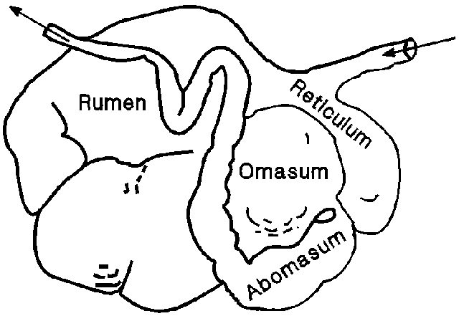

4. List the functions of the digestive system of animals include?
1. Ingestion (eating)
2. Chewing (mastication)
3. Swallowing (deglutition)
4. Absorption of nutrients
5. Elimination of solid wastes (defecation)

5. Monogastric systems have a simple stomach structure and only one compartment.

6. Some animals with monogastric digestive systems are pigs and rabbits. Humans also have monogastric digestive systems.

7. List the 6 sources of nutrients and their importance.
1. Water – 1) serves as a lubricant for all nutrients that enter the body and reacts with chemical compounds to help breakdown food into usable products. 2) aids in the regulation of body heat, through perspiration and evaporation. 3) cheapest and most important nutrient to provide to animals.______________________________________________________

2. Carbohydrates – 1) account for 65-80% of the feeds normally consumed by animals.____________________________________________________

- Fats – 1) adding fats to a dies can increase energy intake without increasing the total feed intake._________________________________

- Protein – 1) major component of tissues and muscles_______________

- Vitamins – 1) Are used in the clotting of blood, forming bones, reproduction, lactation, and prevention of certain nervous system disorders 2) Organic compounds 3) essential for proper utilization of proteins, fats and carbs._______________________________________

- Minerals – 1) minerals in animals are required in minimal quantities b they are very important as they are the catalyst for other body processes._______________________________________________

8. Describe protein requirements for Ruminants.
Ruminant – 1) vary according to the weight as well as the level of production (growth, reproduction, and lactation. 2) it is also important to know the protein levels of various feed so that management can match the protein available in an animal’s with the animal’s needs. 3) crude protein values give a good indication of whether or not a particular feed will satisfy he protein needs of the animal____________________________________

Draw and describe (one): Drawings may vary

9. Warm Season Perennial:
Bahia
Bermuda
Dallisgrass
Johnsongrass

11. Cold Season Annual:
Sorgum-Sudan Grass
Rescuegrass
Annual Ryegrass
Small Grains: Rye, Oats, Wheat and Barley

10. Warm Season Legume:
Cowpea

12. Cool Season Legume:
Alfalfa
Clover

13. Formulate 1000 lb. of a complete sheep diet containing 12% CP. Use corn at 8.5% CP and a supplement at 38% CP. Show ALL your work!!

Corn- 8.5% CP
26 parts corn

12%

Supp. - 38% CP
3.5 parts Supp.

29. 5 Total

26 / 29.5 = .8814 x 100 = 88% corn
3.5/29.5 = .1186 x 100 = 12% supplement

88% corn x 1000 lbs. = 880 lbs. of corn needed
12% supplement x 1000 lbs. = 120 lbs. of supplement needed

14.You are the owner of a feedlot and have to formulate a ration that will be cost efficient and provide the necessary nutritional requirements for your animals. Formulate a 2500 lb. ration with 43% CP for your cattle using the list of feed options shown below. Choose ONE main feed and ONE supplement as labeled. Show ALL work, including your math on how much your feed will cost you.

Main- Corn | 10% CP | $0.80 per lb.
Main- Barley | 5% CP | $0.65 per lb.
Main- Wheat Straw | 8.4% CP | $0.65 per lb.
Supp.- Fish Meal | 78% CP | $2.65 per lb.
Supp.- Soybean Meal | 45% CP | $1.50 per lb.
Supp.- Molasses | 6.7% CP | $0.45 per lb.

Barley – 5% CP
36.3

43%

Molasses- 6.7% CP
38

74.3 Total

36.3 / 74.3 = .49 x 100 = 49% barley
38/72.3 = .51 x 100 = 51% molasses

49% barley x 2500 lbs. = 1225 lbs. of barley
51% molasses x 2500 lbs. = 1275 lbs. of molasses

1225 lbs. of barley x $0.65 = $796.25
1275 lbs. of molasses x $0.45 = $573.75
= $1,370 total to make feed

