Swimmer’s Itch (Cercariea) Life Cycle:

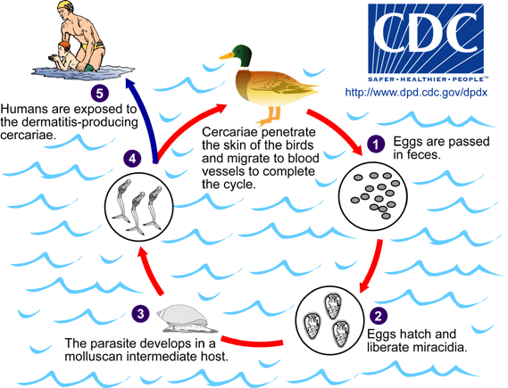

Hosts of avian schistosomes can be either year-round resident or migratory birds, including seagulls, shorebirds, ducks, and geese. Adult worms are found in the blood vessels and produce eggs that are passed in the feces . On exposure to water, the eggs hatch and liberate a ciliated miracidium that infects a suitable snail (gastropod) intermediate host . The parasite develops in the intermediate host to produce free-swimming cercariae that are released under appropriate conditions and penetrate the skin of the birds and migrate to the blood vessels to complete the cycle . Humans are inadvertent and inappropriate hosts; cercariae may penetrate the skin but do not develop further . A number of species of trematodes with dermatitis-producing cercariae have been described from both freshwater and saltwater environments, and exposure to either type of cercaria will sensitize persons to both.

Hydatid Disease Life Cycle:
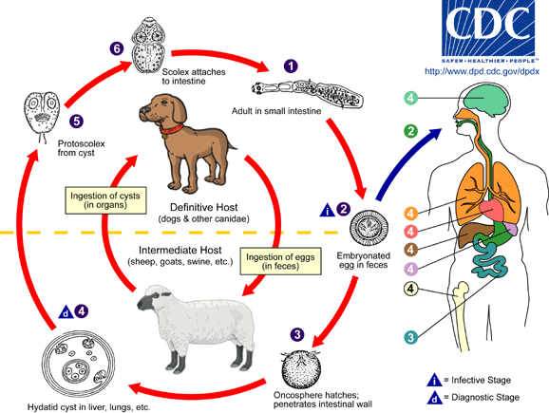
The adult Echinococcus granulosus (3 to 6 mm long) resides in the small bowel of the definitive hosts, dogs or other canids. Gravid proglottids release eggs that are passed in the feces. After ingestion by a suitable intermediate host (under natural conditions: sheep, goat, swine, cattle, horses, camel), the egg hatches in the small bowel and releases an oncosphere that penetrates the intestinal wall and migrates through the circulatory system into various organs, especially the liver and lungs. In these organs, the oncosphere develops into a cyst that enlarges gradually, producing protoscolices and daughter cysts that fill the cyst interior. The definitive host becomes infected by ingesting the cyst-containing organs of the infected intermediate host. After ingestion, the protoscolices attach to the intestinal mucosa , and develop into adult stages in 32 to 80 days. The same life cycle occurs with E. multilocularis (1.2 to 3.7 mm), with the following differences: the definitive hosts are foxes, and to a lesser extent dogs, cats, coyotes and wolves; the intermediate host are small rodents; and larval growth (in the liver) remains indefinitely in the proliferative stage, resulting in invasion of the surrounding tissues. With E. vogeli (up to 5.6 mm long), the definitive hosts are bush dogs and dogs; the intermediate hosts are rodents; and the larval stage (in the liver, lungs and other organs) develops both externally and internally, resulting in multiple vesicles. E. oligarthrus (up to 2.9 mm long) has a life cycle that involves wild felids as definitive hosts and rodents as intermediate hosts. Humans become infected by ingesting eggs , with resulting release of oncospheres in the intestine and the development of cysts , , , , , in various organs.
Toxoplasmosis Life Cycle:
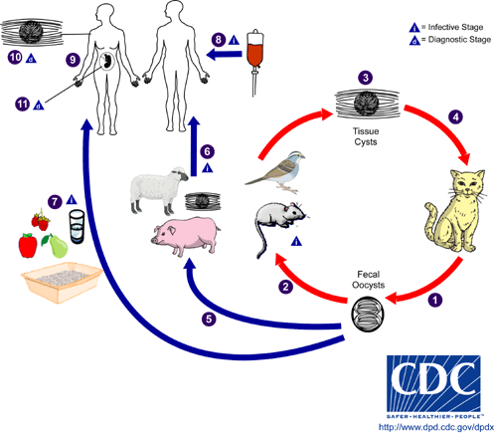
The only known definitive hosts for Toxoplasma gondii are members of family Felidae (domestic cats and their relatives). Unsporulated oocysts are shed in the cat’s feces . Although oocysts are usually only shed for 1-2 weeks, large numbers may be shed. Oocysts take 1-5 days in the environment to become infective. Intermediate hosts in nature (including birds and rodents) become infected after ingesting soil, water or plant material contaminated with oocysts . Oocysts transform into tachyzoites shortly after ingestion. These tachyzoites localize in neural and muscle tissue and develop into tissue cysts called bradyzoites . Cats become infected after consuming intermediate hosts harboring tissue cysts . Cats may also become infected directly by ingestion of sporulated oocysts. Animals bred for human consumption and wild game may also become infected with tissue cysts after ingestion of sporulated oocysts in the environment . Humans can become infected by any of several routes:
- eating undercooked meat of animals harboring tissue cysts .
- consuming food or water contaminated with cat feces or by contaminated environmental samples (such as fecal-contaminated soil or changing the litter box of a pet cat) .
- blood transfusion or organ transplantation .
- transplacentally from mother to fetus .

Chagas Disease Life Cycle:

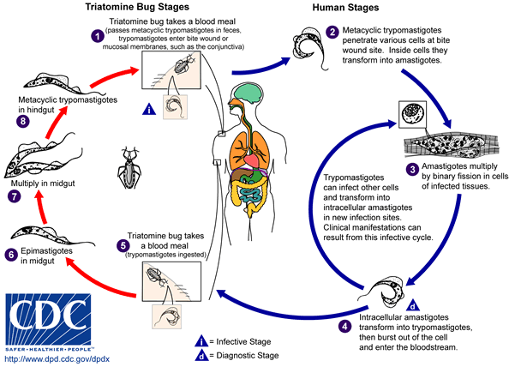

An infected “kissing” bug takes a blood meal and releases the trypomastigote stages of the parasite in its feces near the site of the bite wound. The parasite enters the host through the wound or through intact mucosal membranes, such as around the eye . Common vector species for trypanosomiasis are known as kissing bugs. Inside the host, the parasite invades cells near the site of inoculation, where they begin further development into amastigotes. The parasites then multiply by binary fission and then are released into the circulation as bloodstream trypomastigotes . Trypomastigotes infect cells from a variety of tissues and transform into intracellular amastigotes in new infection sites. The bloodstream trypomastigotes do not replicate. Replication resumes only when the parasites enter another cell or are ingested by another vector. The “kissing” bug becomes infected by feeding on human or animal blood that contains circulating parasites . The ingested trypomastigotes develop in the vector’s midgut . The parasites multiply and differentiate in the midgut and differentiate into the infective form in the hindgut .
Trypanosoma cruzi can also be transmitted through blood transfusions, organ transplantation, transplacentally, and in laboratory accidents.

Tapeworm Life Cycle:

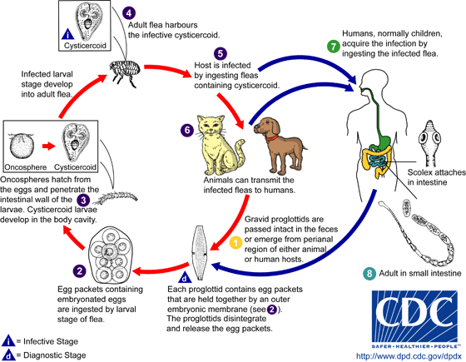
Individual body segment of the worm, proglottids, are passed intact in the feces or emerge from the perianal region of the host . Subsequently they release typical egg packets . On rare occasions, proglottids rupture and egg packets are seen in stool samples. Following ingestion of an egg by the intermediate host (larval stages of the dog or cat flea Ctenocephalides spp.), the parasite develops into a larva . The larva develops into an adult, and the adult flea harbours the infective stage of the parasite . The vertebrate host becomes infected by ingesting the adult flea containing the parasite . The dog is the principal definitive host for Dipylidium caninum. Other potential hosts include cats, foxes, and humans (mostly children) , . Humans acquire infection by ingesting the larvae contaminated flea. This can be promulgated by close contact between children and their infected pets. In the small intestine of the vertebrate host the larvae develops into the adult tapeworm which reaches maturity about 1 month after infection . The adult tapeworms (measuring up to 60 cm in length and 3 mm in width) reside in the small intestine of the host, where they each attach by their scolex. They produce proglottids. The proglottids mature, become gravid, detach from the tapeworm, and migrate to the anus or are passed in the stool .

Hookworm Life Cycle:

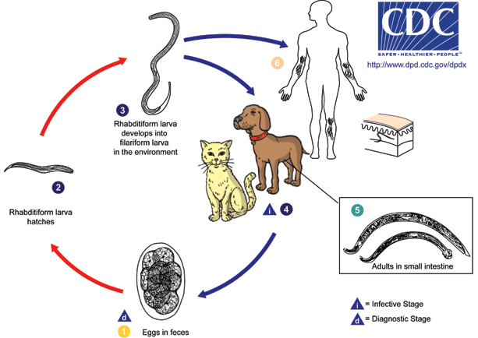

Cutaneous larval migrans (also known as creeping eruption) is a zoonotic infection with hookworm species that do not use humans as a definitive host, the most common being A. braziliense and A. caninum. The normal definitive hosts for these species are dogs and cats. The cycle in the definitive host is very similar to the cycle for the human species. Eggs are passed in the stool , and under favorable conditions (moisture, warmth, shade), larvae hatch in 1 to 2 days. The released rhabditiform larvae grow in the feces and/or the soil , and after 5 to 10 days (and two molts) they become filariform (third-stage) larvae that are infective . These infective larvae can survive 3 to 4 weeks in favorable environmental conditions. On contact with the animal host , the larvae penetrate the skin and are carried through the blood vessels to the heart and then to the lungs. They penetrate into the pulmonary alveoli, ascend the bronchial tree to the pharynx, and are swallowed. The larvae reach the small intestine, where they reside and mature into adults. Adult worms live in the lumen of the small intestine, where they attach to the intestinal wall. Some larvae become arrested in the tissues, and serve as source of infection for pups via transmammary (and possibly transplacental) routes . Humans may also become infected when filariform larvae penetrate the skin . With most species, the larvae cannot mature further in the human host, and migrate aimlessly within the epidermis, sometimes as much as several centimeters a day. Some larvae may persist in deeper tissue after finishing their skin migration.

Trichinella Life Cycle:

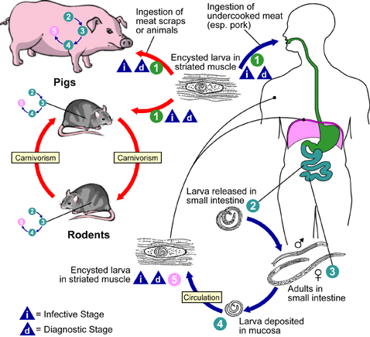

Trichinellosis is acquired by ingesting meat containing cysts (encysted larvae) of Trichinella. After exposure to gastric acid and pepsin, the larvae are released from the cysts and invade the small bowel mucosa where they develop into adult worms (female 2.2 mm in length, males 1.2 mm; life span in the small bowel: 4 weeks). After 1 week, the females release larvae that migrate to the striated muscles where they encyst . Encystment is completed in 4 to 5 weeks and the encysted larvae may remain viable for several years. Ingestion of the encysted larvae perpetuates the cycle. Rats and rodents are primarily responsible for maintaining the endemicity of this infection. Carnivorous/omnivorous animals, such as pigs or bears, feed on infected rodents or meat from other animals. Different animal hosts are implicated in the life cycle of the different species of Trichinella. Humans are accidentally infected when eating improperly processed meat of these carnivorous animals (or eating food contaminated with such meat).

