
Strawberry DNA Extraction Lab by C. Kohn, WUHS and Stacy Fritz, NAAE
Name: Hour Date:
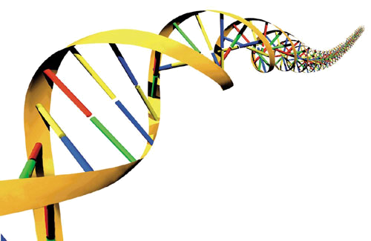
Date Assignment is due: At end of hour Why late? Score: /10
^{Day of Week} ^{Date} If your project was late, describe why
Materials
- measuring cup measuring spoons ice-cold rubbing alcohol
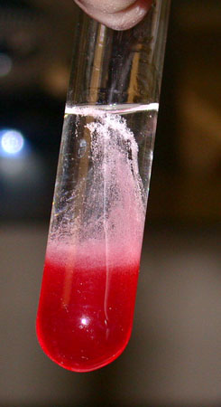
- 1/2 teaspoon salt 1/3 cup water 1 tbsp Dawn dishwashing detergent
cheesecloth Re-closable plastic sandwich bags test tube (or small glass jar)
3 strawberries (green tops removed) cup bamboo kabob skewer or Q-tip
Directions:
- Mix the salt, water, and Dawn detergent in a glass or small bowl. Set the mixture aside. This is your extraction liquid.
- Line the funnel with the cheesecloth, and put the funnel’s tube into the glass.
- Put the strawberries in the plastic bag and push out all the extra air. Seal it tightly.
- With your fingers, squeeze and smash the strawberry mixture for 2 minutes.
- Add 3 tablespoons of the extraction liquid you made in Step 2 to the strawberries in the bag. Push out all the extra air and reseal the bag.
- Squeeze the strawberry mixture with your fingers for 1 minute.
- Put cheesecloth over the funnel and place the funnel in your test tube. Pour the strawberry mixture from the bag into the funnel. Let it drip into the test tube until there is no liquid left in the funnel.
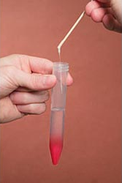
- Throw away the cheesecloth and the strawberry pulp inside. Pour out the contents of the test tube so it is 1/4 full.
- Tilt the test tube or jar and very slowly pour the cold rubbing alcohol down the side. The alcohol should form a layer on top of the strawberry liquid. (Don’t let the alcohol and strawberry liquid mix. The DNA collects between the two layers!). Slowly add enough alcohol so that you have equal parts of both liquids.
- Dip the bamboo skewer into the test tube where the alcohol and strawberry layers meet. Pull up the skewer. The whitish, stringy stuff is DNA containing strawberry genes!
Questions
- What does mashing the strawberries and treating them with detergent do to their cells

- What part of the cell did the DNA come from

- Why can’t you see the double helix structure of DNA

- A person cannot see a cotton thread 100 feet away, but if you wound thousands of threads together into a rope, it would be visible at some distance. How is this statement an analogy to our DNA extraction

- Was this really DNA? Explain what you think and why:

- List and describe one thing that you found surprising or interesting that you learned from this lab

