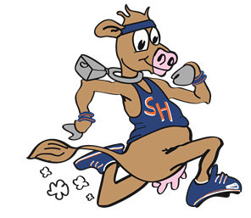

Participant #: __________
Registration Fee: __________

$25 registration fee includes a T-shirt

Name: _______________________________ Sam ID#: _________________________
Email Address: _________________________ Shirt Size: ________________________
IN ORDER TO BE GUARANTEED A SHIRT, REGISTRATION FORM NEEDS TO BE TURNED IN BY OCTOBER 16TH TO DR. BEVERLY OR DR. ANDERSON
List any medical conditions and/or allergies: _______________________________________ ___________________________________________________________________________
Affirmation, Waiver, and Liability Release
In, consideration of the permission given to me by Sam Houston State University (SHSU) to participate in the above-described activity, I, (for myself, my heirs, executors, and administrators), release, discharge, and agree to indemnify SHSU, the Board of Regents, Texas State University System, the supervisors named above, and all of the university’s regents, officers, agents, and employees (“the released parties”) from any and all liability arising from or in connection with my participation in the above-described activity, regardless of whether such liability is caused by the negligence of the released parties. I intend that the indemnity provided in this waiver and release is indemnity by me to indemnify the released parties from the consequences of their negligence, whether that negligence is the sole or a concurring cause of the liability.
I have been informed and understand the risks and danger inherent in the above-described activity and that I participate freely and without guarantee or compulsion. I am of lawful age and legally competent and empowered to execute this affirmation, waiver, and release on my own behalf.

______________________________ _______________________
Signature Date

