SHSU CELLO
EXCERPTS Fall 2015
Solo of your choice & pick 3 of the following excerpts

BEETHOVEN Symphony No. 5, mvt. 3 (pickup to mm.141 – mm.218, no repeat)

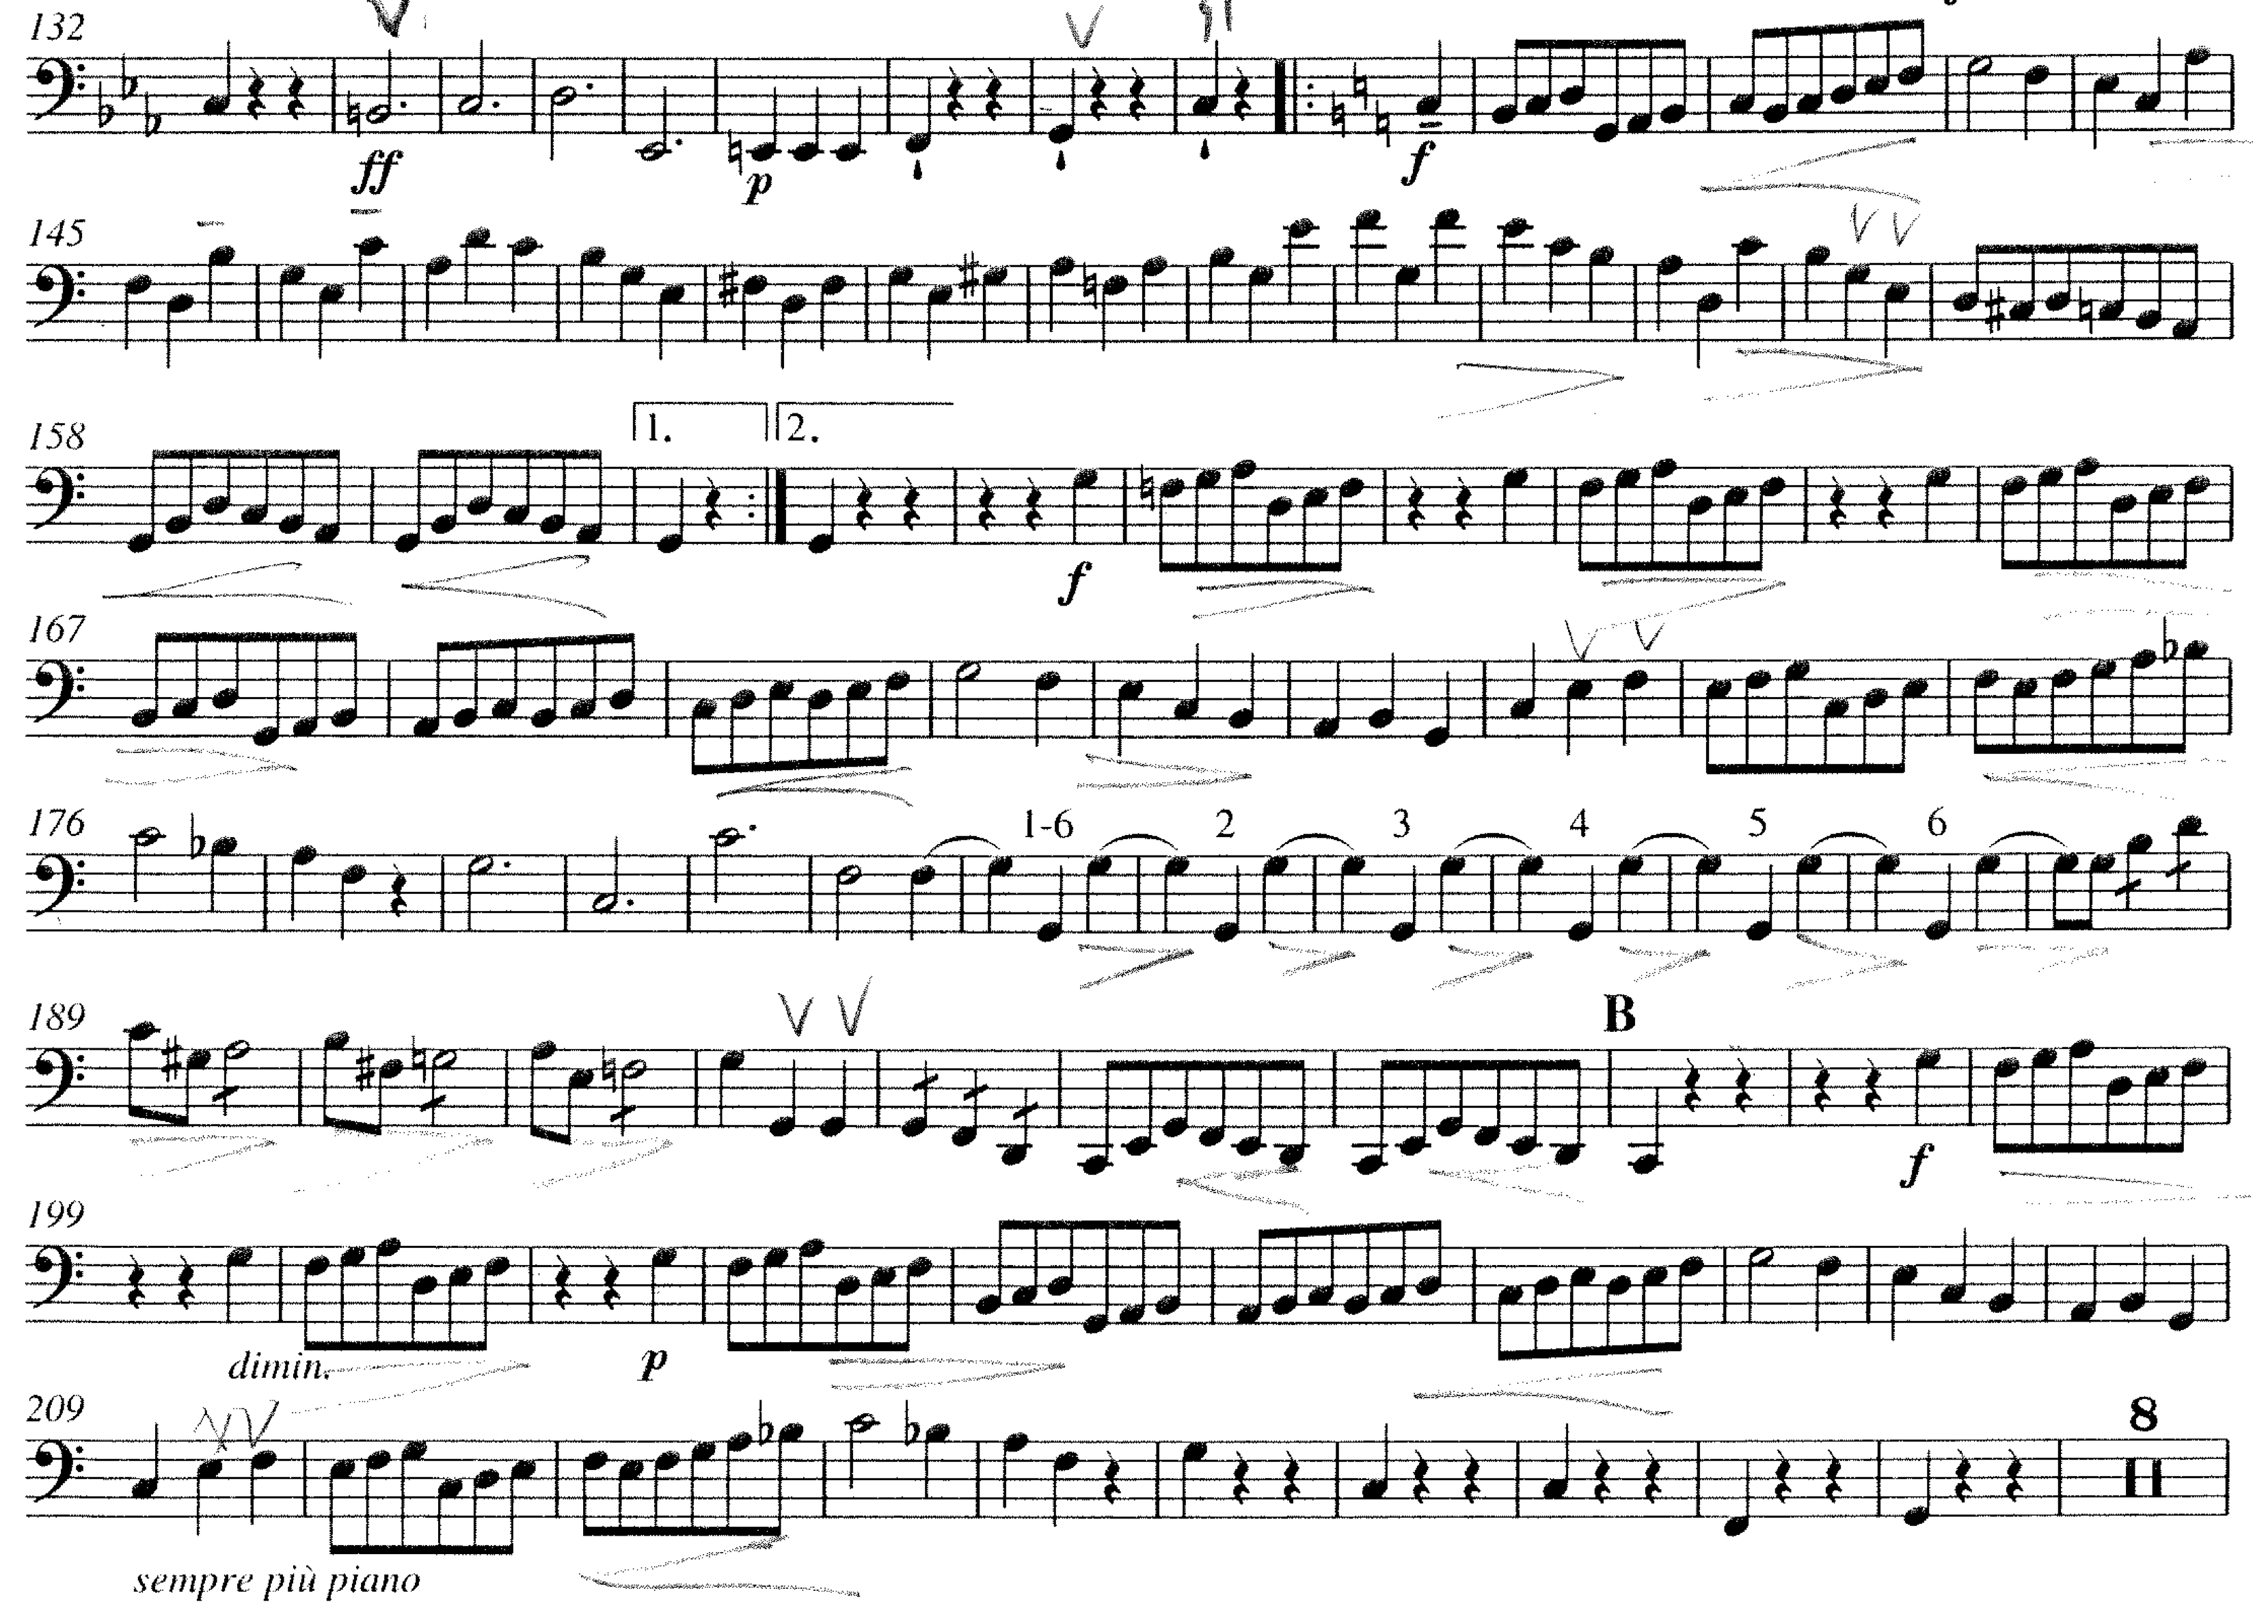

MOZART Symphony No. 35, mvt. 1 (mm. 13 – mm. 66)

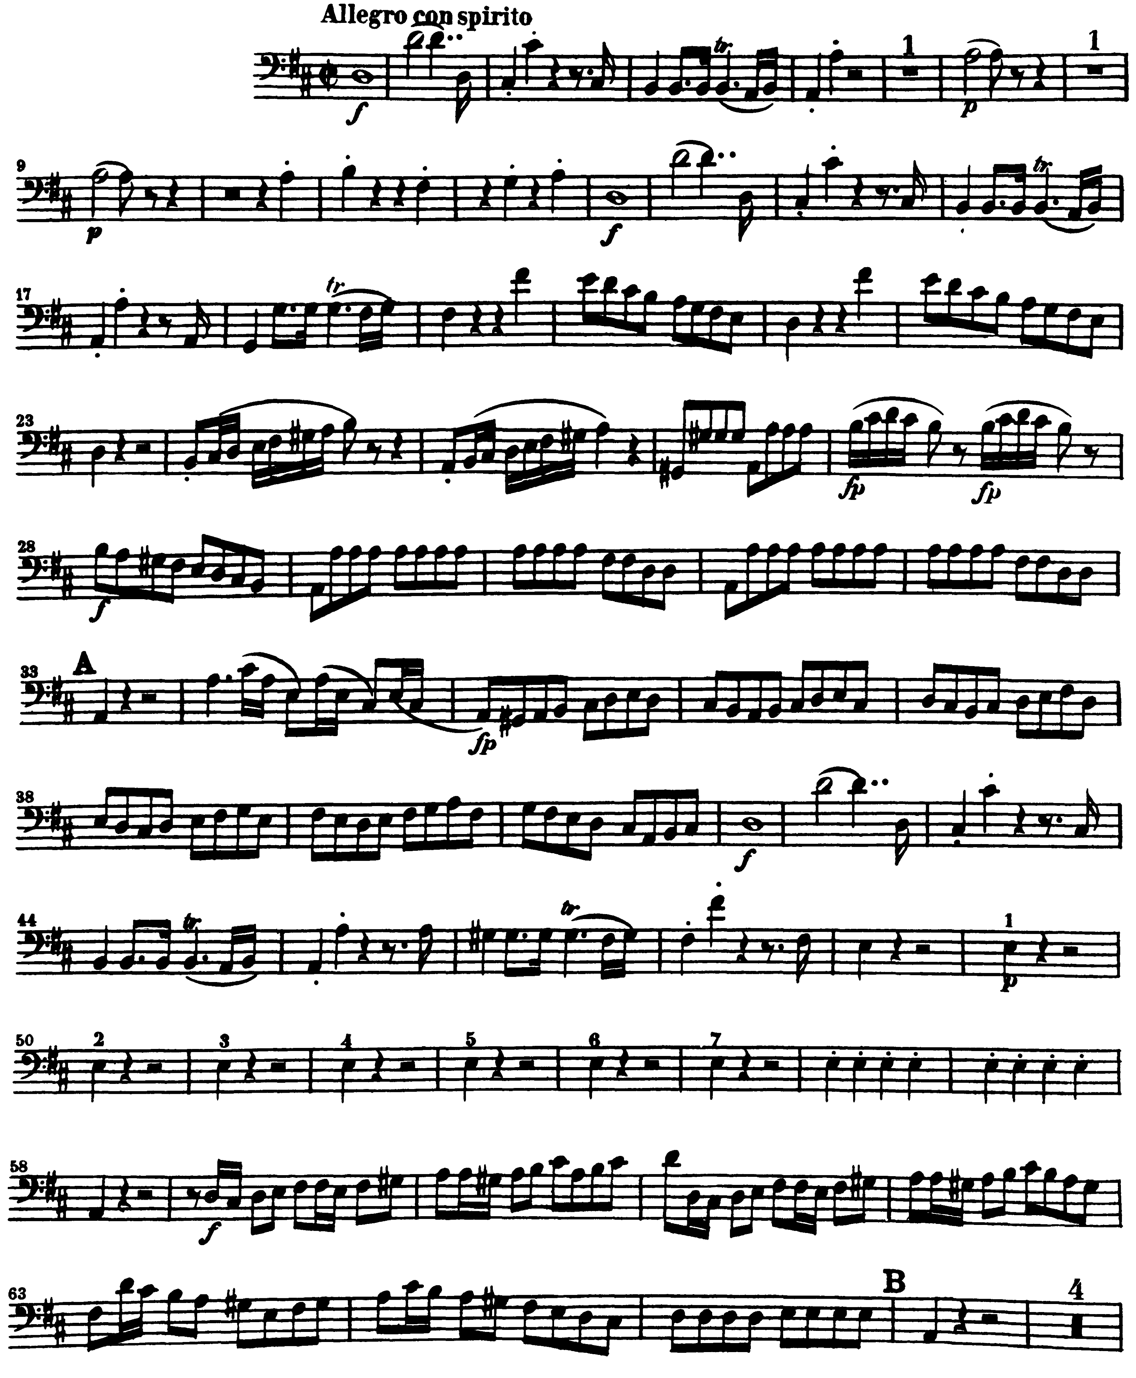

ROSSINI Overture to William Tell (mm. 1 – mm.48)

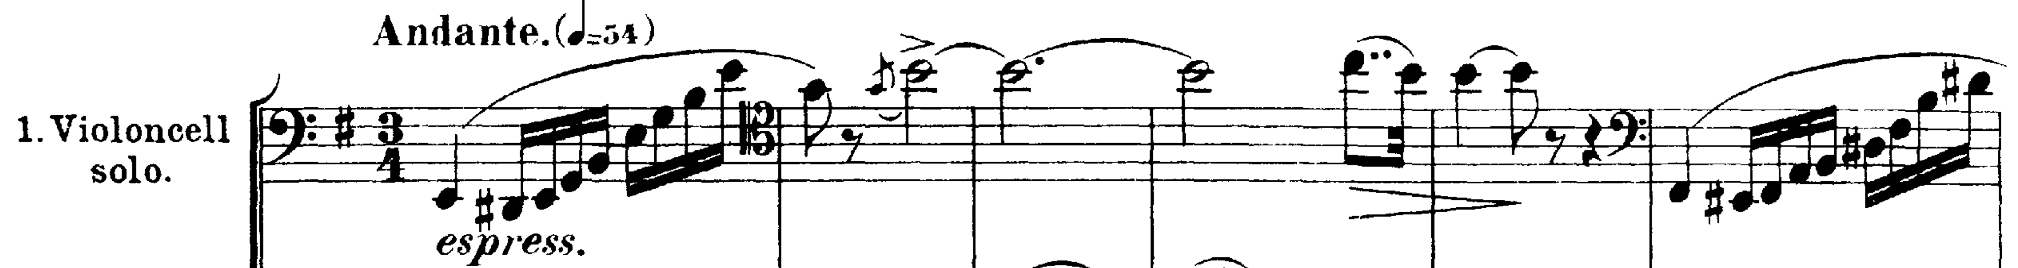
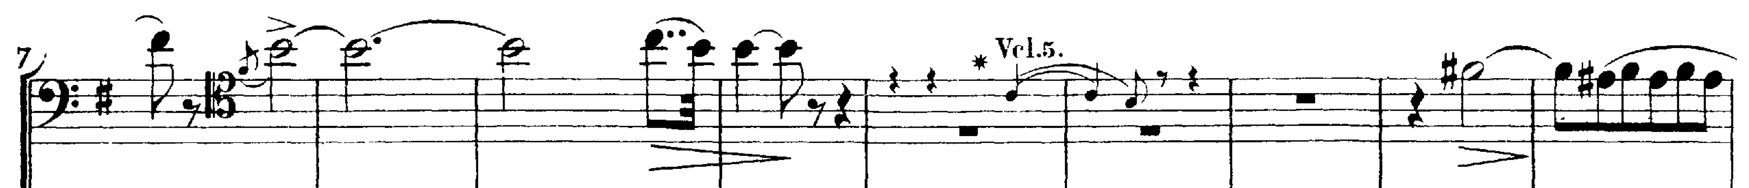

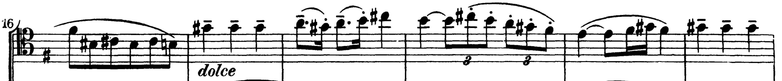

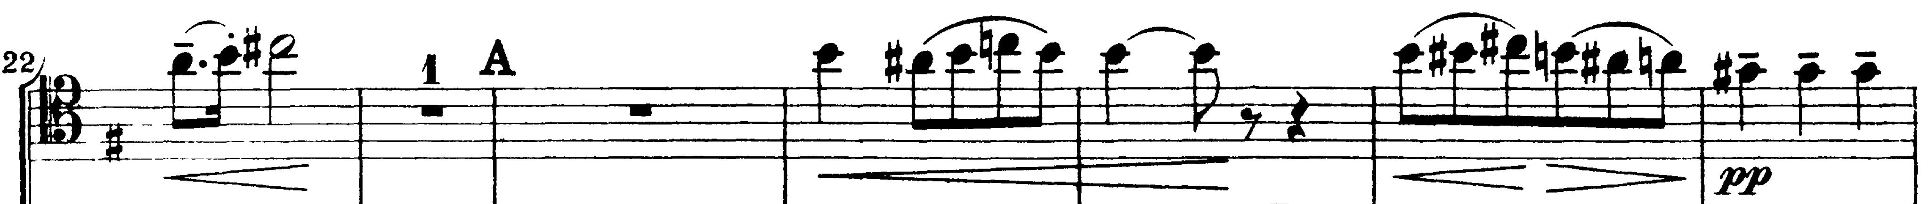

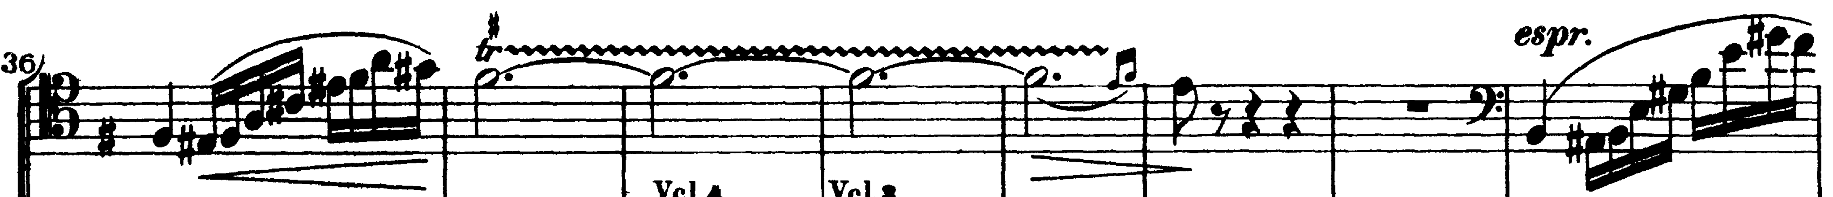

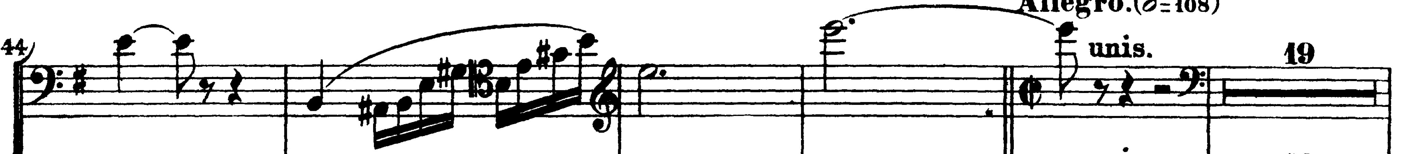

RESPIGHI Pines of Rome, mvt. 1 (pickup to mm. 10 – mm. 25)

