SHSU BASS
EXCERPTS Fall 2015
Solo of your choice & pick 3 of the following excerpts

BEETHOVEN Symphony No. 5, mvt. 3 (pickup to mm.141 – mm.218, no repeat)

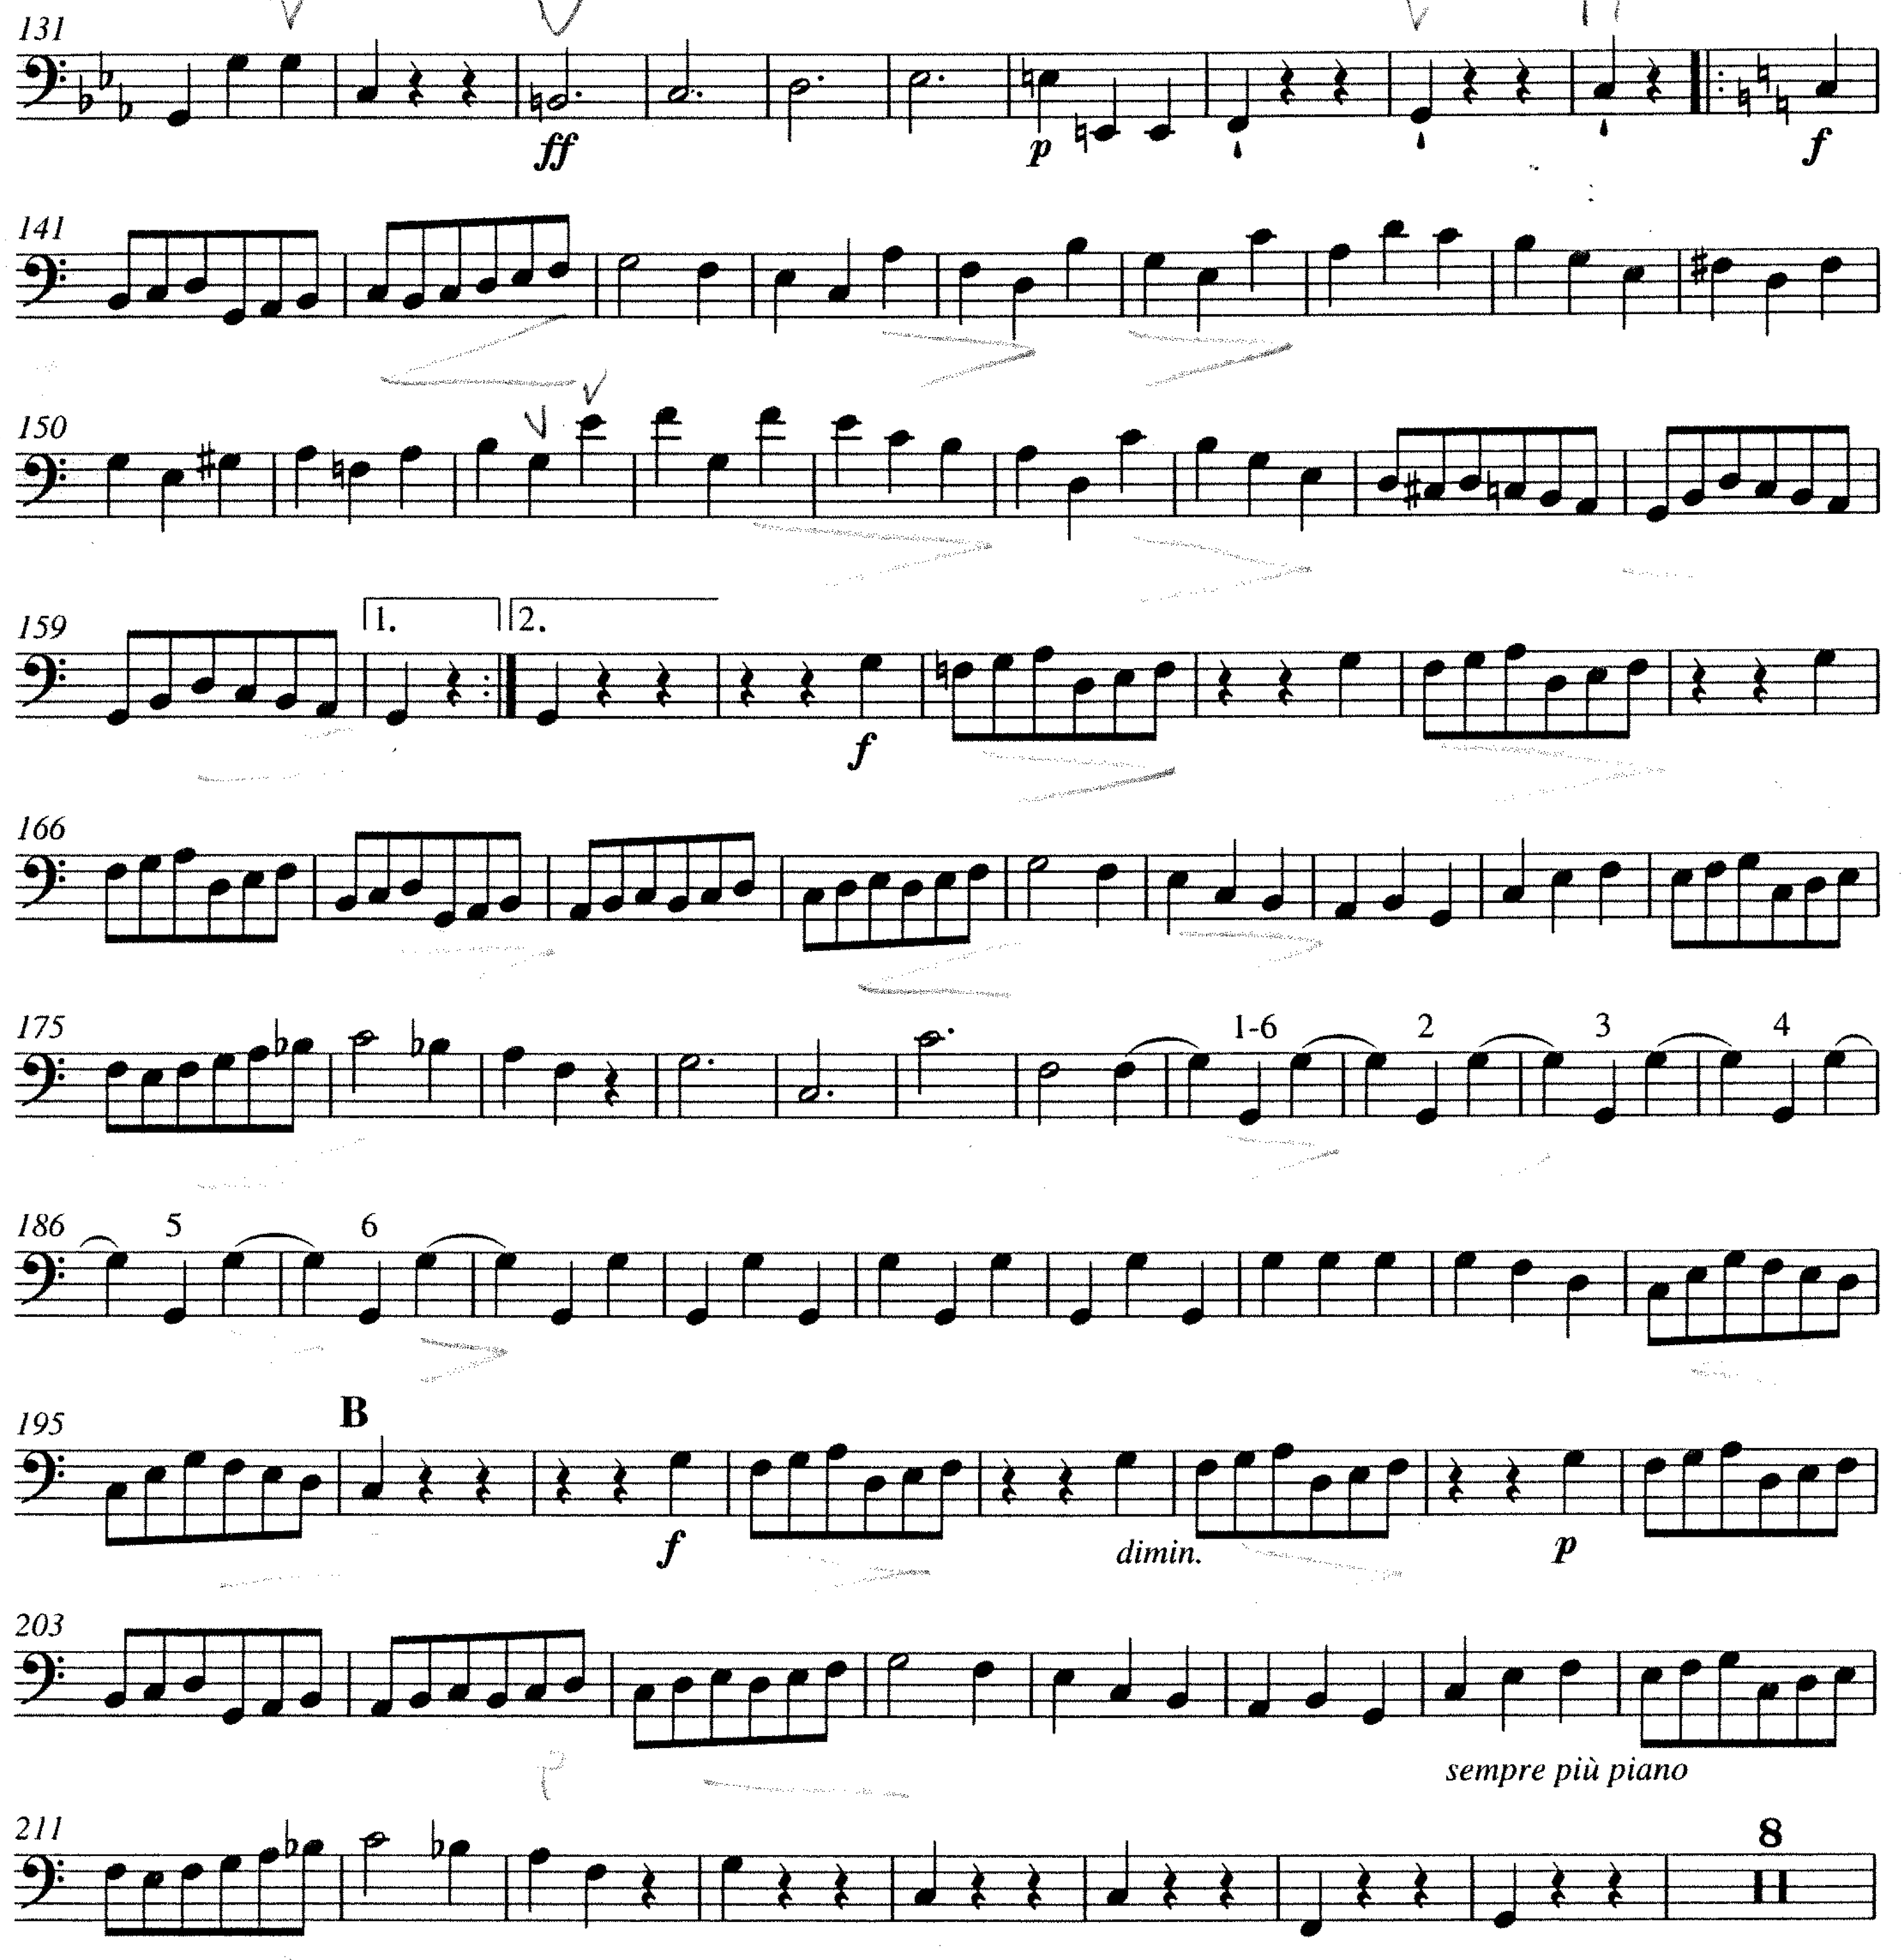
MOZART Symphony No. 35, mvt. 1 (mm.13 – mm.66)

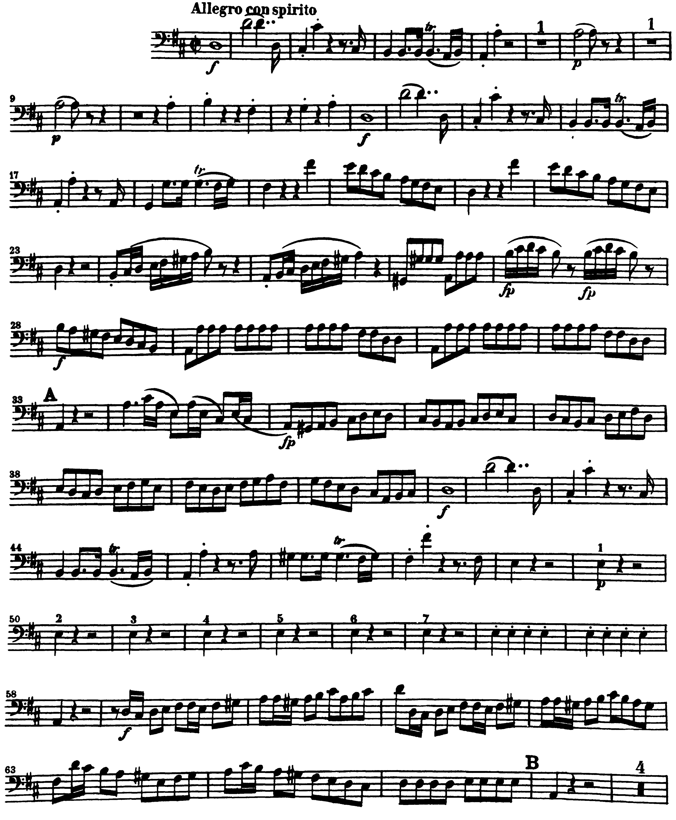

MAHLER Symphony No. 1, mvt. 3 (mm.3 – mm.10)

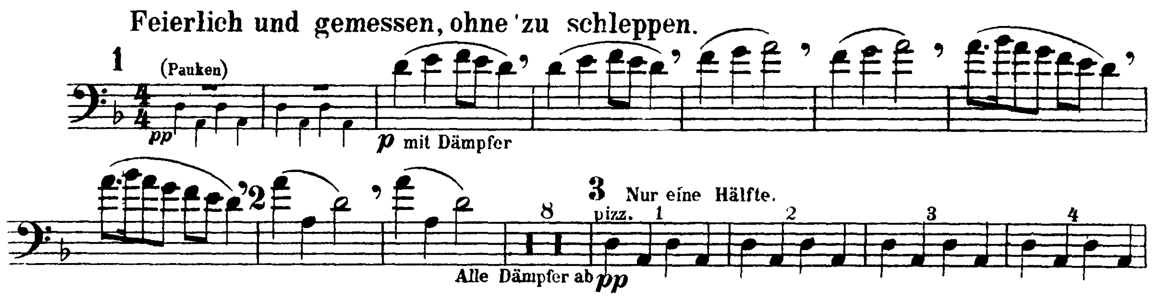

ROSSINI Overture to William Tell (mm. 110 – 123)

