Protein Folding C. Kohn, Waterford WI
Name: Hour Date:
Date Assignment is due: upon finishing PPT Why late?
^{Day of Week} ^{Date} If your project was late, describe why
- DNA is copied by in a direction
- mRNA is read in groups of ( ) by a
- Each codon codes for a specific
- Each amino acid is delivered by a
- A string of amino acids creates a and peptides join for form a
- The shape of a protein comes from its and this shape determines its
.
- Proteins are made from amino acids
- Each amino acid has a set of that helps to create the shape of the protein
  - List some examples of these:
- What are three ways in which you can identify the amino acid Asparagrine?
- Do amino acids stay in a straight chain after they are assembled?
- What three kinds of charge can an amino acid have?
- How does the charge of an amino acid change the way they line up?
  - Amino acids with a similar charge will
  - Amino acids with opposite charges will
- What is hydrophobicity?
- Hydrophobic amino acids will
- Hydrophilic amino acids will
- In the picture below, label with amino acids are hydrophobic and which are hydrophilic
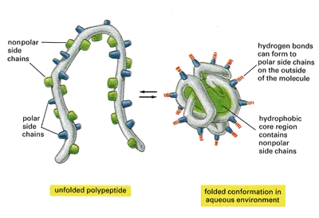
- What is a cysteine?
- Why are cysteines different from other amino acids?
- What is the bond called between two cysteine molecules?
- In the picture below, circle the cysteine bond
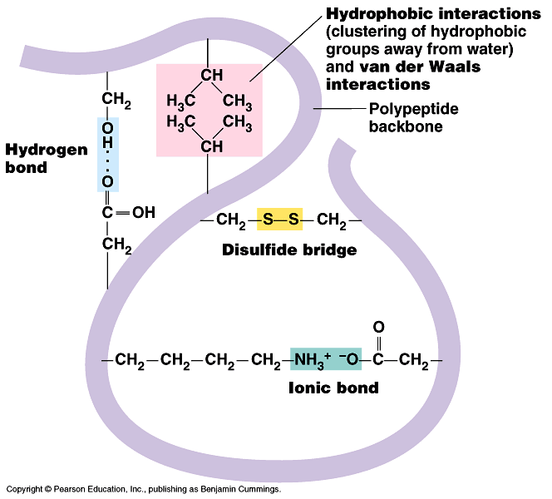
- In the space below, draw an α helix
- In the space below, draw a β sheet
- Describe each of the following levels of protein organization
Primary
Secondary
Tertiary
Quaternary

- In the space below, design a protein.
  - For hydrophobic amino acids, draw a square □
  - For hydrophilic amino acids, draw a circle Ο
  - For negative charges, draw a triangle Δ
  - For positive charges, draw a diamond ◊
  - For cysteines, draw a circle with a C in it (©)
  - Keep in mind, an amino acid could have a charge and be hydrophobic or hydrophilic
  - Be sure to draw your amino acids first and connect them with a line second; your hydrophobic amino acids should be on the inside; your hydrophilic amino acids should be on the outside
  - Amino acids with opposite charges are attracted to each other; amino acids with identical charges are opposed to each other
  - Cysteines are attracted to each other; if you have two cysteines, they will move toward each other (if you have an odd number of cysteines, one will be unaffected – they can only form bonds in pairs, not in 3’s)

