Food Plots For Turkeys
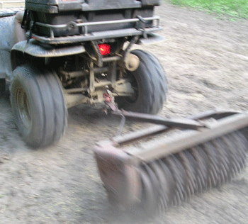
Turkeys prefer foraging on the edge of small clearings in wooded areas. SO, when choosing a location for a food plot for turkeys, you want to be near a wooded area. Turkeys require water every day and a water source should be no more than a mile away. If there is not a dependable water source nearby like a creek or a pond within that distance, you can always construct a water hole.
It is a good idea to have some taller weeds in the vicinity. It provides needed cover for the turkeys and will provide insects for the turkeys to eat in addition to the food that you will be providing them. Insects and seeds are important more in the spring hunting season because they provide needed protein for the hens to fulfill their reproductive requirements. By the way, because of turkeys eating so many insects, it is a good idea to stay away from pesticides and to avoid mowing during nesting seasons.
The biggest reason you want to place your food plot near a wooded area is because turkeys use fallen timber tops to roost and more importantly, they love eating acorns, it is their favorite food. Planting a choice food source in a good location will increase the potential for sightings, and if you are hunting turkeys, that is important. Even with abundant natural food sources, food plots will attract wild turkeys.
It is best to have long, narrow grow strips. If you are doing your plot on public land, check out utility rights of way and widening logging roads. It is also good to have some dry areas to allow the turkeys to take a dust bath. Plots with long narrow grow strips allow for dusting and are ideal for allowing gobblers to strut their stuff for the hens.
For turkeys, plant perennials like grasses that seed, weeds that attract insects and berry plants (Blackberries, Blueberries, Gooseberries, etc.) Suggestions for other plants that are annual are Alfalfa, Sesame, Chufa, Peas and Wheat. Some people like to do a mix. Specifically, you can try a mix of Orchard Grass, Buckwheat, White Proso Millet, Chufa, WGF Sorghum, Durana White Clover and German Foxtail Millet.
The biggest thing when you are creating a food plot for turkeys is that you need to remember that turkeys prefer thin vegetation. It is possible that they wouldn’t even use a plot if there is too much in it. In other words, more is not better with turkeys.
Follow these directions and you will have a nice food plot for turkeys to enjoy and you to benefit from. Happy hunting.

