Understanding Flight Zone and Point of Balance to Improve Handling of Cattle, Sheep, and Pigs
(Revised November 2010)
http://www.grandin.com/behaviour/principles/flight.zone.html

This picture illustrates the flight zone of a large flock of sheep, herds of cattle behave much the same way. Notice that the sheep are circling around the handlers while maintaining a safe distance and keeping the people in sight. Note that the sheep tend to move in the opposite direction of handler movement. Walking in the opposite direction of the direction of desired movement can be used to move groups of animals. Walking in the opposite direction tends to speed up movement and walking in the same direction tends to slow down movements. These principles work with all herding animals. When animals are completely tame they will have no flight zone. Leading is usually the most effective way to move very tame animals. Handlers on farms and ranches can reduce the size of the flight zone by spending time walking through the herd or flock. | 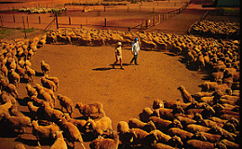
The point of balance is usually at the animal's shoulder and it is determined by the animal's wide angle vision. All species of livestock will move forward if the handler stands behind the point of balance. They will back up if the handler stands in front of the point of balance. Many handlers make the mistake of standing in front of the point of balance while attempting to make an animal move forward in a chute (race). Groups of cattle or pigs in a chute (race) will often move forward without prodding when the handler walks past the point of balance in the opposite direction of each animal in the chute (race). It is not necessary to prod every animal. If the animals are moving through the chute (race) by themselves, leave them alone.
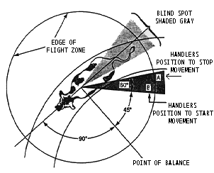 | This diagram illustrates the general flight zone of an animal. The actual flight zone of an individual animal will vary depending on how "tame" the animal is.  An animal's flight zone will vary depending on how calm it is. The flight zone gets bigger when an animal becomes excited. The flight zone is also bigger when you approach "head on". Calm cattle are easier to move. If cattle become excited, it takes 20 to 30 minutes for them to calm back down. People should be quiet when moving animals. Yelling and loud noise is very stressful. High pitched noises are especially stressful.
Handlers who understand the concepts of flight zone and point of balance will be able to move animals more easily. The flight zone is the animal's personal space, and the size of the flight zone is determined by the wildness or tameness of the animal. Completely tame animals have no flight zone and people can touch them. An animal will begin to move away when the handler penetrates the edge of the flight zone. If all the animals are facing the handler, the handler is outside the flight zone. There principles will work on ranches, stockyards, lairages, feedlots, and many other places.
When the handler is outside the flight zone the animals will turn and face the handler, and maintain a safe distance. When animals become accustomed to a calm handler and learn to trust the handler they will have less of a tendency to look at the handler. The animals have learned that the calm handler will back up and remove pressure from the flight zone when they go where the handler wants them to go. | 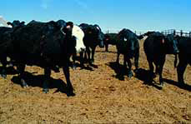

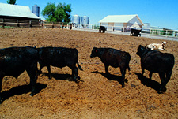 | When the handler enters the flight zone the animals will turn away.

Handler movement pattern to keep cattle moving into the squeeze chute in a curved chute system. | 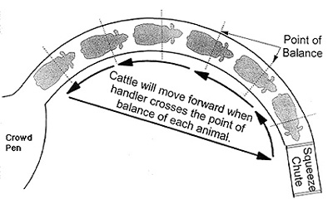

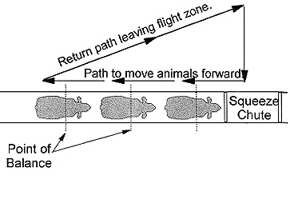 | Handler movement pattern to keep cattle moving into a squeeze chute or restrainer.
Cattle and other ruminants have a tendency to move in the opposite direction when a handler walks deep in their flight zone. The principle of these two diagrams is that the handler walks inside the flight zone in the opposite direction of desired movement. When the handler returns, he or she walks outside the flight zone in the same direction.
When an animal is being held in the squeeze chute the handler should stand outside the flight zone. To move the next animal into the squeeze chute, the handler enters the flight zone and the animal will move forward after the handler crosses the point of balance at the shoulder.
To move only one animal, the handler should stop walking when the point of balance of the animal is crossed.
When cattle are being handled in confined areas such as races and chutes the point of balance will usually be at the shoulder as shown in the diagrams. When a group of cattle are handled in an open pen the location of the point of balance may be more variable. Ron Gill, a cattle handling specialist, states that the point of balance may not be at the shoulder. He conducts many cattle handling demonstrations where cattle are handled in large open pens. Often a cow will move forward when the handlder moves just past her eye. The point of balance on any one particular animal in a large pen or field may vary depending on how it is moving with the group.
When moving livestock from a large open area, understanding flight zone behavior and utilizing a few basic principles, moving animals in a calm and orderly fashion at a walk becomes very easy. To keep the animals moving in an orderly manner the handler alternates between penetrating the collective flight zone and withdrawing from the collective flight zone. Alternating pressure on the flight zone is more effective than continuous pressure. Continuous pressure on the flight zone may make the herd run. The handler should back out of the flight zone when the herd is moving in the right direction. This rewards the herd for doing what you want. When the herd slows down or stops, pressure should be applied again. When the handler moves in the zig zag pattern he/she penetrates the flight zone when walking in the opposite direction of desired movement and retreats from the flight zone when walking in the same directionof desired movement. | 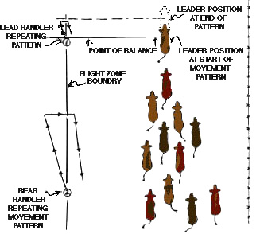
Move in straight lines and do not circle around the animals. Do not chase a lone animal or a few stragglers. The motion of the herd will attract them back. A group of animals will have point of balance for the entire group. A good stock person can move the herd by working the group point of balance. The handler should avoid the blind spot behind the animal's rear. Deep penetration of the flight zone should be avoided. Animals become upset when a person is inside their personal space and they are unable to move away. If cattle turn back and run past the handler while they are being driven down a drive alley in the stockyard, overly deep penetration of the flight zone is a likely cause. The animals turn back in an attempt to get away from the handler. If the animals start to turn back, the handler should back up and increase the distance between himself and the animals. Backing up must be done at the first indication of a turn back. If a group of animals balk at a smell or a shadow up ahead, be patient and wait for the leader to cross the shadow. The rest of the animals will follow. If cattle rear up in the single file chute (race), back away from them. Do not touch them or hit them. They are rearing in an attempt to increase the distance between themselves and the handler. They will usually settle down if you leave them alone.
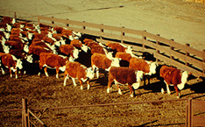 | A group of cattle moving as a herd maintains eye contact with each other, that way the entire herd can move as a coordinated whole.  The next animal behind the leader is positioned just behind the leader's point of balance.  * This is the same position that a person would stand in to move the animals.

Using the principles of flight zone behaviour, a handler is able to move cattle into a pen in a calm and orderly way. Using the positions shown on this diagram will enable the handler to control the flow of cattle through the gate. Cattle movement can be slowed or speeded up by moving forward or backward. | 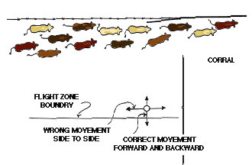

Video Clips - Caution: Require a broadband Internet connection; clips are in Windows Media format.
Moving cattle quietly with a flag by using flight zone and point of balance principles. (36 second video/1550KB file)
Moving cattle quietly through a crowd pen. (15 second video/696KB file)
Moving cattle quietly out of a gate. (25 second video/1091KB file)

References
Grandin, T. (Editor) 2007 (3rd Edition). Livestock Handling and Transport. CAB International,Wallingford Oxon, United Kingdom.
Grandin, T. (1989). Behavioral Principles of Livestock Handling Professional Animal Scientist. December 1989. Pages 1-11.
Grandin, T. and Deesing, M. 2008. Humane Livestock Handling. Storey Publishing, North Adams, Massachusettes.
Grandin, T. (Editor). Improving Animal Welfare: A Practical Approach. CABI Publishing, Wallingford, Oxon, United Kingdom.
Kilgour R. and Dalton D.C. 1984. Livestock Behaviour, A Practical Guide. Collins Technical Books. Glasgow United Kingdom.

