SHSU VIOLA
EXCERPTS Fall 2015
Solo of your choice & pick 3 of the following excerpts

RESPHIGHI Pines of Rome, mvt. 1 (Rehearsal 4 – Rehearsal 5)

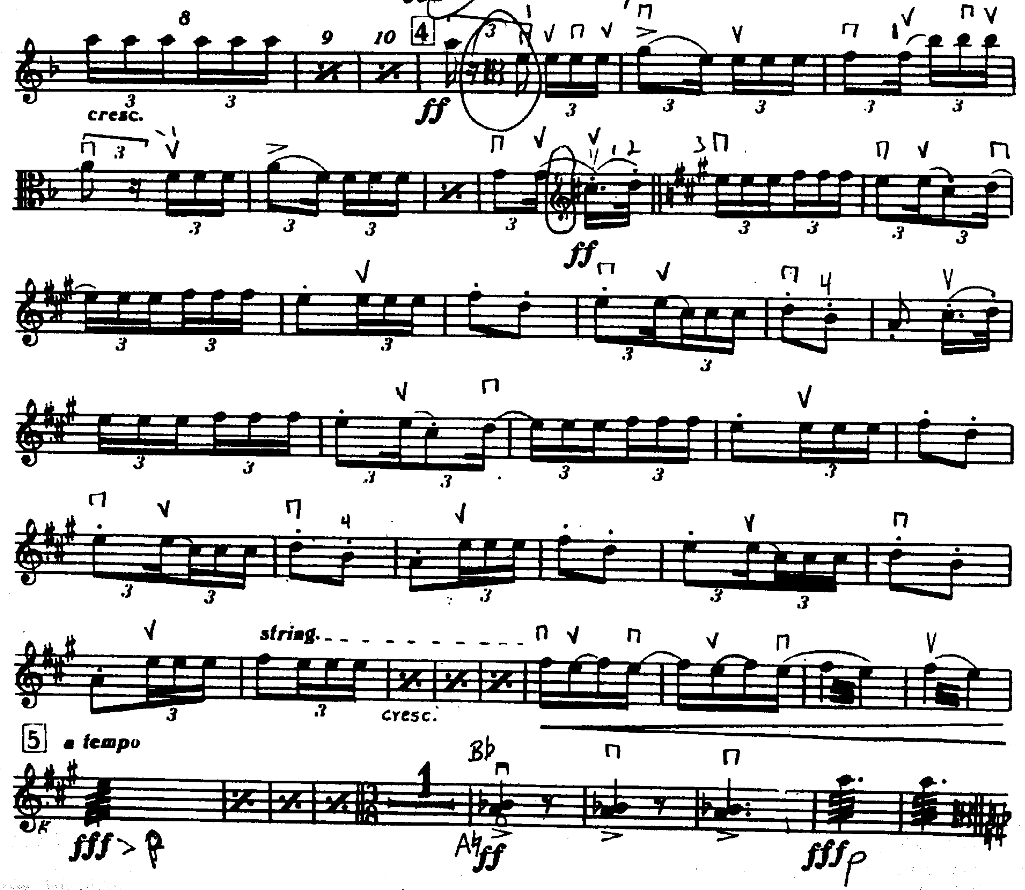

MOZART Symphony No. 35, mvt. 1 (pickup to mm. 14 – mm. 66)

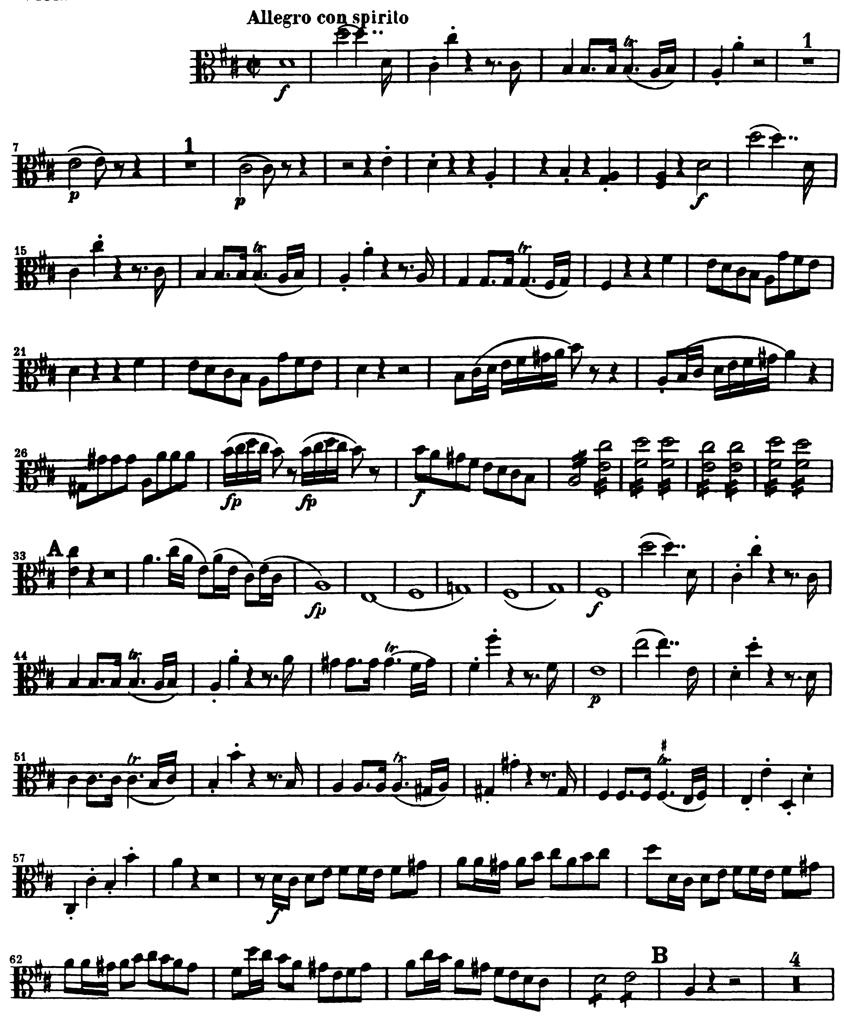
BEETHOVEN Symphony No. 3, mvt. 3 (mm. 1 – mm.127, no repeat)

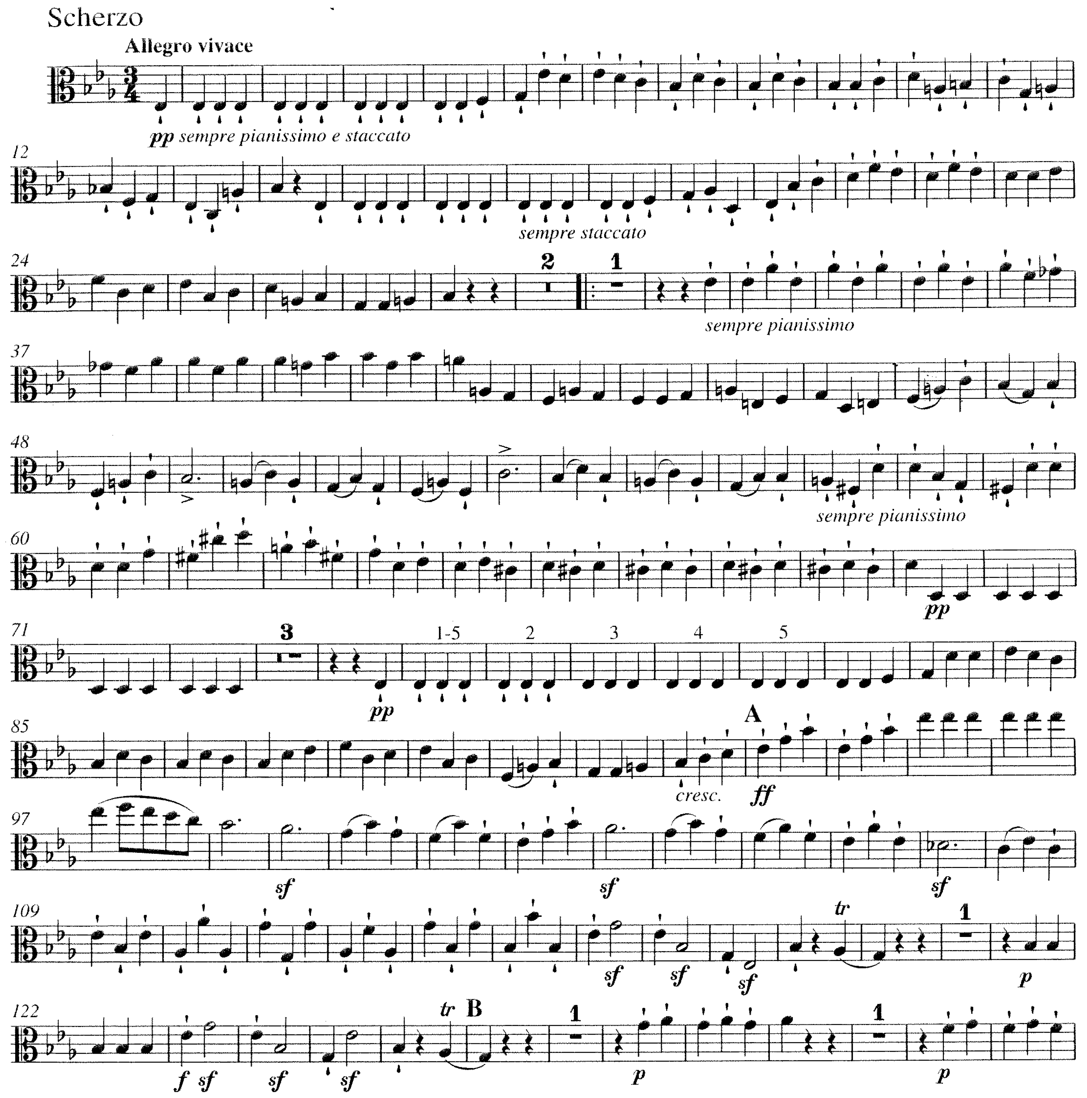

BERLIOZ Roman Carnival Overture (pickup to 3 after Rehearsal 1 – 8 after Rehearsal 3)

