Unit 5 Exam
Animal Growth and Performance
Definitions (1pt each)
- Growth - The general or normal expansion of size as produced by the accretion of tissues similar to that of the original tissue or organ
- Myofibrillogenesis – the creation of myofibrils
- Muscle growth – postnatally is an increase in muscle fiber size
- Hormone action - Hormones act in an endocrine manner when secreted by cells and then transmitted via the bloodstream to act on distant target cells
- Compensatory growth - growth exhibited by an animal after a period of nutritional stress
- Totipotent - ability to become any cell in the entire body
- Determination- process in which a previously undifferentiated cell is already programmed to become a specific cell type
- Differentiation- process by which a less specialized cell develops or matures to possess a more distinct form and function
- Osteoclasts – involved in bone reabsorption (breakdown) and remodeling.
- Maturity - is the point in time when an animal reaches its highest level of complexity or development
- Insulin – increases the storage of glucose, fatty acids, and glycogen
- Glucagon – pulls glucose and glycogen from the blood stream

T/F (1pt each)
- An increase in muscle fiber number occurs prenatally T
- An increase in muscle size number occurs prenatally F
- An intrafasicularly terminating fibers does not extend the entire length of the muscle T
- As we enter the fattening stage of the growth curve we slow growth of other tissues, leaving more energy to be stored as fats T
- Animals exposed to low temperature will mobilize adipose tissue to support heat production. T
- At high temperatures feed intake is increased so as to inhibit heat producing processes. F
- Glucagon and Insulin act on a positive feedback system F

Matching (1pt each)
- Simple – D

- Squamous – AE

- Epithelium – AD

- Connective – A

- Muscle – E

- Stratified – B

- Cuboidal – AC

- Columnar – AB

- Nervous – C

a. Provides structural framework for the animal
b. Multiple Layers
c. Made of glial cells
d. Single Layer
e. Functions in locomotion and breathing
ab. Shaped like columns
ac. Shaped like squares
ad. Thin layer of tissue that covers all free surfaces of the body
ae. Thin and flat

Multiple Choice (2pts each)
- Tissues are classified by their:
- Size
- Shape
- Number
- A & B
- B & C

- The fetal phase is characterized by
- A dramatic increase in size of existing organs
- Tissue differentiation
- Cells maintain totipotency
- Attachment of the placenta to the uterine wall

- Embryonic phase is characterized by
- A dramatic increase in size of existing organs
- Tissue differentiation
- Cells maintain totipotency
- Attachment of the placenta to the uterine wall
- Both b&d

- The ovum phase is characterized by
- A dramatic increase in size of existing organs
- Tissue differentiation
- Cells maintain totipotency
- Attachment of the placenta to the uterine wall
- Both b&d

- Brown fat is important in the neonate because it
- Produces energy
- Promotes a healthy digestive system
- Generates heat
- Helps improve heart health

- A triglyceride structure includes
- A glycerol backbone an one fatty acid
- A glycerol backbone an two fatty acids
- A glycerol backbone an three fatty acids
- A glycerol backbone an four fatty acids

- Endochondral ossification includes
  - Ossification from a cartilage template
  - Ossification in the absence of a cartilage template
  - Depends on the situation
  - None of the above

- Intramembranous ossification includes
  - Ossification from a cartilage template
  - Ossification in the absence of a cartilage template
  - Depends on the situation
  - None of the above

- Muscle changes in carcass composition
  - Increases at a decreasing rate
  - Fastest growing during early life and post weaning, yet decreases with time
  - Fastest growing at physiological maturity
  - None of the above

- Bone changes in carcass composition
  - Increases at a decreasing rate
  - Fastest growing during early life and post weaning, yet decreases with time
  - Fastest growing at physiological maturity
  - None of the above

- Fat changes in carcass composition
  - Increases at a decreasing rate
  - Fastest growing during early life and post weaning, yet decreases with time
  - Fastest growing at physiological maturity
  - None of the above

- Androgens synthesis induces
  - the development of mature male characteristics such as: larger muscles in the forequarter, neck and crest region
  - maturation of repro tract, female behavior, mammary development

- Estrogen synthesis induces
  - the development of mature male characteristics such as: larger muscles in the forequarter, neck and crest region
  - maturation of repro tract, female behavior, mammary development

- What is NOT an effect of epinephrine
  - Mobilization of glycogen for energy
  - Increased heart rate
  - Increased blood flow
  - Increased body temperature
  - All are an effect

Short Answer
Compare are contrast true growth and fattening (4pts)
- True growth – increase in the amount of muscle and bone
- Fattening – increase in the accumulation of fat
- New calf has true growth
- Fattening occurs at the end of a life stage
What are some of the differences in animal growth from the past and present? (6pts)
Past
- Smaller/fatter/lighter muscled
Present
- Taller/ leaner/heavier muscled
What are the four fat depots? (4pts)
Visceral
Subcutaneous
Intermuscular
Intramuscular
What are the three shapes of bone and where are they found? (6pts)
Long – Arm and leg
Irregular – Pelvis and vertebrae
Flat – Skull

What are two purposes for feeding antibacterial feed additives? (4pts)
Commonly fed to cattle because of increased growth efficiency
Alter the cell membrane properties and play a major role in altering microbial populations in the digestive system
Change the population of metabolism of rumen microbes
Can be used as a coccidio stat (anticoccidial drug)
Improves feed conversion

Graph/Draw
Draw a flow chart explaining nutrient partitioning (7pts)
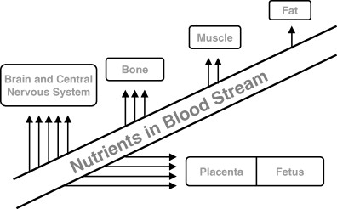

Draw a basic growth curve. Include muscle, bone, and fat. (3pts)
Fat
Muscle

Bone

Draw a flow chart explaining somitogenesis (10pts)
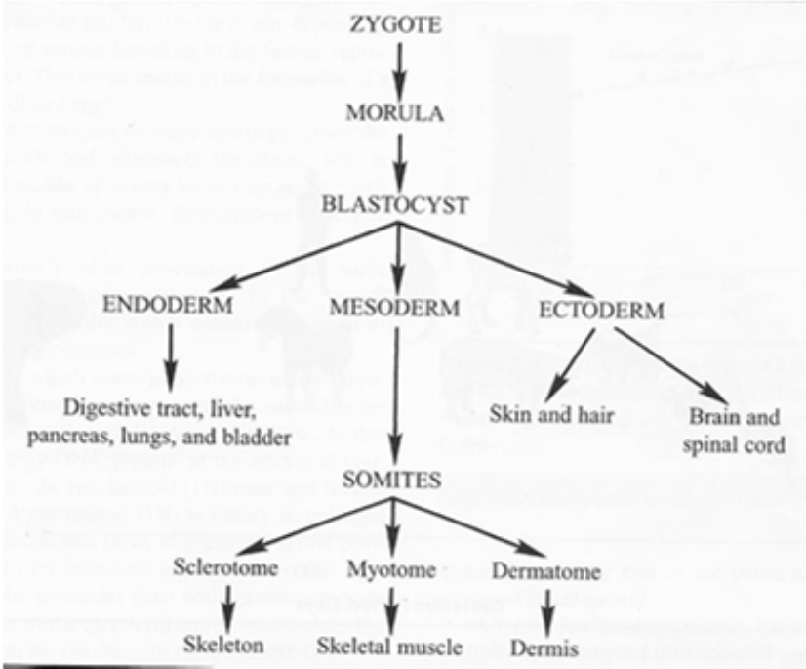
Bonus
Callipyge means – beautiful buttocks in Greek

