Avoid the 12 most common laboratory safety problems
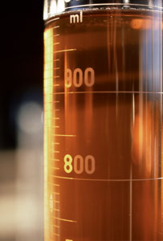
- Eyewashes should be flushed weekly and documented on eyewash tags.
- Label chemical waste with specific contents. Keep waste tag attached to the container at all times.
- Maintain labels on chemical containers received from manufacturers and label secondary containers. Replace old and deteriorated labels.
- Segregate chemicals properly. Store acids in an acid cabinet or in a plastic container (tub). Store nitric acid separately.
- Dispose of unwanted chemicals through using a waste disposal program.
- Keep chemical waste containers closed (do not forget to remove the funnel).
- Chemical fume hood sashes should be kept closed whenever possible. Maintain the minimum possible opening when working. Limit storage in hoods to essential items only.
- Do not store or consume food or drinks in labs where hazardous materials are present.
- Secure gas cylinders properly and keep safety caps on cylinders when not in use.
- Do not wear shorts or open-toed shoes (e.g. sandals) in labs. Wear appropriate personal protective equipment (PPE) when working in labs where hazardous materials are present.
- Have appropriate spill supplies available and follow response procedures.
- Remove clutter and practice good housekeeping. Keep exits and aisles clear. Eliminate extension cords and power strips in series.

