Botany Basics - Roots C. Kohn, Waterford WI
Name: Hour Date:
Date Assignment is due: upon finishing PPT Why late?
^{Day of Week} ^{Date} If your project was late, describe why
- What are plant organs?
- What are the two groups of plant organs?

- Sexual reproductive parts include what structures?
- Vegetative parts include what structures?
- Which kind of structure is used for sexual reproduction?
Which kind is used for asexual reproduction?
- What are four major reasons to understand plant roots? Plant roots have an major impact on…
1
2
3
4
- What are the four principle functions of roots?
1
2
3
4
- What is a fifth function of roots in some plants?
- Write the name of each of the structures below:
- What are the three major parts of a root and their function?
1
2
3
- Write the name of each of the structures below:
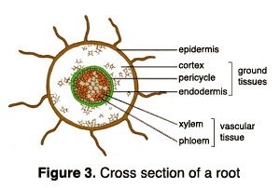
- What is the epidermis?
  - What is its function?
- What are the two functions of the cortex?
- What are the two kinds of vascular tissue and what are their functions?
- What are the two areas of importance on the exterior of the root?

- What is the function of the root cap?
- What is the function of the root hairs?
  - How long do they live?
  - How might they be affected by transplanting?
  - How could this be prevented during transplanting?
- What are the two kinds of roots? and
- What determines whether or not a plant will have a taproot system or a fibrous root system?
- How could a nursery induce a plant with fibrous roots to naturally produce a taproot?
  - Why would they want to do this?
- What can help the early growth of most row crops in terms of root development?
- Once a plant is established, what determines the effectiveness of the roots?
1
2
- Where does most of the absorption of nutrients occur for most plants?
  - Why is this the case?
- What are 5 key factors in root growth?
1
2
3
4
5
- What are three examples of edible roots grown as crops?

