EXAM: LIVESTOCK NUTRITION

- What is a ruminant?

- What is a monogastric (non-ruminant)?

- Label the four parts of a ruminant stomach.

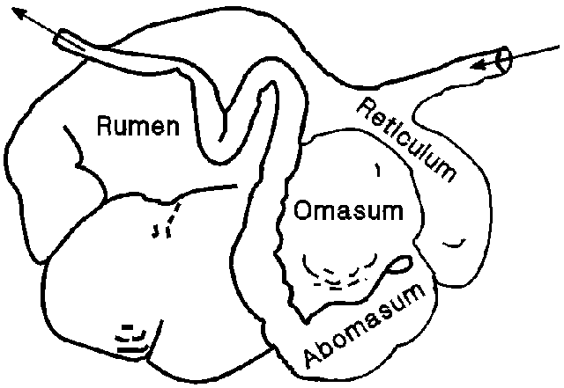

4. List the functions of the digestive system of animals include?
1.
2.
3.
4.
5.

5. Monogastric systems have a ____________ stomach structure and only one compartment.

6. Some animals with monogastric digestive systems are __________ and rabbits. ___________ also have monogastric digestive systems.

7. List the 6 sources of nutrients and their importance.
1.________________________________________________________________________________________________________________________

2.________________________________________________________________________________________________________________________

3.________________________________________________________________________________________________________________________

4.________________________________________________________________________________________________________________________

5.________________________________________________________________________________________________________________________

6._______________________________________________________________________________________________________________________

8. Describe protein requirements for Ruminants.
_______________________________________________________________________________________________________________________________________________________________________________________
___________________________________________________

Draw and describe (one):

9. Warm Season Perennial:

11. Cold Season Annual:

10. Warm Season Legume:

12. Cool Season Legume:

Formulation Rations:
- Formulate 1000 lb. of a complete sheep diet containing 12% CP. Use corn at 8.5% CP and a supplement at 38% CP. Show ALL your work!!

- You are the owner of a feedlot and have to formulate a ration that will be cost efficient and provide the necessary nutritional requirements for your animals. Formulate a 2500 lb. ration with 43% CP for your cattle using the list of feed options shown below. Choose ONE main feed and ONE supplement as labeled. Show ALL work, including your math on how much your feed will cost you.

Main- Corn | 10% CP | $0.80 per lb.
Main- Barley | 5% CP | $0.65 per lb.
Main- Wheat Straw | 8.4% CP | $0.65 per lb.
Supp.- Fish Meal | 78% CP | $2.65 per lb.
Supp.- Soybean Meal | 45% CP | $1.50 per lb.
Supp.- Molasses | 6.7% CP | $0.45 per lb.

