Name:_______________________ Date:__________
Test for Advanced Animal Science- Unit 4

Questions will pertain to Genetics of cattle and reproduction of cattle.
Multiple Choices:
- Purebred animals consist of how many breeds?
- One
- Three
- Four
- Too many to count
- What type of selection is under Human Control?
- Natural Selection
- Replacement Selection
- Artificial Selection
- General Selection
- How can a scientist tell the difference between Polygenic Traits and Simply-Inherited Traits?
- Simply-Inherited traits are traits that you simply get from being born.
- Polygenic traits are traits affected by many genes, on no single gene.
- They both can only happen in certain animals, that’s how scientists can tell.
- Genetic prediction is able to tell the difference between the two traits.

Matching Questions:
1. Gene a. Alternative form of a Gene
2. Chromosome b. Have corresponding loci
3. Homolog c. Basic unit of Inheritance
4. Locus d. Present in Pairs
5. Allele e. Specific location of a Gene

True/False Questions:
- The combination of genes at a particular locus is called a Genotype.
True
- Homozygous has one-locus genotype containing functionally different genes. False
- Heterozygous has one-locus genotype containing functionally identical genes.
False

Fill in the Blank:
- Linkage is the occurrence of how many Loci of interest on the same chromosome? _______________________________
2 or more loci
- When does Crossing Over occur? __________________
Prior to the time chromosomes are separated to form gametes during meiosis
- Recombination is a result of what? _____________________
Result of crossing over
Short answer:
- Show the proper use of a Punnett Square using horned and polled bulls.
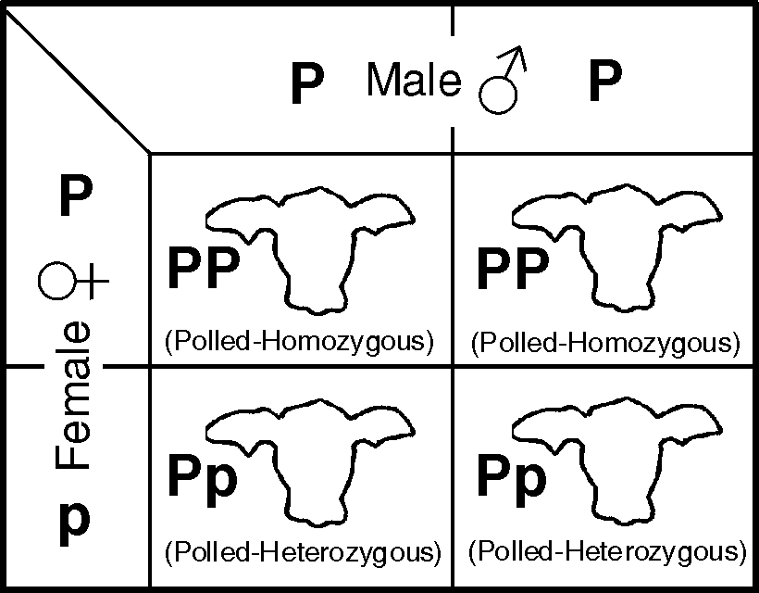

- Discuss the difference between Sex-linked and Sex-influenced traits.
Sex Linked - The X chromosome is larger and longer than the Y chromosome, which means a portion of the X chromosome does not pair with genes on the Y chromosome.

Sex-Influenced - Modes of gene expression differ between males and females. An allele may be expressed as a dominant in one sex and a recessive in the other. Scurs on cattle is a sex-influenced inheritance.

- Define heritability and give at least 2 examples.
Heritability: the capacity of a trait to be passed down from a parent to offspring.
Fertility, Weaning Weight, Postweaning rate of gain, fat thickness, LEA, percent lean
BW | WW | Milk | YW | Marb | REA | FAT | %IMF | RE | FAT | %RP

- Define phenotype and genotype.
  - Phenotype – The appearance of an animal.
  - Genotype – What genes are present and how they are combined.

