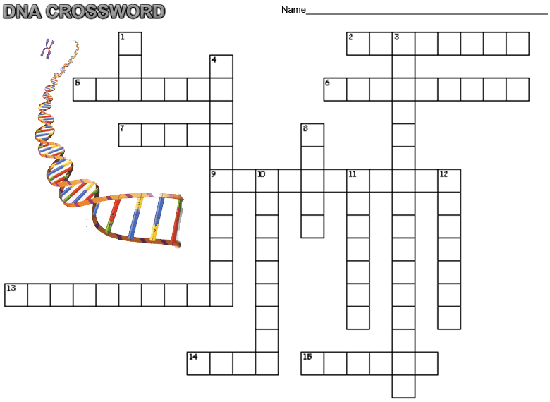
Across  2. the two sides of DNA held together by weak ____ bonds  5. always pairs with cytosine  6. where protein is assembled from the message on the RNA  7. the shape of DNA, double ____  9. process of copying DNA  13. composed of a sugar, a base, and a phosphate  14. sections of DNA that code for a trait  15. replaces thymine in RNA | Down  1. carries the message of DNA to ribosomes  3. the long form of DNA, ____ acid  4. the sugar found in DNA  8. DNA's stucture established by Watson and _____  10. the sides of the DNA ladder composed of sugar and _____  11. always pairs with thymine  12. where DNA is found in the cell

