Botany Basics Test Guide
The following are likely to be included in the upcoming Botany Test. They are included in order as you would find them on the online PowerPoints.
All PowerPoints can be found under This Week in the Department or under Previous Weeks’ Assignments

Roots
- Sexual vs. vegetative structures in plants
- Impact of roots on plant size, vigor, propogation, and needs from soil
- Functions of roots in plants
- Identification of root parts
- 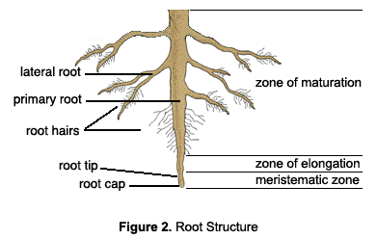
- Definition of meristem
- Roles of zone of maturation and zone of elongation
- Identification of structures via a cross section of the root
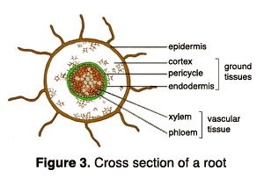
- Role of the epidermis
- Role of the cortex
- Role of the vascular tissue
- Role of the root cap
- Role of the root hairs
- Difference between primary roots and lateral roots
- Difference between fibrous roots and taproots
- How roots grow
- Factors important to root growth
- Examples of food from roots

Stems
- Roles of the stem
- Stem terminology
- Vasculature components of the stem
- Importance of vasculature components to gardeners
- Difference between monocot stems and dicot stems
- 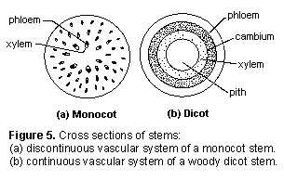
- Definition and role of nodes
- Importance of internodes
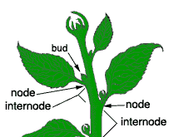
- Role of nodes and pruning
- Factors that affect internode length
- Types of stems – crowns, spurs, stolons
- Difference between roots and below-ground stems
- Rhizomes
- Impact of rhizomes on weed control
- Bulbs
- Difference between tunicate and nontunicate bulbs
- Corms and tuberous stems
- Stems and propogation
- Examples of stems as food

Leaves, Fruits, and Flowers
- Function of leaves
- Leaf anatomy – petiole, node, and axil
- Layers of a leaf cross-section
- Role of the epidermis
- Cuticle and cutin – impact on leaves
- Role of guard cells and stomata in plant regulation of water, oxygen, and carbon dioxide
- Factors that open or close the guard cells
- Layers of the mesophyll
- Importance of the mesophyll
- Types of modified leaves
- Purpose of flowers
- Role of flowers in classification
- Male and female parts of a flower
- Parts of the stamen
- Parts of the pistil
- Petals, corolla, sepals, and calyx identification
- Complete flowers vs. incomplete flowers
- Perfect flowers vs. imperfect flowers
- Formation of seeds via pollination
- Difference between animal pollinated and wind pollinated flowers
- Steps of fertilization
- Formation of fruits
- 3 types of fruits

