How To Age A Wild Turkey
By Will Allen
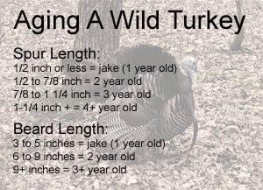
It seems like every time someone is lucky enough to get a turkey they try to age the bird right away. I’ve seen hunters at registration numbers come up with some pretty funny formulas for declaring the age of their bird. One thing is for sure. It is not an exact science. However, there are a few variables that can help narrow down the age of a spring gobbler.
How much did it weigh? Weight is one of the first things many hunters ask when you tell them you got a turkey. Weight is a good indicator when it comes to offensive lineman. But it’s not going to tell you much about the age of a turkey. Habitat and food availability are the main factors there. I’ve killed jakes that pushed the scale at nearly twenty pounds during hunting seasons after a mild winter and mature gobblers as light as 18 pounds after harsh winters. These were both birds living in the same approximate area. Take weight out of the equation.
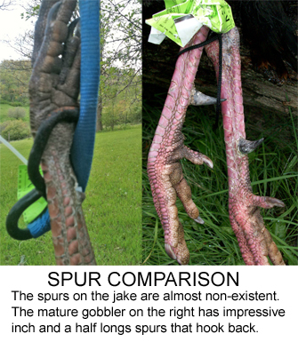
Beard size is a good measuring stick. A jake is typically going to have a three to four inch beard. Of course, it’s pretty easy to figure out the age of a jake. As a male turkey ages, his beard continues to grow. A gobbler with a six to nine inch beard is usually a two year old. These beards on these birds will often have an amber tip. At three years old the beard will typically grow to about ten inches. Once they reach ten inches long, beards will tend to wear down as they get dragged on the ground. Of course, turkeys with multiple beards will grow them at a different rate as well.
A turkey’s spurs may be the best way to judge it’s age. A jake’s spurs will often be less than a half inch long. At two years old a gobbler’s spurs are typically between a half inch and 7/8 of an inch. If your gobbler sports 7/8 inch to inch and a quarter long spurs, he’s probably a three year old. Longer than that and you’ve got yourself a wily old veteran.
Of course, these are just guidelines. What do you do when the bird has a six inch beard and inch and a half long spurs? You can average it out if you want. Personally, I would always go with the spur length as the best indicator. However, in my opinion all turkeys are trophies and any attempts at aging them should only be done for fun. Good luck on your next hunt!

