New User
SHSU DISSERTATION TEMPLATE USAGE GUIDE

- On the SHSU homepage, go to Graduate Students. Click on “Thesis/Dissertation;” then right click on the current dissertation template entitled “New Fall 2015 Thesis/Dissertation Template.”

- Save this Macro-Enabled Word document by right clicking on the link and selecting Save Link As…. It is highly encouraged that you rename this file in the following manner: Last Name_Initial_dissertation or Last Name_Initial_thesis.

- Once saved, open the Word Macro-Enabled document (.dotm). You will type your dissertation into this document.

- As noted, this template uses macros. If you receive a warning when opening the document that macros have been disabled, enable the content by clicking on the security warning and click Enable Content on the ribbon across the screen if it appears.
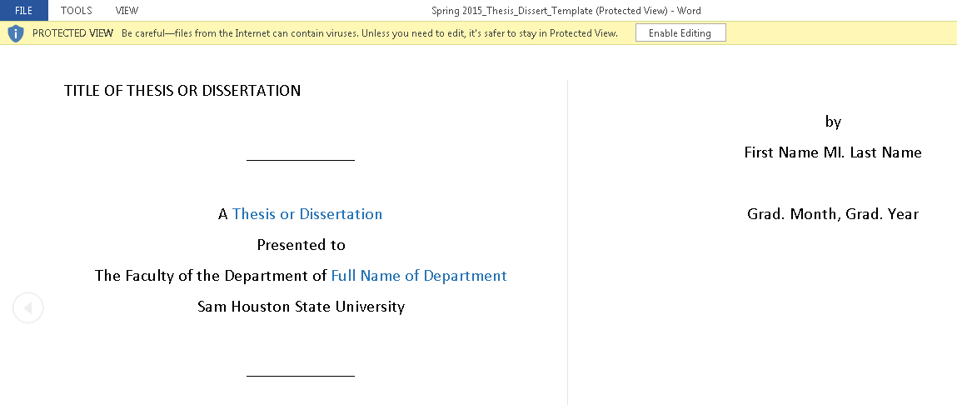
- WELCOME MESSAGE: A welcome message will pop up with instructions.
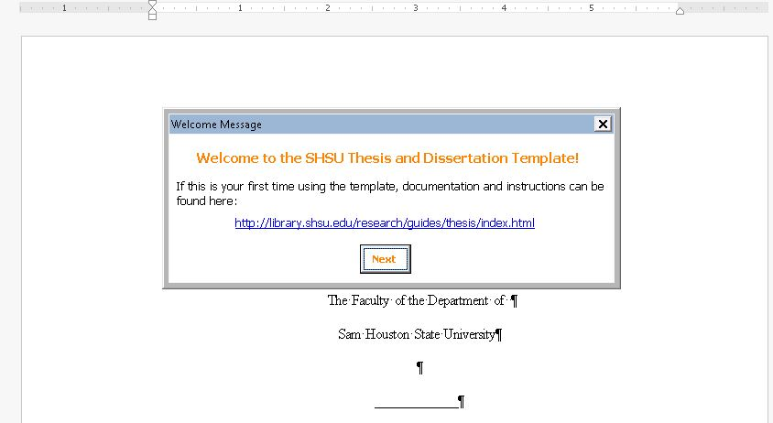
Click on “Next” to pull up another dialogue box asking you to fill in information such as your name and graduation date. The template will use the information you enter in these opening boxes to fill in your title pages and abstract automatically. Fill in the requested information and click “Okay.”
- After clicking the Okay button, another dialog box for committee information will appear. Fill in your committee information. The template will use the information you enter in these opening boxes to fill in your title pages and abstract automatically. Click “Okay.”

- Read the instructions on the third box, called “Getting Started.”
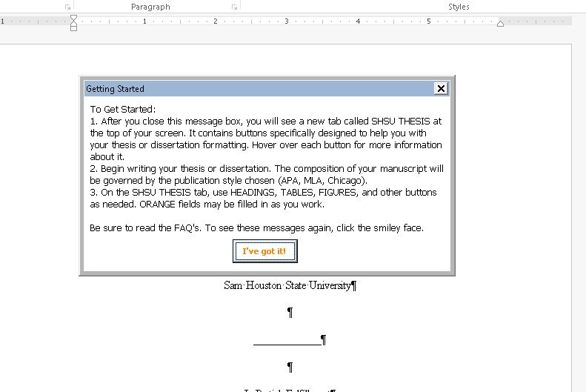

- Once you have read and understand the directions, close this box by clicking “I’ve got it!”
Using the SHSU Thesis tab, click on the smiley face icon any time to see these boxes again and edit your information.

- SHSU THESIS TAB: You will use the SHSU Thesis tab (next to the Home tab) for most of your actions in the template. Note: Hover your mouse over the items in the SHSU Thesis tab for an explanation of each item’s function. Show hidden formatting by going to the SHSU Thesis tab and clicking on the paragraph marker in the top left corner (see the screenshot on the next page).
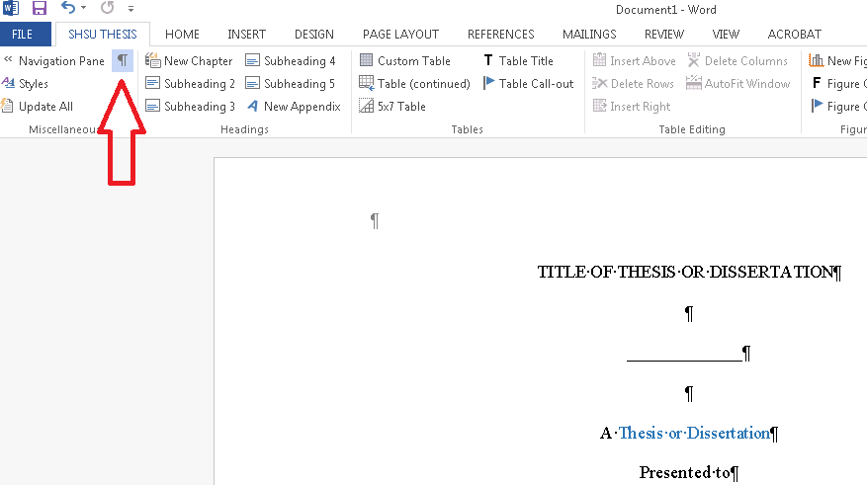
- STYLE RIBBON: You can find the Style ribbon by clicking on “Styles” in the SHSU Thesis tab. If you are transferring or manually entering content, the Style ribbon allows you another option for applying different styles to this content.

- OPEN NAVIGATION PANE: Click on the SHSU Thesis tab and then Navigation Pane. You can use the Navigation Pane to navigate anywhere in the document.
Note: To delete pages you will not use, right click and select Delete in the Navigation Pane; you cannot press the Delete key on the keyboard to delete a page. Required pages cannot be deleted. Conversely, if you need to replace a page that has been deleted, see the FAQs.
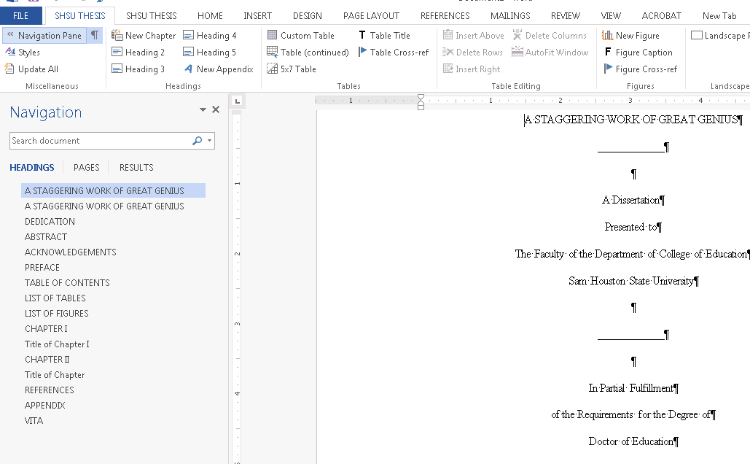

- DEDICATION: Scroll to or select DEDICATION on the Navigation Pane. Type content over the orange text (or if you are not using the Dedication page, use the Navigation Pane to delete the unused page: right click, choose delete).
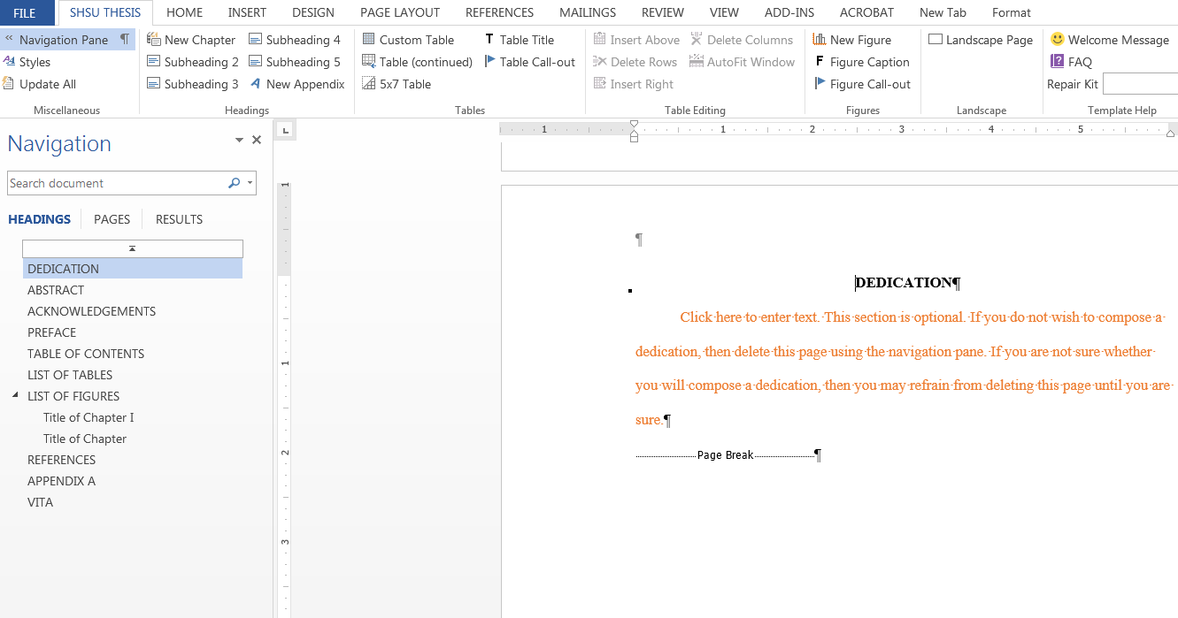

- ABSTRACT: Scroll to or select ABSTRACT on the Navigation Pane. Your information should already be filled out after entering it in the automatic opening dialog boxes, but if not, click the smiley face icon on the SHSU Thesis tab to complete or correct your information. Click on the orange text to add your content for the Abstract and your keywords; the Abstract must be no more than 350 words in length.
Click into the Keywords box and add key words for the abstract using the tip provided. Note: Tips will appear over each input box when clicked on.

- ACKNOWLEDGEMENTS: Scroll to or select ACKNOWLEDGEMENTS on the Navigation Pane. Type content (or use the Navigation Pane to delete the unused page: right click, choose delete).
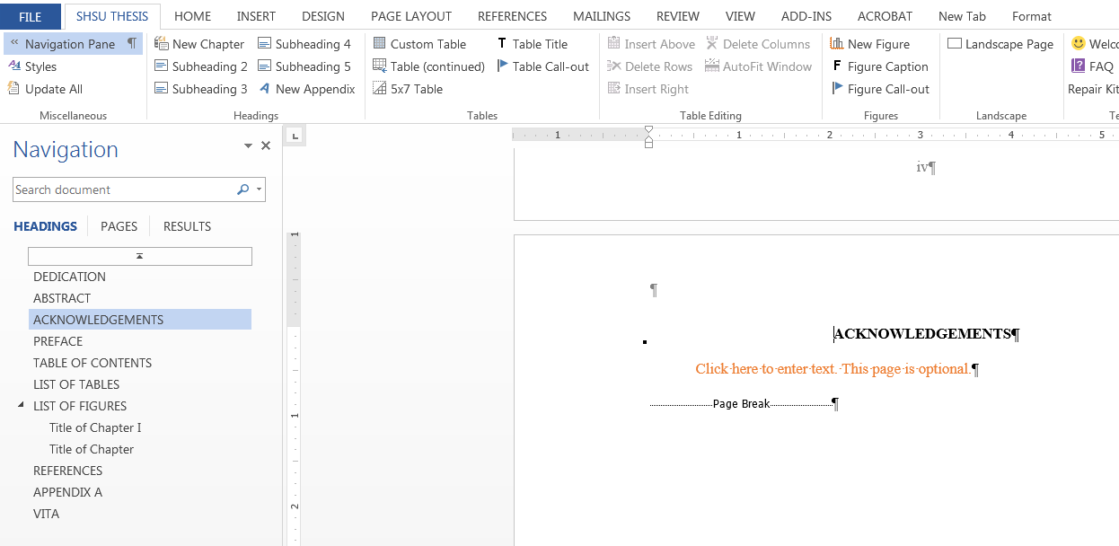
- PREFACE: Scroll to or select PREFACE on the Navigation Pane. Type content (or use Navigation Pane to delete unused page: right click, choose delete).
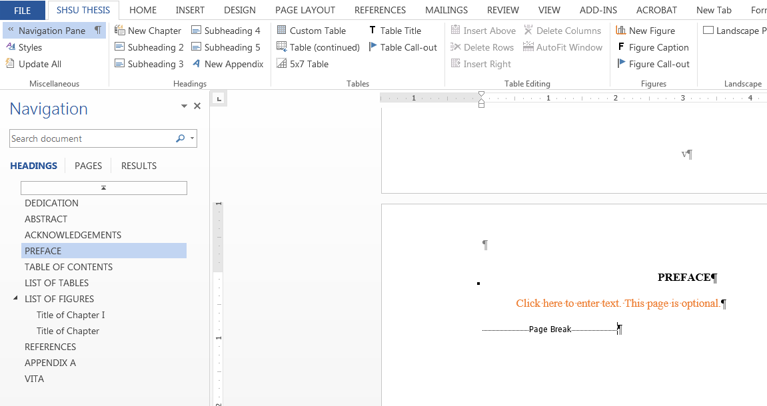

- TABLE OF CONTENTS.
CAUTION: Do not type in any information on the Table of Contents (TOC) page, the List of Tables (LOT) or the List of Figures (LOF). The TOC, LOT, and LOF will automatically populate as you enter information into the chapters of your thesis/dissertation. Once you have typed the contents of a chapter and added the appropriate headers into the template as instructed in this guide, be sure to update the TOC/LOT/LOF by clicking on Update All in the SHSU Thesis tab (left corner).
Notes: the front matter, TOC, chapters, appendices, and vita are hyperlinked in the TOC. To navigate elsewhere in the dissertation (for example, Chapter III), you can use the Navigation Pane or go to the TOC, and hold down the Ctrl key while clicking the mouse on the title of the chapter to which you want to navigate.

- CHAPTER I: Use the Navigation Pane to navigate to the Title of Chapter I. The proper heading style is already provided; click the text box to insert a Heading 2. Afterward, make sure to click below the box for your chapter title in order to begin entering chapter content.
Note: At any time, you can hover over the Headings selections in the SHSU Thesis tab to see tips or instructions about adding your heading to the chapter. After entering your title, you will notice that your new title now appears in the Navigation Pane.
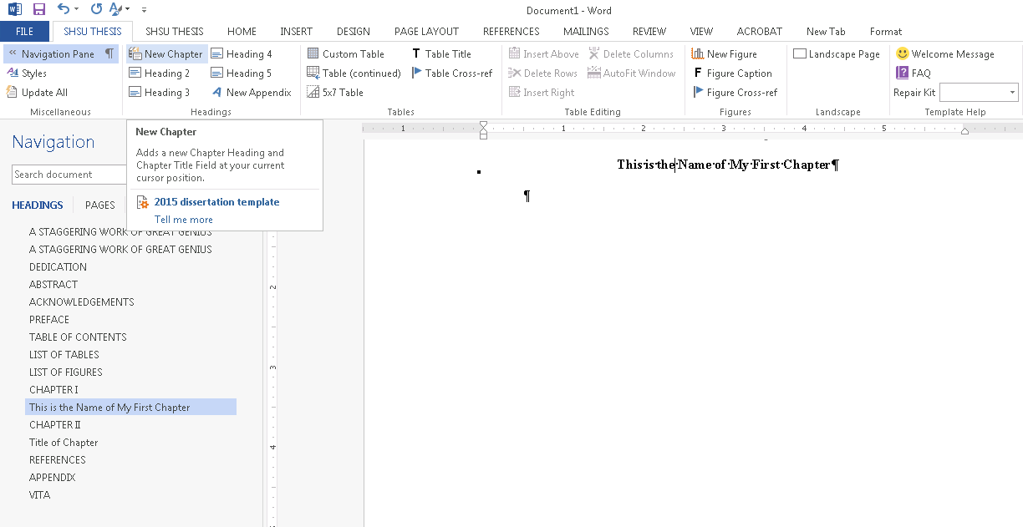

- INSERTING SUBHEADINGS: Use the appropriate button to insert a subheading. Click into the box that is created and type the heading. A tip will pop up with formatting directions that you must follow. Once you have typed the heading according to the formatting directions, click outside the heading.
  - Go to the SHSU Thesis tab to select the proper subheading style. Choose the needed subheading from the SHSU Thesis tab; then type the title of the subheading in the given text box.
  - The Navigation Pane will automatically update with each subheading you add, but you will need to go to the SHSU Thesis tab and select Update All for the Table of Contents to update.
Important: Do not copy and paste your headings from another document into the template. If you are transferring content from another document, please see the Transfer User’s Guide.

Note: To make certain that you are not typing your content into a heading text box, always click outside the heading text box after you type in the heading.

- BUILDING TABLES OR FIGURES:

Note: Please build your tables in the template. If you are copying a table from an Excel document or another source, please first create a custom template that is the same dimensions as your source table. Then, highlight the table and right click, click Paste Options, and choose Keep Text Only. Never “link” a file, or your document may become corrupted.
To build tables, use the SHSU Thesis tab: Put your cursor where you want to insert the table in the document. Click on 5x7 Table in the SHSU Thesis tab for a standard table. You can also click on Custom Table in the SHSU Thesis tab to designate the number of rows/columns desired. As you can see from the screenshot below, the table automatically produce a section for a note. Simply fill this section out if needed. However, if you do not need a Note, delete the text box and the word Note. Further, it is required that you left-justify information in first column in tables. To accomplish this, place your cursor where the first piece of information would be in the first column, and then backspace, as seen below.
When you insert a table, you will automatically be given a text box to enter the table title.
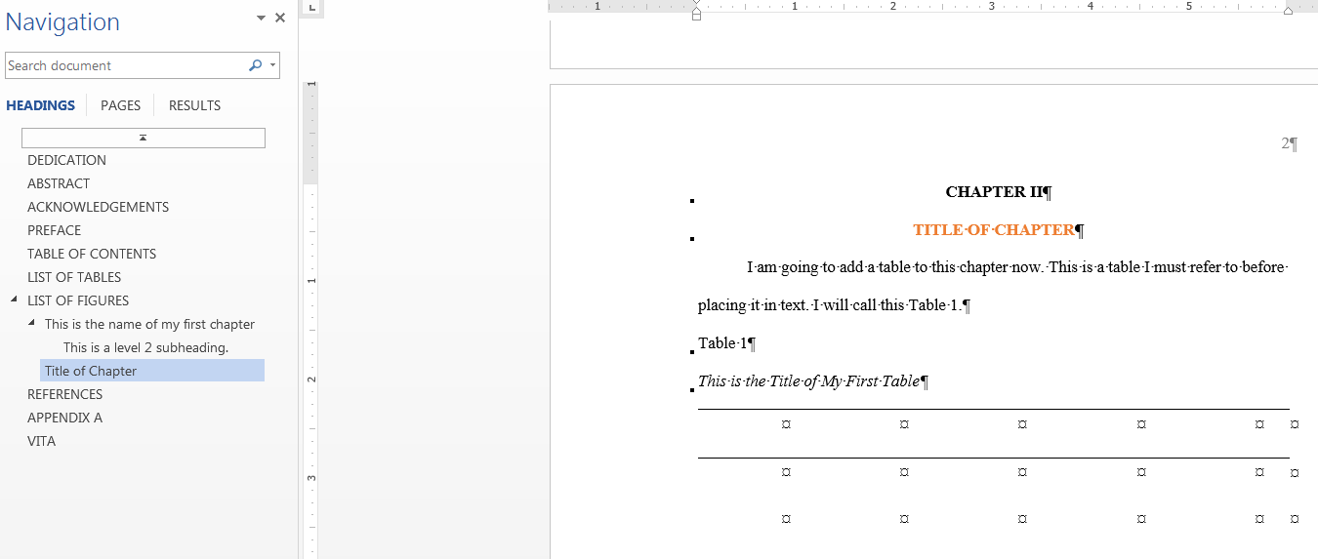
Be sure to click on UPDATE ALL on the SHSU Thesis tab to add your table title to the List of Tables.
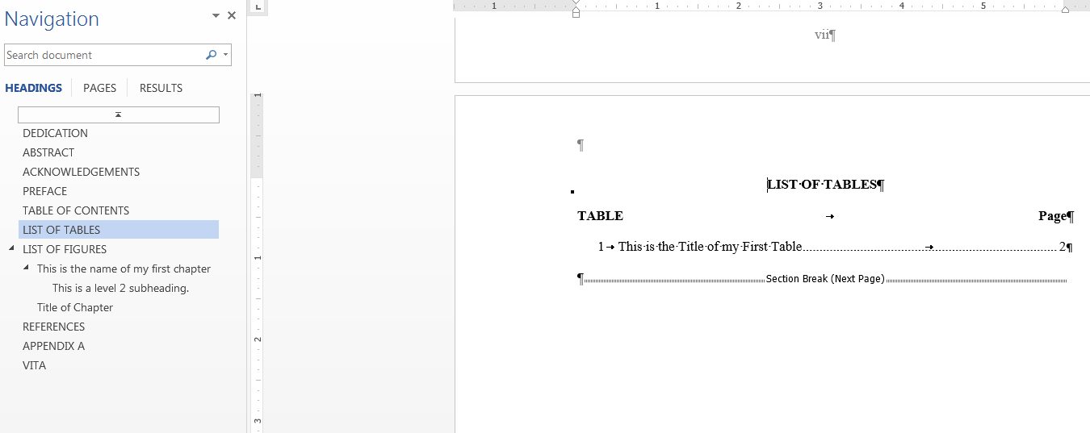

You will use the same process to add figures to your chapter, only you will click on New Figure in the SHSU Thesis tab to insert the figure. You will automatically be given a text box to type the figure caption.
Type the figure caption in the figure caption text box. Update the document by clicking on the SHSU Thesis tab and selecting Update All.
LANDSCAPE table: To Add a Landscape Table:
To create a landscape table, you must first create a Landscape page. Place your cursor where you want to add the landscape page. Click Landscape Page on the right-hand side of the SHSU Thesis tab. The template will automatically add a landscape page with the correct page number format.
Then, select either Custom Table or 5x7 Table in the SHSU Thesis tab to insert a table as before.
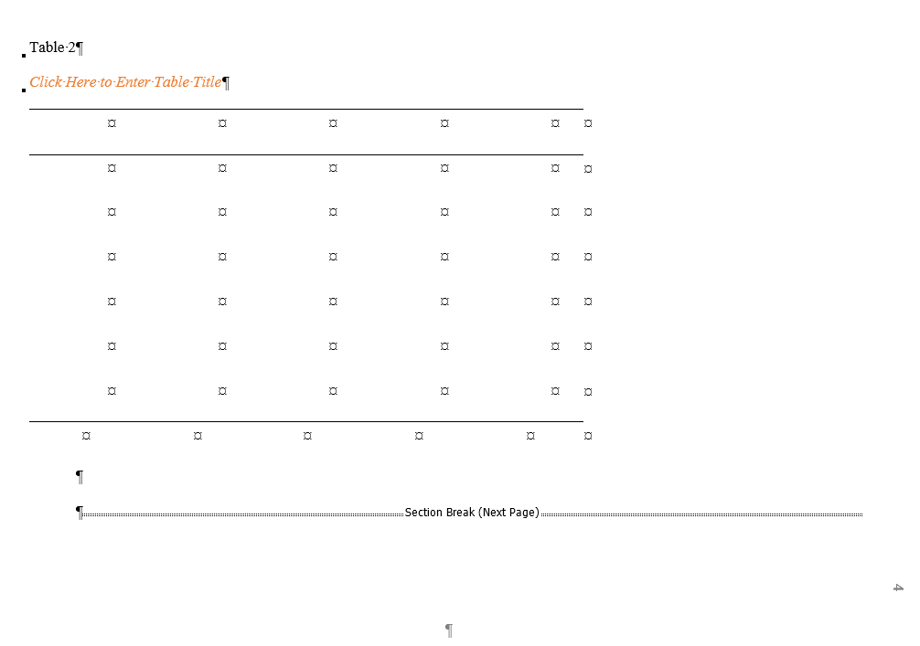
CONTINUED TABLES: For tables that exceed one page (split tables): Place your cursor in the last row of the page; then click on Table (continued) on the SHSU thesis tab. You may wish to add the “continued” near the end of your process after all of your dissertation has been typed, so that you know where and which tables will split. (Note: the default Table continued format will carry over table headers)
- LIST OF TABLES (LOT): Remember, this will automatically populate. The LOT will hyperlink to the caption you create for each table (see Item 22 below for instructions on creating table and figure cross-references).
- LIST OF FIGURES: Remember, this will automatically populate.
Note: As in the TOC and LOT, figures are hyperlinked in the LOF. (See Item 22 below for instructions on creating table and figure cross references).
- CROSS REFERENCES: Remember to provide a cross reference for all tables and figures mentioned in text. (Note: Please, be aware that Tables and Figures must be built prior to the addition of a Cross-reference). To create a cross reference, click on the text before the point where you would like to create your reference in the text (this process will insert the words “Table [N]” or “Figure [N]” in this spot, where [N] is the number of the table or figure being inserted). Then click on either Table Cross-ref or Figure Cross-ref in the SHSU Thesis tab to insert the appropriate cross-reference. Enter the number of the table or figure, then click “Okay.”
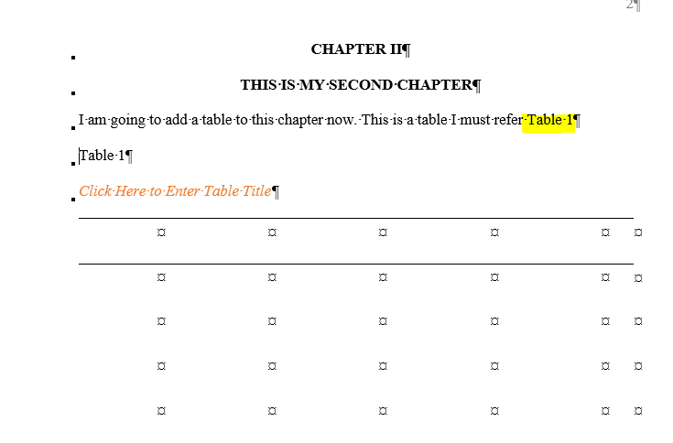
- NEW CHAPTERS: You can add new chapters by clicking on New Chapter in the SHSU Thesis tab. Continue until all chapters of the dissertation have been completed. Note: Place your cursor where you would like the new chapter to begin, then click “New Chapter.”
- REFERENCES: See instructions on the reference page in the template; you may either enter references manually or use the References tab.
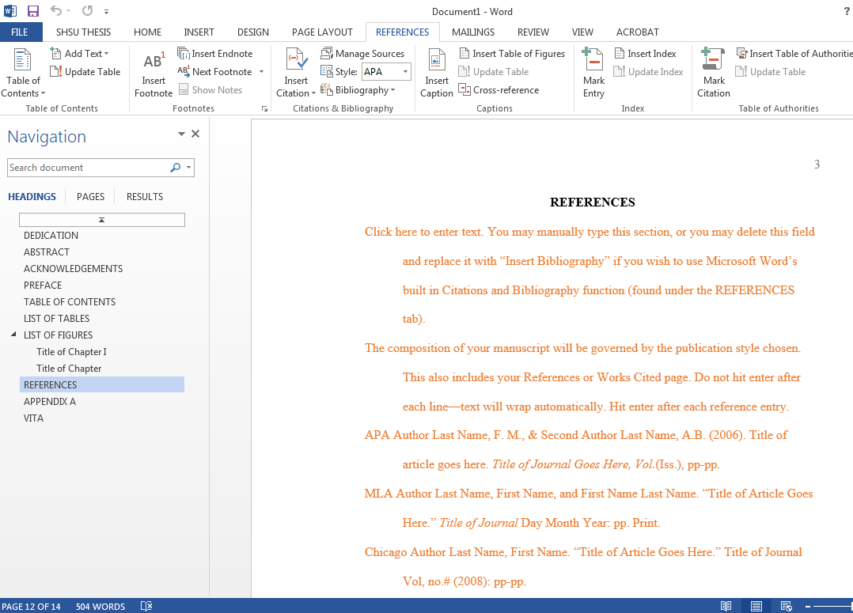
- APPENDICES: Add APPENDICES as needed: Go to the Navigation Pane on the SHSU Thesis tab. Click on Appendix and then add “A” to the end of the first appendix title. Right click on Appendix A in the Navigation Pane and select New Heading After. Repeat as necessary to add more appendices.
- VITA: Go to the Navigation Pane on the SHSU Thesis tab. In the text box, you have two choices. You can type content into the text box, or copy content from another document and under Paste Options (right click where you would like to paste), select “Keep Source Formatting.”

Note: Be sure to remind your dissertation committee or any reviewers that they will need to save the document as a Macro-Enabled Document using Microsoft Word 2010 or later in order to preserve the ability to use the macros in the document. Otherwise, you will need to contact a NGL Thesis Library Clerk for assistance in reattaching the template to the document.

That’s it! Just be sure to save frequently, keeping macros enabled by saving as a Macro-Enabled Word Document (.dotm), and use the SHSU Thesis tab to update your page numbers and titles as you work through your document. If you need assistance with the template format, you can contact the Thesis Clerk in the Newton Gresham Library at 936-294-3678, who can assist you on many issues regarding the template.

